Tickets Service

Tickets Service will be responsible for creating Tickets, Fetching Tickets, Fetching Single Ticket, Updating Ticket

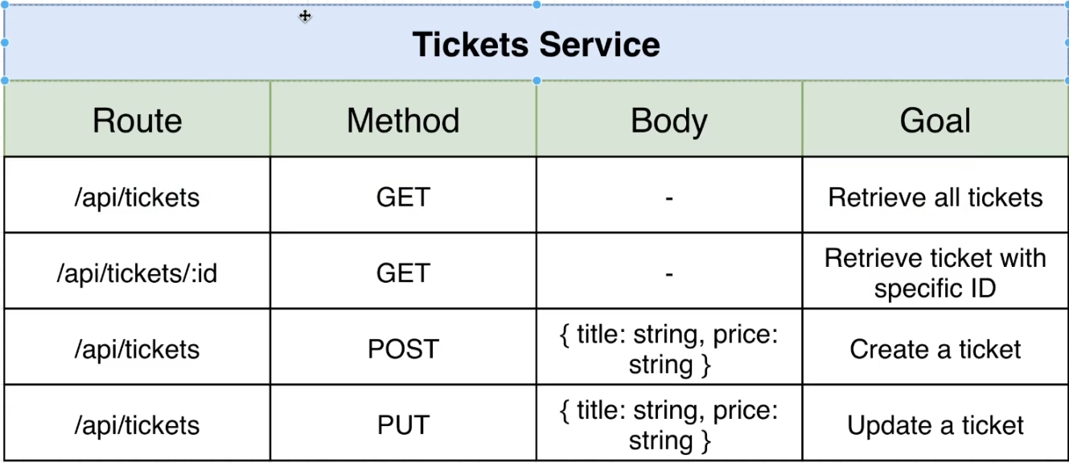

Points to Note

1. This Service will be independent from other services
2. It contains its own mongodb Database independent from others.

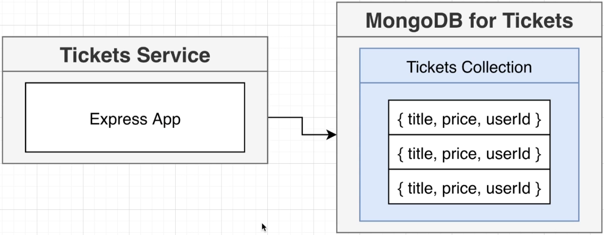

Process of Creating Service

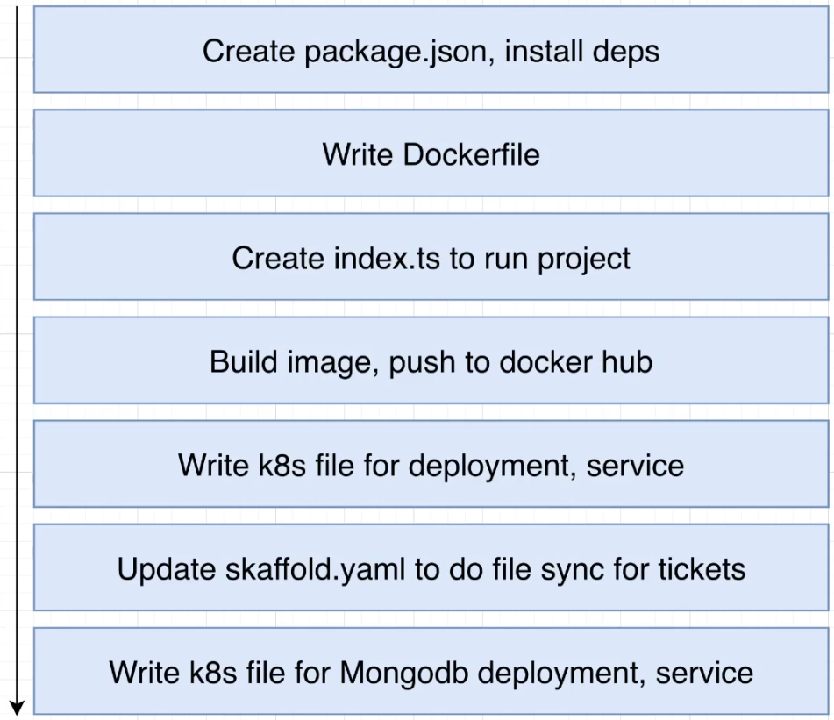

After Successfully Scaffold dev CMD

Create and env MONGO_URI of

env:

- name: MONGO_URI

value: "mongodb://tickets-mongo-srv:27017/tickets"

This will create an dynamic variable which can be configured while deploying image.

we can use process.env.MONGO_URI instead of

`mongodb://tickets-mongo-srv:27017/tickets`

inside server.

Implementing Tickets Service by Test-first Approch

Test-First Approch is used via creating Test Suits First and then implement the code.

So Start creating test suit files.