# Mailchimp vs SendGrid

Both Mailchimp and SendGrid can be used as email providers by Chameleon. Many features are common between the two platforms, however they each have slightly different offerings to target different businesses. This report will provide a breakdown of their key features, and provide a suggestion to the company explaining which platform will be better for them.

**Comparison of key features:**

|  |  |  |
| --- | --- | --- |
|  | **Mailchimp:** | **SendGrid:** |
| Designing emails: | * More focussed on no-code design with ready to use templates and layouts. | * Versatility of both template/drag-and-drop, or design using the built-in HTML editor. |
| Landing pages: | * Can be used to create landing pages containing signup forms. * Can create embedded signup forms (such as on the Chameleon website) | * Limited form functionality, but can still create embedded forms. |
| Email list management: | * Uses a feature called ‘audiences’ to manage multiple lists. * Can be difficult to manage contacts across all audiences. | * Import contact data via CSV or API integrations. * Contacts can contain custom data. |
| Automation: | * Simple automations included in their free plan. | * Similar automation features to Mailchimp. |
| Analytics: | * Basic analytics on free plan, paid plans offer more complex analytics and A/B testing. | * Basic analytics, A/B testing. * Uses a feature called ‘Reputation Monitoring Indicator’, which is a percentage that is calculated based on bounce, block, spam, and invalid rates. * Can help improve sender reputation. |
| Customer Support | * Only phone support for lower tier plans. Email and live support for higher plans. | * 24/7 ticket support for all customers, 24/7 chat support for paying customers, and phone service for higher-tier plans. |

**Plan Comparisons:**

SendGrid:

Important to note:

* Pricing is based on maximum emails sent/month. Up to 50,000 emails/month costs $19.95/month; 200,000 is $89.95/month.
* This pricing model may be more favourable for Chameleon.

Mailchimp:

Important to note:

* Mailchimp bases their pricing on how many contacts a company has. For the quotes below, I selected a sample number of 50,000 contacts. Plans still have sapped email sends/month, although these are much higher than SendGrid.
* 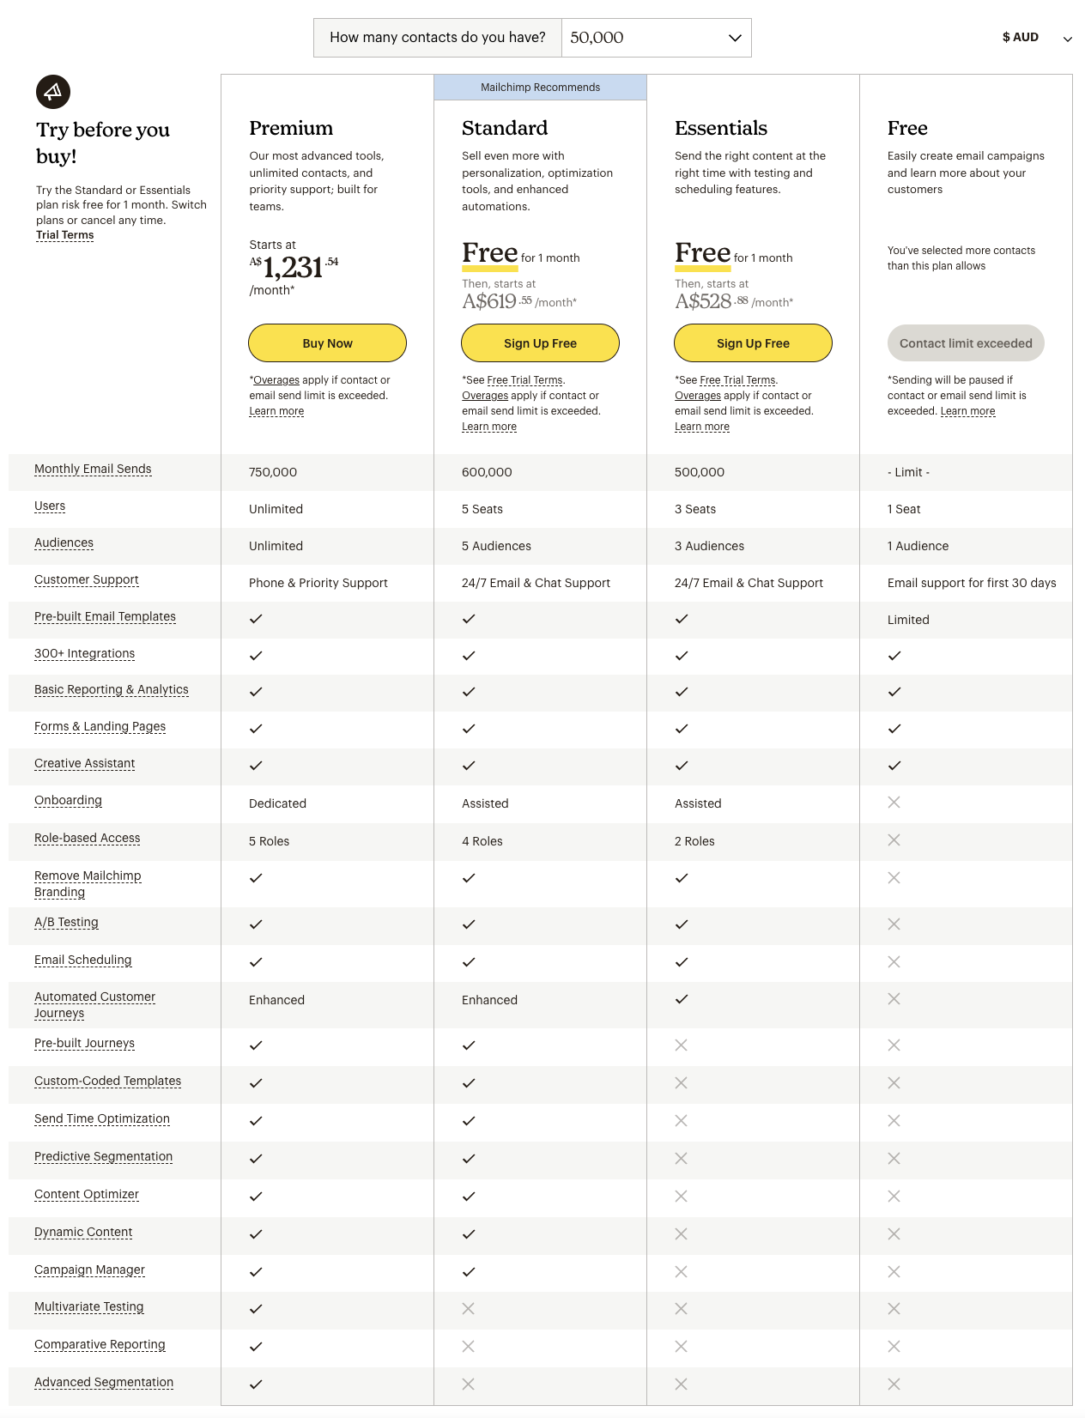Mailchimp’s cheapest paid plan is for 500 contacts and starts at just under $20/month. It is quite limited (5000 emails/month) when compared to SendGrid’s Essentials plan, which is around the same price and offers up to 50,000 emails/month.

**API Implementation:**

SendGrid:

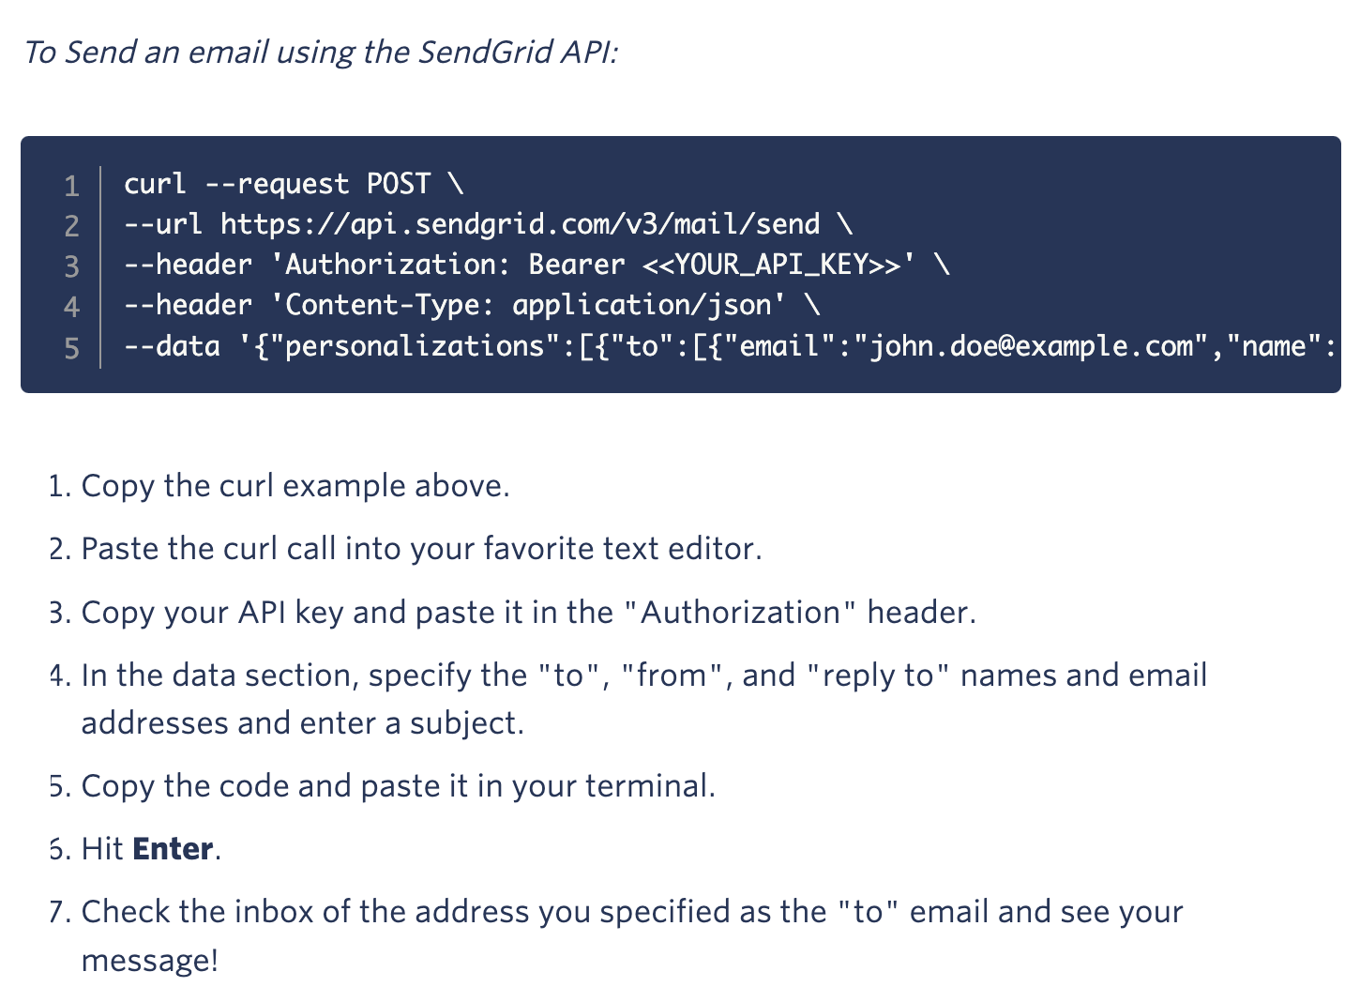Below is an example of sending a basic email using SendGrid’s API:

Mailchimp:

Below is an example of sending a basic email using Mailchimp’s API:

1. const mailchimpClient = require("@mailchimp/mailchimp_transactional")(

2. "YOUR_API_KEY"

3. );

4.

5. const run = async () => {

6. const response = await mailchimpClient.messages.sendTemplate({

7. template_name: "template_name",

8. template_content: [{}],

9. message: {},

10. });

11. console.log(response);

12. };

13.

14. run();

15.

**Conclusion:**

Mailchimp differentiates itself by providing advanced marketing features and being easy to use. They are more targeted towards marketing teams wanting to send emails to promote a company. It is in most cases more user-friendly than SendGrid. The ease of use comes at the cost of reduced flexibility in designing and automation. When it comes to pricing, Mailchimp is the more expensive option of the two. SendGrid is more suitable for Chameleon as we have a team of developers who can utilise the more advanced tools SendGrid offers. SendGrid is also more capable at sending larger amounts of emails per month, and can be used for ecommerce. They also provide better data and analytics tools which can be useful for Chameleon in analysing trends in customer/subscriber data.