**Library Management System**

Objective:

The primary objective for making this java code is to make easier for the people to borrow books from library ,as well as to reduce the efforts for managing the library by librarian and admin.

Existing Solutions:

There are lot of existing solutions for library management system example: Lucidea Integrated Library Systems,

Sierra etc but each one has different pros and cons like they both don’t

Support barcode reader for books.So there is a need to make improvements in library management system.

Our Approach:

we have created a management that has basic as well as advanced features. Admin can add ,view and delete librarian. He will provide librarian with id and password. Librarian will login with that credentials and can add, view books .

People can issue the books by going to librarian or manually. If someone goes to librarian he or she will provide identification details and book id to issue books while if want to do manually then they have two options first he or she need to type his details in machine , verify the phone number and scan the barcode of books on machine. Second option is he or she need to place his id card on machine, verify the phonenumber and scan the barcode of books. Librarian can view the whole list of people who have borrowed the books and details of books which are issued. People can return the books by going to librarian. we added new feature for manually issue books which will save lot of time of people they do not need to stand in long ques. while it also reduce the efforts of management. Barcode feature will give precise information and reduce the time of adding details manually for books.

Algorithm Design:

In this java project we have made four classes Admin,Librarian,Menu and Library. Librarian is extending Admin while Menu is extending Librarian

Admin has six instance variables and four methods which includes void addLibrarian() ,void view(),void Delete() and boolean adminVerify() which will give return type boolean. Librarian class also has six instance variables and six methods in which five of them are not returning anything void addBook(), void viewBook(),

void IssueBook(),void booksIssued() and void returnBook().One has boolean return type named as boolean verify().Menu class has only one void showMenu() method.

Inside this method there is a while loop as while(true){} which will repeat the code again and again. Inside this there are if elseif statements First one will enter the user in to admin block in which there is verification first using if statement then do while loop then inside switch cases for different methods.

In Second one too there is same type of algorithm as used in first case except different methods and variables. While in third elseif statement, different switch cases are used.

”this” keyword is used in different methods to set instance variables having same name as local variables.try and catch is also used to catch the errors like when user will put letters in phonenumber.In the library class there is main method in which we create and give space to object name as “obj” and then we call the showMenu() method as obj.showMenu(); .

Implementation:

While implementing this code we faced some problems which are discussed below with their solutions.

First problem that we face when we try to match the string values for verification of admin and librarian. Syntax was correct but if statement was not comparing the vaules example:

boolean adminVerify(String AdminName){

if (AdminName=="sunny"){return true;}

else{return false;}

}

Input:AdminName="sunny"

The output should be true but output was false.

So we find the solution instead of == which is operator we need to use .equals() which is method. == operator checks if both objects point to the same memory location whereas .equals() compares the values in objects.

So now

boolean adminVerify(String AdminName){

if (AdminName.equals("sunny"){return true;}

else{return false;}

}

Input:AdminName="sunny"

Now output is true;

Second problem we face is due to complexity of code . variable was not getting the value that we want it to get after rechecking the code we saw that instance variable and local variable was having same name. Like

String LibrarianName;

void addLibrarian(String LibrarianName) {

LibrarianName = LibrarianName;

}

Intput: addLibrarian(“jagdeep”)

Output: LibrarianName=null;

As we see LibrarianName was not getting the value jagdeep because instance variable was hidden.so to set the value for instance variable having same name we need to use “this” keyword like this

String LibrarianName;

void addLibrarian(String LibrarianName) {

this.LibrarianName = LibrarianName;

}

Intput: addLibrarian(“12”)

Output: LibrarianName=12;

Third problem that we face was that after when user type letter in phonenumber(long) it gives error and code stops it will not move forward from that line.so to make code working we need to use try and catch like this

try {

System.out.println("Enter the phone Number");

long phonenumber = scan.nextlong();

IssueBook("kharoud", "234", " sunny", phonenumber);

} catch (Exception e) {

System.out.println("Enter integer value");

}

Now if user enter phonenumber as letters it will show us “Enter integer value” and code will also works fine as well as it also don’t store that values in variables.

ScreenShot of Eclipse Console:

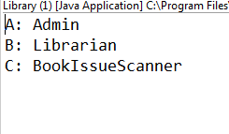

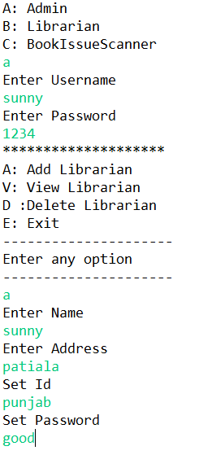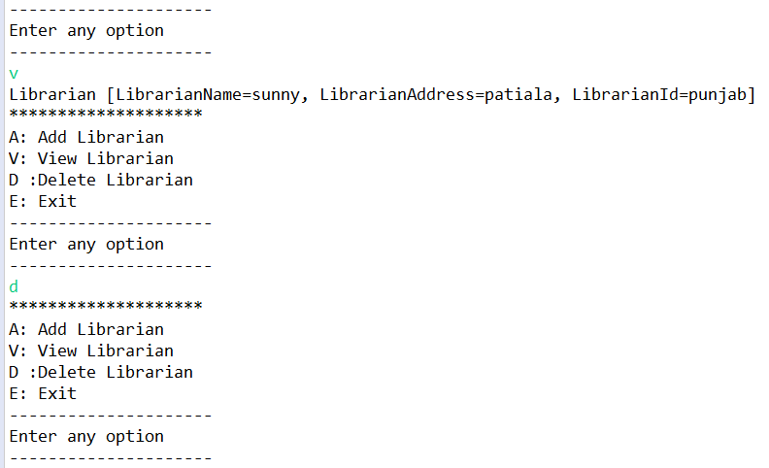

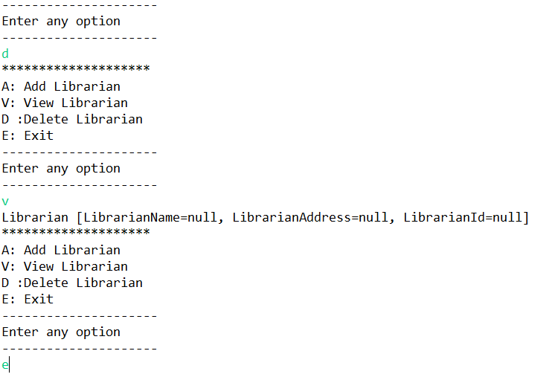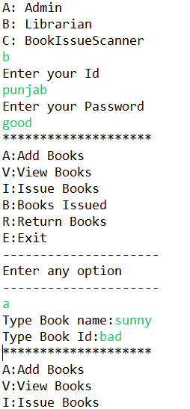

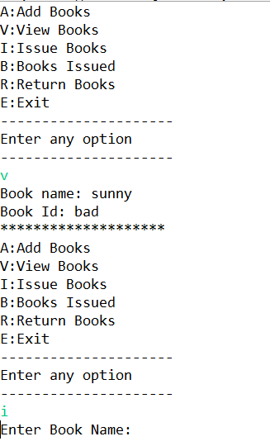

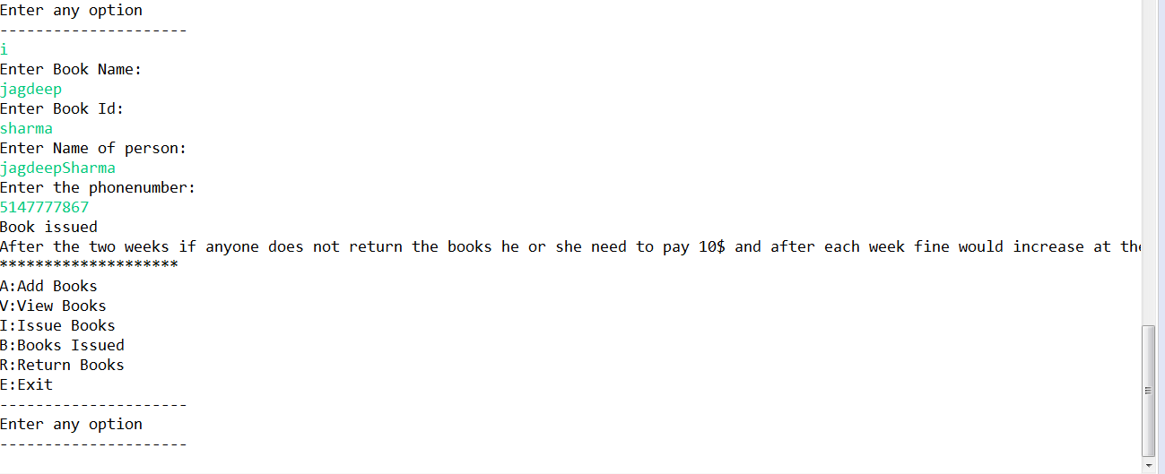

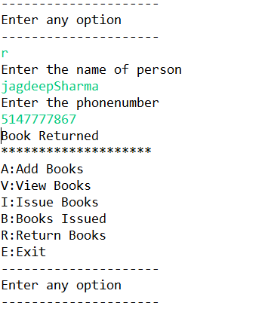

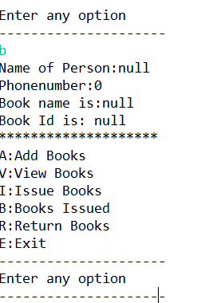

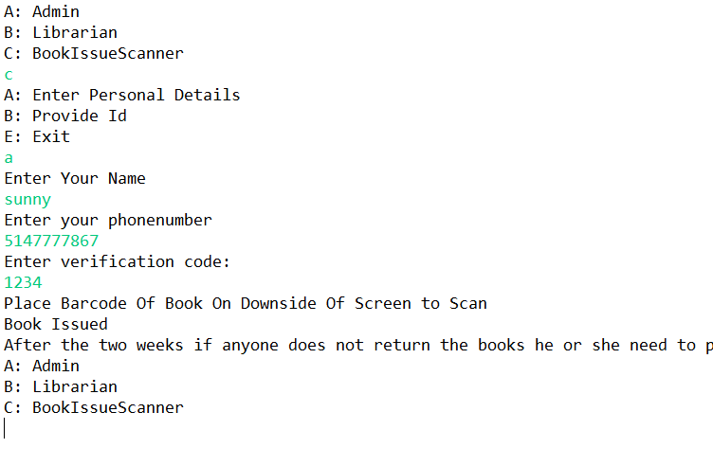

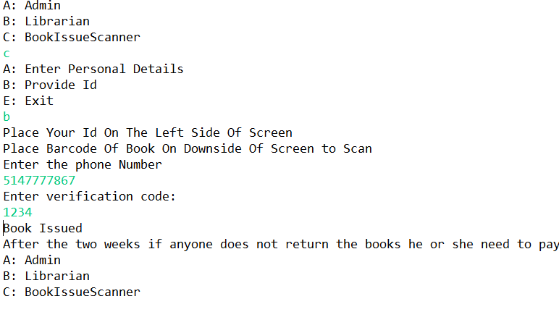

Eclipse Code:

Class Admin :

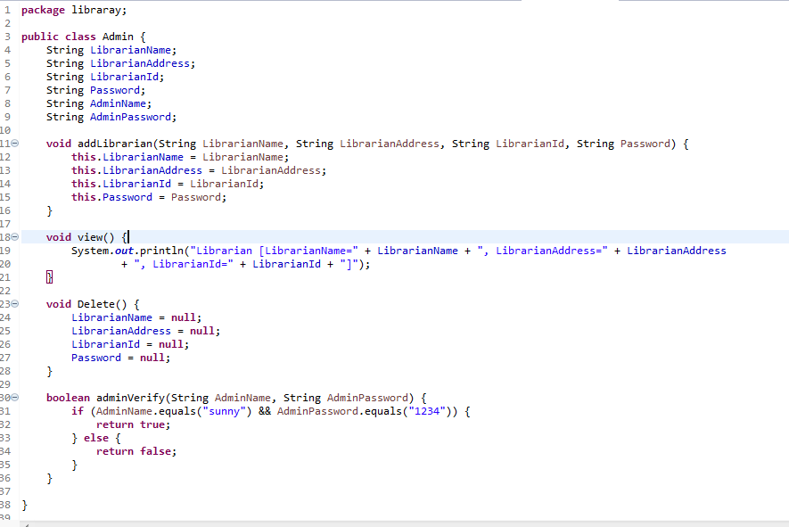

Class Librarian:

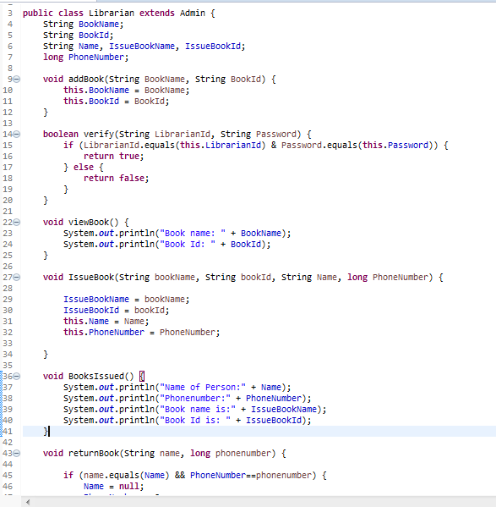

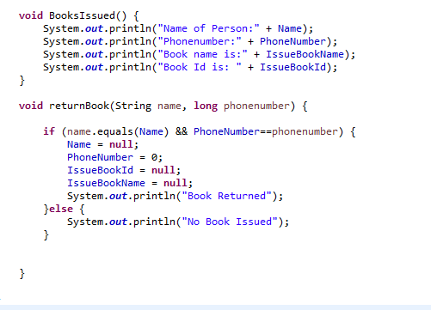

Class Library:

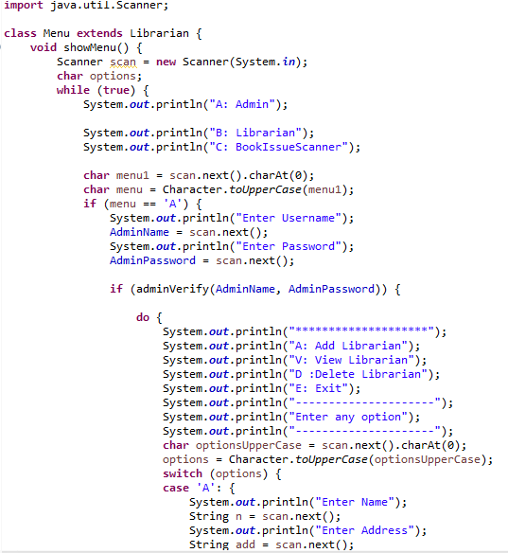

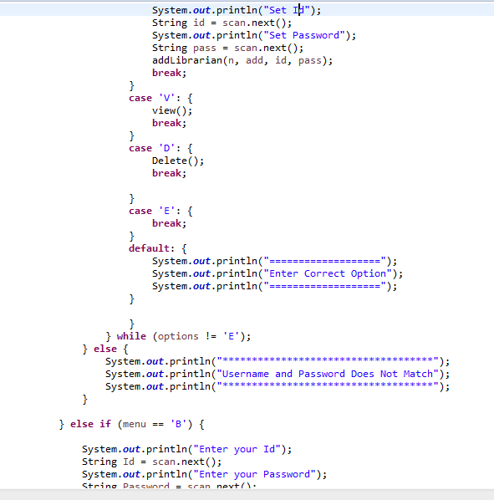

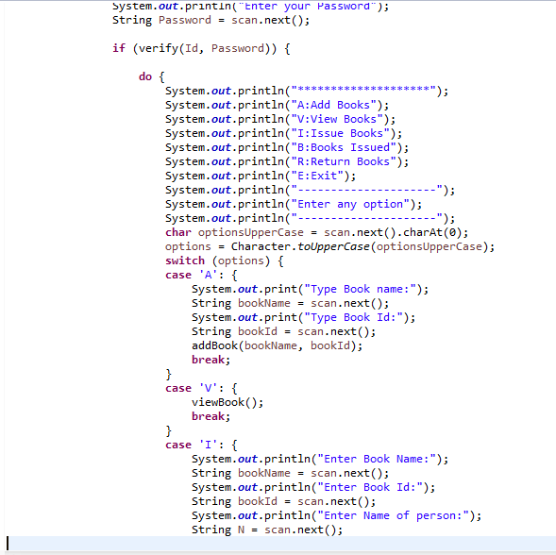

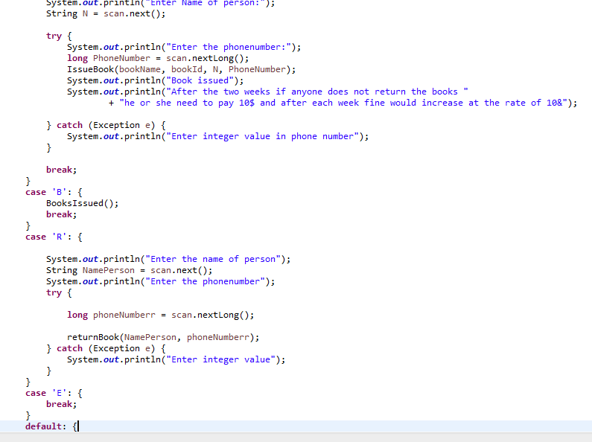

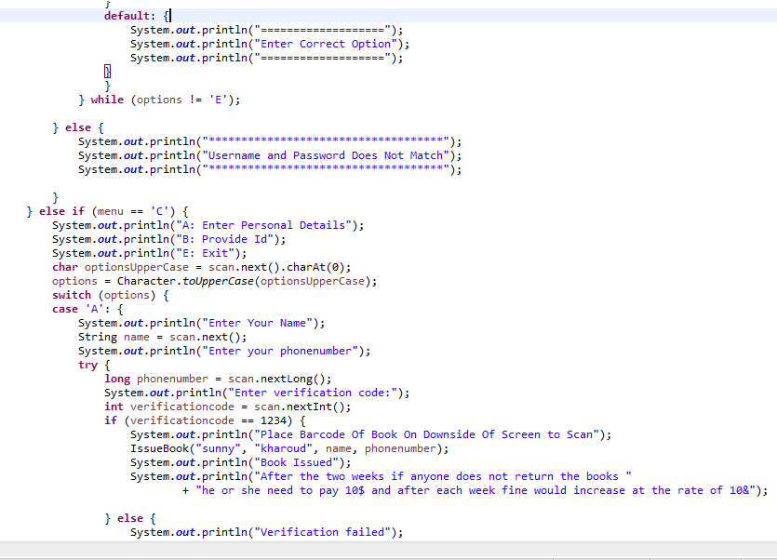

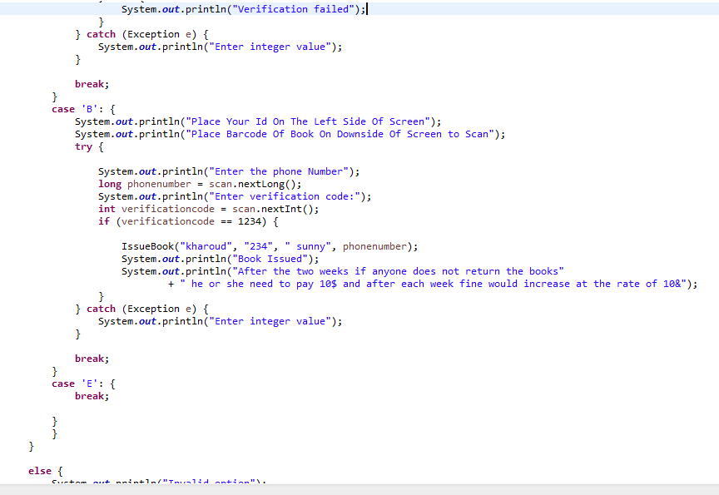

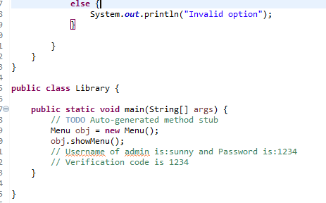

Conclusion:

We have done improvements in the code like adding barcode scanner feature etc to make easier for the management to handle the library as well as less efforts for issue books by people. while making the code we faced problems but while finding the solution we learned a lot from them therefore never copy java code from internet or any other source always make yourself.

Reference:

You can check our code by visiting

https://github.com/DavinderSinghKharoud/Library-Management-System