

# Activity 6

# 1) String Formatting Of Dates

## **Create the following program:**

* Write a python program to convert a date string input to the format YYYY-MM-DD
* Take a date input from the user in the form of: Day Month Year
* Day can be written in the following format: 1st, 2nd, 3rd, 4th, 5th ..30th, 31st
* Month can be written in format: Jan, Feb, Mar, Apr, May, Jun, Aug, Sep, Oct, Nov, Dec
* Year can be any year from 1900 to 2100
* Some sample output examples:

Example 1:

**Input**: date = 10th Sep 2008

**Output**: ‘2008-09-10’

Example 2:

**Input:** date = 7th Jul 1976

**Output: ‘**1975-07-07’

Example 3:

**Input:** date = 30th Dec 1922

**Output: ‘**1922-12-30’

Assume all inputs given by the user are in the correct, proper format as displayed above, therefore no error handling is necessary on the programmers’ side.

# 2)THE MATRIX DISPLAY (2 DIMENSIONAL)

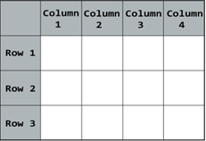

## **Create the following python program:**

* This program will display a mark table to the user, depending on its input.
* The columns represents the subjects.
* The rows represents the students.
* Algorithm to input data from the user:
  + Ask the user how many subjects (columns) is necessary.
  + Ask the user how many students (rows) is necessary.
  + For each student, loop and ask a mark for each subject
* The final output needs to be similar to the following:

**How the program will display the final output:**

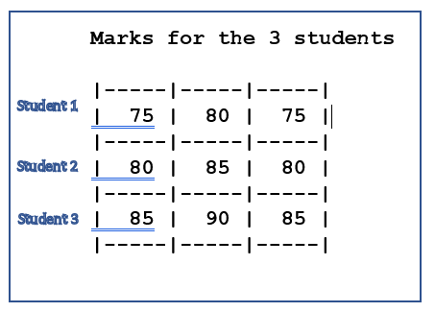

# 3) 1000 Dot . Separator

## **Create the following python program:**

* This program will take an input integer ‘n’ from the user.
* The value will add the dot character “.” as a *thousands* separator and return it in string format
* Valid input from the user should between 0 and ‘n’ where n is any real number
* Some examples below for further explanation:

Example 1:

**Input**: n = 645

**Output**: ‘645’

Example 2:

**Input:** n = 1334

**Output: ‘**1.334’

Example 3:

**Input:** n = 987654321

**Output:** ‘987.654.321’

# 4) Histogram

## **Create the following program:**

* Write a python program to display the marks in the class of 20 students
* The marks of the students will be stored in a list or tuple (of your choice)
* Each element will be an integer between 0 and 9 (inclusively)
* The histogram will have a series of stars for each possible value of the mark
* A sample output if your marks are the following:



