

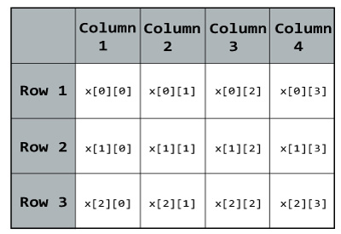

# Activity 10

# THE MATRIX DISPLAY (2 DIMENSIONAL ARRAY)

## CONCEPT

***Two****-****dimensional Arrays****. ... A* ***2D array*** *has a type such as int[][] or String[][], with* ***two*** *pairs of square brackets. The elements of a* ***2D array*** *are arranged in rows and columns, and the new operator for* ***2D arrays*** *specifies both the number of rows and the number of columns. For example, int[][] A; A = new int[3][4];*

## **Create the following java program:**

* This program will display a mark table to the user, depending on its input.
* The columns represents the subjects.
* The rows represents the students.
* Algorithm to input data from the user:
  + Ask the user how many subjects (columns) he wants.
  + Ask the user how many students (rows) he wants.
  + For each student, loop and ask a mark for each subject
* The final output needs to respects the following:

**How the program will display the final output:**

**Marks for the 3 students**

**|-----|-----|-----|**

**| 75 | 80 | 75 |**

**|-----|-----|-----|**

**| 80 | 85 | 80 |**

**|-----|-----|-----|**

**| 85 | 90 | 85 |**

**|-----|-----|-----|**