FUNCTION PRACTICE PROBLEMS

**[1]** Write a program that incorporates a function/method that takes three numbers from the user and then returns to the user the smallest number, the largest number and the average of the three numbers (use a function in your program).

**[2]** Write a program that incorporates a function/method that will take a String from the user and then computes how many vowels are in that String (make sure to use a function in your solution).

**[3]** Write a program that incorporates a function/method that will compute the future returns of an investment with an initial deposit (some amount for initial investment i.e. $1000), an annual percentage of return for each year and the amount of years the investment is locked up for. Calculate the amount to be compounded each year and return the total amount to the user

**[4]** Write a program that incorporates a function/method(s) to compute the Fibonacci sequence. The Fibonacci sequence and be explained with the following example/picture:

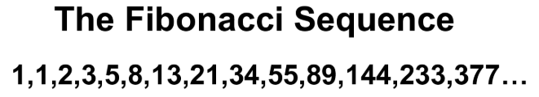

The sequence can be explained by adding the two previous numbers together to derive the next number in the sequence. Write a program that takes a number from the user that then goes through a function which computes and displays the sequence of the sequence to the number taken from the user (do so **without** using a *recursive* function).