ARRAYS NOTES +

ACTIVITY 8

# Declaring Arrays Examples:

**­**

int[] k; float[] yt; String[] names;

# Allocating Arrays Examples:

k = new int[3];

yt = new float[7]; names = new String[50];

# Initializing Arrays Examples:

k[0] = 2;

k[1] = 5;

k[2] = -2;

yt[6] = 7.5f;

names[4] = "Fred";

# Filling Arrays:

float[] squares = new float[101]; for (int i=0; i <= 100; i++) { squares[i] = i*i;

}

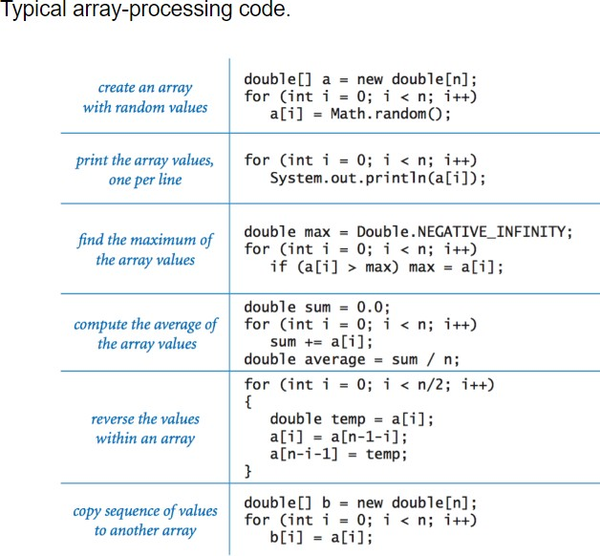

Activity 8

Write one program that will use all of the six array algorithms above. Your program should implement a menu with a choice of options for the user to choose from. For each menu item ask the user to input either the size of array and/or to populate an array with numbers. This will vary for each menu field, for instance when your program loads it should look similar to the below example but does not have to be identical to it:

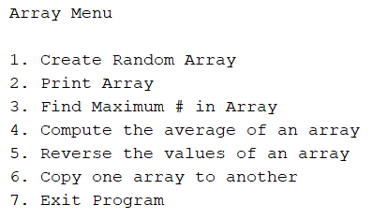

Your program should loop until the user to decides to quit the program. When entering one of the choices the program should prompt the user for either an array size, array values or an additional array to be copied to another (option six).

In option six ask the user for a number and create two arrays of the same size, then ask the user to input values and implement a check to see if the values are the same as the other array. If the values are the same, do not accept them and continue to prompt the user until the inputs are of different numbers. If the numbers are not the same then the program should copy the values of the first array to the second one.