**Activity 9:**

**Grading: 5% of final grade**

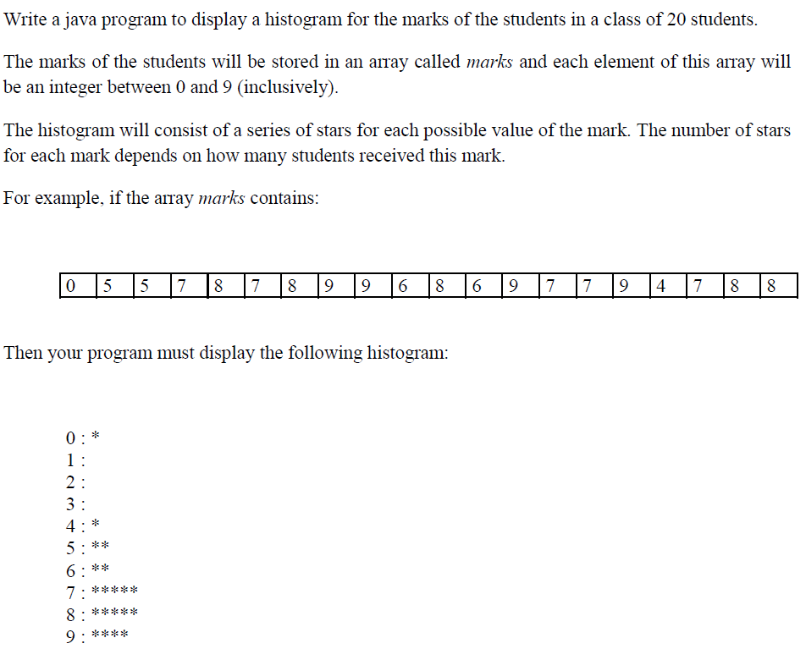

You may hard code the values of the array or randomly generate them, you do not need to take the input from the user.

Submit on Omnivox before end of class, please note no late activities will be accepted so ensure to upload your **.java** file on time. The activity is to be completed and submitted individually.