Activity #6

Grade Worth: **5%**

**Description:** This activity must be done **individually**. Submit your activity on Omnivox and do NOT MIO. Assignments sent via MIO will be deducted marks. Assignments must be done alone and collaboration between individuals or groups is strictly forbidden. Submissions that are late will not be accepted and students who missed the activity will receive a grade of 0.

**General Guidelines When Writing Your Programs:**

Include the following in comments at the top of your program:

// -----------------------------------------------------

// Activity (include number)

// Written by: (include your name and student ID)

// Short Description of your project/code and how you designed it.

// -----------------------------------------------------

Throughout your program, include comments in your program describing the main steps where necessary.

1) Write a program to (3 points):

1. Ask the users for a line of text

2. Then re-display this line, but with all lower case ‘a’ ‘e’ and ‘i’ in the line replaced by a star (‘*’).

Your program cannot use the method **replace** from the String class.

Here is an example of how your program should behave:

Please enter a line of text:

hello Angella Eralli

h*llo Ang*ll* Er*ll*

**Solution:**

public static void main(String[] args)

{

String s;

Scanner keyboard = new Scanner(System.in);

System.out.println("Please enter a line to display");

s = keyboard.nextLine();

for (int i =0; i < s.length() ; i++)

{

if ((s.charAt(i) == 'a') || (s.charAt(i) == 'e') ||

(s.charAt(i) == 'i'))

{

s = s.substring(0, i) + "*" + s.substring(i+1);

}

}

System.out.println(s);

}

2) Write a program to reverse the words of a given line of text. You can assume the words are separated by one space character. Make the program: (2 points):

- Using a while or for loop (choose one only)

For example, if the user entered “My name is Jane”, your program should display, “Jane is name My”. You must include one of each type (using a for loop and using a while loop). You may not use StringBuilder in your solution.

Upload your submission on Omnivox when complete using separate java files for each question i.e.: Question1.java and Question2.java should be present. Late submissions will not be accepted nor will submissions via MIO.

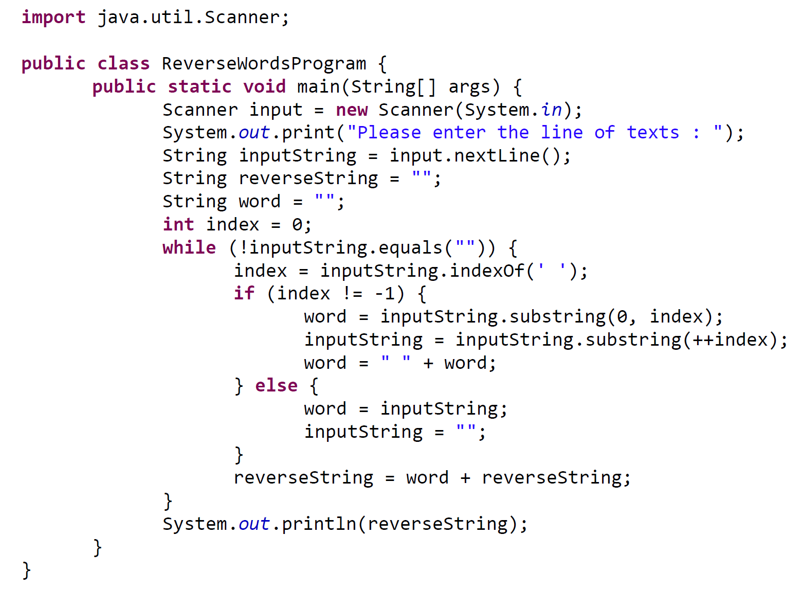

**OR**

