Pop Quiz Solutions

**Logo1**

**Cégep de la Gaspésie et des Îles**

## Montreal Campus

**Algorithms**

# First Name:

# Last Name :

# Student ID:

**Signature:** _____________________

Don’t write anything in this page

Part 1 Grade:

Part 2 Grade:

Part 3 Grade:

Total Grade (out of 35): _______

Part 1: Multiple Choice (10 points):

Half a point per question and circle only **one** answer per question

1) Which of the following is not a valid identifier?

**a)** $1yz_

**b) _**z_xc3

**c)** $abc

**d)** 4yxz

**e)** none of the above

2) The method public double mySqrt(int x){ … }

**a)** defines a method called mySqrt which takes a double as an argument and

returns a integer

**b)** defines a method called double which calculates square roots

**c)** defines a method called mySqrt which takes an argument of type x and returns a

double

**d)** defines a method called mySqrt which takes a double as an argument and returns

an integer

**e)** none of the above

3) What are the final values of a and b after the following instructions have

been executed?

int a = 2, b = 1;

b -= a + 4;

a *= b - a;

**a)** a= -5, b= -7

**b)** a= -14, b= -5

**c)** a= 7, b= 2

**d)** a= 4, b= 6

**e)** a=-12, b=-5

4) What will be the value of *a* after the following instructions?

int a = 6, b = -6, c= 0;

a = b = c + 10;

**a)** 10

**b)** 4

**c)** 16

**d)** 0

**e)** 1

5) What will be the value of *a* after the following instructions?

int a = 3, b = -2, c= 0;

a = 5 + (b++) + (++c);

**a)** 0

**b)** 6

**c)** 2

**d)** 4

**e)** None of the above

6) What is the result of the expression: "abc" + 4 + 5 + "fgh"?

**a)** "abc45fgh"

**b)** "abc4fgh5"

**c)** "abc9fgh"

**d)** Not a legal Java expression

7) What is the value of the variable c in the statements that follow?

String phrase = "Make hay while the sun is shining.";

**char** c = phrase.charAt(10);

**a)** h

**b)** w

**c)** i

**d)** None of the above

8) 5) What is the Java expression for 4a^2 + 2b * c?

**a)** (4 * a) + (2 * b) * c

**b)** ((4 * a * a) + (2 * b)) * c

**c)** (4 + a * a) + ((2 + b) * c)

**d)** (4 * a * a) + ((2 * b) * c)

9) What does this code fragment print?

int result = 9;

for (int cnt = 2; cnt < result; cnt += 3)

result = cnt;

System.out.println("result = " + result);

**a)** result = 2

**b)** result = 8

**c)** result = 9

**d)** result = 11

10) What is the output:

int x =0;

System.out.println(“x=“ + (++x - --x + x + x++));

**a)** x=0  
**b)** x=1  
**c)** x=2  
**d)** x=3

Part 2: Output Questions (2 points each)

1) Review the following algorithms and determine what is the output of the fragments of code? (2 points each)

A)

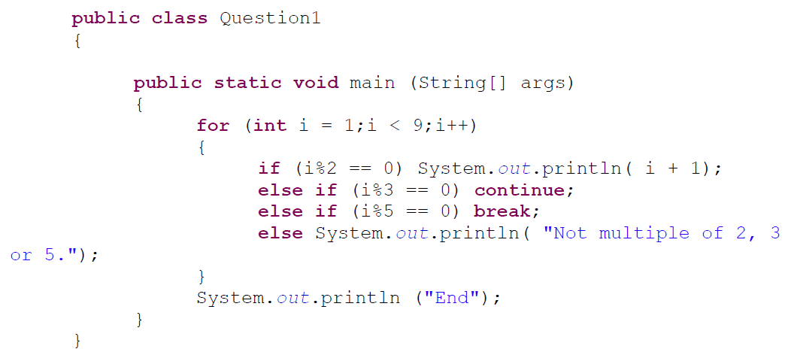

Not multiple of 2, 3 or 5.

3

5

End

B)

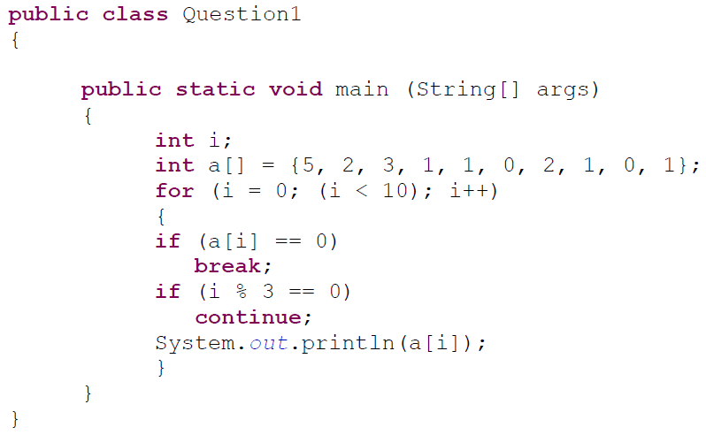

2

3

1

C) Assume the following code:

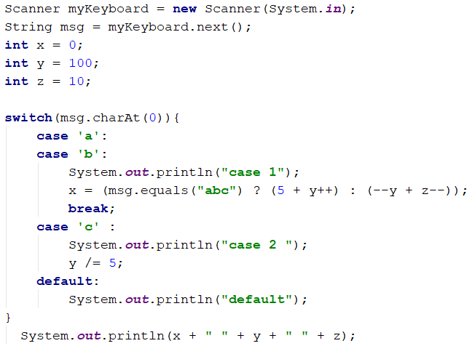

a) case 1

105, 101, 10

b) case 1

109, 99, 9

c) case 2

default

0 20 10

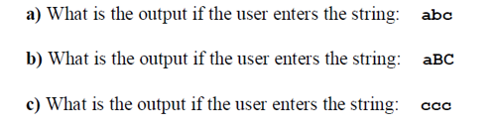

Solution:

a) case 1

105, 101, 10

b) case 1

109, 99, 9

c) case 2

default

0 20 10

d)

String s1 = "abc";

String s2 = **new String("abc");**

**Output:**

**10**

**18**

**if(s1 == s2)**

System.*out.println(14);*

**else**

System.*out.println(10);*

**if(s1.equals(s2))**

System.*out.println(18);*

**else**

System.*out.println(7);*

e)

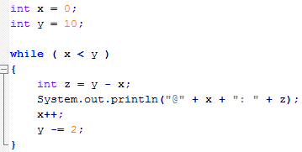

Output:

@0:10

@1:7

@2:4

@3:1

Part 3: Programming Question (15 points):

1) Write a program that takes a temperature from the user in Fahrenheit and then converts that number to Celsius. The code must be written in **full** and include any packages necessary with the class name, main method etc. Use the space below to write your answer and read the formula *carefully* when answering the question.

*T*(°F) = *T*(°C) × 9/5 + 32

**package** exam;

**import** java.util.Scanner;

**public** **class** exam4 {

**public** **static** **void** main(String[] args) {

**double** f,c;

Scanner lucas = **new** Scanner(System.***in***);

System.***out***.println("please enter degree in Fahrenheit");

f=lucas.nextDouble();

c=((5*f)-160)/9;

System.***out***.println("the degree in celicius is "+ c );

}

}

2) Give the pseudo or java code that prints the following pattern and assume the length or number of rows is a number taken from the user (5 points)

[*](javascript:%20void(0);)

[**](javascript:%20void(0);)

[***](javascript:%20void(0);)

[****](javascript:%20void(0);)

[*****](javascript:%20void(0);)

import java.util.*;

print("Enter number of rows: ");

int rows = nextInt();

/* Iterate through rows */

**for**(i=1; i<=rows; i++)

{

/* Print spaces in decreasing order of row */

**for**(j=i; j<rows; j++)

{

print(" ");

}

/* Print star in increasing order or row */

**for**(j=1; j<=i; j++)

{

print("*");

}

/* Move to next line */

print("\n");

}