Davion Davis

SDEV 140, Introduction to Software Development

Professor Liu

10 May 2024

**User Manual with Validation Testing**

 The purpose of my application was to provide users with a tool to input a temperature and instantly convert it from Celsius to Fahrenheit or vice versa. Based on the temperature, the program would then suggest the appropriate category of clothing for the current weather conditions. This feature allows users to dress appropriately for the weather outside and stay comfortable. My main inspiration for this idea stems from how living in Europe we are introduced to using Celsius as a means of measuring temperature. This app allows individuals to input the temperature they would find on their mobile devices, computer, or television and spew out with the converted integer as well as what they should wear to mitigate harmful/dangerous weather conditions.

**Instructions**

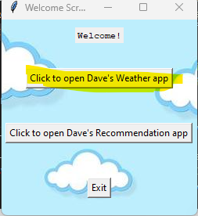 When the program is opened the user is prompted with a welcome message and is given three options on the main home screen window.

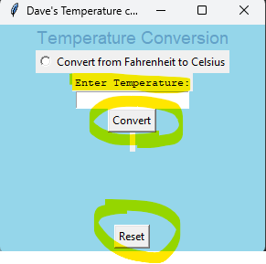When the user selects the first textbox, a new window will open. This window will enable the user to input a temperature in Celsius without selecting the radio button. The temperature will then be converted to Fahrenheit. If the user clicks the radio button, the opposite will occur, and the temperature will be converted from Fahrenheit to Celsius. After the user inputs the temperature, they must click the convert button to display the converted temperature information. If the user inputs anything other than a number, a message will appear advising them to enter a valid number. Finally, a reset button is available at the bottom of the window to allow the user to reset the entry box.

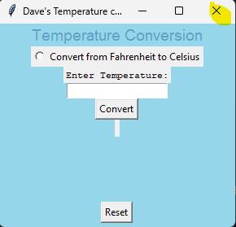If the user would like to exit the program at this moment there is a close window button on top of the border which will then prompt the user with a warning message.

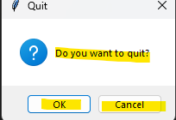

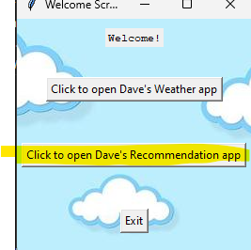After converting the temperature in the conversion window, the user will access the welcome screen and click the recommendation app to see suggested clothing items.

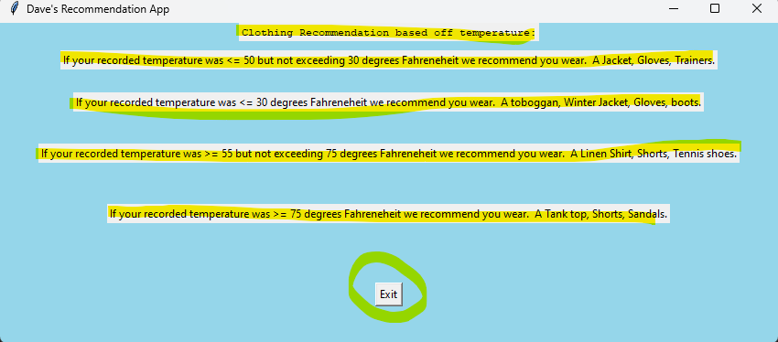

On the clothing recommendation window that the user opens from the main home screen menu. They are displayed four sentences. Each sentence displays information regarding the temperature value they received from inputting the enter on the previous window. Based on that temperature that was converted the user is allowed to take the recommendation from the program and use it as a suggestion on what clothing items they should be wearing. There is an exit button located at the bottom of the page which terminates the program upon completion.

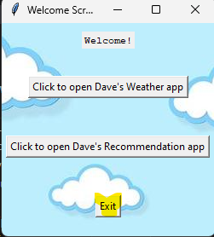

**Validation testing**

In this part of the user manual I included what the current temperature would be outside in the area that I am in which is 20.90 degrees celsius. By not clicking the radio button above the entry box it and clicking the convert button instead my program displays the today outside it will be 69.62 or 70 degrees Fahrenheit today. After my results are analyzed I then open the recommendation window which then displays that for weather that happens to be more than 55 degrees fahrenheit but below 75 degrees that I should wear a Linen shirt, shorts and tennis shoes.

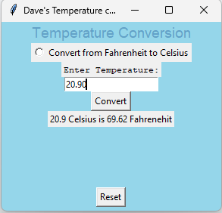

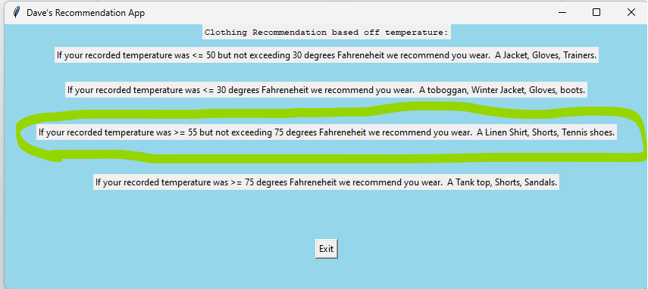

In my second validation test I used the -2 degrees Celsius . With -2 Celsius being converted it displayed as 35.60 degrees Fahrenheit. With 28.40 degrees Fahrenheit I was able to determine that I would need to wear a toboggan, a winter jacket, gloves, and boots.

