STUDENT MANAGEMENT SYSTEM PLUS
Object Oriented Programming Using Java

Name: Davis Addo Glenn
Index Number: 01220839B
Submission Date: 23 February 2026

1. Introduction
This project presents the development of an offline desktop application called Student Management System Plus, built using Java, JavaFX, SQLite, and JDBC. The system improves data integrity, usability, and reporting while following clean object-oriented design principles.

2. Problem Statement
Spreadsheet-based systems cause duplicate IDs, inconsistent GPA calculations, missing required fields, poor reporting capabilities, and weak data validation. This system solves these issues using structured architecture and database constraints.

3. Objectives
• Apply object-oriented programming principles
• Build a professional JavaFX GUI
• Use SQLite safely with prepared statements
• Implement validation rules
• Generate useful academic reports
• Write unit tests using Maven
• Use GitHub professionally

4. System Architecture
The system follows a layered design:
UI Layer – JavaFX Controllers and Views
Domain Layer – Student Model
Service Layer – Business Logic and Validation
Repository Layer – SQLite Database Operations
Utility Layer – Logging and File Handling

5. Database Design
SQLite database with Student ID as primary key.
Constraints enforce GPA range (0.0–4.0), valid level values, NOT NULL rules, and safe queries using prepared statements.

6. Functional Features
CRUD operations (Add, View, Update, Delete)
Search, Filter, and Sorting
Reports: Top Performers, At Risk Students, GPA Distribution, Programme Summary
CSV Export and Import with validation and error reporting

7. Data Validation Rules
Student ID: 4–20 alphanumeric characters, unique
Full Name: 2–60 characters, no digits
Programme: Required
Level: 100–700 only
GPA: 0.0–4.0
Email: Must contain '@' and '.'
Phone: 10–15 digits only

8. GUI Design
Dashboard with statistics
Students Screen with table and form
Reports Screen with export option
Import/Export Screen with summary results
Settings Screen for GPA threshold configuration

9. Testing
At least 12 unit tests covering validation logic, repository operations, and report calculations. Tests executed using Maven (mvn test) and evidence saved.

10. Logging
Application logs stored in data folder.
Logs include application start/close, CRUD operations, import/export summaries, and database errors.

11. Conclusion
The Student Management System Plus demonstrates strong understanding of object-oriented programming, database integration, clean architecture, validation, and professional software development practices.

12. Screenshots of the Application
Figure 1: Dashboard Screen
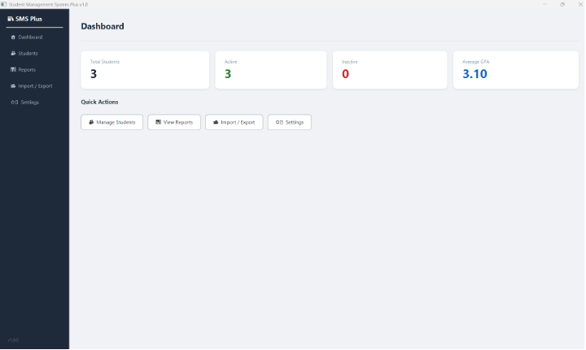
Figure 2: Students Screen

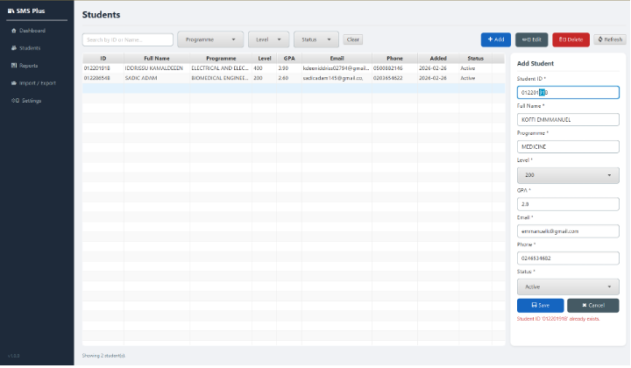

Figure 3: Reports Screen

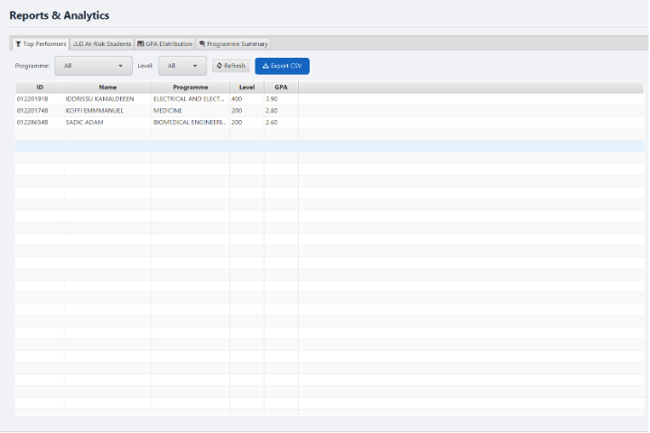

Figure 4: Import/Export Screen

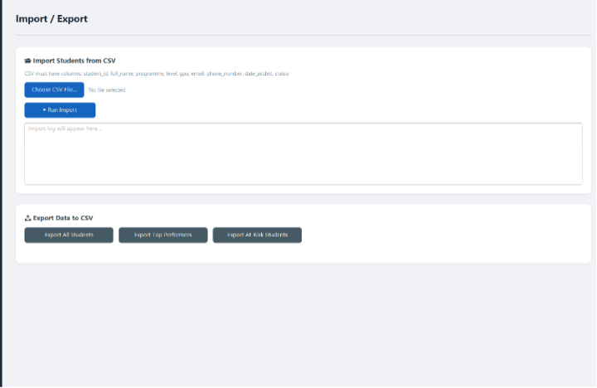

Figure 5: Settings Screen

