Operator Discovery Run: Order-Book Imbalance Relaxation
BTC/USD Coinbase Level-2 Order Book
DavisAI Systems | 2026-06-22

1. Dataset
Field | Value
Source file | btc_coinbase_book.jsonl
Records | 209,998
Duration | 350.0 min
Snapshot interval (median) | 0.100 s
Gaps > 1 s | 0
Levels per side | 10
Mid price range | 63,863.925 - 64,699.995
Unique mid values | 10,875
100ms log-return std | 1.463e-05
Nonzero-return fraction | 0.0714
Total trades | 78,825
Snapshots with trade | 0.1927

2. State Variables
Per snapshot t, bid sizes b_i and ask sizes a_i over levels i = 1..10:
depth_imbalance(t) = (Sum b_i - Sum a_i) / (Sum b_i + Sum a_i)
top_imbalance(t) = (b_1 - a_1) / (b_1 + a_1)
ofi(t) = buy(t) - sell(t)
ret(t) = log mid(t) - log mid(t-1)
bid_depth(t) = Sum b_i / mean(Sum b_i)
ask_depth(t) = Sum a_i / mean(Sum a_i)

3. Operator Form
Linear first-order operator fit by least squares on a 60% train split; reported R-squared is out-of-sample on the held 40%.
X[t+1] = phi * X[t] + c
Rolling estimation: window 3,000 snapshots (5 min), step 300 snapshots (30 s). Quiet-gap fits restrict pairs to snapshots with n_trades = 0.

4. Single-Step Operator Fits (OOS R-squared)
Target | Inputs | OOS R2 | Gate 0.05
ret(t+1) | imb, top_imb, ofi, ret | 0.0445 | KILL
imb(t+1) | imb, top_imb, ofi, ret | 0.8657 | PASS
imb(t+1) | imb only | 0.8651 | PASS
Imbalance AR(1): phi = 0.9363, half-life = 10.53 steps (1.05 s) at 100 ms sampling.

5. Decimation Sweep (imbalance AR(1))
Step (s) | phi | OOS R2 | Half-life (s)
0.1 | 0.9363 | 0.8651 | 1.053
0.5 | 0.7991 | 0.6270 | 1.545
1.0 | 0.6853 | 0.4719 | 1.834
2.0 | 0.5238 | 0.2996 | 2.144
5.0 | 0.2760 | 0.1069 | 2.692
10.0 | 0.1657 | 0.0232 | 3.856

6. Imbalance Operator: Trade vs Quiet Snapshots
Subset | n | phi | OOS R2
Quiet (n_trades = 0) | 169,532 | 0.9474 | 0.9041
Trade (n_trades > 0) | 40,465 | 0.8833 | 0.7261

7. Imbalance to Forward Price (trade snapshots)
Horizon | OOS R2 | Dir. acc. | Slope
1 (0.1 s) | 0.0238 | 0.1260 | 1.38e-05
5 (0.5 s) | 0.0321 | 0.2398 | 2.82e-05
10 (1.0 s) | 0.0347 | 0.3063 | 3.94e-05
30 (3.0 s) | 0.0239 | 0.4213 | 6.30e-05

8. Rolling Quiet-Gap Operator (690 windows)
Quantity | Min | Max | Mean | Std
phi | 0.791 | 0.991 | 0.940 | 0.0322
OOS R2 | 0.625 | 0.978 | - | -

9. Operator Loudness vs Realized Volatility
Loudness = 1 - R2 per rolling window. Cross-correlation with normalized realized volatility; positive lag = loudness leads volatility.
Lag (min) | Corr
-3.0 | 0.81
-2.5 | 0.82
-2.0 | 0.83
-1.5 | 0.82
-1.0 | 0.81
-0.5 | 0.79
0.0 | 0.76
+0.5 | 0.72
+1.0 | 0.67
+1.5 | 0.62
+2.0 | 0.58
+3.0 | 0.51

10. Conditioned on Calm Windows (current vol below median)
Measure | Value
Calm windows | 344 / 689
P(spike next | calm) | 0.006
P(spike next | calm AND alarm) | 0.000
Spearman: current vol -> fwd vol | +0.904
Spearman: (1-R2) -> fwd vol | +0.394
Spearman: |phi-base| -> fwd vol | -0.214
Spearman: resid_std -> fwd vol | +0.517
Corr: operator stress -> fwd vol | current vol removed | -0.002

11. Separated Bid/Ask Channels vs Forward Signed Move
Channel | Spearman vs fwd dir
phi_bid - phi_ask | +0.012
res_bid - res_ask | +0.025
phi_bid | -0.078
phi_ask | -0.027

12. Local Lead/Lag State (loudness vs vol, 20-min rolling)
Measure | Value
Lag range (windows) | -8 to +8
Lag std (windows) | 4.94
Operator leads (lag > 0) | 18.9%
Operator lags (lag < 0) | 58.9%
Corr(local lag, upcoming |move|) | -0.082
Mean |fwd move| when leading | 7.98e-04
Mean |fwd move| when lagging | 9.93e-04

13. Figure
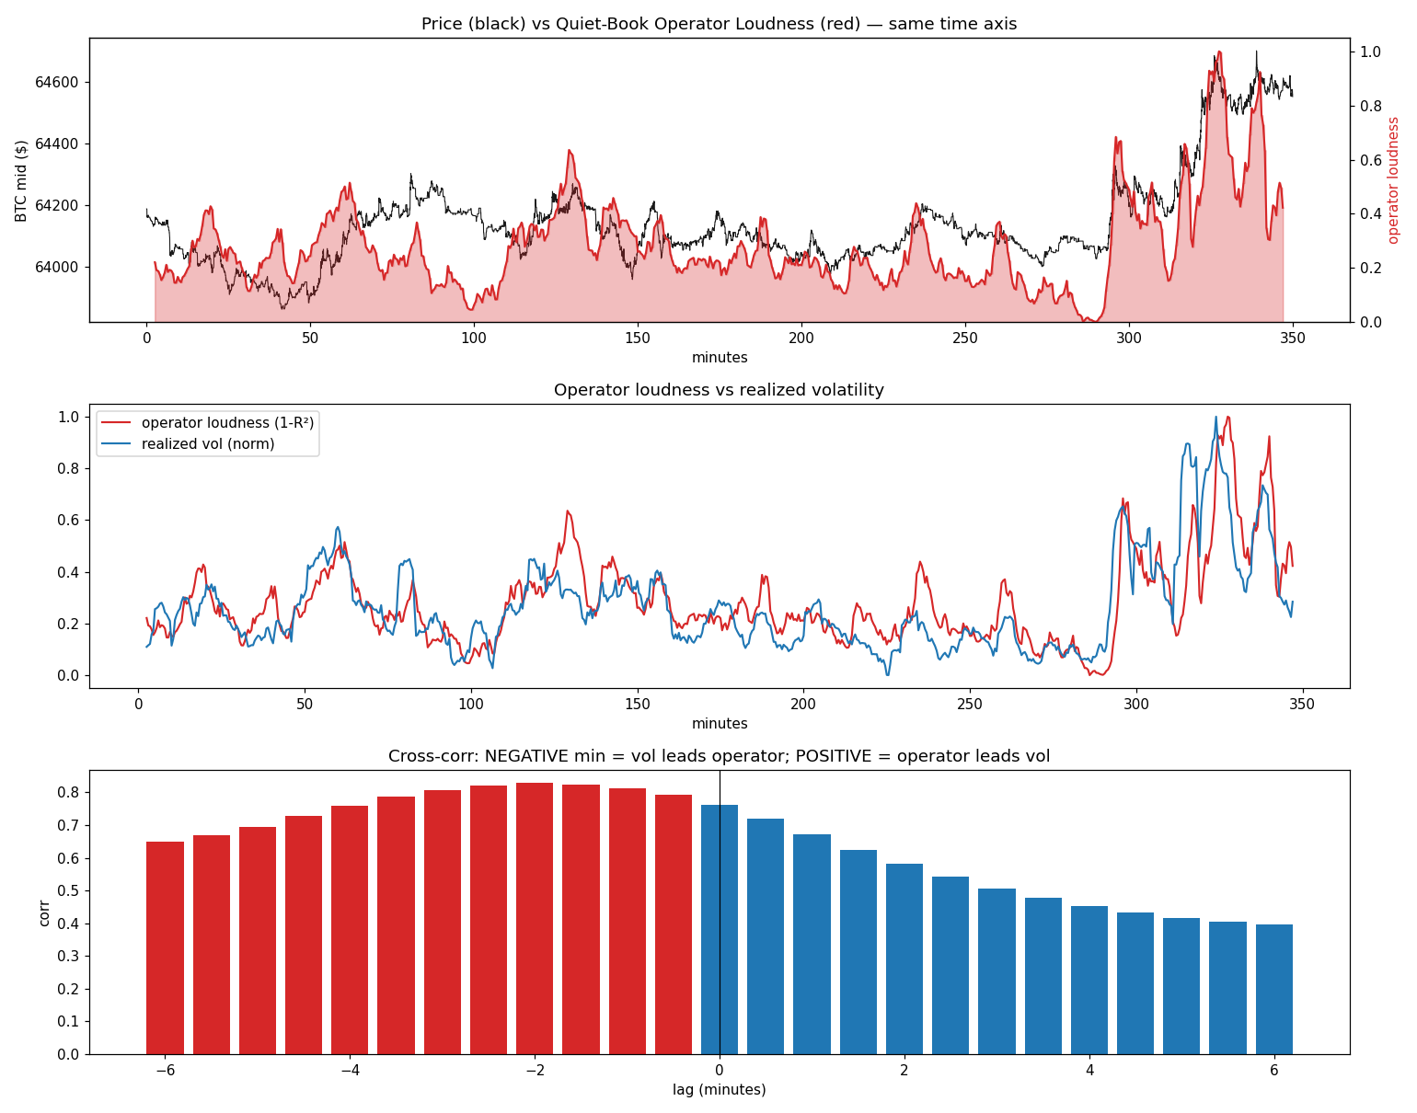
Top: BTC mid price and operator loudness (1-R2). Middle: operator loudness vs normalized realized volatility. Bottom: cross-correlation by lag.

