**Five Guys Fun Facts**

By Davis Treybig, Syed Adil,

Lefko Charalambois, Mehul Mehta, and Brian Dorsey

Copyright © 2017 by Davis Treybig, Mehul Mehta, Lefko Charalambois, Brian Dorsey, and Syed Adil

All rights reserved. This book or any portion thereof may not be reproduced or used in any manner whatsoever without the express written permission of the publisher except for the use of brief quotations in a book review.

*To the people and places that brought us together*

**Contents**

Preface

The Fun Facts

Graham’s Number

Sokaiya

The Moving Sofa Problem

1936 Berlin Olympics

Women’s Shirt Buttons

The Arginine Conman

Null Island

The Maillard Reaction

Medical Residency Matching

Segway Gets Punked

The Most Complicated Trial of all Time

Russian Special Forces Training

Seedless Plants

How to Beat Spotify

The Fold and Cut Theorem

**Preface**

Did you know that…

1. Figuring out how big a sofa you can move through a hallfway is one of

The Fun Facts

**Graham’s Number**

There is a huge number called Graham’s number. Far bigger than googolplex if y’all know of that. Graham’s number is “so large that the observable universe is far too small to contain an ordinary digital representation of Graham’s number, assuming that each digit occupies one Planck volume, possibly the smallest measurable space.”

**Sokaiya**

The Yakuza, the most prominent organized crime group in Japan, use a racketeering practice called sokaiya to extort Japanese companies. In Japan, people view shame as the worst possible outcome, sometimes even worse than death. The yakuza prey on this by purchasing the minimum number of shares in a company to be invited to its annual shareholder’s meeting. They then threaten the company’s executive that the Yakuza will come to the meeting and essentially troll them, asking very detailed and pointed questions about small mistakes the company made or making fun of the executives’ wives or mistresses. Unless the company will pay them off (often by purchasing absurdly marked up subscriptions to useless magazines), the yakuza follow through and essentially have ended some executives’ careers.

This is such a big problem that all major corporations will now schedule their meeting on the same day at the same time to limit the number of companies that can be hit by the yakuza in any given year. There is even a specific division of the Tokyo police who only work on preventing sokaiya. In 1984, the law made first steps to reduce the threat from sōkaiya by establishing that you had to own 50,000 yen minimum to be allowed into the shareholder meeting, leading to a slow decline of the number of sōkaiya. In response to this, some sōkaiya would drive what essentially I imagine as ice cream trucks around the building that was holding a meeting, blaring their trolling of the company over the truck’s loudspeakers to try and shame the executives as shareholders walked in and out.

**The Moving Sofa Problem**

When you think of modern problems in mathematics and algorithms, you often think of obscure things, like topology, artificial intelligence, etc. But there are actually a ton of problems that seem SUPER simple, but remain unsolved. For instance, moving furniture.

Consider the following question: What is the largest area of a 2D shape that can be maneuvered through an L shaped planar region with legs of unit width? In other words, if you have the following hallway, what is the maximum area of an object that can be moved through it?

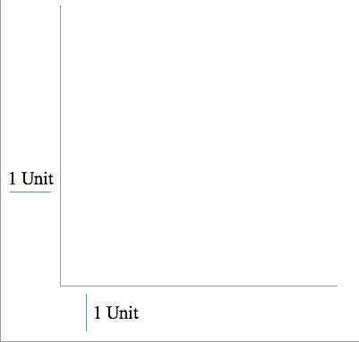

A unit length L-hallway

This problem is known as the “Moving Sofa” problem, and was originally postulated in 1966. The answer to the question (the unknown maximum area A) is known as the sofa constant.

So, what is the elusive sofa constant? Well, we don’t currently know. However, some mathematicians have made some interesting progress on bounding the answer.

The most trivial lower bound is that of a unit square. Below is a gif that demonstrates this behavior. Clearly this lower bounds the sofa constant to 1.



Unit Square Sofa

But, we can do better. Below is another gif, this time demonstrating how a circle of half radius can move through the hallway. This lower bounds the area to π/2.



Semicircle Sofa

At this point, though, it gets a bit more interesting. A guy by the name of Jon Hammersley figured out that if you split a semi circle into two quarter circles, and then add a rectangular block in between with a semi circle cut out of it, you get another shape that can move through the hallway! He did all this in a paper called On the enfeeblement of mathematical skills by “Modern Mathematics” and by similar soft intellectual trash in schools and universities. Impressive stuff. Below is a depiction of Hammersley’s sofa:



Hammersley’s Sofa

Hammersley’s sofa improved the lower bound of the sofa constant to π/2+2/π. But, this is where it starts to get interesting. A guy named Gerver decided to go full YOLO[1] and compose the shape below, in his very appropriately named paper On moving a sofa around a corner. You’ll note that it looks quite similar to Hammersley’s sofa. However, in fact, it is a shape made of 18 different arcs, each with a distinct formula. (the small demarcations on the shape pinpoint places where different arcs come into play)

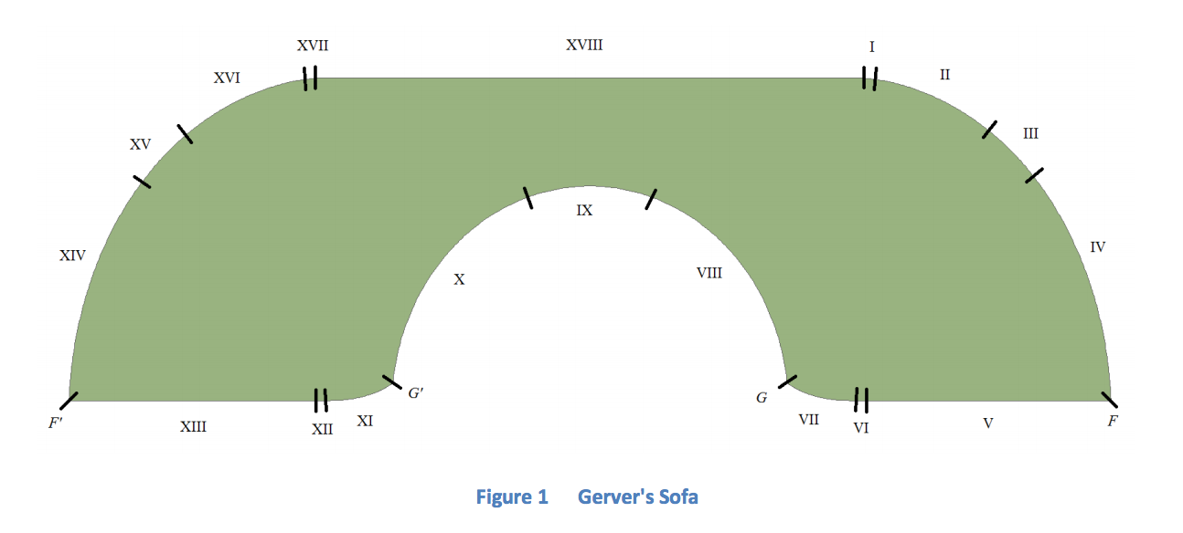

Source: Philip Gibbs, “A Computational Study of Sofas and Cars”

Cool! So what’s the area of Gerver’s fancy 18 arc sofa? Well, that can be answered via some simple math, shown below:

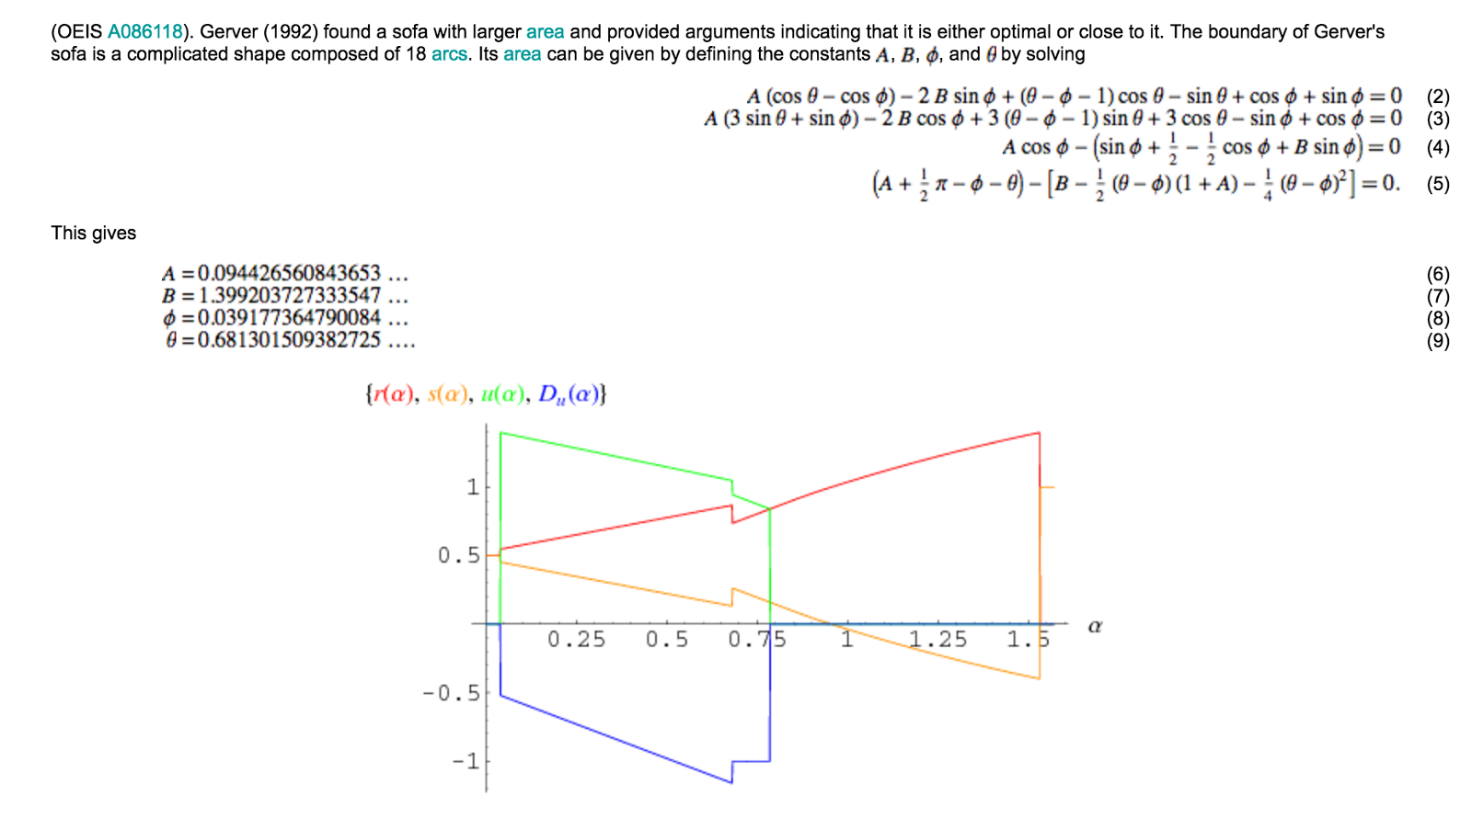

Source: Wolfram Alpha

I don’t understand it either. But, the result is that Gerver’s ridiculously complex sofa has an area of ~2.19…, which is approximately ~.013 higher than Hammersley’s sofa’s area. And as of today, this is the largest sofa proven to go through the unit length hallway.

Furthermore, it is believed that this may indeed be the optimal value (the elusive sofa constant). A discretized version of the problem was solved numerically in 2014 by Philip Gibbs. He adopted a somewhat interesting approach in doing this. Instead of constructing different shapes and seeing which could move through the hallway (this is extremely difficult computationally), he considered how a hallway could move around a fixed sofa. In other words, he used a computer to calculate all possible paths a hallway could take around a fixed sofa, in which case the maximum area which fits within the intersection of every hallway path would be the maximum size sofa that can fit in the hallway! (if that doesn’t quite make sense, you can read his paper here) Below is the figure he ended up getting:

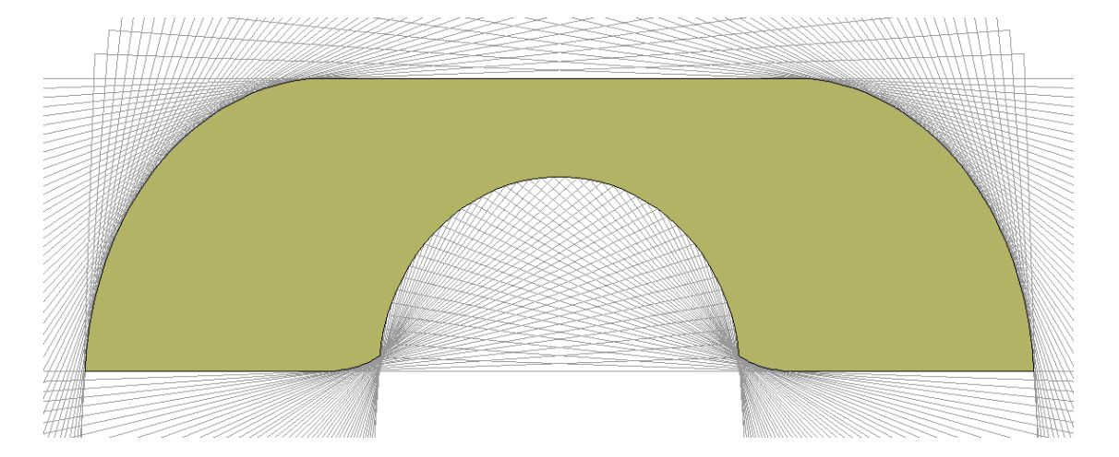

Gibbs’ Sofa

This solution agrees with Gerver’s to 8 significant figures! But, because it is just a discretized version of the problem, we still do not have conclusive proof that this shape is indeed the optimal sofa. :(

There also exist generalizations of this problem that people are still investigating! For instance, what about a hallway that has BOTH a left turn and a right turn? A guy named Dan Romik found the below shape, which is the current best:



Source: Dan Romik

The area of this dumbell looking sofa can be calculated via the following fun formula:



Source: Dan Romik

But, it’s unknown whether this is a truly optimal shape or not. Either way, mathematicians will likely continue to ponder moving sofas through arbitrary spaces, and I can’t wait to see what crazy shapes come next.

**1936 Berlin Olympics**

At the 1936 Berlin Olympics, the US men’s basketball team beat Canada 19–8 to win the gold medal. The game was held outdoors on a dirt court in the pouring rain. The conditions prevented dribbling, which is why the score was so low.

**Women’s Shirt Buttons**

Why do women’s shirts button from the opposite direction? Goes back to the 13th century, when only rich women had shirt buttons. Rich women also had handmaidens dress them, so for their convenience, buttons were placed on the other side. And it stayed like that ever since.

**The Arginine Conman**

Back in the 90’s arginine was all the rage in the Stanford biochemistry department. They had just received a huge grant to study the effects of arginine on blood flow, and there was hope that it could play a key role in unclogging arteries by improving blood flow to poorly supplied areas of the body.

The initial results were a huge success, and so the professor patented the use of arginine as a health supplement and built a small company around it. Tangentially, this is interesting because arginine is a naturally occurring and crucially important amino acid, and so it is a little strange that it can be patented.

Anyways, this professor starts making health bars with arginine in them and markets them. They’re mildly successful and he swears by the stuff. To continue his scholarly pursuit, he gets another federally funded trial for a longitudinal study to prove that on a broad scale these things are good for you. The results come back and it turns out that arginine is actually detrimental to patients with high risk blood flow.

Dr. X was crushed; his life’s work was just proven to be a false lead. Being the good scientist that he was, he admitted defeat and threw in the towel, not wanting to kill people with his business. The patent ends up staying under control of the Stanford patent office for years, until a man named Ron Kramer spotted it. Kramer saw an opportunity and bought the rights to the patent, which Stanford was happy to sell because most university patent offices barely break even.

With the patent, Kramer started a health company called “ThermoLife”. However, the goal of this company wasn’t really to sell useful supplements. Rather, it was a medium by which Kramer could troll the shit out of other supplement companies.

ThermoLife (<http://www.thermolife.com/products/> has about 9 products listed on their website, and for a long time, 7 of the 9 have been unavailable. What does Kramer do instead of sell products? He finds companies that make legitimate products with arginine, and then sues them for illegal infringement of his patent, using ThermoLife’s few pseudo-supplements as the rationale.

This has pissed off a bunch of people in the industry, who are now teaming up against him and his bullshit. They are calling for the repeal of the laws that allow him to pull off these patent shenanigans, and the movement has even gained the notoriety of president Obama. Their goal is to change the Bayh-Dole act, which allows this to happen.

**Null Island**

There is a fictional island in the South Atlantic, off the west coast of Africa, at latitude/longitude 0,0, called “Null Island.” Although it doesn’t exist in reality, this one-square-meter plot of land helps geographic analysts flag errors in a process called “geocoding.”

Geocoding is the function performed by a geographic information system (GIS) that converts addresses into coordinates which can be easily mapped. This is actually what happens every time you type an address into Google Maps. Due to typos, messy data, or glitches in the geocoder itself, the geocoding process doesn’t always run smoothly. Misspellings and other errors can confuse a geocoder, causing the output to read “0,0”. While this output indicates that an error occurred, since “0,0” is in fact a location on the Earth’s surface according to the coordinate system, the feature will be mapped there, as nonsensical as the location may be. As a result, we end up with an island of misfit data.

Countless GIS professionals and cartographers end up frequently sending data points to Null Island, and this shared experience among map enthusiasts has fed the mystique of Null Island, with GIS enthusiasts creating fantasy maps, a “national” flag, and articles detailing Null Island’s rich history. So not only is Null Island a useful tool to catch errors, but it’s also an elaborate inside joke among cartographers. At “0,0” there is actually a buoy permanently anchored (called “Soul”) to collect data on air temperature, water temperature, wind speed, wind direction and other variables.

After years of geocoder errors, Null Island has hundreds of addresses and places labelled to it that do not, in reality, exist there. This means that it is one of the most interesting, most visited places on Earth, despite the fact that it’s only a data dump that’s been fictionalized by geographers.

Learn more: [2]

**The Maillard Reaction**

The Maillard reaction, as you may know, is what happens when you sear meat. However, this is only one case where the Maillard reaction happens. It’s actually a very common reaction that happens in a lot of different situations, including almost every time we cook food. Searing steaks, browning butter, toasting bread, toasting marshmallows, roasting coffee, baking cookies, and roasting grains are all examples of the Maillard reaction.

In the culinary world, the Maillard reaction is referred to as the “browning reaction”. It starts as a simple chemical reaction between carbonyl groups in sugars and amino groups in amino acids, but ends up being an extremely complicated reaction. This chemical reaction drastically changes the texture and taste of the food involved. And because all different foods have a different combination of sugars and amino acids, the Maillard reaction yields different new flavors for almost every food. Given that, it is hard to say that the Maillard reaction produces this or that taste, but in general it creates a savory or “umami” flavor. Depending on the food, the Maillard reaction can produce a flavor that is especially toasty, nutty, wholesome, or gamey.

The Maillard reaction is drastically accelerated between 284 and 329 Fahrenheit. Above that temperature caramelization occurs (which is delicious), and above that temperature pyrolysis (aka charring) occurs, which creates a bitter taste. So, a burnt marshmallow isn’t going to just taste a little bit different than a golden brown marshmallow - it will taste completely different due to the distinct chemical reaction that occurred.

Now, these chemical reactions can be combined, such that when a single piece of food is done, it has undergone some set of Maillard chemical reactions, some set of pyrolysis chemical reactions, and various other chemical reactions, all for different time spans and with different effects. Different molecules will be created based on all of these factors and temperatures.

Keep in mind that the temperatures we are talking about are not the ambient temperatures (such as the temperature of the oven). Rather, it is the temperature of the food itself that determines the reaction. This is why you need to typically sear a steak on a very hot surface for it to taste good – if you just heat the meat up but never get it to the Maillard reaction temperature, it will taste like shit.

In a typical Maillard reaction for a certain food, HUNDREDS of new flavor compounds are created that were not present before the reaction. This also happens to be how artificial flavors are created. Scientists combine different sugars and amino acids, put them through a Maillard reaction, and then taste it and think  ”Hey, this almost tastes like peanut butter”. Then they tweak the combination of sugars and amino acids until they have the recipe for the artificial flavor for peanut butter.

Here are some other tidbits about the Maillard reaction:

* The Maillard reaction also happens in the human eye, and can cause degenerative diseases.
* Searing before cooking vs searing after cooking will create different tastes, which makes sense. Cooking is always changing the chemical makeup of the food, and searing it first will give food a different initial chemical makeup, so it will react differently and produce a different set of new chemical compounds than if you didn’t sear it.
* Maillard reactions require high heat and a lack of moisture. Given this, it makes sense that foods cooked with a lot of moisture have a distinctively anti-Maillard taste. Namely, poaching, steaming, boiling, etc. One way to get a Maillard reaction while cooking in water is to use a pressure cooker, because it raises the boiling point of the water and allows the food to reach that ~300 F sweet spot.

Want to learn more? [3]

**Medical Residency Matching**

In the early 1900s, there was no standardized system in place for assigning medical school residencies. As a result, in their desire to win over top students, hospitals began to push their recruiting timelines earlier and earlier. This not only resulted in students having to make quick decisions before they could consider all their potential options, but it resulted in medical schools having very little data to go on, as recruitment was happening as early as the beginning of junior year of medical school.

In the 1940s, some attempts were made to standardize the dates that offers were released, but all this did was change the problem. Hospitals, still competing with each other and still desperate for the top students, would offer extremely short time spans for students to accept or decline an offer. In 1945 it was around 10 days, but by 1949 the deadline was less than 12 hours for most schools. Many hospitals, in fact, would demand an immediate reply over the telephone, because if they waited too long for a candidate to reply, and that candidate then declined, it would be too late for the school to get other good candidates which had all already been snapped up by other schools.

To fix these problems, and to hopefully make residency matching easier for everyone involved, the Association of American Medical Colleges decided to move to a “Clearinghouse” system in 1952 — a system where students and hospitals would independently rank their preferences, and an algorithm would determine the best possible overall matching. While this idea was supported overall, there was debate over what algorithm should be used.

The Mullin-Stalnaker Algorithm

The originally proposed algorithm (proposed by Mullin and Stalnaker) had medical schools rank students, such that if the med school had X spots, up to X students could be rank 1, up to X students could be rank 2, etc. At the same time, students ranked the schools they were applying to. Matching priority would be 1–1 matches, then 2–1 matches (when a hospital ranks a student as 2 but that student ranks the hospital as 1), then 1–2 matches, then 2–2, 3–2, 2–3, etc.

The espoused benefit of this system is that it prioritizes students over hospitals, which can be seen in how 2–1 matches are chosen before 1–2 matches. However, a problem arises if a student ranks a hospital they have a minimal chance of getting into as 1. In such a case, the student’s 2nd or 3rd choice hospitals may have ranked him or her as 1, but could easily fill up on their 1–1 and 2–1 matches (since students who ranked those hospitals 1st are given priority). Thus, this theoretical student is penalized for ranking a longshot school highly.

The Gale-Shapley Algorithm

An alternative algorithm was proposed to address the aforementioned issue. This algorithm proceeds in rounds. In each round:

1. Each hospital (assuming the hospital has X open spots) offers residencies to their top X remaining students, according to their preference list.
2. Each student accepts their best offer, according to their preference list of hospitals. This means if a student already has a better offer from an earlier round, they keep it and decline the new offer, but if they are unassigned or a better offer comes in, they take it.

This process repeats until all positions have been filled.

In simpler terms, this algorithm (which is also known as the deferred acceptance algorithm) has each hospital send out offers according to its preference list, and each student holds on to the best offer they have received overall, rejecting a previous offer if a new, better offer comes in. Note how this addresses the issue from before — if a student’s top choice is a longshot school, but they don’t get in, they can still accept an offer from their 2nd or 3rd choice school if that school has the student ranked at the top of their list.

More broadly, this algorithm is stable, meaning that it will output no pair of assignments Person 1 to Hospital 1 and Person 2 to Hospital 2, such that Person 1 would prefer Hospital 2 and Hospital 2 would prefer Person 1. This is a very important property to have because if a hospital and applicant would both have preferred to be matched with each other, they would have tried to circumvent the process in some way. In other words, an unstable outcome would be produced. More broadly, stability is desired in any marketplace, since a stable output implies that no parties will want to undergo further transactions after an initial matching has occurred.

The impact of unstable and stable matching algorithms has been well documented. For instance, in the 1960s, the British National Health Service started using algorithms to assign medical interns. Each region of the Health Service devised its own algorithm. As it turns out, all regions with unstable algorithms quickly abandoned their systems, as interns and hospitals began circumventing the matching process due to widespread unhappiness with the result. In contrast, those regions that used stable algorithms saw widespread success with their matchings, and their systems remained in use.

Ironically, stability in matching algorithms was not really understood until 1962, when Gale and Shapley wrote a paper analyzing the mathematics of pairwise matching algorithms (and as a result they had the algorithm listed above named after them). In that sense, the Association of American Medical Colleges got somewhat lucky in choosing a stable algorithm in 1952, a choice that caused residency matching to be fairly successful in the US for the rest of the century.

Beyond Stability

For any given matching problem, there are a number of possible stable outcomes. So, the question then becomes, which is the best?

As an example, consider an alternative implementation of Gale-Shapley, where instead of hospitals making offers, students make offers and hospitals accept or reject them. This is still a stable algorithm (since fundamentally the same process occurs), but the difference is that it prioritizes student choice over hospital choice. More specifically, the algorithm where hospitals make offers gives the best possible outcome for hospitals that is still stable overall, whereas the algorithm where students make offers gives the best possible outcome for students that is still stable overall.

In the 1990s, Al Roth was hired to improve the residency matching system in the face of criticisms such as this. His proposed algorithm was not only based on student offers in order to favor students more, but also accounted for the increasing prevalence of couples applying to residencies. Couples could now submit rank order lists of pairs of positions, to ensure they ended up in the same location. In addition, Roth’s new algorithm accounted for students who desire specialized rotations requiring multiple residencies. Students could submit a “primary” list of hospitals for their second year as well as a “secondary” list for their first year (such that if the student is accepted for a primary, they would be considered by hospitals for a secondary), and the algorithm would balance these more complex requirements. Finally, Roth revised the algorithm to account for research that had shown that the original Gale-Shapley algorithm was vulnerable to strategic manipulation in some cases by someone declining an offer that they should normally accept because it is their best so far.

Roth’s new algorithm is what is still in place today for medical residency matching. Sadly, though, the increased complexity of couples and multiple residencies, among other things, have made it such that the current algorithm is not guaranteed to produce a stable output. In fact, it has been proven that given the complexity of the residency matching requirements today, it is not possible to know in polynomial time whether a stable output even exists given a certain set of input data. The current algorithm has also drawn some criticism due to the fact that the ordering in which the input data is processed has some minor effects on the output.

Nevertheless, Roth’s system is on the whole well regarded, so much so that Roth and Shapley shared a 2012 nobel prize in economics for their research on stable matchings in marketplaces. As it turns out, this research actually has implications in a lot of situations beyond residency matching. A few are described below.

High Schools

In 2003, Al Roth was hired to improve the high school admission system in New York. New York’s public high school system previously used an algorithm where kids would submit a top 5 high school list, and those lists would be sent to schools, who would then decide who to accept, defer, or decline. This repeated for 3 total rounds. This system was disastrously bad; 30,000 kids each year were placed in a high school not in their top 5.

After a variant of the Gale-Shapley algorithm was adopted by the state with the help of Roth, the number of kids placed in a school not in their list dropped by 90%. This system’s success in New York has led to a number of other school districts adopting similar practices.

Kidney Matching

Shapley studied the problem of kidney donor matching, which is quite different from medical residency matching as one side of the marketplace is totally passive. However, by focusing his research on the same idea of stability, Shapley devised an algorithm for kidney transplants known as the Top Trading Cycle. This algorithm has been used to great effectiveness in a number of states, as it identifies much more complex kidney matches than would otherwise be identified.

Online Auctions

While the original algorithms proposed by Shapley and Roth did not involve prices for each transaction, they can be modified to do so. Such algorithms have been used heavily in online auction systems such as the advertisement marketplaces used by companies like Google, Facebook, and more.

Want to learn more? [4]

**Segway Gets Punked**

Here’s another classic example of someone getting punked in the business world. A Chinese company called Ninebot Inc. made a knock off of the Segway (the following wheely transportation thing).



When Segway tried to sue, Ninebot used the money they made from selling the knock offs to buy the company that originally made the Segway. #getrekt

**The Most Confusing Trial of All Time**

There’s a famous case study in the law literature regarding the story of Ronald Opus. Almost every law student has heard this story, and it has one of the most complicated and controversial analyses in history. The story is as follows:

On March 23, 1994, a medical examiner viewed the body of Ronald Opus and concluded that he died from a gunshot wound of the head caused by a shotgun. Investigation to that point had revealed that the decedent (short for someone who has recently died) had jumped from the top of a ten-story building with the intent to commit suicide (He left a note indicating his despondency). As he passed the 9th floor on the way down, his life was interrupted by a shotgun blast through a window, killing him instantly. Neither the shooter nor the decedent was aware that a safety net had been erected at the 8th floor level to protect some window washers, and that the decedent would most likely not have been able to complete his intent to commit suicide because of this.

Ordinarily, a person who starts into motion the events with a suicide intent ultimately commits suicide even though the mechanism might be not what they intended. That he was shot on the way to certain death nine stories below probably would not change his mode of death from suicide to homicide, but the fact that his suicide intent would not have been achieved under any circumstance caused the medical examiner to feel that he had homicide on his hands.

Further investigation led to the discovery that the room on the 9th floor from whence the shotgun blast emanated was occupied by an elderly man and his wife. He was threatening her with the shotgun because of an interspousal spat and became so upset that he could not hold the shotgun straight. Therefore, when he pulled the trigger, he completely missed his wife, and the pellets went through the window, striking the decedent.

When one intends to kill subject A but kills subject B in the attempt, one is guilty of the murder of subject B. The old man was confronted with this conclusion, but both he and his wife were adamant in stating that neither knew that the shotgun was loaded. It was the longtime habit of the old man to threaten his wife with an unloaded shotgun. He had no intent to murder her; therefore, the killing of the decedent appeared then to be accident. That is, the gun had been accidentally loaded.

But further investigation turned up a witness who said that the couple’s son was seen loading the shotgun approximately six weeks prior to the fatal accident. That investigation showed that the mother (the old lady) had cut off her son’s financial support, and her son, knowing the propensity of his father to use the shotgun threateningly, loaded the gun with the expectation that the father would shoot his mother. The case now becomes one of murder on the part of the son for the death of Ronald Opus.

Now comes the exquisite twist. Further investigation revealed that the son, Ronald Opus himself, had become increasingly despondent over the failure of his attempt to get his mother murdered. This led him to jump off the ten-story building on March 23, only to be killed by a shotgun blast through a 9th story window. The medical examiner closed the case as a suicide.

The kicker? The story is entirely false, but was originally told in a speech by Don Harper Mills at a forensics banquet to illustrate how complex a legal situation can get and how pursuit of legal repercussions can change with every twist in the story. It has, however, been misreported repeatedly in the media as true, and has been depicted in movies and on TV. There are a variety of analyses as to what legal route to take, but most people agree that the older gentleman is guilty of homicide.

Want to learn more? A bunch of people have chimed in with their explanations on Reddit[5]

**Russian Special Forces Training**

At one point during Russian special purpose forces training, the trainees are shot at the chest while wearing body armor to give them a taste of the real battlefield. They literally stand there, and then they wait for someone to casually walk past them but then suddenly draw a pistol and shoot them repeatedly in the chest. After taking these hits, they are to return fire — and they have to aim just inches away from the attacker’s unprotected face. If they miss by a few inches they blow the head off the trainer.

In a second drill, the trainee is given multiple cardboard targets to shoot, but while he does so, he is pushed and shoved by trainers, has stuff yelled in his ear, and guns fired immediately adjacent to his ears. These are all supposed to simulate distractions on the battlefield and enhance the trainees’ focus in stressful situations.

In an even higher-stakes version of the drill, they put real humans immediately adjacent to the cardboard targets, so they if they miss, they hit real people. This is supposed to train them to focus on their shooting even when innocent bystanders are nearby.

Want to learn more? [6]

**Seedless Plants**

Seedless plants are super interesting. A seedless variety is created by cross pollinating plants such that the plant has three chromosomes. This makes meiosis very difficult because all the chromosomes can’t match up for reproduction. As a result, no seeds are produced, and this plant cannot reproduce.

So, how do we make more of a plant that can’t reproduce?

Sometimes we just use graftinf, where they cut off a young branch of the seedless plant and basically just tape it to the branch of a normal plant. Also, sometimes the plant will need fertilization to produce fruit, so they will be put next to a normal plant to provide pollen. A negative consequence is that virtually all the fruit produced is genetically identical, making them extremely vulnerable to viruses or other infections. In fact, the current species of banana we eat is in danger of getting wiped out due to a new disease that has been affecting them. This species replaced a species that was completely wiped out in the 50s. [https://en.m.wikipedia.org/wiki/Cavendish_banana](https://medium.com/r/?url=https%3A%2F%2Fen.m.wikipedia.org%2Fwiki%2FCavendish_banana)

**How to Beat Spotify**

There’s a band called Vulfpeck that released a silent album called Sleepify. They asked their fans to play it whenever they could on repeat on Spotify, especially while they were sleeping. The band earned around $20,000 in royalties from this before Spotify closed the loophole. They then went on a small tour where they gave away all the tickets for free as a thanks to their fans. They even picked the tour stops as the cities that streamed the album most.

**The Fold and Cut Theorem**

1. YOLO means “You Only Live Once” – it is commonly used among today’s youngsters to reference doing something crazy or ridiculous.
2. Learn more about Null Island: <https://blogs.loc.gov/maps/2016/04/the-geographical-oddity-of-null-island/>
3. Learn more about the Maillard Reaction: [Wikipedia](https://en.m.wikipedia.org/wiki/Maillard_reaction), [Modernist Cuisine](http://modernistcuisine.com/2013/03/the-maillard-reaction/)
4. Learn more about Medical Residency Matching: [Roth’s 1999 paper on residency matching](https://web.stanford.edu/~alroth/papers/rothperansonaer.PDF), [Gale and Shapley’s 1962 pape on stability in matching](http://cramton.umd.edu/market-design/gale-shapley-college-admissions.pdf), [Stanford article on the history of residency matching](https://web.stanford.edu/~alroth/papers/JAMA.OriginsAndHistoryNRMP.Roth.pdf), [Wikipedia overview of the residency matching program](https://en.wikipedia.org/wiki/National_Resident_Matching_Program)
5. Learn [more about Ronald Opus’ favorite legal case](mailto:https://www.reddit.com/r/AskReddit/comments/4uzrm9/whats_your_favourite_paradox/)
6. Check out this [video of Russian Special Forces crazy training](https://www.youtube.com/watch?v=rI01qKAqYts)