Model System:

Mira/Weinreich E. Coli strain: DH5-alphaE w/ plasmid pBR322 expressed.

Strain TEM-19

Protocol heavily inspired by the following paper: https://journals.plos.org/plosone/article?id=10.1371/journal.pone.0122283

Steps:

Days 1-20:

1. Grow up TEM-19 stock in overnight culture (16 hours)
2. Transfer 2 microliter of culture to 96-well plate with 10 microliters of drug solution (20 microliters for CPR) and 189 microliters of MHB+TET (179 microliters for CPR)
   1. \*see Eshan’s plate prep protocol for more details on this step
   2. We chose 2 microliters of turbid culture because we were having lots of wells not grow at all with a 1 microliter inoculum
3. Place adhesive membrane over the plate
4. Incubate for 22 hours in plate reader at 37 degrees Celsius
5. Collect measurements of cell density at wavelength of 600 nm every 20 minutes after brief agitation to “homogenize and oxygenate the culture”
6. Passage 2 microliters to a new 96-well plate with 189 microliters of MHB+TET
7. Wait 1 hour
8. Add updated drugs (10 microliters of drug solution) to the new
9. Add glycerol to each well + freeze old plate in -80
10. Repeat steps 3-7 x 20 days

Day 20: Collateral Sensitivity assay for all replicates/drugs

Experimental Conditions:

1. RL-fit test condition: CTX,AMC,CTX,AMC,CTX,CPR,CTX,AMC,CTX,CPR
2. Random Drug Cycling condition. We will generate random 10-day sequences of drugs for each replicate in this condition
3. Monotherapy
   1. Single drug at same concentration in well for all 10-days
   2. CTX
   3. CPR
   4. AMC

Making the plates:

1. I will print out guide sheets every day that color code which drug should go in which well based on the experimental conditions

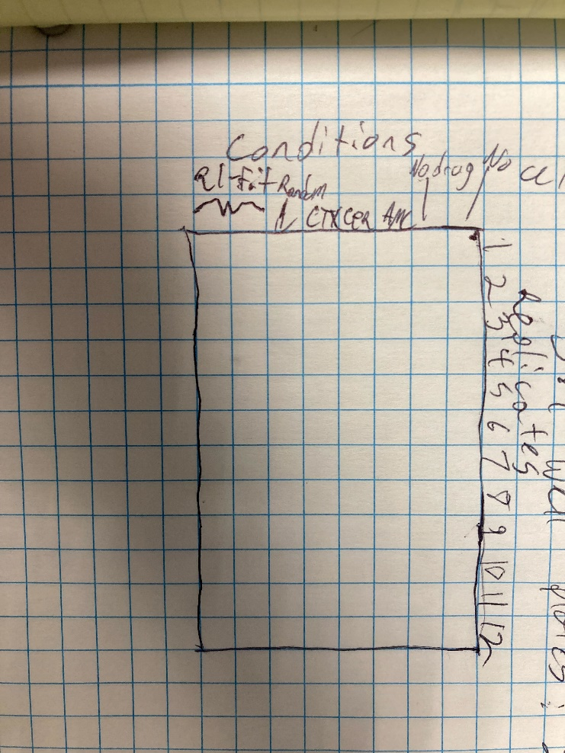

Drug Concentrations:

1. AMP: Ampicillin 2048 μg/ml.
   1. Doesn’t really dissolve in DMSO so we only have aqueous dilutions
   2. Only need 8 μL of AMP 50 mg/ml aqueous dilution
2. CEC: Cefaclor 1 μg/ml.
3. CTX: Cefotaxime 0.05 μg/ml.
4. ZOX: Ceftizoxime 0.03 μg/ml.
5. CXM: Cefuroxime 1.5 μg/ml
6. AMC: Amoxicillin/Clavulanate 16 μg/ml and 8μg/ml. \*
   1. For this one we need 20 total μl of drug (10 + 10) – add media accordingly
7. CAZ: Cefazidime 0.1 μg/ml.
8. CTT: Cefotetan 0.312 μg/ml.
9. CPR: Cefprozil 100 μg/ml.
   1. Need 20 μl of aqueous dilution to meet target concentration
10. CPD: Cefpodoxime 2 μg/ml.
11. TZP: Pipercillin / Tazobactam 12μg/ml and 8 μg.ml.
12. FEP: Cefepime 0.0156μg/ml

Notes:

1. Do not try and use the trough for applying drugs to the wells
2. Eshan has an excel sheet where he computed all the aqueous dilutions from the DMSO drug stocks.
3. Including the volume of dmso drug stock needed for a 1 ml broth dilution of drug
   1. Can do both or aqueous dilution

Computing growth rate:

Linear fit of ln(OD) in the exponential phase of bacterial growth

SEE Eshan’s protocol for more details about plate prep