**Kiss of Shame Graphics Layers**

**Layer 0:** This layer is the background.



**Layer 1:** This layer will sit on top of the background. I will animate the alpha of this layer.



**Layer 2:** This layer is one of the “fond” images. Note that the circular regions around each knob location must be transparent so we will be able to see the pink layer behind the image.

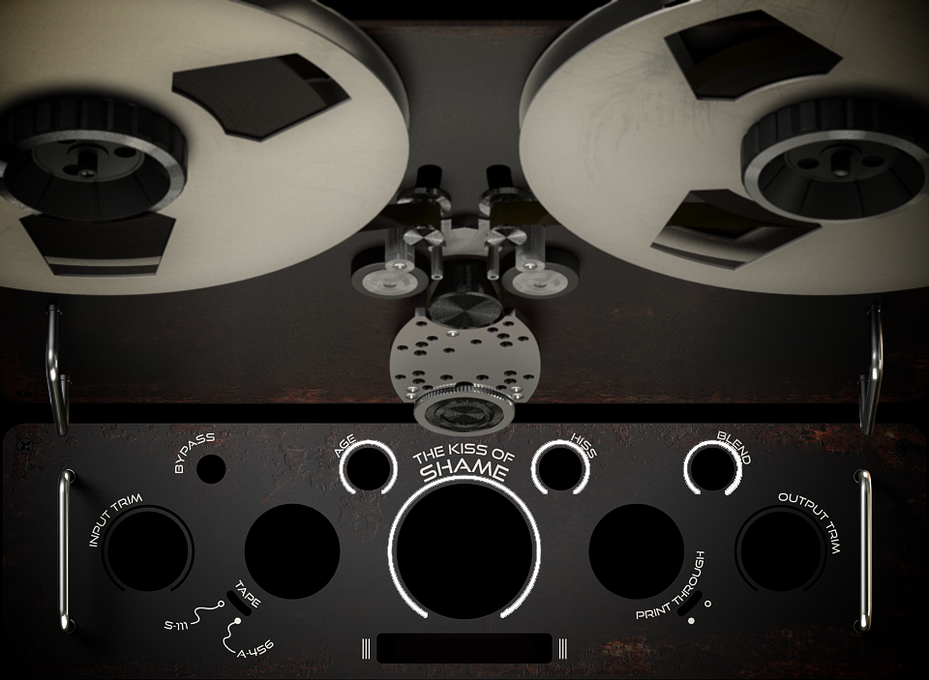

**Layer 3:** This layer would be one of the knob images that sits on top of the “fond” image. As the knob is rotated, the outer circular region needs to be transparent (instead of pink) so we can see the through to the animated pink layer.



**All the layers together:** The diagram below displays how all the layers fit together.

