Donnell Sample

CLC Milestone 1

01/17/2021

Sprint product log/Back log/ Burn down chart

Github: https://github.com/Davon55/CST--247-C-

This chart represents the weekly hours allocated to the project which comes from the release backlog.

|  |  |  |  |  |  |  |  |  |  |
| --- | --- | --- | --- | --- | --- | --- | --- | --- | --- |
| **Settings** | **Start** | **Week1** | **Column4** | **Column5** | **Column6** | **Column7** | **Column8** | **Column9** | **Column10** |
| Planned Hours |  | 25 |  |  |  |  |  |  |  |
| Actual Hours |  | 15 |  |  |  |  |  |  |  |
| Remaining Effort | 400 | 385 |  |  |  |  |  |  |  |
| Ideal Burndown | 400 | 375 |  |  |  |  |  |  |  |

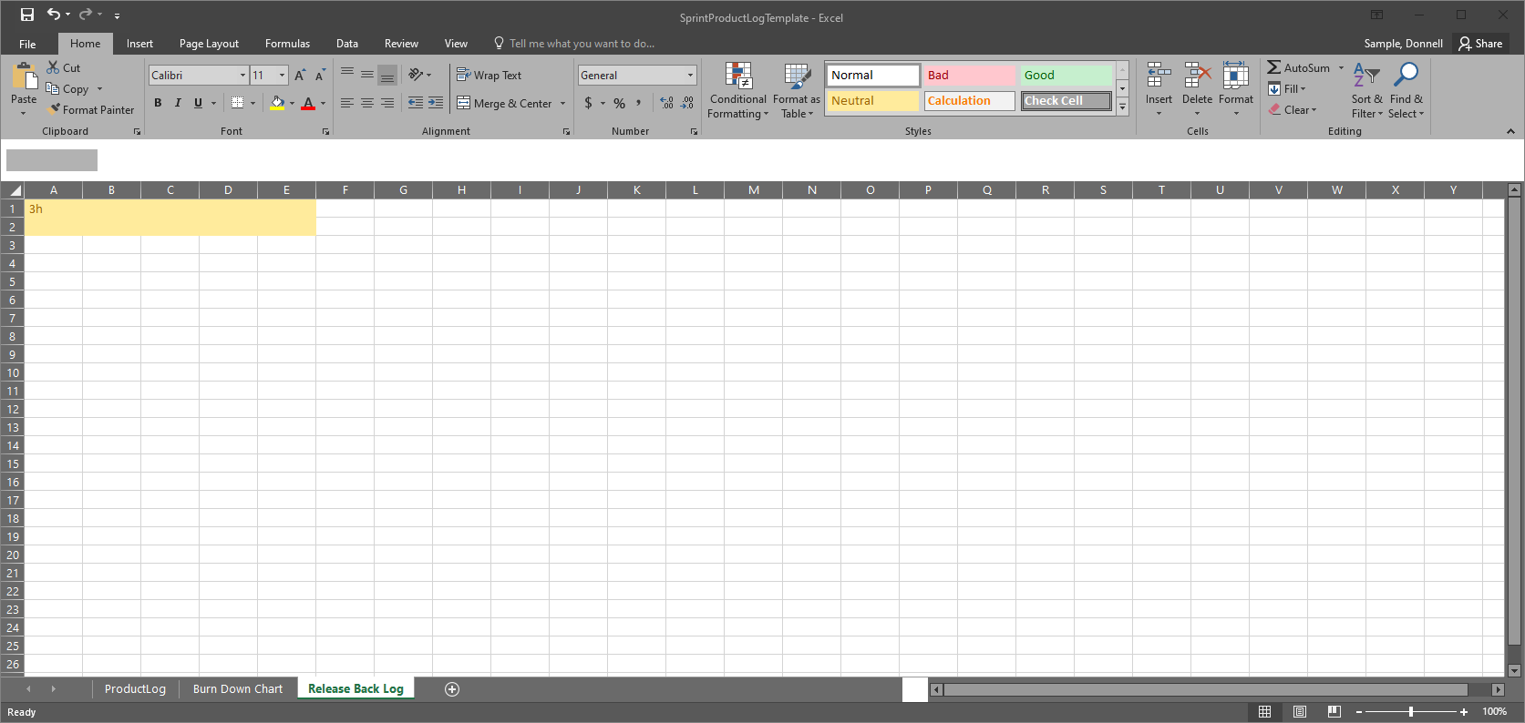

**Burn Down Chart**

These charts explain the effort on the Minesweeper project and the data accumulated over week 1, time spent and remaining.

Product Backlog

