Chapter I
BACKGROUND/RATIONALE
Digital learning environments have become essential in higher education because they help institutions manage instructional delivery, assessment, communication, and academic records in a centralized system. Among the most widely used learning management systems is Moodle, an open-source platform known for its flexibility, modular structure, and plugin-based extensibility (Dougiamas & Taylor, 2003; Moodle Pty Ltd., 2025a, 2025b). Through Moodle, educational institutions can organize quizzes, assignments, examinations, grading records, and classroom communication within a single online environment. Despite these capabilities, many academic institutions still experience operational inefficiencies when preparing official grade reports because institutional reporting requirements are often processed outside the learning management system.
In many colleges and universities, faculty members use Moodle primarily for uploading learning materials, recording scores, conducting assessments, and monitoring student performance. However, the preparation of official grade sheets commonly remains dependent on manual spreadsheet processing. Faculty members frequently export raw grade data from Moodle into CSV or spreadsheet files, rearrange records manually, compute grades using separate formulas, apply transmutation rules, and reformat the output according to the Registrar’s required template. This process creates duplicate work because grades that already exist digitally inside Moodle still need to be manually transferred into another reporting format. Previous studies have shown that faculty members often continue to rely on parallel workflows when institutional reporting requirements are not fully integrated into the learning management system (Beatty & Ulasewicz, 2006; Lonn & Teasley, 2009).
Manual grade preparation presents several operational concerns. Studies related to educational workflow systems have noted that repetitive manual processing increases inefficiency and raises the possibility of clerical and computational errors in academic reporting tasks (Henderson et al., 2017). First, the process is time-consuming because instructors must repeatedly clean, reorganize, and validate exported records before submission. Second, repetitive copy-pasting and spreadsheet manipulation increase the possibility of clerical errors, incorrect formulas, omitted records, and inconsistent formatting. Third, the process becomes more burdensome during grading periods when faculty members handle multiple classes and submission deadlines simultaneously. Although Moodle already stores the necessary academic data, the lack of direct registrar-aligned report generation forces faculty users to rely on external processing methods.
Existing Moodle gradebook functions support grade storage, grade computation, and export features, but they are not fully aligned with the specific reporting format required by the institution (Ltd, 2025), (2025), (Moodle, 2025), (Moodle, 2025). While spreadsheet software can still be used to manually prepare reports, these tools do not directly automate institutional workflows inside the Moodle environment itself. This creates a gap between digital grade management and official grade reporting.
To address this problem, the study proposes the development of an Automated Grade Sheet Generation Plugin for the Moodle Learning Management System for Faculty Grade Reporting. The proposed system will function as a Moodle plugin that automatically retrieves student grade data from the Moodle gradebook and transforms the records into a registrar-aligned grade sheet. Instead of requiring faculty members to manually export and reconstruct reports using spreadsheets, the plugin will automate the retrieval, computation, organization, formatting, and generation of official grade reports.
The proposed plugin will include features such as automatic retrieval of student information and grade records, grade computation and transmutation support, registrar-aligned formatting, exportable reports, and printable grade sheet generation. Because the plugin will operate directly within Moodle, faculty members will remain inside the existing institutional system rather than transferring data to separate applications.
The uniqueness of the proposed system lies in its direct integration with the institution’s Moodle workflow and official reporting process. Unlike generic spreadsheet-based grading methods, the proposed plugin is intended to automate registrar-aligned reporting directly within Moodle through a plugin-based extension, which is technically supported by Moodle’s modular architecture (Dougiamas & Taylor, 2003). The system is not intended to replace Moodle or the institutional grading policies; instead, it will extend Moodle’s capabilities by automating a repetitive and localized reporting task that currently requires manual intervention.
The need for the study is further supported by the preliminary assessment conducted among the identified faculty users. Based on the preliminary questionnaires and interview clarifications, faculty respondents reported that grade preparation currently involves exporting Moodle data, manually arranging records, and rechecking formulas and formatting before submission. Respondents also identified the process as time-consuming and operationally repetitive. Additionally, the respondents expressed strong interest in features such as one-click report generation, automatic transmutation, automatic inclusion of student information, registrar-aligned layouts, and export-ready grade sheets.
The local context of the study also strengthens its relevance. In the College of Computer Studies of Eastern Samar State University Main Campus, faculty members who currently use Moodle for the identified workflow still rely on external spreadsheet processing to prepare official grade reports. Although the direct user group is limited, the workflow impact remains operationally significant because these faculty members manage multiple students, courses, and class sections. Since the respondents represent the complete target user group for the identified process in the selected locale, their feedback will be directly relevant to the development and evaluation of the proposed plugin.
In view of these conditions, the study will design, develop, and evaluate an Automated Grade Sheet Generation Plugin for the Moodle Learning Management System for Faculty Grade Reporting. The proposed system aims to reduce repetitive manual work, minimize clerical and computation-related errors, improve consistency in grade reporting, and streamline the preparation of official grade sheets within the College of Computer Studies of Eastern Samar State University Main Campus.
Objectives of the Study
The general objective of the study is to design, develop, and evaluate an Automated Grade Sheet Generation Plugin for the Moodle Learning Management System for faculty grade reporting in the College of Computer Studies of Eastern Samar State University Main Campus.
Specifically, the study will aim to:
- determine the system requirements and architectural design needed for the development of the proposed automated grade sheet generation plugin;
- develop the proposed plugin for seamless integration with the existing Moodle environment in terms of:
a. data retrieval from the Moodle gradebook,
b. grade computation, transmutation, and student status management; and
c. registrar-aligned report formatting and export; and
- evaluate the level of user acceptability of the developed plugin based on the ISO/IEC 25010 software quality characteristics, specifically in terms of:
a. functional suitability,
b. usability, and
c. performance efficiency.
Scope and Limitations of the Study
This study will focus on the design, development, and evaluation of an Automated Grade Sheet Generation Plugin for the Moodle Learning Management System for faculty grade reporting in the College of Computer Studies of Eastern Samar State University Main Campus. It will concentrate on creating a plugin that will automate the generation of Registrar-aligned grade sheets using existing academic records available in Moodle, including grades from quizzes, examinations, attendance, and selected course activities, subject to the approved grading structure of the covered courses.
The study will cover requirements gathering, architectural design, plugin design, prototype development, testing, and user evaluation. It will include core features such as retrieval of grade data from the Moodle gradebook, grade computation, transmutation support when applicable under approved grading rules, student academic status overrides (e.g., Incomplete, Dropped), automatic arrangement of student records, registrar-aligned report formatting, and exportable output in PDF and Excel formats. It will also utilize the accomplished survey questionnaire and interview-based clarification to identify the functional and presentation requirements of the proposed plugin. The survey instrument will specifically cover current workflow, time spent on reformatting, common pain points, and desired plugin features, which will serve as inputs to the requirements analysis of the system.
The study will be limited to the College of Computer Studies of Eastern Samar State University Main Campus and to the three faculty members who currently use Moodle for the identified grade-reporting process. Because these respondents represent the actual user group in the target locale, their responses will be directly relevant to the design and evaluation of the proposed plugin. However, the findings will not be intended for broad statistical generalization to all colleges, campuses, or institutions.
The study will not cover institution-wide registrar automation, student information system replacement, or migration to platforms outside Moodle. Consistent with the definition of a Registrar-Aligned Grade Sheet in this study, the plugin will produce a system-generated document that replicates the Registrar's required structure and format; it will not produce a scanned or manually reproduced copy of the physical form. It will also not attempt to revise institutional grading policies or registrar standards. Instead, the study will align the developed plugin with the existing institutional requirements, approved report format, and grading rules currently followed by the relevant academic unit.
Significance of the Study
The study may provide benefits to the following:

College of Computer Studies
The study may serve as a practical software development initiative that addresses an actual operational problem experienced within the college. It may also demonstrate the application of software engineering, educational technology, and systems integration in improving institutional workflows.

Faculty Members
The study may reduce repetitive manual work involved in preparing official grade sheets. It may also lessen the likelihood of clerical and computational errors while reducing the time required for grade preparation, report formatting, and submission.

Students
Students will directly benefit through a dedicated interface allowing them to view their personal computed grade cards within Moodle, in addition to indirectly benefiting from faster institutional grade processing.

Registrar and Academic Offices
The study may help improve the consistency, readability, and standardization of submitted grade sheets through the use of system-generated registrar-aligned reports.

Future Researchers and Developers
The study may serve as a reference for future Moodle plugin development, registrar-related automation projects, and studies involving educational workflow automation and learning management system extensions.
Definition of Terms
Automated Grade Sheet Generation Plugin—a software extension that will be developed within Moodle to automatically compute, organize, and format grades into an official grade sheet for faculty reporting.
Comma-Separated Values (CSV) - a plain-text file format used to store tabular data in which values are separated by commas, often used for exporting grade data between systems.
Faculty Grade Reporting - the academic process through which instructors prepare and submit official student grades in the format required by the institution.
Grade Transmutation - the process of converting raw scores or computed values into an institutional grading scale such as 1.0–5.0 or 75–100, depending on approved grading rules.
Gradebook - Moodle’s built-in tool for collecting, calculating, displaying, importing, and exporting grades associated with student activities (Moodle Pty Ltd., 2025a, 2025b).
Learning Management System - a digital platform used to manage learning materials, assessments, communication, and course records in an organized online environment (Coates et al., 2005).
Moodle - an open-source learning management system designed to support online teaching, assessment, and course administration and extensible through plugins (Dougiamas & Taylor, 2003; Moodle Pty Ltd., 2025a, 2025b).
Plugin - a modular software component that adds new functionality to an existing platform without replacing the core system (Moodle Pty Ltd., 2025a, 2025b).
Registrar’s Format - the official institutional structure, arrangement, and presentation required for submitted grade sheets.
Registrar-Aligned Grade Sheet - a system-generated report that replicates the structure, required fields, and presentation of the Registrar's Format. The term refers to formatting and structural compliance and does not mean that the plugin produces a scanned or manually reproduced copy of the physical form.
ISO/IEC 25010 Software Quality Model - an international standard for evaluating software quality, which will be used as the primary framework for assessing the plugin’s functional suitability, usability, and performance efficiency.
User Acceptance Testing - a testing stage in which target users evaluate whether the proposed system is acceptable for actual or intended use.

Chapter II
REVIEW OF RELATED LITERATURE AND STUDIES
Learning management systems have long been recognized as important digital environments in higher education because they centralize instructional materials, assessments, and academic records. Coates et al. (2005) argued that learning management systems affect teaching and learning not only through technological access but also through the way academic work is structured and standardized. This perspective is important to the present study because grade reporting is not only a matter of storage; it is also a matter of workflow design, institutional compliance, and how data move from instruction to administration.
Studies on Moodle have emphasized its flexibility, modularity, and suitability for educational environments that need customizable features. Dougiamas and Taylor (2003) described Moodle as an open-source course management system built around learning communities and extensibility. Because Moodle supports plugins, institutions can develop additional tools that fit local processes instead of forcing all users to adapt to generic built-in functions. This characteristic makes Moodle an appropriate platform for the proposed system because the problem identified in the local setting concerns not the absence of digital grade data but the absence of Registrar-aligned reporting directly inside the existing LMS.
Research on faculty use of learning management systems has also shown that the availability of a platform does not guarantee the transformation of all academic tasks. Lonn and Teasley (2009) found that faculty members often use LMS tools in ways that preserve existing practices rather than fundamentally changing them. In many cases, the LMS becomes a support tool for teaching, while official reporting, formatting, and administrative compliance continue to rely on separate manual processes. This finding closely relates to the present study because the identified local workflow also reflects a mixed environment in which Moodle stores grades, but faculty members still transfer them to external templates for final submission.
Beatty and Ulasewicz (2006) reported that faculty perceptions of Moodle included practical benefits associated with course organization and instructional management. Their work suggests that user acceptance grows when the system supports authentic academic tasks rather than merely offering technical features. In the context of the present study, the proposed plugin will not be an abstract enhancement but a direct response to a repetitive task faculty members already perform. This alignment between user need and system feature will likely foster higher acceptance.
Costa et al. (2012) likewise highlighted that Moodle can support academic management effectively, yet actual value depends on how well the platform matches institutional practices and user expectations. This idea will be relevant to the proposed plugin because the intended output must not only be system-generated but also institutionally usable. A tool that computes grades but fails to match official formatting, ordering, and report presentation will still leave the original problem unresolved.
Faculty workload and efficiency issues are also relevant in the literature. Henderson et al. (2017) observed that users tend to value digital technologies that are clearly useful, time-saving, and directly related to their academic responsibilities. This pattern is consistent with the preliminary problem assessment attached to the proposal, where respondents emphasized time spent on cleaning and reformatting data and marked the proposed one-click solution as extremely helpful. When users perceive a technology as simplifying a real task, adoption becomes more plausible.
The notion of usefulness is further supported by the Technology Acceptance Model of Davis (1989), which explains that perceived usefulness and perceived ease of use influence a user’s acceptance of information technology. Although the present study will primarily follow a software development framework for system construction, Davis’s model will still help explain why the proposed plugin may be accepted by faculty users: if the plugin reduces time, effort, and rechecking while remaining easy to operate inside Moodle, then its perceived usefulness and ease of use will likely be high.
Official Moodle documentation also reinforces the technical basis of the study. Documentation regarding the gradebook, grades, import and export functions, and plugin development shows that Moodle is designed to manage academic scoring and can be extended by developers to support institution-specific functions. These documented capabilities will support the feasibility of creating a plugin that will draw from Moodle records and produce output tailored to local grade reporting requirements (Moodle Pty Ltd., 2025a, 2025b, 2025c, 2025d).
Beyond standard point accumulation, official academic reporting requires the application of institutional grading rules. Guskey (2015) notes that educational systems frequently require the conversion or transmutation of raw scores into standardized ordinal or categorical scales for institutional records. Furthermore, digital grading environments must handle complex student academic states, such as "Incomplete" or "Dropped," which are non-numeric but essential for data integrity and registrar compliance (Bates, 2015). For a learning management system to fully bridge the gap between classroom assessment and administrative reporting, it must accurately apply these specific transmutation formulas and academic status overrides directly to the stored data.
To present this processed data appropriately, web-based educational platforms must be capable of dynamic document generation. Standard web architectures often rely on external processing libraries to automate the extraction of database records into formatted, print-ready documents such as PDFs or spreadsheets (Welling & Thomson, 2016). Integrating these document generation technologies within the LMS eliminates the need for manual data extraction, ensuring that the exported reports strictly adhere to official institutional templates and layouts.
From a software engineering standpoint, developing a specialized extension for an existing platform requires an appropriate development methodology. Sommerville (2015) asserts that the Prototyping model is highly effective when a system must be shaped around specific, localized user interfaces and strict output requirements, such as a registrar-aligned grade sheet. By building an initial working prototype, developers can facilitate early user interaction, gather direct feedback from faculty members, and iteratively refine the plugin’s data retrieval and formatting functions before final deployment.
Once developed, the software must be rigorously evaluated to ensure it meets both user and technical expectations. The ISO/IEC 25010 Software Quality Model serves as an internationally recognized framework for evaluating software systems (International Organization for Standardization, 2011). According to Miguel, Mauricio, and Rodríguez (2014), evaluating a system through this model provides a comprehensive assessment of its practical viability. For the proposed plugin, evaluating its functional suitability ensures it computes grades and manages statuses accurately; usability ensures the interface is manageable for faculty within Moodle; and performance efficiency ensures the automated generation of PDF and Excel documents occurs without degrading the platform's performance.
Taken together, the reviewed literature suggests several important points that will guide the present study. First, while learning management systems like Moodle provide robust platforms for digital learning, they do not automatically resolve localized administrative workflow inefficiencies. Second, accurately automating faculty grade reporting requires not only data retrieval but also the application of grade transmutation, academic status management, and formatted document generation. Third, an iterative prototyping approach is best suited for developing a system heavily dependent on specific user and institutional formatting requirements. Finally, the ISO/IEC 25010 framework provides a standardized approach to validating that the completed plugin is functionally accurate, usable, and efficient. These concepts logically justify the design, development, and evaluation of the proposed Automated Grade Sheet Generation Plugin.

Chapter III
METHODOLOGY
The methodology is the general research strategy that outlines the way in
which research is to be undertaken and, among other things, identifies the methods to be used in it.
Software Development Lifecycle Model
The study will use the Prototyping Model in developing the proposed Automated Grade Sheet Generation Plugin for the Moodle Learning Management System. The model will allow the researchers to gather user requirements, create an initial prototype, evaluate the system with the intended users, and improve the plugin based on feedback until the system becomes acceptable for faculty grade reporting.
Requirements Gathering
During this phase, the researchers will identify the requirements needed for the development of the proposed plugin. The researchers will conduct preliminary surveys and interview clarifications among the identified faculty users to determine the existing workflow in preparing grade sheets using Moodle and spreadsheet-based processing.
The researchers will gather information regarding:
- current grade-reporting procedures;
- time spent in manual formatting and computation;
- common problems encountered during report preparation;
- required grade sheet format;
- grading and transmutation rules; and
- desired system features.

Design
During this phase, the researchers will prepare the overall design of the proposed system. This phase includes: system architecture; data flow diagrams; system flowcharts; database structure; entity relationship diagram; output layout; and user interface mockups. The researchers will also prepare the proposed grade sheet format and plugin interface based on the requirements gathered from the intended users.
The system architecture will follow a thin-controller and thick-service modular pattern. In this architectural design, all core processing functions—such as grade extraction, computation formulas, transmutation, and validation logic—will be centralized within backend service and helper components to establish a single source of truth. The presentation and controller layers will be strictly responsible for formatting and rendering the data. This modular separation of responsibilities ensures that the user interface screens and the export modules compute grades consistently and prevents calculation divergence among the generated on-screen previews, PDF documents, and Excel spreadsheets.

Development
During the development phase, the researchers will construct the proposed Moodle plugin using appropriate programming tools and technologies compatible with the institution’s Moodle environment.
The plugin will include modules for:
- course selection;
- retrieval of Moodle grade records;
- grade computation and transmutation;
- registrar-aligned formatting;
- report preview; and
- export generation.
The researchers will conduct continuous revisions and debugging during development to ensure proper integration with the Moodle platform.
Testing
After development, the proposed plugin will undergo rigorous testing procedures to evaluate its technical performance, functionality, usability, and efficiency. The testing procedures will include unit-level verification of core computation functions (transmutation boundaries, category weighting, status-override handling), integration-level verification of the end-to-end grade pipeline from raw Moodle gradebook data through to final remarks, and system-level User Acceptance Testing with the target faculty respondents. Unit and integration checks are implemented as an assertion-based custom test harness that also benchmarks performance under synthetic cohorts of up to 2,500 students. Backend Command Line Interface (CLI) scripts are used to automate the generation of test courses, mock grade data, and form-hook validations in support of this testing process. Technical testing will specifically encompass the verification of authorized access through system capabilities and session security gates to ensure protected data retrieval. The system will also undergo strict validation of its grading calculations, including checks on custom transmutation rules, academic status overrides, and verification that category weight totals strictly sum to the required thresholds. Furthermore, testing will evaluate the structural and computational consistency of the generated outputs, guaranteeing that the on-screen previews, PDF documents, and Excel spreadsheets present mathematically identical data.
Following technical verification, the system will undergo User Acceptance Testing with the target faculty respondents. The level of user acceptability will be assessed using a standardized evaluation questionnaire adapted from the ISO/IEC 25010 Software Quality Model, focusing specifically on functional suitability, usability, and performance efficiency. Corrections and revisions will be applied based on the results of these evaluations and the feedback gathered from the respondents.

Data Flow Diagram
The proposed process will automate the retrieval, computation, formatting, and generation of grade sheets directly within Moodle.
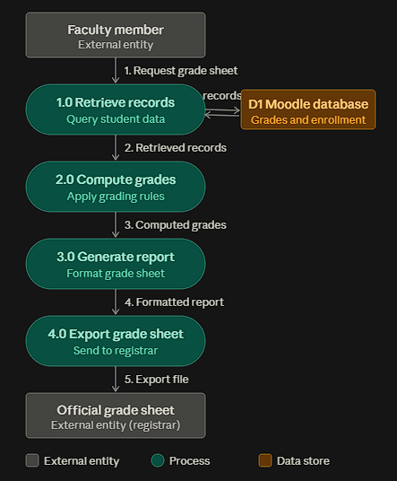

Figure 3.1. Proposed Data Flow Diagram of the Moodle Grade Sheet Plugin
Flowchart
A flowchart is a diagram that depicts a process, system, or computer algorithm. While the data flow diagram illustrates how data moves through the system, the flowchart will detail the specific sequential operations and logical conditions executed by the plugin.
The system workflow will begin with the retrieval and normalization of grading data from the Moodle gradebook. The system will then process the records by mapping individual grade items to their respective grading periods and categories. Following this, the workflow applies defined category percentage weights to mapped assessment items. Assessment items that have not been explicitly mapped to a grading category are safely excluded from the period computation and flagged with an on-screen warning banner to prevent grade inflation or distortion. A critical step in the process involves the validation of grading data and the evaluation of weight totals; the system will verify that the defined weights sum to exactly one hundred percent. If this validation fails, the workflow will intentionally block the printing and exporting functions to prevent the generation of inconsistent or invalid report outputs. Upon successful validation and transmutation scaling, the system will finalize the workflow by generating identical report outputs across the supported on-screen preview, PDF, and Excel formats.
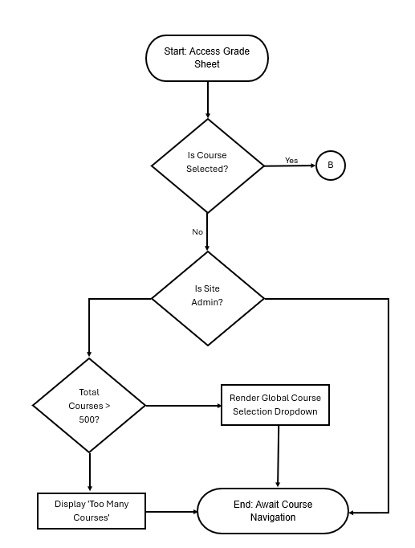
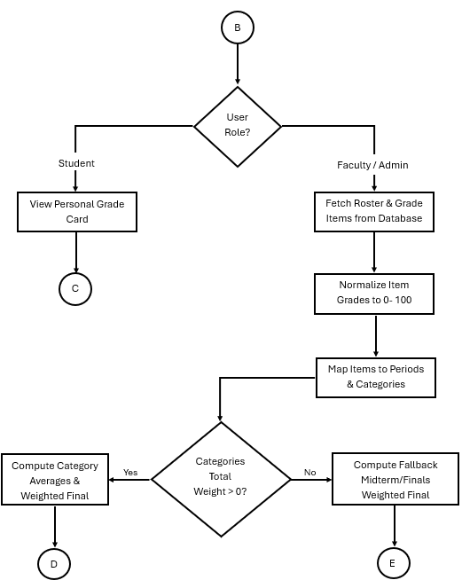
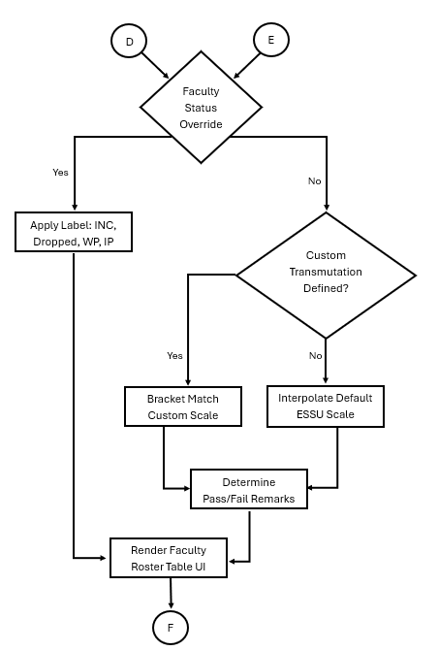
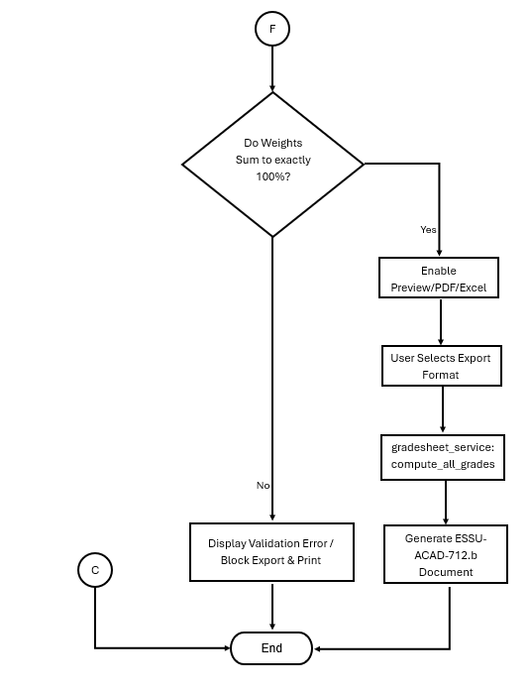
Figure 3.2. Gradesheet Plugin Flow Chart

Database
A database is an organized collection of data that stores, manages, and retrieves information. For this project, the proposed system will operate as a local plugin within the Moodle database environment. The plugin will utilize Moodle's underlying database management system, such as MySQL or MariaDB, and interact with it through Moodle's built-in database abstraction and application programming interfaces. The database schema, consisting of custom tables for course configuration, grading categories, item mapping, custom transmutations, and student academic statuses, will be defined and managed using Moodle's XMLDB mechanisms to ensure proper installation, version upgrades, and structural integration within the existing learning management system.

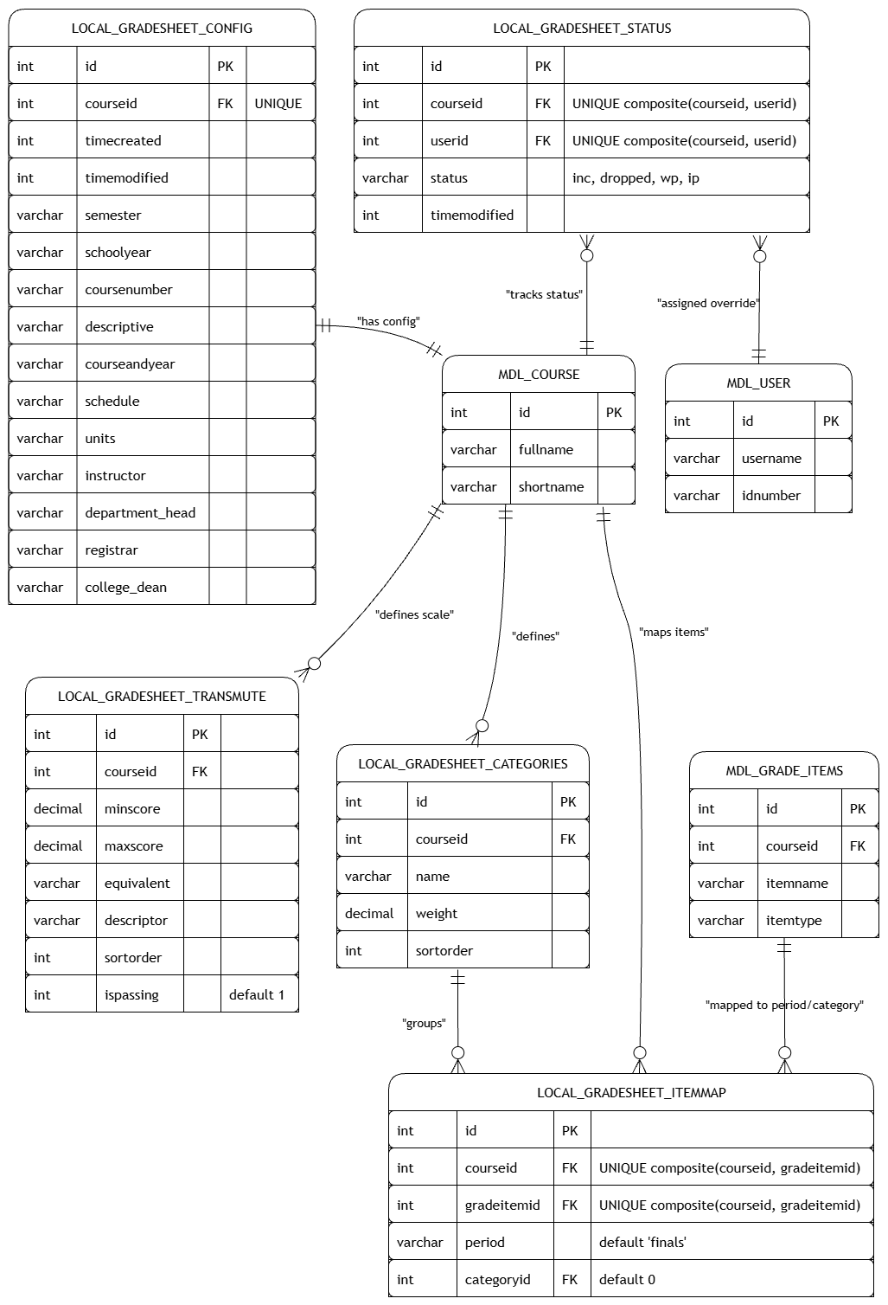
Figure 3.3. Gradesheet Plugin Database Schema
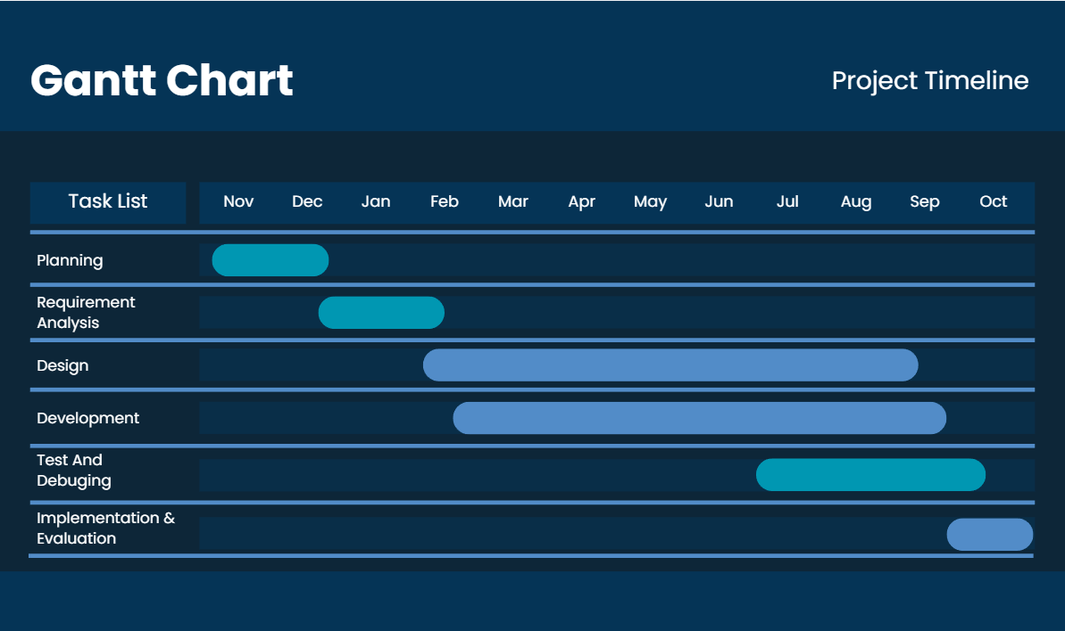
Gantt Chart

Figure 3.4 outlines the proposed project schedule, detailing the specific duration and sequence of activities spanning requirements gathering, system design, prototyping, testing, and final evaluation. This timeline ensures that all software development life cycle phases are completed within the allotted academic term.
This figure shows the schedule of each phase throughout the development of
the system.

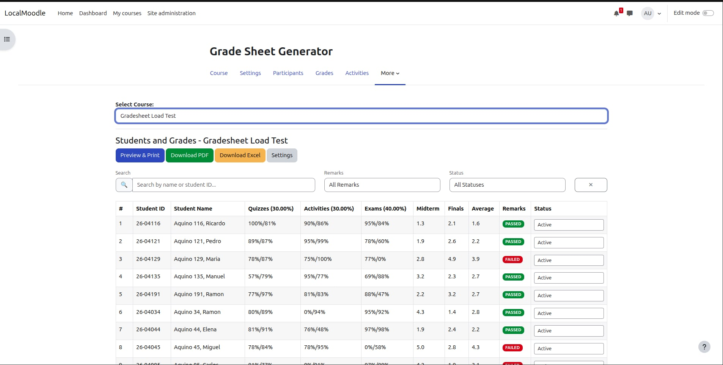
UI Mockup

Figure 3.5 presents the initial wireframe for the Faculty Dashboard, which provides users with a centralized interface for course selection, grade retrieval, and one-click report generation. Figure 3.6 illustrates the proposed output layout, demonstrating how the system will automatically parse and format the retrieved Moodle data to accurately mirror the Registrar's official spreadsheet template.
The figure shows the UI mockup for the Faculty Dashboard. The design will be improved or kept if found sufficient
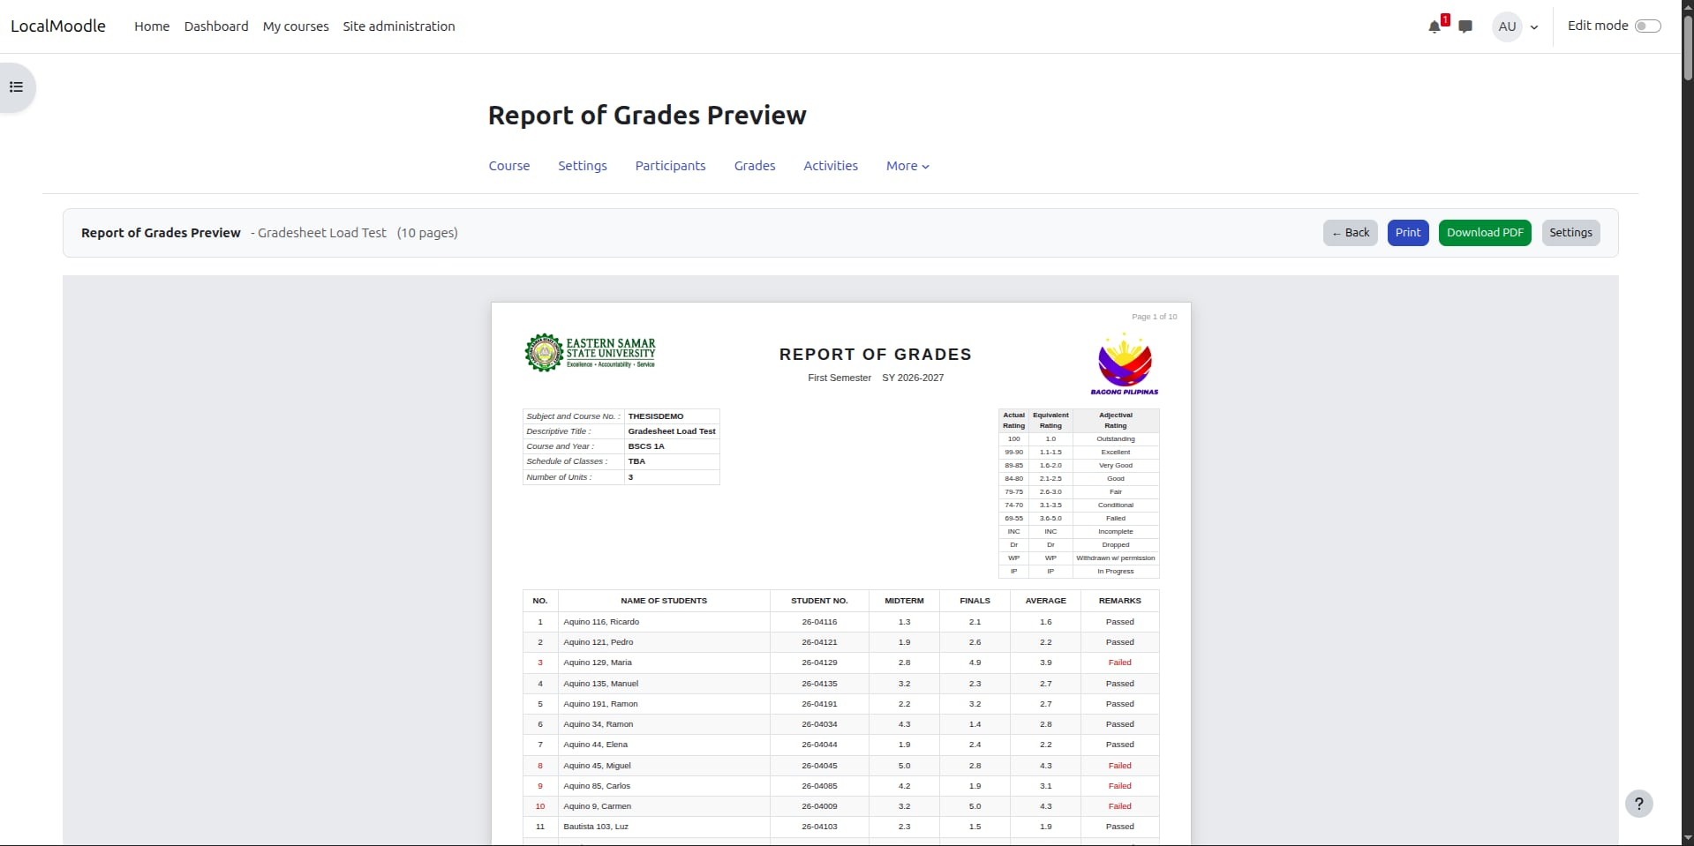
Figure 3.6. Proposed Output Layout of the Automated Grade Sheet
Research Methodology
This shows the methodologies that employed in the study.
Research Design
The study will use a developmental-descriptive research design. It will be developmental because it will involve the design, construction, testing, and evaluation of an Automated Grade Sheet Generation Plugin intended to improve the existing grade-reporting process within Moodle. It will be descriptive because it will gather and describe the system requirements, user expectations, and reporting needs of the target faculty users that will serve as the basis for the architectural design and development of the proposed plugin.
Locale
The study will be conducted at Eastern Samar State University Main Campus, specifically in the College of Computer Studies. This locale will be selected because it is the actual setting in which the identified workflow problem occurs and because the intended users of the proposed system are located in this academic unit.
The locale will be appropriate for the study because the proposed plugin is not intended as a purely theoretical prototype. It will be designed for an existing institutional environment in which Moodle is already being used for academic activities and where faculty members still need to prepare grade sheets for official reporting. The local setting will therefore provide both the operational context and the target deployment environment for the proposed plugin.

Respondents and Sampling
The respondents of the study will be the three faculty members of the College of Computer Studies who currently use Moodle for the identified grade-reporting process.
The study will use complete enumeration (total population sampling) because these three identified faculty respondents represent exactly 100% of the target users currently utilizing Moodle for this specific workflow within the selected locale. Because the sample covers the entire actual user base, the feedback gathered will be directly relevant and sufficient for the design and evaluation of the proposed plugin.

Instrumentation
The study will use the following instruments:
- researcher-made survey questionnaire;
- semi-structured interview guide;
- requirements validation checklist; and
- user evaluation form.
To evaluate the completed software, the study will utilize a standardized evaluation questionnaire adapted from the ISO/IEC 25010 Software Quality Model, specifically focusing on functional suitability, usability, and performance efficiency.

Data Gathering Procedure
The researchers will first secure permission from the relevant offices before conducting the study.
The researchers will then conduct survey questionnaires and interviews among the identified faculty respondents to gather the requirements needed for the development of the proposed plugin.
After development, the respondents will evaluate the proposed system in terms of:
- functionality;
- usability; and
- efficiency.

Data Analysis
The researchers will analyze quantitative data gathered from the respondents using descriptive statistics such as:
- frequency count;
- percentage; and
- mean.
Qualitative responses from interviews and open-ended comments will be analyzed using thematic grouping.

CHAPTER IV

PRESENTATION, ANALYSIS, AND INTERPRETATION OF DATA
This chapter presents, analyzes, and interprets the empirical data gathered during the preliminary requirements investigation, the technical architecture of the implemented system, and the framework for software verification. The findings are organized in accordance with the specific objectives of the study: (1) requirements analysis of the existing faculty grading workflow, (2) system architecture and implementation of the automated grade sheet plugin modules, (3) technical verification and testing design, and (4) user acceptance evaluation under the ISO/IEC 25010 Software Quality Model.

4.1 Requirements Analysis and Existing Workflow Findings
To establish the empirical basis and technical requirements for the proposed system, a pre-development baseline survey and semi-structured interviews were conducted among the target faculty users in the College of Computer Studies (CCS) at Eastern Samar State University (ESSU) Main Campus. The respondent group comprises complete enumeration (N = 3), representing 100% of the faculty members who actively utilize the Moodle Learning Management System for student grading within the academic unit.

Profile and Baseline Grade-Reporting Practices
The operational context and current workflow methods utilized by the faculty respondents are summarized in Table 4.1.

Table 4.1: Demographic and Operational Profile of Faculty Respondents (N = 3)
Profile Variable | Category / Option | Frequency (f) | Percentage (%)
Department / College | College of Computer Studies (CCS) | 3 | 100.00%
Average Class Size | 26–40 students | 1 | 33.33%
 | 41–55 students | 0 | 0.00%
 | 56+ students | 2 | 66.67%
Current Workflow Method | Exporting CSV from Moodle & copy-pasting into a template | 3 | 100.00%
 | Manual typing (looking at Moodle & encoding into Excel) | 0 | 0.00%
 | Using personalized Excel macros/formulas | 0 | 0.00%
Time Spent per Semester | Less than 2 hours | 0 | 0.00%
(Reformatting & Data Cleaning) | 3–5 hours | 1 | 33.33%
 | 6–10 hours | 2 | 66.67%
 | 10+ hours | 0 | 0.00%

As shown in Table 4.1, 66.67% (n = 2) of the instructors handle large class sizes exceeding 56 students per section, while 33.33% (n = 1) manage sections with 26 to 40 students. All three respondents (100.00%) currently generate official grade reports by exporting raw CSV gradebook files from Moodle and manually copying, splitting, and pasting values into offline spreadsheet templates. Consequently, 66.67% of the faculty spend between 6 to 10 hours per semester purely on data extraction, row re-alignment, and formatting adjustments, with the remaining 33.33% spending 3 to 5 hours. Across the department, this manual bridging process consumes substantial academic work hours that are detached from instruction.

Assessment of Workflow Pain Points and Clerical Vulnerability
The preliminary survey assessed the specific operational friction and risks associated with manual spreadsheet processing using a 5-point Likert scale ranging from 1 (Strongly Disagree) to 5 (Strongly Agree).

Table 4.2: Faculty Assessment of Baseline Workflow Pain Points (N = 3)

Indicator Statement | Evaluator Ratings (n1​,n2​,n3​) | Weighted Mean (xˉ) | Adjectival Rating
1. I find the process of manual data entry/reformatting tedious and prone to error. | 5, 5, 5 | 5.00 | Strongly Agree
2. I have experienced "encoding fatigue" when handling large class sections. | 5, 5, 5 | 5.00 | Strongly Agree
3. I have had to double-check or redo grades due to clerical errors during transfer. | 4, 5, 5 | 4.67 | Strongly Agree
Composite Baseline Mean |  | 4.89 | Strongly Agree

The data in Table 4.2 demonstrate significant workflow dissatisfaction under the manual method, yielding an overall composite mean of 4.89 (Strongly Agree). Statements 1 and 2 attained unanimous maximum scores of 5.00 (x̄ = 5.00), showing that all instructors experience severe encoding fatigue and view offline data reformatting as inherently tedious and vulnerable to human error.
Furthermore, Statement 3 obtained a mean of 4.67 (x̄ = 4.67, Strongly Agree), indicating that instructors routinely find themselves double-checking or recalculating grade sheets to correct clerical anomalies introduced during external spreadsheet consolidation. This aligns with Guskey (2015), who highlighted that administrative grade processing external to learning environments creates recurring clerical vulnerabilities.

Proposed Feature Prioritization
Faculty respondents were asked to rate the perceived utility of an automated "one-click" Moodle grading plugin and prioritize key functional features.

Variable / Indicator | Category / Feature | Frequency (f) | Percentage (%)
Perceived Plugin Helpfulness | Extremely Helpful | 3 | 100.00%
 | Moderately Helpful | 0 | 0.00%
 | Neutral / Not Necessary | 0 | 0.00%
Prioritized Feature Demand | Automated Transmutation (Raw Scores to 1.0–5.0 / 75–100) | 3 | 100.00%
(Multiple Choices Allowed) | Automatic Alphabetical Roster & Student ID Placement | 2 | 66.67%
 | Direct "Ready-to-Print" Official Headers & Footers | 2 | 66.67%
 | Summary of Pass/Fail Class Statistics | 2 | 66.67%
Table 4.3: Perceived Utility and Desired System Features (N = 3)Table 4.3 confirms a 100.00% consensus (n = 3) that an integrated Moodle plugin would be "Extremely Helpful" for faculty operations. In terms of system capabilities, Automated Transmutation was identified as the highest-priority requirement (100.00%), followed by automated alphabetical student demographic alignment (66.67%), ready-to-print official institutional layouts (66.67%), and pass/fail summary metrics (66.67%). These baseline empirical findings directly governed the architectural scope and user interface specifications of the developed software.

4.2 System Architecture and Implemented Modules
To address the documented requirements, the local_gradesheet plugin was constructed following a "thin-controller and thick-service" modular design pattern. Presentation controllers (index.php, course_settings.php, preview.php, export.php, export_excel.php) delegate all mathematical computations, grade extraction, transmutation scaling, and validation rules to centralized service classes (classes/gradesheet_service.php and classes/helper.php). This guarantees computational parity: identical algorithms govern the HTML screen preview, the generated PDF, and the exported Excel spreadsheet.
1. Course Selection and Grade Overview Roster (index.php)
This module serves as the primary faculty dashboard. Upon accessing a course, instructors are presented with the class roster extracted directly from Moodle core tables (mdl_user and enrollment contexts). The module automatically organizes students alphabetically by surname, displays computed midterm and final percentages, transmutated grades, and includes an administrative status selector.

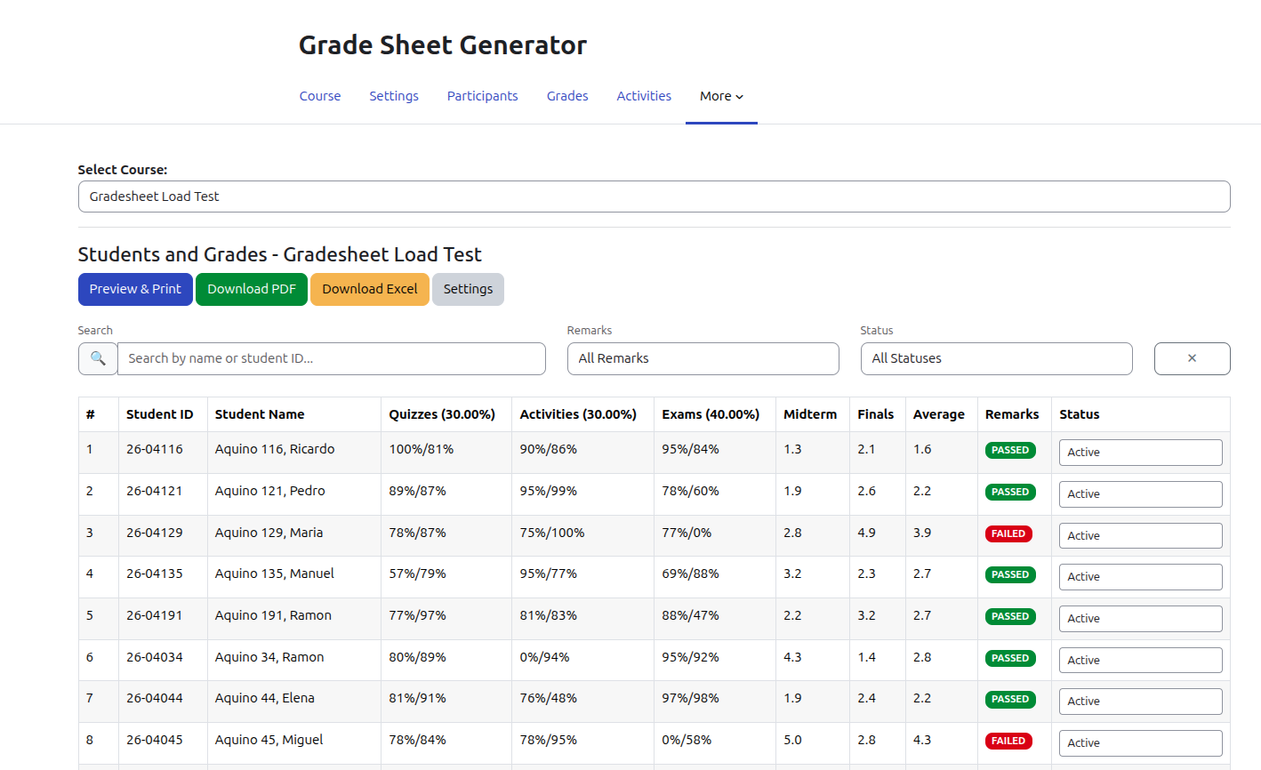

Figure 4.1. Course Roster and Grade Overview Interface(index.php)
2. Course Settings and Assessment Mapping (course_settings.php)
This interface enables instructors to configure course-specific reporting parameters and institutional signatories. Through dynamic form components, faculty map native Moodle gradebook items (mdl_grade_items) into distinct academic grading categories (e.g., Quizzes, Laboratory Tasks, Major Examinations) and assign percentage weights. It also allows instructors to select or define custom transmutation scales stored in local_gradesheet_transmute

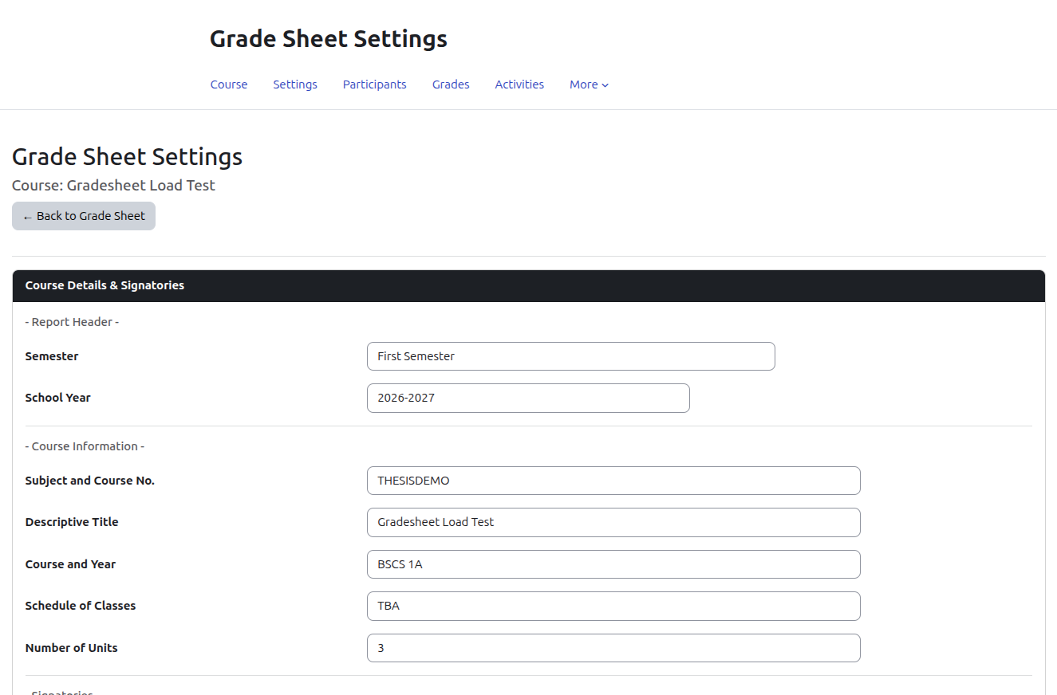
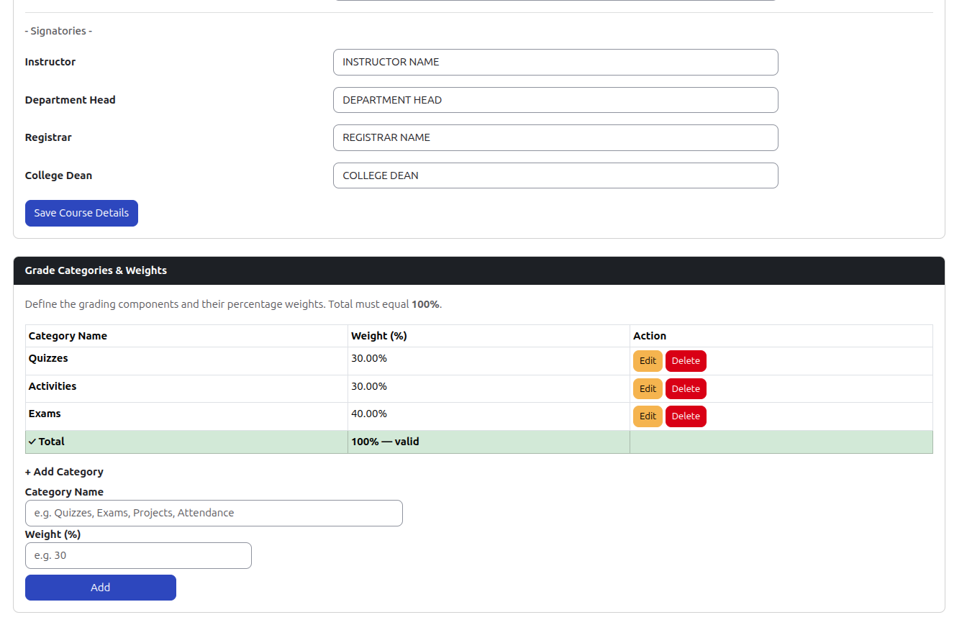
Figure 4.2. Course Details and Signatures and Grade categories and Weights (course_settings.php)

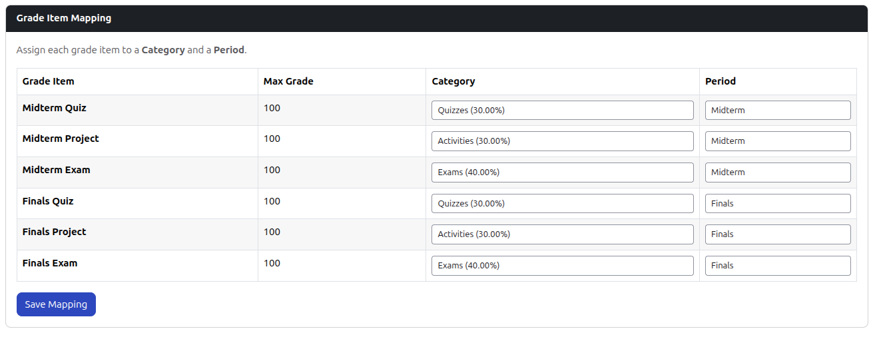
Figure 4.3. Grade Item Mapping (course_settings.php)
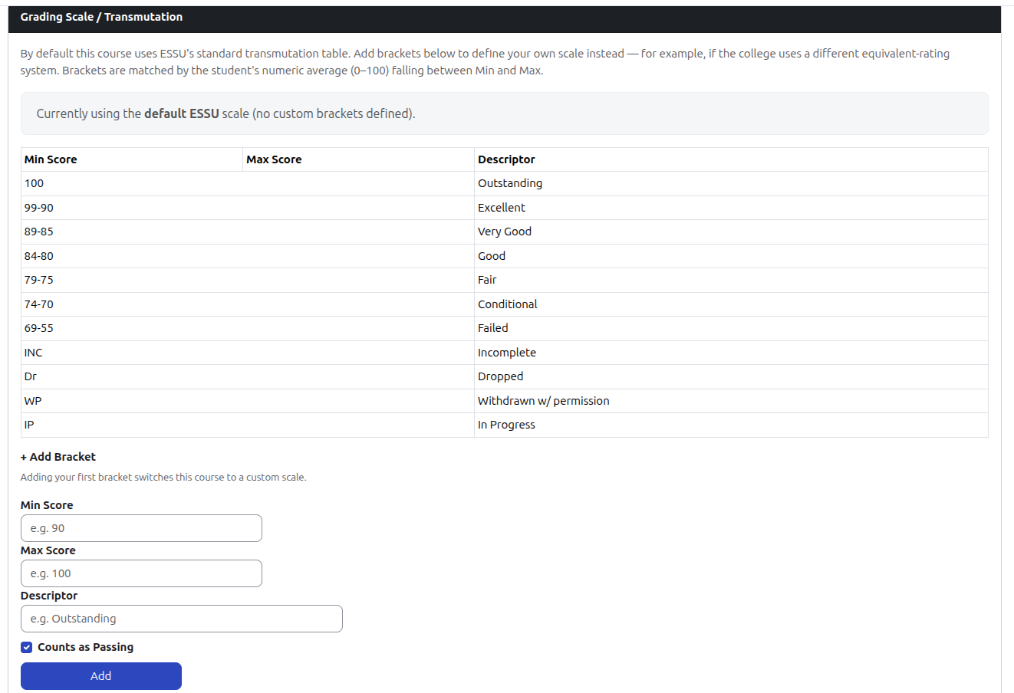
Figure 4.4. Grading Scale (course_settings.php)

3. Institutional Print-Ready On-Screen Preview (preview.php)
The preview controller renders the extracted and computed grades directly in browser HTML formatted to ESSU-ACAD-712.b Version 5 standards. It paginates records into exactly 20 student rows per page, displays official institution logos (essu-header.png and bagong-pilipinas.png), injects registrar rating legends, and formats formal signature lines (Instructor, Department Head, College Dean, and University Registrar). To guarantee output integrity, the preview controller enforces a hard validation gate: if category weights do not sum to exactly 100%, the system blocks rendering entirely and displays an error banner directing the faculty member to Settings.
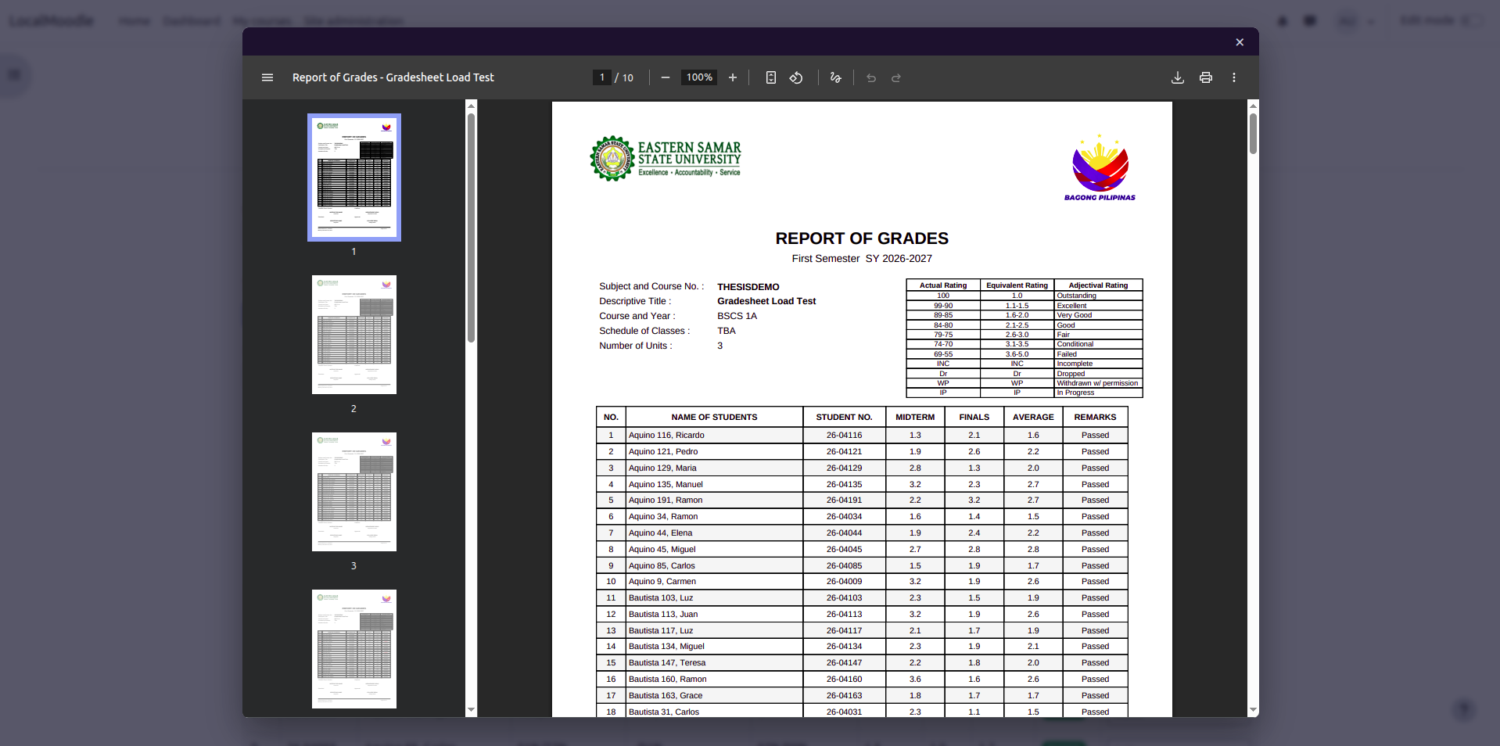
Figure 4.5. On-Screen Registrar-Aligned Print Preview (preview.php)
4. Registrar Export Engines (export.php and export_excel.php)
The export modules allow faculty to generate publication-grade official grade sheets with a single click. The PDF generator (export.php) utilizes TCPDF to compile vector-precise documents that match university registrar forms, automatically placing the institutional marker *** Nothing Follows *** beneath the final enrolled student. The spreadsheet engine (export_excel.php) utilizes PhpSpreadsheet to produce structured Microsoft Excel files. Grade values are computed server-side by the shared service layer and written as final, pre-calculated values rather than live spreadsheet formulas, ensuring the exported figures cannot diverge from the on-screen preview or PDF output. Institutional styling — fonts, borders, fills, and column layout - is applied to match the Registrar's template.

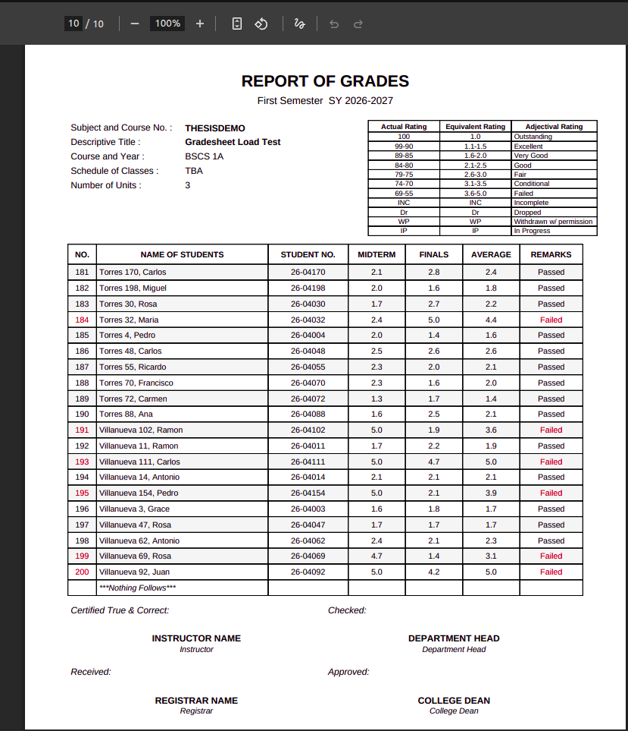
Figure 4.6. Official Registrar Export Outputs (PDF Formats)

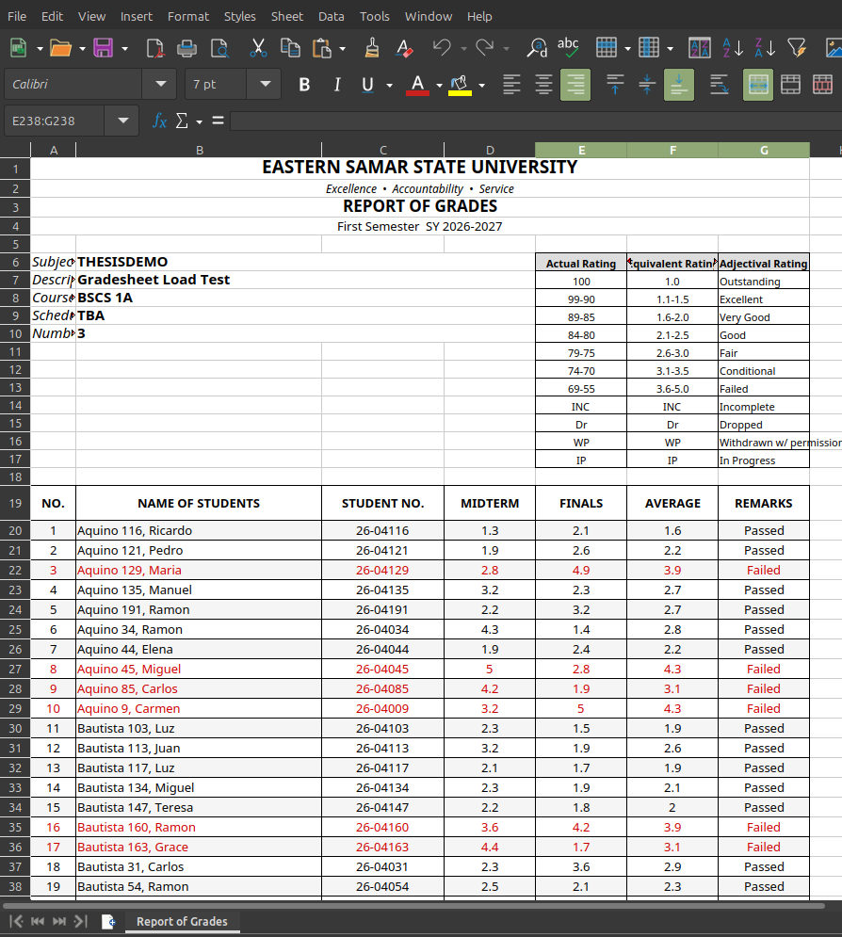
Figure 4.7. Official Registrar Export Outputs (Excel Formats)

5. Student Personal Grade Card
In compliance with the project's educational objectives, students enrolled in the course are provided a dedicated, read-only view of their individual academic performance. Accessed via the course navigation, this interface displays period marks (Midterm and Finals), overall computed averages, transmutated ratings, and remarks without exposing class rosters or peer records.
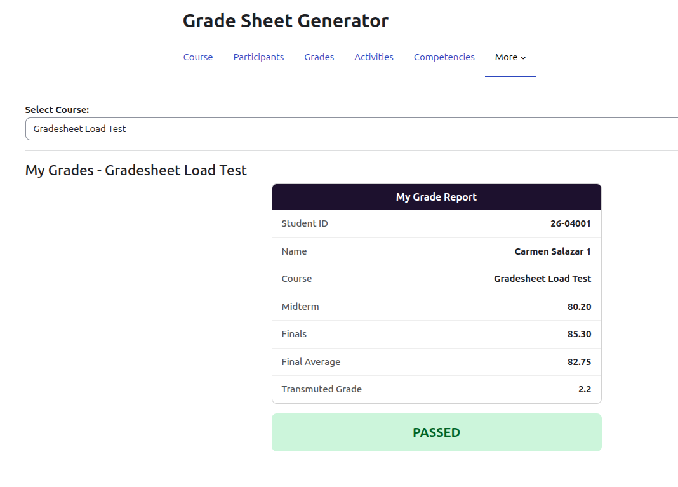
Figure 4.8. Student Personal Grade Card View

Database Schema and XMLDB Integration
The plugin persists configuration data using five relational tables registered through Moodle’s XMLDB layer (db/install.xml), maintaining referential integrity with Moodle core without modifying native schemas:
- local_gradesheet_config: Stores course-specific report metadata, descriptive titles, academic terms, and authorized institutional signatories.
- local_gradesheet_categories: Stores dynamic category definitions, display names, and assigned percentage weights.
- local_gradesheet_itemmap: Acts as a junction table linking native Moodle grade items (gradeitemid) to specific grading periods and categories.
- local_gradesheet_transmute: Defines transmutation boundary brackets, minimum/maximum raw percentage thresholds, equivalent grade points (1.0–5.0), and passing indicators.
- local_gradesheet_status: Tracks student-specific academic status overrides (e.g., Incomplete, Dropped, Withdrawn).
Built-in Security and Architectural Controls
To safeguard academic integrity, guarantee platform stability, and ensure non-intrusive LMS integration, the codebase incorporates several production-grade security mechanisms and architectural hooks:
- Access Control and Group Isolation (SEPARATEGROUPS Mode): The plugin strictly enforces Moodle capability checks (local/gradesheet:view, manage) across all controller endpoints. For courses configured in SEPARATEGROUPS mode, the helper method check_group_access() validates URL request parameters (?group=id) against groups_is_member(). If an instructor attempts unauthorized cross-section access via URL parameter manipulation, the request is intercepted, blocked, and redirected with an error notification.
- Native Moodle Course Form Hook (classes/hooks.php): The plugin integrates into Moodle core navigation via form injection hooks (callbacks/course_edit_form). Instead of requiring instructors to navigate to separate configuration menus, official report metadata and signatory fields (Instructor, Department Head, College Dean, and Registrar) are injected directly into Moodle’s native course settings screen (/course/edit.php), allowing automated persistence alongside standard course metadata.
- Gradebook Visibility Synchronization Lock ($course->showgrades): In index.php, the system queries the core course configuration parameter $course->showgrades. If an administrator or instructor sets gradebook display to hidden (showgrades = 0), student access to their personal grade card is automatically suspended, preserving institutional grade publication embargoes.
- Numerical Data Whitelist Filtering: During grade extraction in helper.php (prefetch_course_grades), database queries explicitly filter for gradetype = 1 (numerical grades). Qualitative letter scales, textual ratings, and feedback categories in the Moodle gradebook are discarded, preventing non-numeric data types from corrupting arithmetic averages and transmutation algorithms.
- Failsafe Weight Sum Validation Gate: The service method validate_weight_sum() verifies that assigned category percentage weights total exactly 100.0% (±0.01 tolerance). If weights are incomplete or exceed 100%, action buttons for print previews and document exports are disabled, and a warning banner is rendered to prevent invalid report publication.

References
International Organization for Standardization. (2011). Systems and software engineering — Systems and software Quality Requirements and Evaluation (SQuaRE) — System and software quality models (ISO/IEC 25010:2011).
Bates, A. W. (2015). Teaching in a digital age: Guidelines for designing teaching and learning. BCcampus.
Guskey, T. R. (2015). On your mark: Challenging the conventions of grading and reporting. Solution Tree Press.
Beatty, B. J., & Ulasewicz, C. (2006). Faculty perspectives on moving from Blackboard to the Moodle learning management system. *TechTrends, 50*(4), 36–45.
Coates, H., James, R., & Baldwin, G. (2005). A critical examination of the effects of learning management systems on university teaching and learning. *Tertiary Education and Management, 11*(1), 19–36. doi:10.1080/13583883.2005.9967137
Costa, C., Alvelos, H., & Teixeira, L. (2012). The use of Moodle e-learning platform: A study in a Portuguese university. *Procedia Technology, 5*, 334–343. doi:10.1016/j.protcy.2012.09.037
Davis, F. D. (1989). Perceived usefulness, perceived ease of use, and user acceptance of information technology. *MIS Quarterly, 13*(3), 319–340. doi:10.2307/249008
Dougiamas, M., & Taylor, P. C. (2003). Moodle: Using learning communities to create an open source course management system. In *Proceedings of EdMedia: World Conference on Educational Media and Technology* (pp. 171–178). Association for the Advancement of Computing in Education.
Miguel, J. P., Mauricio, D., & Rodríguez, G. (2014). A review of software quality models for the evaluation of software products. International Journal of Software Engineering & Applications, 5(6), 31-53.
Henderson, M., Selwyn, N., & Aston, R. (2017). What works and why? Student perceptions of useful digital technology in university teaching and learning. *Studies in Higher Education, 42*(8), 1567–1579. doi:10.1080/03075079.2015.1007946
Lonn, S., & Teasley, S. D. (2009). Saving time or innovating practice: Investigating perceptions and uses of learning management systems among faculty. *Computers & Education, 53*(3), 686–694. doi:10.1016/j.compedu.2009.04.008
Moodle Pty Ltd. (2025a). Gradebook. Moodle Documentation.
Moodle Pty Ltd. (2025b). Grades. Moodle Documentation.
Moodle Pty Ltd. (2025c). Import and export grades. Moodle Documentation.
Moodle Pty Ltd. (2025d). Plugin types. Moodle Developer Resources.
UNESCO. (2023). *Global education monitoring report 2023: Technology in education: A tool on whose terms?* UNESCO Publishing.
Sommerville, I. (2015). Software engineering (10th ed.). Pearson.
Welling, L., & Thomson, L. (2016). PHP and MySQL Web development (5th ed.). Addison-Wesley Professional.

DEVELOPMENT OF AN AUTOMATED GRADE SHEET GENERATION PLUGIN FOR THE MOODLE LEARNING MANAGEMENT SYSTEM FOR FACULTY GRADE REPORTING
An Undergraduate Thesis
Presented to the Faculty of the
COMPUTER STUDIES DEPARTMENT
College of Computer Studies
Eastern Samar State University
Borongan City, Eastern Samar
In Partial Fulfillment of the Course Requirement for the Degree
BACHELOR OF SCIENCE IN COMPUTER SCIENCE
Montes, Gabriel A.
Aseo, Davon Argel B.
Afable, Warren C.

