Davon Grant

CIS453 – HW #2

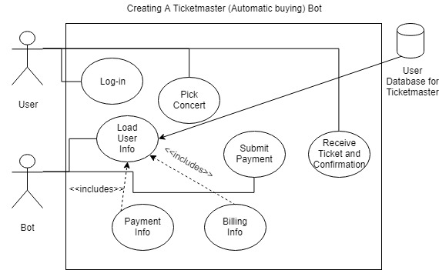

Use-Case Descriptions:

Name: Load User Info

ID: 1

Importance Level: High

Primary Actor: Bot

Use-Case Type: Essential

Stakeholders and Interests: User – Allows the user to instantly buy tickets through preloading their information into the bot so that the bot can confirm the purchase

Description: The user’s payment (credit card) information and their billing information are automatically input into the system so that the bot can automatically confirm the purchase of the tickets.

Type: Internal

Relationships:

Association: User

Include: Payment info, billing info

Extend: None

Generalization: None

Normal flow of events: User logins to Ticketmaster, chooses the concert he wishes to attend, then the bot automatically fills out all the prompts with the user’s necessary information to instantaneously buy the tickets

Sub-flows: None

Alternate/Exceptional Flows: If the system crashes, the bot will not be able to follow through with the purchase

Name: Pick Concert

ID: 2

Importance Level: High

Primary Actor: User

Use-Case Type: Essential

Stakeholders and Interests: Bot – Gives the bot the redirection to the right page so they can input the information for the user in and buy the tickets for the desired concert

Description: The user chooses from a selection of concerts and picks the one they want to attend and leads the bot to the correct page to input the information for the user.

Type: Internal

Relationships:

Association: Bot

Include: None

Extend: None

Generalization: None

Normal flow of events: User logins to Ticketmaster, chooses the concert they’d like to attend from a generated list of upcoming events

Sub-flows: None

Alternate/Exceptional Flows: If the concert is already sold out or the event already happened, it won’t let the user choose it for the bot to buy tickets for.