

**Student name: Davide Jarik De Rosa**

**Matriculation number: 234009**

**Exam date: 03/10/2023**

**Professor: Castelli Dezza Francesco**

Induction Machine: electrical drive for an air compressor

­­­

Electrical machine and drives (2022-2023)

# 1 - Abstract

The aim of this report is to show an application of Field Oriented Control. We consider the air treatment system of a blast furnace based on a centrifugal compressor driven by an induction motor.

In this project, we first simulate the IM without load at nominal voltage in order to evaluate the starting transient. Then we design and simulate speed, current and flux control to cover the given fluid demand at least one decade faster than the intrinsical characteristic of the uncontrolled system.

# 2 - Load and Machine characteristics



The load has the following characteristics:

The compressor is coupled to the IM with a gearbox

The equivalent inertia seen from the motor side is

Friction effect

The compressor behaviour sees a load torque proportional to the square of the shaft speed as where

FIGURE 1: CENTRIFUGAL COMPRESSOR

# 3 – First question: evaluate the parameters

The induction motor has the following characteristics:

Type: Asynchronous

Initial parameters:

Further parameters:

We are asked to simulate the IM without load at nominal voltage to evaluate the starting transient by figuring out:

• stator  and rotor current

• torque vs speed

• position of and in the reference frame

Figure 2: Induction Motor in no-load test

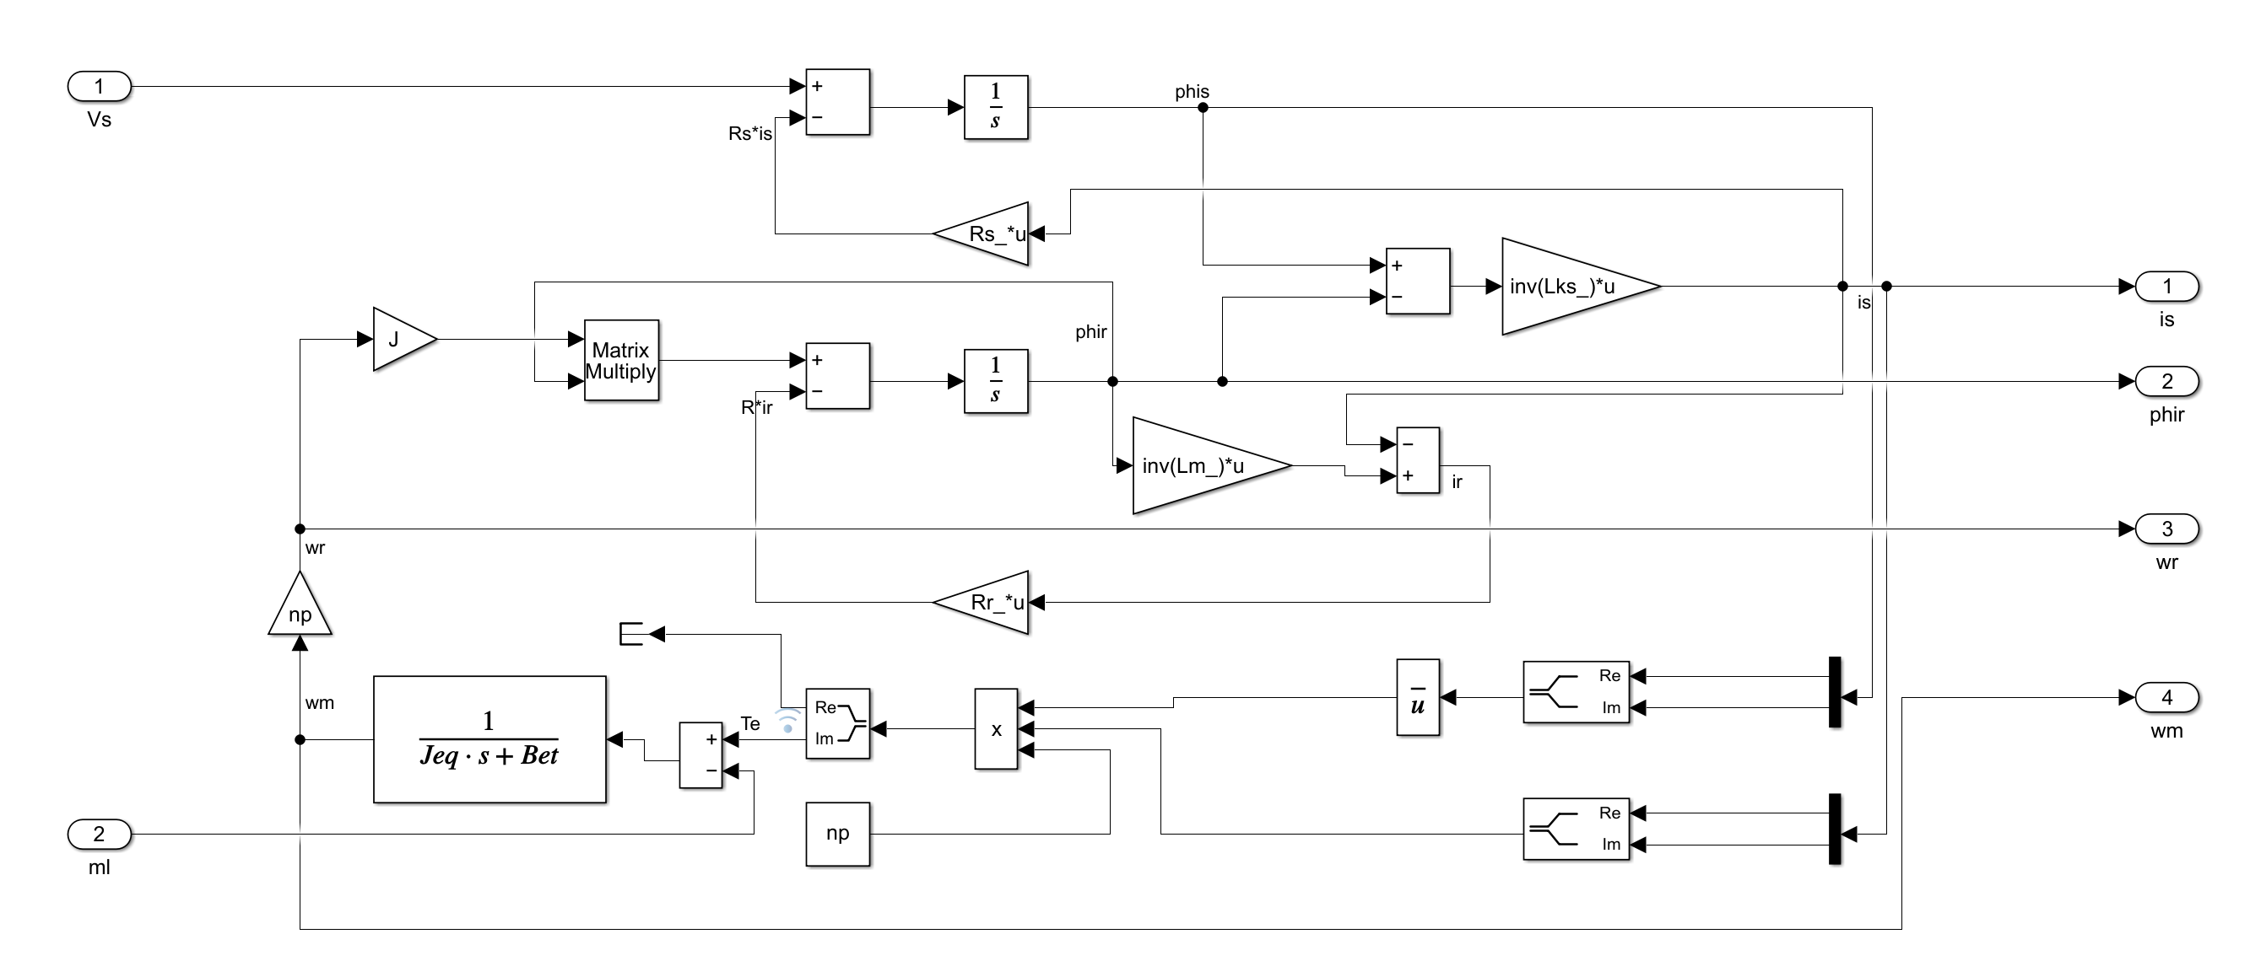

Figure 3: Induction Motor in Alpha Beta reference frame

# 3.1 – The theory of IM

We first have to the induction machine model to find a simpler one. Obviously, we will not enter into the details, and we will not specify every single step performed, we will focus on the results needed for the Matlab/Simulink model.

We first write the dynamic equation of the induction machine, with 3 stator and 3 rotor equations. We consider the isotropic structure of the rotor (no dependency of the self and mutual inductance on the mechanical angle), the sum of the currents is always zero (delta or star connection) and the conservativity of the system to simplify the equations. Then we apply the space phasor transformation and change the coordinates to the reference system:

Starting from the 5 parameters model. If we apply a rotation of we move the system the system to a generic reference frame , where the d axis is fixed with the rotor flux. By means of an ideal transformer we reduce the 5 parameters model to 4 parameters model:

# A graph of a function Description automatically generated with medium confidence3.2 – PID turning

Figure 4: from left to right, bode diagram of the loop transfer function of current, rotor flux and speed

I computed all regulators to cancel the system poles and choose a desired bandwidth. The three regulators are PI. The PI regulators for current and flux cancels the system poles, this guarantees a phase margin of 90°. Furthermore, since time constants of the currents are same, there was no need to design 2 different regulators. The time responses, in close loop, were chosen to be 10 times faster than the system in open loop.

# 3.2 – The simulation

After this short theorical introduction we can perform on Matlab a no-load test on the machine applying . To implement the no-load test, we apply directly on the dynamic model of the system without control unit. The simulation time is 5 seconds. We will describe just the important results.

Figure 5: Stator currents

The direct and quadrature currents converge to the nominal values after a small transient. The direct current converges to and the quadrature current to . Those values will be used to saturate the currents requested by the PI regulators.

We can set:

Figure 6: TORQUE-VELOCITY PLOT

The oscillations of the torque are significative for low speed. The speed of the stator flux is high wrt the speed of the rotor flux, so the torque changes fast. For high speed the torque goes to zero and there will be in a constant speed since there is no rotational force applied to the rotor. With no load, the torque after some time of fluxing transient goes to zero and the speed reaches the base value (approximately 104.5 rad/sec).

Figure 7: Rotor flux space phasor at nominal supply with no load

# 4 – Second question: speed, current and flux control

We are asked to design and simulate speed, current and flux control to cover the given fluid demand at least one decade faster than the intrinsical characteristic of the uncontrolled system. The speed control is made by F.O.C method.

# 4.1 – Estimators

We need to estimate some non-measurable system states. I implemented both V-I and Ω-I estimator.

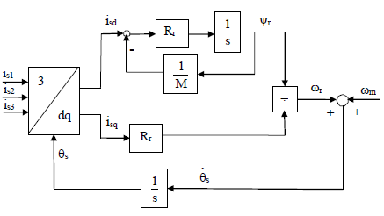

Figure 9: Ω-I ESTIMATOR

Figure 8: V-I ESTIMATOR

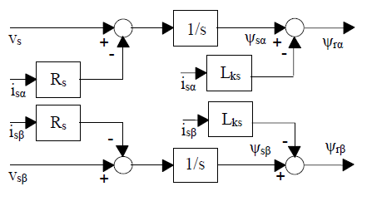

With a good “” estimation I was able to decouple the direct and quadrature currents dynamics. Adding two other compensations I obtained the right conditions to project independent regulators for “” and “”.

In this control scheme, I assumed that the voltage refences are being followed without any dynamics by the inverter. Probably it would be more realistic adding an inverter, driven by SVM algorithm, and simulate its dynamics. Under the hypothesis that the problem requires very low velocities I avoided implementing it.

# 4.2 – Operating Regions

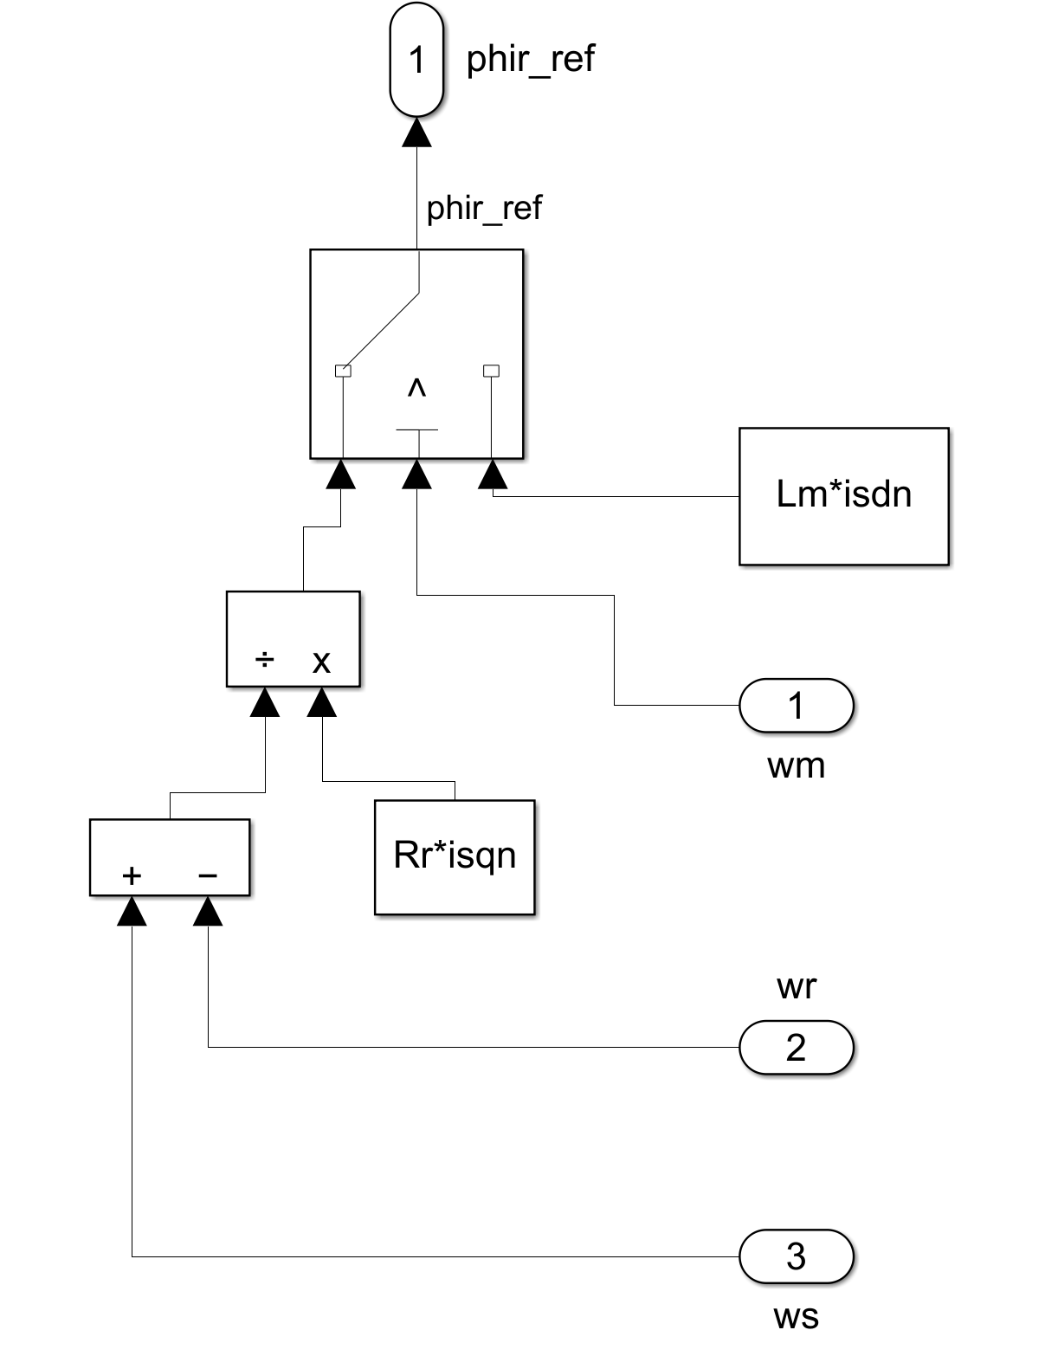

In RFOC, as in many machines, the rotor flux reference depends on the mechanical speed. Before the base speed it will be set to its nominal value to guarantee a correct usage of the ferromagnetic material. Above the base speed it will decrease. I had to put a switch to make a comparison between base speed and motor speed to recognize the difference between constant power region and constant torque region.



Figure 10: Switch used for selecting operating region

# 4.4 – Simulations

Figure 11: Control scheme and Dynamic model of the IM

The time considered for this simulation is 55 seconds. In the first graph we can see and

Figure 12: the actual speed and the reference speed

The speed reference is followed correctly. We can appreciate a small overshoot, I assumed that it can be accepted the compressor system.

For what concerns the current:

Figure 13: the isa current over time

Figure 14: the voltage vsa over time

I decided to display one real stator current instead of to visualize just one current, the amplitude we get is the same. As we may appreciate the stator current saturate to the maximum value almost immediately, thanks to the high bandwidth of the controllers. We notice that if the velocity goes up the voltage does the same.

Finally, for what concerns the torque:

Figure 15: the motor torque over time

As we know from theory, total motor torque is the sum of internal friction, the external load and the inertia terms. Due to the load characteristic, it increases with a quadratic shape while the speed reference is increasing linearly in time. We can appreciate some spikes, caused by the overshoots introduced by the regulator.