

User Manual

Storyline

Follow the adventures of Peety the Beefy as he battles his arch enemy, Matty the Meaty, in this 2D platform shooter. Use power-ups to conquer and explore 12 unique levels (currently 2) and discover the truth of David’s reality.

Controls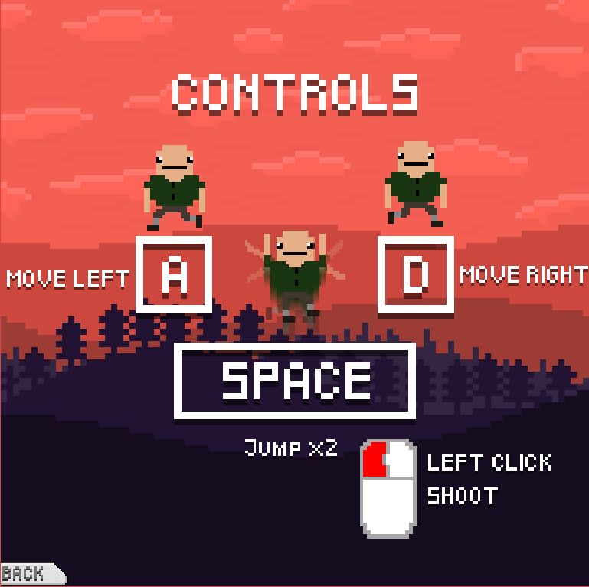

A - Move Left

D - Mover Right

Space - Jump (x2)

Left Click - Shoot

Mouse - Aim

**This is Peety the Beefy.**

As Peety, use your incredible brawn and beefy figure to defeat Matty the Meaty, but be warned; Matty does not skip leg day. After clearing a wave, you may proceed to the next level, encountering new enemies as you progress



This is your health and ammo in your water gun (Matty is deathly allergic to water). Use your water wisely because you only have 4 pellets, but you can pick them up off the ground after you shoot them

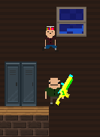

Be Careful!

If Matty the Meaty Jumps on your head with his meaty thighs, you will lose a life! You only have 4 lives before you get suspended from school and have to retry the level.

Matty requires 2 water pellets to be defeated so try and shoot him before he gets to you.

Tip: You can arch your bullets to hit Matty the Meaty!

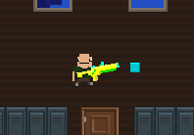

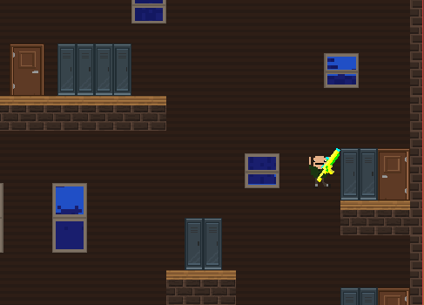

End

At the end of the wave, go to the door on the far right in the middle to progress to the next level



Now you are ready to play the adventure of ***Peety the Beefy!***

Have fun!

