মাতৃNest
The Safe Nest Every Mom and Baby Deserve
A Maternal & Child Healthcare Web Platform

Full Project Report
Academic Project Submission · Business Documentation

Submitted By | Submitted To
Tanjina Akter Nisa (22201086)  Md. Daudul Islam (22201088)  Saswata Ghosal (22201090)  Team Trinity | Jawad Hossain Lecturer Department of CSE University of Asia Pacific

Course Code: CSE 301 · Course Title: Object Oriented Programming II: Visual and Web Programming
Date of Submission: 2025

Abstract
মাতৃNest is a full-stack web application designed to centralise maternal and child healthcare services in Bangladesh. Built using the Django 5.2 framework (Python 3), the platform addresses a critical gap in the healthcare technology landscape: the fragmentation of services that forces mothers to juggle multiple apps, phone numbers, and paper records during the most demanding period of their lives.
The system provides eight integrated services under two care lines — MamaNest (pregnancy and postpartum) and BabyNest (newborn and early childhood) — covering doctor appointments across five medical specializations, a medicine corner with full CRUD functionality, personal health tracking (blood pressure, weight, glucose), mental wellness support, ambulance booking, an SOS emergency alert, nurse hiring, and user profile management.
The backend implements a three-tier role-based access control (RBAC) system that carefully scopes permissions for three user roles: admin, doctor, and patient. Admins are granted full control including access to the Django admin panel and medicine management; doctors can view the full appointment queue and browse services; patients can book their own appointments, log their own health records, and access all service pages.
The frontend was first developed as a 15-page static HTML/CSS prototype for team approval and then integrated into the Django template system using {% extends %} and {% block %} inheritance, producing a consistent, brand-aligned user interface with a custom CSS design system built around a cream, rose, and sage colour palette.
The project passed a full end-to-end test suite with zero Django system-check errors, all migrations applied cleanly, and all role permissions verified.

Keywords
Django · MVT Architecture · Role-Based Access Control · Maternal Healthcare · Web Application · Python · SQLite · HTML/CSS · Bangladesh Healthcare Technology

Table of Contents
Abstract 2
Table of Contents 3
Chapter 1: Introduction 5
1.1 Objective 5
1.2 Motivation 5
1.3 Critical Challenges 6
1.4 Social and Environmental Impact 6
Chapter 2: Project Description 7
2.1 Description of Project 7
2.2 Proposed Functionalities and Features 7
Core Features (Implemented) 7
Role-Based Feature Access 8
Chapter 3: Project Design 9
3.1 Architecture of the Proposed System 9
Django App Structure 9
3.2 Models 9
CustomUser (users/models.py) 9
Medicine, Appointment, HealthRecord, UserProfile (myapp/models.py) 10
3.3 Views and Role-Based Access Control 10
The @role_required Decorator (myapp/decorators.py) 10
Key View Examples 11
3.4 Templates 11
3.5 ER Diagram 11
Chapter 4: Project Implementation 13
4.1 Tools and Technologies 13
4.2 Frontend Design System 13
4.3 Example Walk-through 14
4.3.1 Homepage and Landing Page 14
4.3.2 Sign Up and Login 14
4.3.3 Patient Dashboard 15
4.3.4 Medicine Corner 15
4.3.5 Appointment Booking 16
4.3.6 Health Tracking 17
4.3.7 Emergency Services 17
4.3.8 User Profile 18
4.3.9 Django Admin Panel 18
Chapter 5: Team Contributions 20
5.1 Team Introduction 20
5.2 Member-wise Task Distribution 20
Chapter 6: Conclusion and Future Work 23
6.1 Conclusion 23
6.2 Limitations 23
6.3 Future Work 24
Phase 2 — Q3–Q4 2026 (Next Sprint) 24
Phase 3 — 2027 (Scale) 24
Chapter 7: CEP Mapping 25
7.1 How K's are Addressed 25
7.2 How P's are Addressed 25
7.3 How A's are Addressed 26
References 28
Appendix A: Setup and Deployment Guide 29
A.1 Prerequisites 29
A.2 Local Development Steps 29
A.3 Testing Role Permissions 29

Chapter 1: Introduction

1.1 Objective
মাতৃNest is a healthcare-focused web application designed to make essential maternal and child health services easily accessible through a unified digital platform. The services include doctor appointments, medicine purchase, personal health tracking, ambulance booking, emergency SOS alerts, mental health care, and nurse hiring.
The primary technical objectives of the project are:
▸ Design and implement a full-stack web application using Django MVT architecture from absolute scratch with no legacy code
▸ Define a clean relational database schema with five core models: CustomUser, UserProfile, Medicine, Appointment, and HealthRecord
▸ Implement a three-role access control system (admin, doctor, patient) enforced at the view layer via a custom @role_required decorator
▸ Develop a consistent frontend design system as a static HTML/CSS prototype first, approved by the team, then integrated into Django templates
▸ Validate the entire system through end-to-end testing of every role's permissions and all 20 URL routes

1.2 Motivation
Bangladesh faces significant challenges in maternal healthcare delivery, particularly in urban centres like Dhaka, where nuclear families increasingly lack the extended-family guidance networks that traditionally supported first-time mothers. Our team identified four specific pain points:

Pain Point | Description
Fragmented access | Trusted doctors, pharmacies, ambulances, and mental health professionals are all accessed through separate channels, placing the coordination burden on the mother.
No personal health record | Vitals such as weight, blood pressure, and blood glucose are written in paper notebooks that are lost, undated, or impossible to share digitally.
Emergency access delays | Booking an ambulance during a pregnancy complication requires multiple stressful phone calls under acute time pressure.
Mental health neglect | Postpartum depression and prenatal anxiety are under-diagnosed because there is no trusted, low-friction channel for mothers to access psychological support from home.

A 47-respondent validation survey conducted during the ideation phase confirmed that emergency access and doctor appointment booking were the two highest-priority features desired by target users.

1.3 Critical Challenges
▸ Role-based access without breaking the user experience — designing one codebase that renders meaningfully different dashboards, nav items, and form states for three distinct roles
▸ Custom email-based authentication — Django's default username-based login required a custom EmailBackend to match modern user expectations
▸ Data privacy enforcement — health records must be blocked at the database query level, not just hidden in the UI
▸ Frontend-first development discipline — building and approving all 15 pages as static HTML before any Django views existed
▸ User trust design — communicating safety and professionalism to first-time mothers unfamiliar with digital health platforms

1.4 Social and Environmental Impact
1. Accessibility — Pregnant women and new mothers in urban Dhaka can book doctors, track vitals, and request emergency services from home.
2. Emergency response — The one-click SOS alert and ambulance booking features reduce the steps required during a time-critical emergency.
3. Mental health de-stigmatisation — A dedicated mental wellness section normalises help-seeking behaviour for perinatal anxiety.
4. Health literacy — The health tracking module gives patients a longitudinal view of their own vitals.
5. Eco-efficiency — Digitising records and bookings reduces paper consumption and unnecessary travel.
6. Economic impact — A subscription and commission revenue model creates income channels for partner doctors, nurses, and pharmacies.

Chapter 2: Project Description

2.1 Description of Project
মাতৃNest offers a centralised, authenticated portal for maternal and child healthcare services in Bangladesh, organised into two named care lines:

MamaNest — Pregnancy & Postpartum Support
Doctor appointments (5 specializations) · Medicine corner · Health tracking (BP, weight, glucose) · Mental wellness sessions · Ambulance booking · SOS emergency alert · Hire a nurse
BabyNest — Newborn & Early-Childhood Care
Baby doctor appointments · Baby medicine corner · Growth & weight tracking · Vaccination schedule reminders · Nursing support · Toy & nutrition guidance

The application is built on a Python 3 / Django 5.2 backend using the Model-View-Template (MVT) pattern. The database layer uses SQLite during development (trivially swappable for PostgreSQL in production). Image uploads are handled via Pillow. The frontend uses Django's template inheritance with a fully custom CSS design system.

2.2 Proposed Functionalities and Features

Core Features (Implemented)
Feature | Description
Authentication | Email-based login (custom EmailBackend), role-selection signup (patient/doctor), logout, auto-created UserProfile via Django signal.
Medicine Corner | Full CRUD: list with search, detail view, add, update, delete. Image upload via Pillow. Write access restricted to admin only.
Appointments | Patients book own appointments (5 specializations). Doctors view the full queue read-only. All appointments are user-scoped.
Health Tracking | Patient-private vitals log: weight, BP, glucose, symptoms, dated entries. Last 10 entries displayed. Strictly scoped to owner.
User Profile | Editable profile (bio, phone, address, profile picture). Auto-created via post_save signal. Role badge displayed.
Ambulance Booking | One-tap call link page with information checklist for emergency dispatch.
Emergency SOS | High-contrast SOS alert page accessible in one click from the dashboard.
Mental Wellness | Three-option wellness page connecting to counsellor booking and mood check-in.
Hire a Nurse | Three service tiers (hourly visit, postpartum care, live-in). All link to appointment booking.

Role-Based Feature Access
Feature / Action | Admin | Doctor | Patient
Browse medicine list | ✔ Yes | ✔ Yes | ✔ Yes
Add / Edit / Delete medicine | ✔ Yes | ✘ No | ✘ No
View ALL appointments | ✔ Yes | ✔ Yes | ✘ No
Book own appointment | ✔ Yes | ✘ No | ✔ Yes
View own health records | ✔ Yes | ✘ No | ✔ Yes
View ALL health records | ✔ Yes | ✘ No | ✘ No
Access ambulance / SOS pages | ✔ Yes | ✔ Yes | ✔ Yes
Access Django /admin/ panel | ✔ Yes | ✘ No | ✘ No
Edit own profile | ✔ Yes | ✔ Yes | ✔ Yes

Chapter 3: Project Design

3.1 Architecture of the Proposed System
মাতৃNest follows Django's Model-View-Template (MVT) architecture, which is Django's adaptation of the classic MVC pattern. The three layers are strictly separated:
▸ Models — define the database schema and relationships. All data access goes through Django's ORM; no raw SQL is written.
▸ Views — contain all business logic. Each view receives an HTTP request, applies role checks, queries the relevant model, and passes context data to a template.
▸ Templates — render the HTML response. Templates never contain logic beyond simple conditionals and loops; all computation happens in views.

Django App Structure
The project is split into two Django applications, fixing the anti-pattern where everything is placed in a single project-level urls.py:

users/
Handles all authentication and identity: CustomUser model, EmailBackend, registration, login, logout, profile views, and UserAdmin configuration.
myapp/
Handles all domain logic: Medicine, Appointment, HealthRecord, UserProfile models; all service views; the @role_required decorator; and admin registrations.

3.2 Models

CustomUser (users/models.py)
The CustomUser model extends Django's AbstractUser to add a user_type field. The email field is made unique to support email-based login. Two helper properties (is_patient, is_doctor) are used in templates without exposing raw database values.

class CustomUser(AbstractUser): USER_TYPE_CHOICES = ( ('patient', 'Patient'), ('doctor', 'Doctor'), ) user_type = models.CharField( max_length=10, choices=USER_TYPE_CHOICES, default='patient' ) email = models.EmailField(unique=True) @property def is_patient(self): return self.user_type == 'patient' @property def is_doctor(self): return self.user_type == 'doctor'

Medicine, Appointment, HealthRecord, UserProfile (myapp/models.py)
Model | Key Fields | Relationship / Notes
Medicine | medicine_name, description, price, image, created_by | ForeignKey(created_by) → CustomUser (nullable, SET_NULL). Image stored in media/medicine_images/.
Appointment | full_name, email, doctor_name, specialization, date, time, reason | ForeignKey(user) → CustomUser (CASCADE). Ordered by -created_at. 5 specialization choices.
HealthRecord | date, weight, blood_pressure, glucose, symptoms | ForeignKey(user) → CustomUser (CASCADE). Ordered by -date. Strictly scoped to owner in views.
UserProfile | bio, phone, address, profile_picture | OneToOneField → CustomUser. Auto-created via post_save signal using get_or_create.

# Auto-create profile on user save @receiver(post_save, sender=settings.AUTH_USER_MODEL) def create_user_profile(sender, instance, created, **kwargs): if created: UserProfile.objects.get_or_create(user=instance)

3.3 Views and Role-Based Access Control

The @role_required Decorator (myapp/decorators.py)
All permission checks are centralised in a single decorator. This means adding a new protected view requires only one annotation line. Admin users (is_staff / is_superuser) always pass through regardless of user_type, meaning the superuser account never needs to be listed in role lists.

def role_required(*roles): def decorator(view_func): @wraps(view_func) @login_required def _wrapped(request, *args, **kwargs): user = request.user # Admins always pass through if user.is_staff or user.is_superuser: return view_func(request, *args, **kwargs) # Block admin-only views if 'admin' in roles and not (user.is_staff or user.is_superuser): messages.error(request, 'Reserved for administrators.') return redirect('home') # Check user_type if getattr(user, 'user_type', None) in roles: return view_func(request, *args, **kwargs) messages.error(request, "You don't have permission.") return redirect('home') return _wrapped return decorator

Key View Examples
# Medicine: admin writes, everyone reads @role_required('admin') def upload_medicine(request): ... # Appointments: role-specific rendering @role_required('patient', 'doctor') def appoint_view(request): if request.user.is_patient: # Show booking form + own appointments only appointments = Appointment.objects.filter(user=request.user) return render(request, 'myapp/appoint.html', {'can_book': True, ...}) # Doctors see full queue, read-only, no form appointments = Appointment.objects.all() return render(request, 'myapp/appoint.html', {'can_book': False, ...}) # Health: strictly patient-private @role_required('patient') def health_view(request): records = HealthRecord.objects.filter(user=request.user)[:10] ...

3.4 Templates
All pages extend a single base.html using Django's template inheritance. The nav bar dynamically shows or hides links based on the logged-in user's role: the Health link is hidden for doctors, the Admin Panel link appears only for staff users, and the Add Medicine button is only rendered for admins.
{% if user.is_patient or not user.is_authenticated %} <a href="{% url 'health' %}">Health</a> {% endif %} {% if user.is_staff or user.is_superuser %} <a href="/admin/">Admin</a> {% endif %}

3.5 ER Diagram
The Entity-Relationship diagram for মাতৃNest models five core database tables and their relationships. All five models are linked to CustomUser as the central entity.

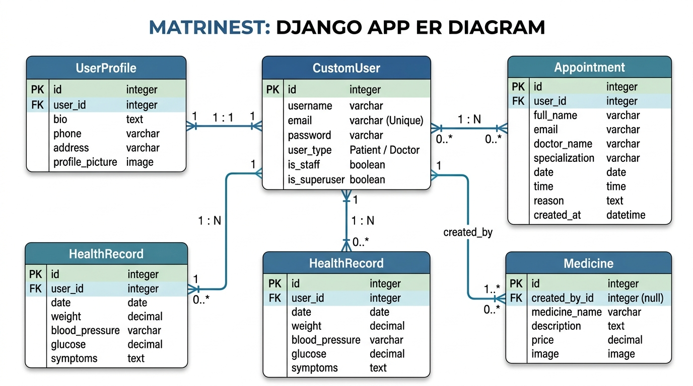
Figure: Entity-Relationship Diagram for মাতৃNest
Entity | PK | Relationships
CustomUser | id | Central entity. All other models reference this via ForeignKey or OneToOneField.
UserProfile | id | OneToOneField → CustomUser (CASCADE). Auto-created on user save via signal.
Medicine | id | ForeignKey(created_by) → CustomUser (nullable, SET_NULL).
Appointment | id | ForeignKey(user) → CustomUser (CASCADE). Ordered by -created_at.
HealthRecord | id | ForeignKey(user) → CustomUser (CASCADE). Ordered by -date.

Chapter 4: Project Implementation

4.1 Tools and Technologies
Tool / Technology | Version | Purpose
Python | 3.14 | Primary backend language. Chosen for readability, Django ecosystem maturity, and ORM capability.
Django | 5.2.15 | Full-stack web framework providing ORM, admin panel, form validation, template engine, migrations, and authentication.
Pillow | 12.2.0 | Image processing library required by Django's ImageField for medicine images and profile pictures.
SQLite | 3.x | Default Django database used in development. Stored in db.sqlite3. Swappable for PostgreSQL by editing settings.py.
HTML5 / CSS3 | — | Frontend structure and styling. A custom design system with CSS variables was written from scratch.
Django Templates | — | Server-side template engine. All 15 pages use {% extends 'base.html' %} for consistent layout.
VS Code | — | Primary code editor with Python and Django extensions.
Git / GitHub | — | Version control. .gitignore excludes venv/, __pycache__/, db.sqlite3, and media/.

4.2 Frontend Design System
The frontend of মাতৃNest is built on a custom CSS design system defined entirely through CSS custom properties. The entire colour palette, typography, and spacing can be changed in one place.

Token | Value | Usage
--cream | #FBF4EC | Page background
--rose | #C2566B | Primary CTA buttons, nav active state
--rose-deep | #A23F54 | Headings, price tags, hover states
--sage | #8FA889 | Secondary buttons, doctor role badge
--gold | #DDA15E | Eyebrow dividers, accent marks
--ink | #3B2A2F | Body text
--font-display | Fraunces (serif) | All headings and the brand name
--font-body | Outfit (sans-serif) | All body text, form labels, nav items

4.3 Example Walk-through

4.3.1 Homepage and Landing Page
When a visitor reaches http://127.0.0.1:8000/, the welcome_view checks authentication status. Authenticated users are redirected to /home/. Others see the public landing page with the hero section, eight service cards, and Sign Up / Log In navigation.

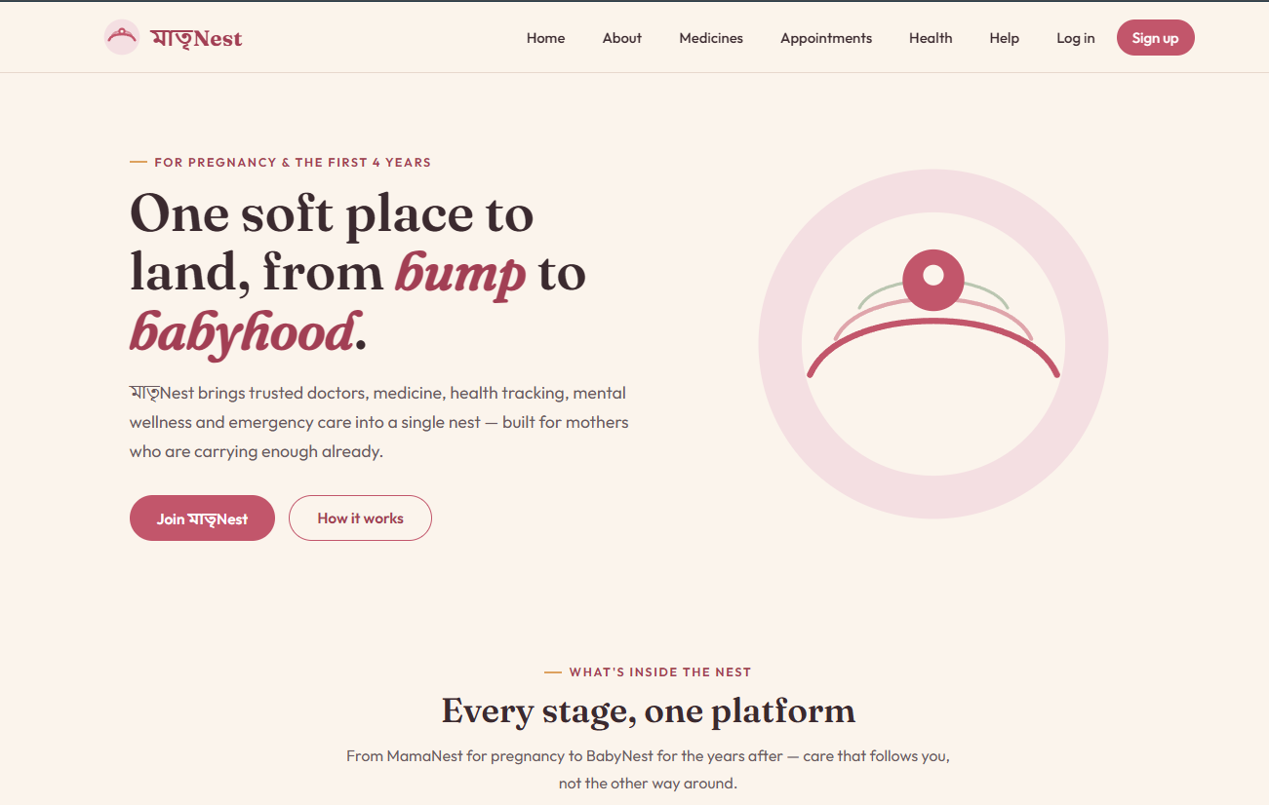
Figure: Landing page — welcome.html

4.3.2 Sign Up and Login
New users register at /signup/ by providing username, email, password, and role (Patient or Doctor). The view validates all fields, checks for duplicate email and username, creates the user via CustomUser.objects.create_user(), and auto-creates a blank UserProfile via post_save signal.
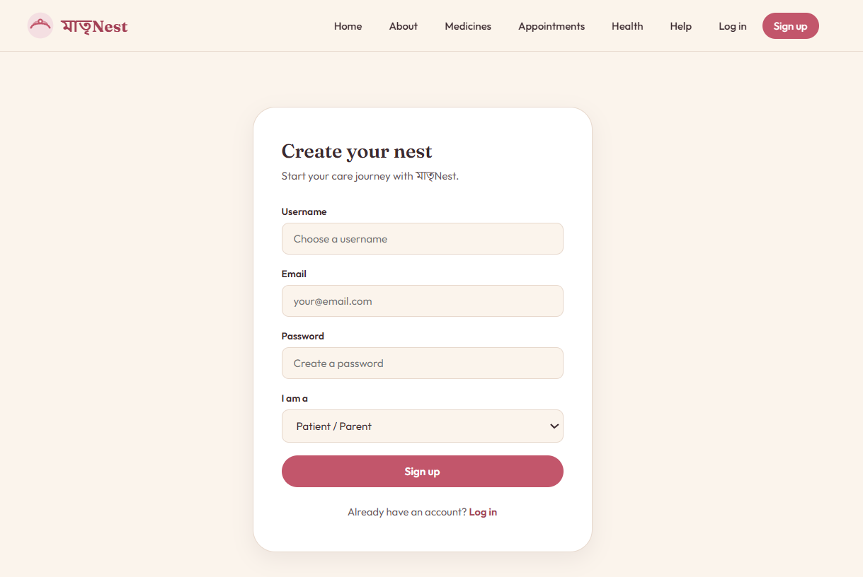
Figure: Sign up page — Auth/signup.html
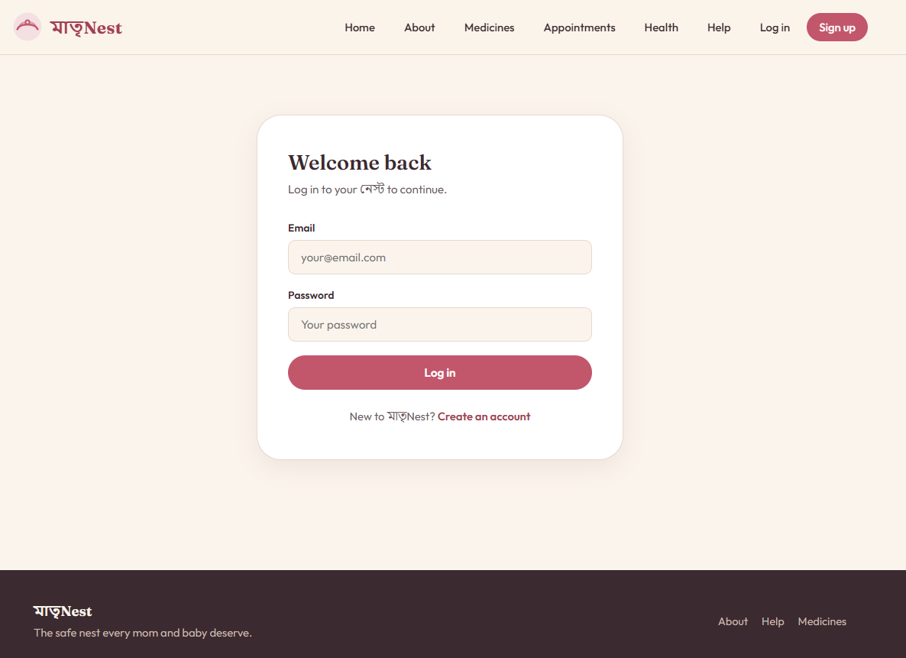
Figure: Log in page — users/login.html

4.3.3 Patient Dashboard
After login, patients see eight service cards on the dashboard: appointments, medicines, health tracking, mental wellness, ambulance, emergency SOS, hire a nurse, and profile. Admin users additionally see Add Medicine and Full Admin Panel cards.
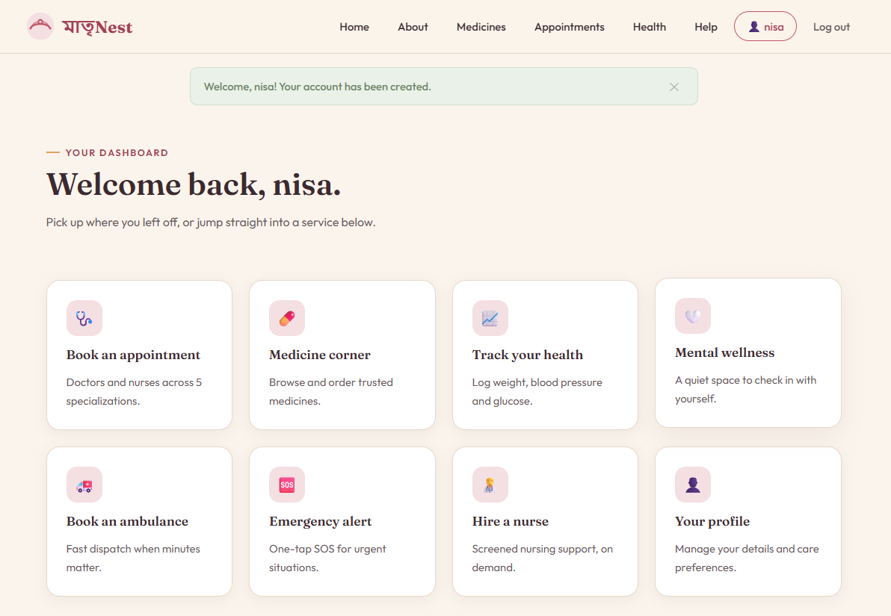
Figure: Patient dashboard — myapp/home.html

4.3.4 Medicine Corner
All logged-in users browse the medicine list at /medicines/. A search box filters by medicine name using a case-insensitive __icontains queryset filter. Only admin users see the Add Medicine button. Patients and doctors attempting /medicines/upload/ are intercepted by @role_required('admin') and redirected with an error message.
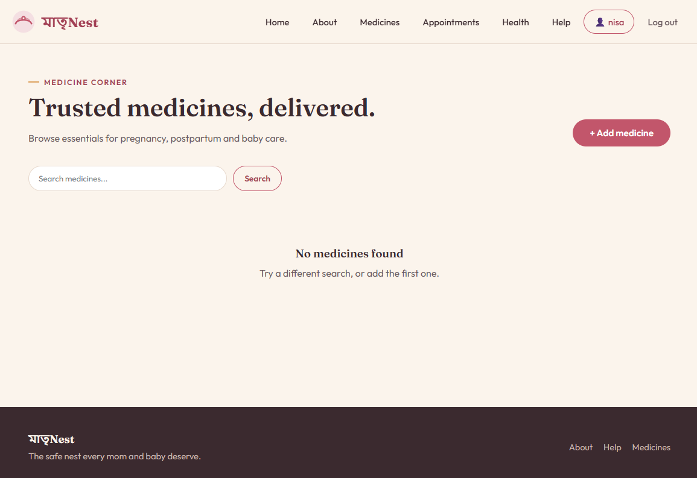
Figure: Medicine listing — myapp/all_medicines.html

4.3.5 Appointment Booking
Patients visit /appoint/ to see their booking form and a list of their own previous appointments. Doctors visiting the same URL see the full appointment queue (all patients) in a read-only card list, with no booking form rendered.
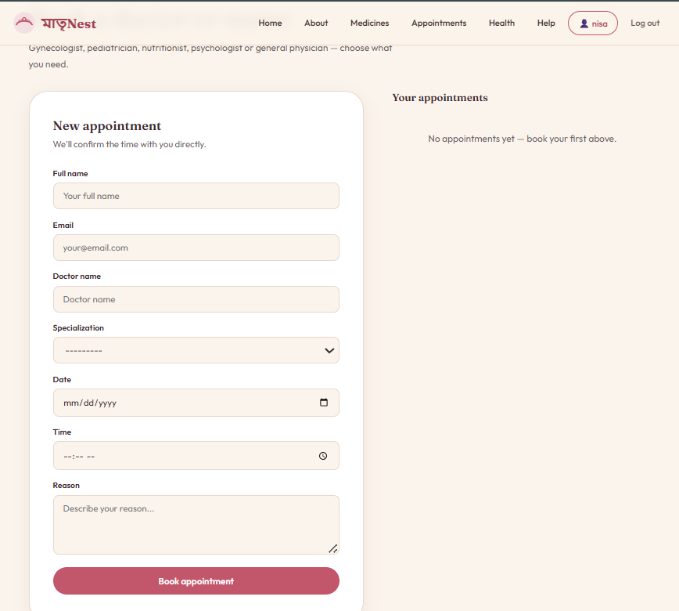
Figure: Appointment booking — patient view
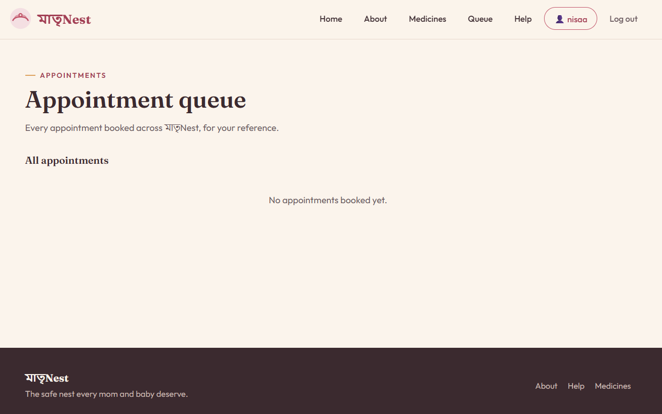
Figure: Appointment queue — doctor view (read-only)

4.3.6 Health Tracking
Patients visit /health/ to log vitals (weight, BP, glucose, symptoms) and view up to 10 previous entries. The view queries HealthRecord.objects.filter(user=request.user) ensuring strict ownership. Doctors attempting this URL are blocked by @role_required('patient').
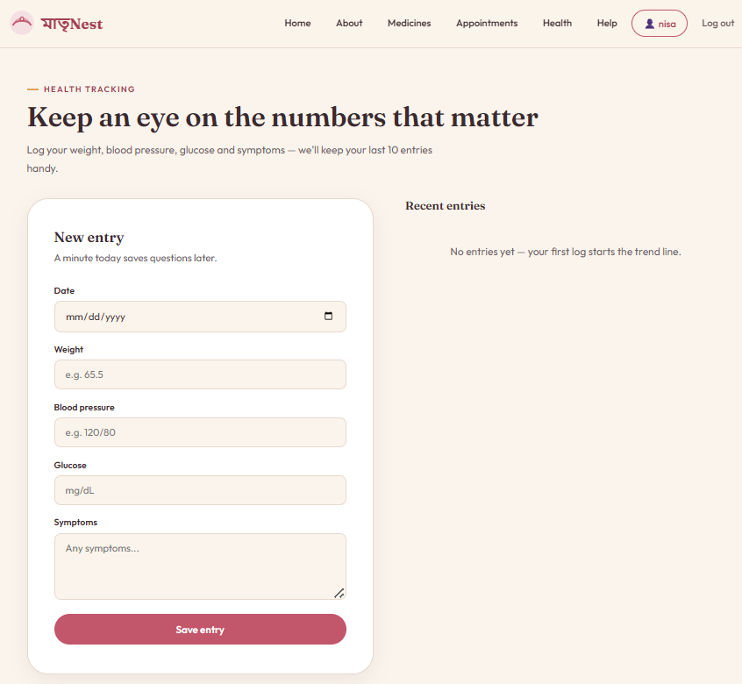
Figure: Health tracking page — myapp/healthtrack.html

4.3.7 Emergency Services
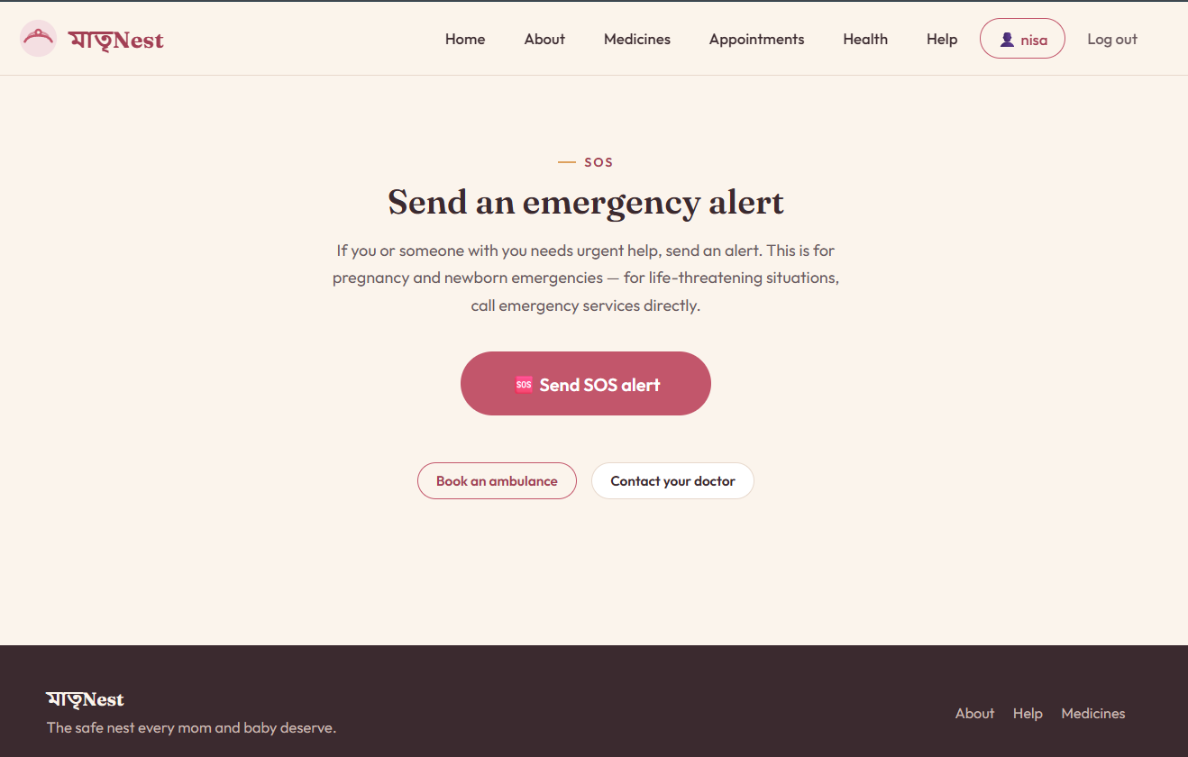
Figure: Emergency SOS page — myapp/emergency.html
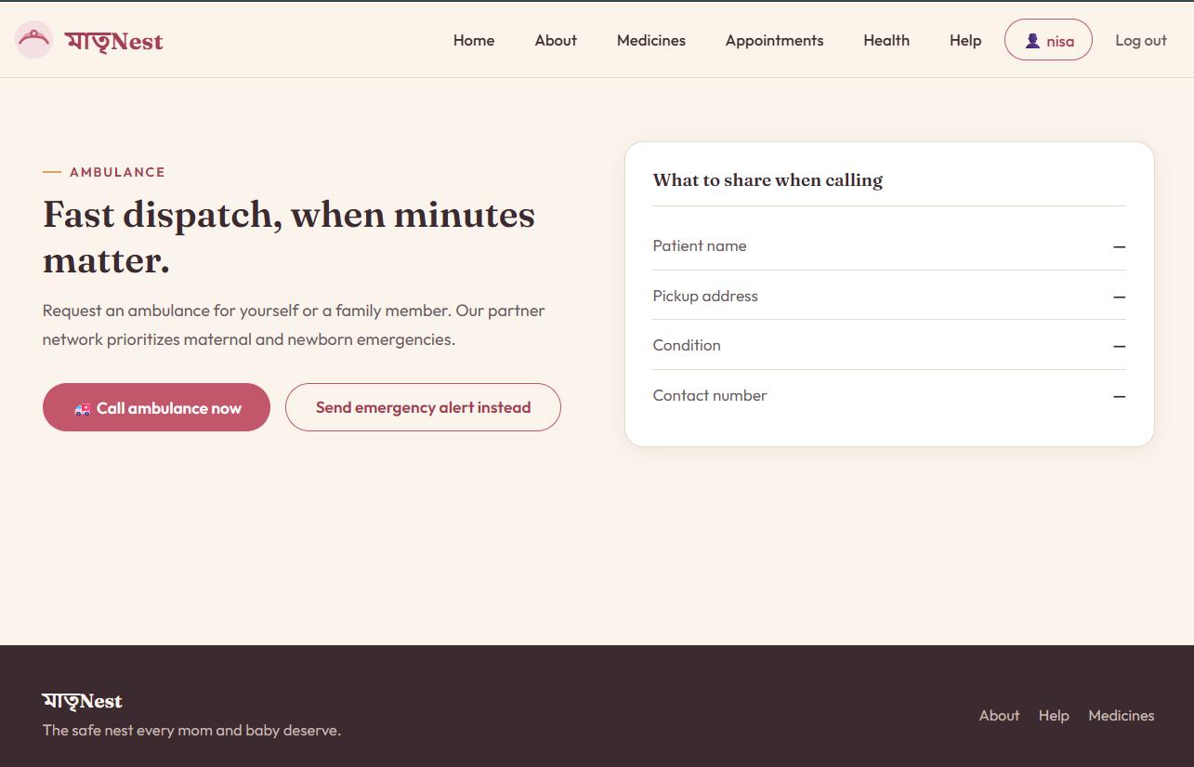
Figure: Ambulance booking page — myapp/bookambulance.html
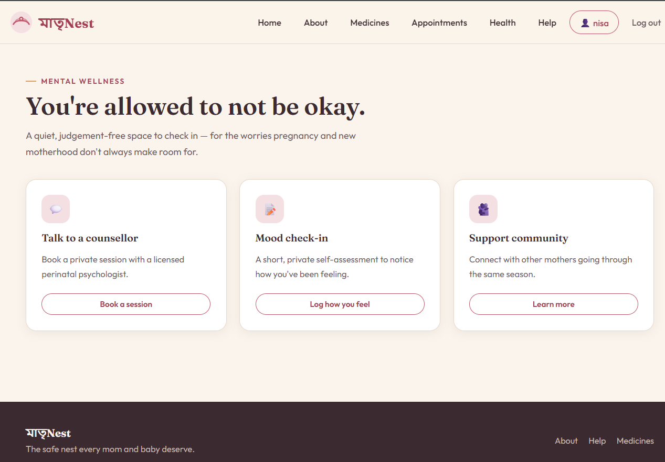
Figure: Mental wellness page — myapp/mentalhealth.html

4.3.8 User Profile
The profile page at /profile/ renders the ProfileForm pre-populated with the current user's UserProfile data. On POST, it saves the updated data and redirects with a success message. Admin users additionally see an Admin Panel link.
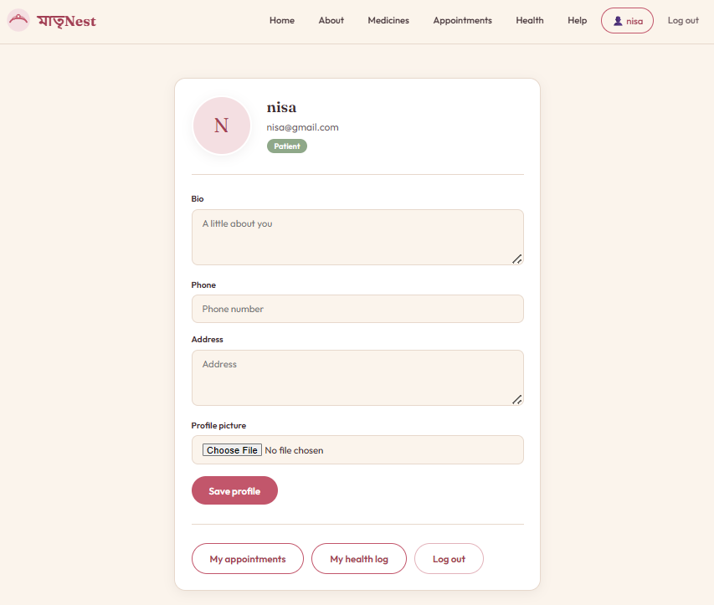
Figure: User profile page — Auth/profile.html

4.3.9 Django Admin Panel
The admin panel at /admin/ is accessible only to superusers created via python manage.py createsuperuser. All five models are registered with custom ModelAdmin classes providing list_display, search_fields, and list_filter options.

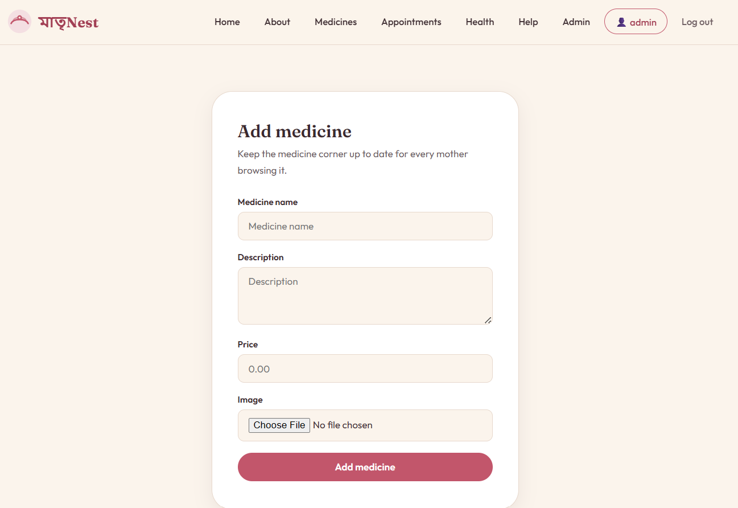
Figure: Django admin panel — medicine management

Chapter 5: Team Contributions

5.1 Team Introduction
মাতৃNest was developed by Team Trinity, a three-member group from the Department of Computer Science & Engineering, University of Asia Pacific. All core decisions — including system architecture, database design, role-based permission logic, and documentation — were made collaboratively through regular team discussions.

Name | Student ID | Primary Role
Tanjina Akter Nisa | 22201086 | Lead Programmer — Django backend, auth system, project architecture, version control
Md. Daudul Islam | 22201088 | Business Analyst & Designer — business model, competitor analysis, pitch deck, UI/UX design
Saswata Ghosal | 22201090 | Frontend Developer & Tester — HTML/CSS prototype, template integration, documentation

5.2 Member-wise Task Distribution
Task | Tanjina Akter Nisa (22201086) | Md. Daudul Islam (22201088) | Saswata Ghosal (22201090)
HTML Page Creation | base.html, home.html, profile.html, about.html, all medicine pages | welcome.html, appoint.html, ambulance, emergency | login.html, signup.html, help.html
CSS & Design System | Full custom CSS design system with variables, buttons, cards, forms, grid, responsive layout | Contributed design direction: colour palette, brand identity, typography choices | Applied CSS to login, signup, help pages
Database Models | CustomUser, UserProfile (with signal), Appointment, HealthRecord, all migrations | Contributed to Medicine model fields and image upload configuration | UserProfile form fields and ProfileForm
Backend Logic | All views, @role_required decorator, URL routing (myapp + users urls.py) | Reviewed and tested all role-based redirect behaviour | Assisted with template context variable naming
Authentication | CustomUser, EmailBackend, register_view, login_view, logout_view, CustomUserAdmin | Validated signup form field names against the HTML prototype | Tested signup and login flows manually
Static HTML Prototype | Reviewed and approved all 15 pages before Django integration | Designed ambulance, emergency, BabyNest page concepts | Built all 15 static prototype pages; cross-linked navigation
Admin Panel | Registered all 5 models with custom list_display, search_fields, list_filter | — | —
Forms | MedicineForm, AppointmentForm, HealthRecordForm, ProfileForm with custom widget attributes | Suggested placeholder text and field labels | Tested form validation edge cases
Version Control | Created and managed GitHub repository, .gitignore, commit history | Assisted with pull request review | Assisted with Git operations
Business Model & Pitch | Reviewed technical feasibility of all business model slides | Led business model: subscription tiers, competitor analysis, revenue projections, survey (47 respondents), all 3 pitch decks | Contributed to conclusion and roadmap sections
Testing | End-to-end role permission testing using Django test client; zero system-check errors confirmed | Manual UI testing across all pages as each user type | Tested form submissions, image uploads, and error messages
Report Writing | Chapter 1, Chapter 3, Chapter 4, Chapter 7 | Chapter 2, ER Diagram, Competitor Analysis, Business Model | Chapter 5, Chapter 6

Chapter 6: Conclusion and Future Work

6.1 Conclusion
মাতৃNest demonstrates that a well-structured, role-aware Django application can meaningfully address the fragmentation of maternal healthcare services in Bangladesh. Starting from a clearly identified problem statement, the team delivered a full-stack web application that consolidates eight healthcare services into a single authenticated platform.

The key achievements of the project are:
1. Clean architecture from scratch — The project was built entirely from scratch with no legacy code. Two Django apps cleanly separate authentication concerns from domain logic, and each app owns its own urls.py.
2. Robust role-based access control — Three user roles (admin, doctor, patient) are enforced at the view layer via a centralised @role_required decorator. Verified end-to-end: patients blocked from medicine management, doctors blocked from health records, admins pass through all checks including /admin/.
3. User-approved frontend — The 15-page static HTML/CSS prototype was built and team-approved before any Django views existed. The final Django templates match the approved prototype exactly in appearance.
4. Data privacy by design — Health records are blocked at two independent layers: database query level (filter(user=request.user)) and view level (@role_required('patient')).
5. Commercially viable structure — The business model (subscription fees, commission on bookings, partner onboarding) and market analysis demonstrate real-world deployment potential.
6. Fully tested and verified — Zero Django system-check errors, all migrations applied cleanly, all role permission redirects verified, all URL routes confirmed reachable.

6.2 Limitations
▸ No real-time features — Ambulance booking and emergency alerts are currently static pages. No real-time dispatch, GPS tracking, or push notification system is implemented.
▸ No payment integration — The subscription and billing model described in the business plan has no corresponding Subscription model or payment gateway in the backend.
▸ BabyNest is prototype-only — The baby care pages exist in the static HTML prototype but have no Django models or views yet.
▸ No email verification — Users can register with any email address. No confirmation email is sent.
▸ SQLite in development — SQLite is not suitable for concurrent production workloads. Migration to PostgreSQL is required before public deployment.
▸ No password reset — There is currently no forgot password flow via email.

6.3 Future Work

Phase 2 — Q3–Q4 2026 (Next Sprint)
▸ BabyNest module — Add BabyProfile, GrowthRecord, and Vaccination models with corresponding views and templates
▸ Subscription and billing — Implement a Subscription model and integrate with SSLCommerz or bKash payment gateway for the Bangladeshi market
▸ Doctor matching algorithm — Match appointment requests to available doctors based on specialization and availability slots
▸ Email verification and password reset — Use Django's send_mail and token-based password reset views
▸ Real-time ambulance dispatch — Integrate Django Channels WebSocket for real-time SOS alerts and dispatch confirmation
▸ Push notifications — Appointment reminders and emergency confirmations via browser push or email

Phase 3 — 2027 (Scale)
▸ AI-powered pregnancy risk alerts — A machine learning model to flag abnormal vitals and suggest the patient contact their doctor
▸ Mobile application — A React Native app for iOS and Android with offline access to health records
▸ Geographic expansion — Deploy in Chattogram and Sylhet with localised partner networks
▸ Partner API — A documented REST API (Django REST Framework) for hospitals, clinics and pharmacies to integrate with the platform
▸ Admin analytics dashboard — Aggregate statistics for appointment volumes, medicine orders, subscription counts, and emergency response times
▸ Production deployment — Migrate to PostgreSQL, configure Nginx + Gunicorn, SSL certificate, cloud deployment on AWS or DigitalOcean

Chapter 7: CEP Mapping
This chapter maps the মাতৃNest project against the Complex Engineering Problem (CEP) attributes defined by the Washington Accord and adopted by the University of Asia Pacific Department of CSE.

7.1 How K's are Addressed
K | Attribute | How it is Addressed in মাতৃNest
K3 | Engineering Fundamentals | The project required sound understanding of HTTP request-response cycle, server-side rendering, database normalisation, relational foreign keys, form validation, and session-based authentication — all core engineering fundamentals applied directly in the Django MVT stack.
K4 | Specialist Knowledge | Demanded specialist knowledge of Django framework internals (models, views, templates, ORM, migrations, admin), Python OOP (model inheritance via AbstractUser, decorators, signals), and maternal healthcare domain knowledge for service design.
K5 | Engineering Design | The system was designed using a structured approach: requirements collected via 47-respondent survey, translated into a database schema (ER diagram), MVT architecture diagram, folder structure plan, URL route table, and a 15-page frontend prototype — all before implementation began.
K6 | Engineering Practice | Implemented using professional practices: version control via Git/GitHub, .gitignore excluding build artefacts, requirements.txt for reproducible environments, virtual environment (venv) for dependency isolation, and end-to-end test run to verify all role permissions.
K7 | Comprehension | Addresses a real societal need (maternal healthcare fragmentation in Bangladesh) and has been evaluated for social impact (accessibility, emergency response, mental health support, eco-efficiency) and business viability (subscription model, market sizing, competitor analysis).

7.2 How P's are Addressed
P | Attribute | How it is Addressed in মাতৃNest
P1 | Depth of Knowledge Required | Cannot be resolved without in-depth engineering knowledge across multiple domains simultaneously: web programming (K3), Django framework internals (K4), database schema and ER modelling (K5), Python and HTML/CSS implementation (K6), and maternal healthcare domain knowledge (K7).
P2 | Depth of Analysis Required | The role-based access control system required careful analysis of at least twelve permission boundary cases and the design of a single elegant solution (@role_required) that handles all twelve cases in one function.
P3 | Depth of Investigation | The team investigated five competing platforms in Bangladesh — Sukhee App, Praava Health, Arogga, Chaldal, Sheba.xyz — to identify the specific gap that মাতৃNest addresses.
P4 | Innovative Solutions | Enforcing data privacy at two independent layers (queryset filter in the view AND @role_required decorator at the URL level) is a defence-in-depth approach that exceeds typical implementations which rely on a single UI-level check.
P6 | Stakeholder Involvement | Four distinct stakeholder groups: (1) patients who book appointments and log health data, (2) doctors who view the appointment queue, (3) admins who manage the full system, and (4) partner pharmacies, clinics and nurse providers who are the business model's Phase 2 revenue partners.
P7 | Interdependence | Features are highly interdependent: appointment flow links to doctor model, nurse hiring, and mental wellness; health tracking data will feed the Phase 3 AI risk alert; subscription model gates premium access tiers; admin panel controls every other module.

7.3 How A's are Addressed
A | Attribute | How it is Addressed in মাতৃNest
A1 | Range of Resources | Human resources: patients, doctors, admins, partner pharmacies and nurses as stakeholders. Technical: Python, Django, HTML, CSS, SQLite, Pillow, Git. Knowledge: MVT architecture, RBAC theory, CSS design systems, business model frameworks. Data: 47 survey responses, competitor feature data.
A2 | Fluency in Use of Tools | Demonstrated fluency in: Django ORM (QuerySet filtering, get_or_create, create_user), Django forms (ModelForm, save(commit=False)), Django signals (post_save, @receiver), Django admin (ModelAdmin, list_display, search_fields), Git version control, and CSS custom properties with responsive grid layout.
A3 | Importance of Health, Safety, Env. | Health and safety are central to the platform's purpose. Sensitive personal health data is protected at two independent layers. Emergency SOS and ambulance features directly address patient safety. Eco-friendly impact is achieved by digitising paper-based health records and reducing travel through online booking.
A4 | Consequences for Society and Env. | Measurable positive consequences: reduced maternal mortality risk through faster emergency access, improved prenatal health literacy through personal tracking, reduced mental health stigma through a low-friction wellness channel, economic opportunity for partner doctors and nurses, and reduced paper consumption through digital record-keeping.

References
1. Django Software Foundation. (2024). Django Documentation — Version 5.2. https://docs.djangoproject.com/en/5.2/
2. Django Software Foundation. (2024). The Django ORM: Models and Databases. https://docs.djangoproject.com/en/5.2/topics/db/
3. Python Software Foundation. (2024). Python 3.14 Documentation. https://docs.python.org/3/
4. Pillow Contributors. (2024). Pillow (PIL Fork) Documentation. https://pillow.readthedocs.io/en/stable/
5. World Health Organization. (2023). Maternal Mortality: Key Facts. https://www.who.int/news-room/fact-sheets/detail/maternal-mortality
6. Mozilla Developer Network. (2024). CSS Custom Properties (Variables). https://developer.mozilla.org/en-US/docs/Web/CSS/Using_CSS_custom_properties
7. SQLite Consortium. (2024). SQLite Documentation. https://www.sqlite.org/docs.html
8. Pressman, R. S. (2014). Software Engineering: A Practitioner's Approach (8th ed.). McGraw-Hill Education.
9. Freeman, E., & Robson, E. (2020). Head First Design Patterns. O'Reilly Media.
10. Google Fonts. (2024). Fraunces and Outfit typefaces. https://fonts.google.com/

Appendix A: Setup and Deployment Guide

A.1 Prerequisites
▸ Python 3.10 or above installed
▸ pip (Python package manager)
▸ Git (for cloning the repository)
▸ VS Code or any text editor

A.2 Local Development Steps
1. Navigate into the project folder: cd MatriNest
2. Create a virtual environment: python -m venv venv
3. Activate it (Windows): venv\Scripts\activate
4. Install dependencies: pip install -r requirements.txt
5. Apply database migrations: python manage.py migrate
6. Create a superuser (admin only — NEVER via the signup form): python manage.py createsuperuser
7. Run the development server: python manage.py runserver
8. Open in browser: http://127.0.0.1:8000/ | Admin panel: http://127.0.0.1:8000/admin/

A.3 Testing Role Permissions
1. As a patient — Sign up selecting 'Patient'. Try navigating to /medicines/upload/. Should redirect to /home/ with 'That action is reserved for administrators.'
2. As a doctor — Sign up selecting 'Doctor'. Try navigating to /health/. Should redirect to /home/ with 'You don't have permission.' Visit /appoint/ and confirm no booking form is shown.
3. As admin — Log in with superuser credentials. Confirm /medicines/upload/, /health/, /admin/ and every other page is accessible without redirection.

মাতৃNest — One soft place to land, from bump to babyhood.
Team Trinity · University of Asia Pacific · 2025

