一、实验目的：
- 掌握张量方式和层方式tensorflow卷积神经网络分类模型编程
- 掌握卷积神经网络分类模型装配、训练与测试
- 掌握经典卷积神经网络ResNet分类模型装配、训练与测试，自动保存模型最佳参数，自动续训练模型，绘制训练集和验证集的acc和loss曲线。
二、实验环境：
操作系统：Windows 7以上、anaconda 4.8.3 或以上版本
Pycharm community 2020.2 或以上版本
Tensorflow 2.0.0 或以上版本
三、实验内容：
- 按照张量方式和层方式使用CIFAR10数据集tensorflow卷积神经网络分类模型装配、训练与测试
- 使用tensorflow和CIFAR10数据集，创建经典卷积神经网络ResNet50 模型，进行装配、训练与测试。
- 使用tensorflow和CIFAR10数据集，从Keras.applications加载经典卷积神经网络ResNet50 模型进行装配、训练与测试。
- 使用tensorflow和fashion_mnist数据集，使用经典卷积神经网络ResNet50 模型进行装配、训练与测试。自动保存模型最佳参数，自动续训练模型，绘制训练集和验证集的acc和loss曲线。
- 实验记录：
实验环境:
CPU:i7-7700hq
GPU:GTX 1050
RAM:2*8G 2400Hz
Python环境:
Python3.8.0
tensorflow-gpu 2.8.0
驱动：
CUDA 11.2
cuDNN 8.1
NVIDIA 512.15
模型结构：
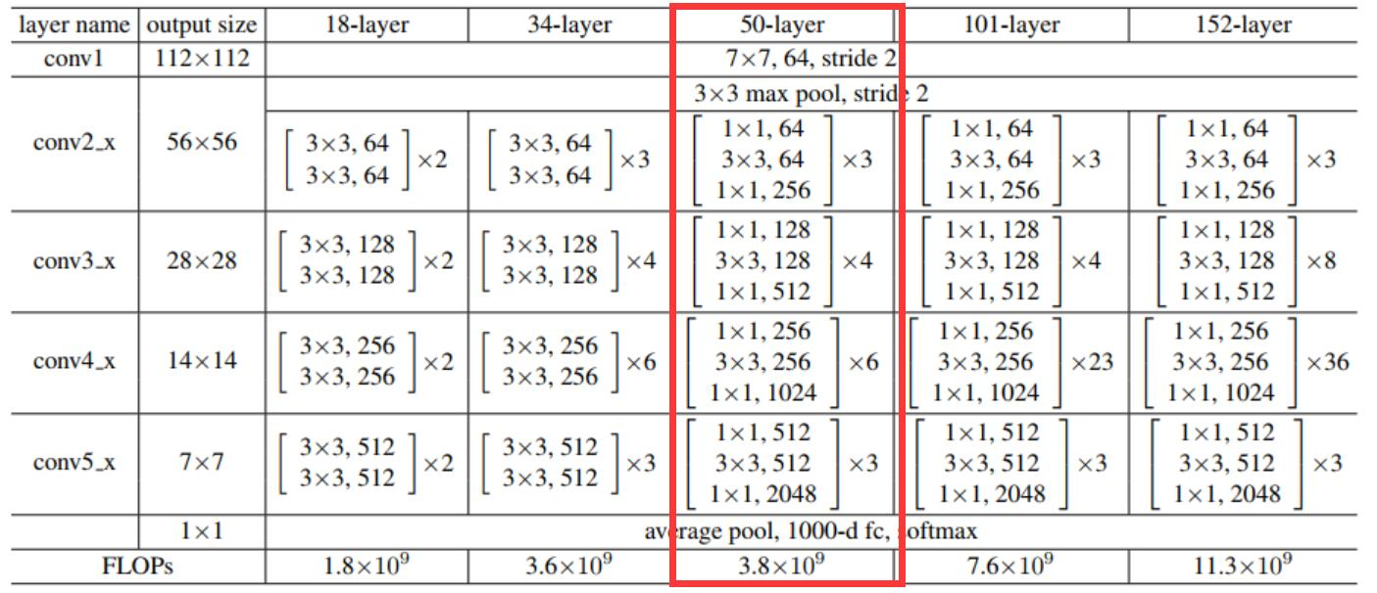
bottleneck residual block：
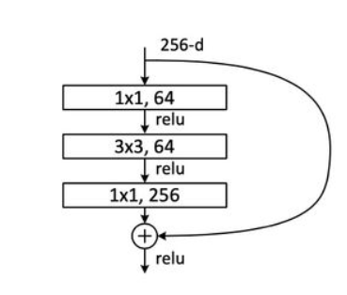
<1 && 2>
实验测试：
在不使用GPU情况下，3小时得出9条结果，约为4轮。实验中默认轮次为100轮，完整运行约75小时。修改batch_size无法大幅减少计算时间。
使用GPU，应使用对应版本(图片仅为部分)。
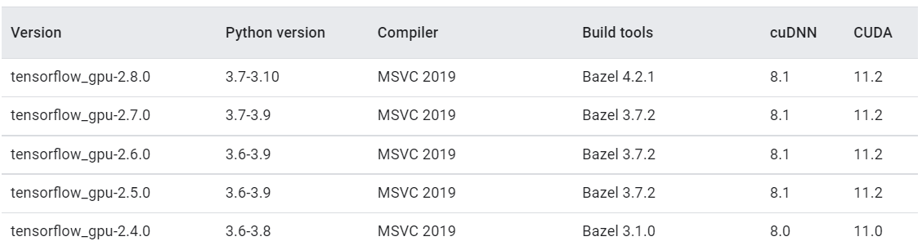
测试经得，需GPU独显为8G左右才能运行，RAM无法共享给独显使用。(台式电脑GPU至少为GTX 1070，GTX 2060 Super,GTX 3060(12G)以上或其他丽台显卡，笔记本电脑GPU至少为GTX 980M,GTX 1070，GTX 2070 Super，GTX 3070。或RAM为8G以上的mac电脑。)
我所使用的的GTX 1050为2G独显，因此降低batch_size为16(初始为512)，训练精度因此下降。更换为GPU计算后，计算速度为30分钟10轮，总计约耗时5小时。因长时间显卡满载运行，总轮次修改为10轮。（当前情况下，resnet18/34的batch_size最高为64，resnet50的batch_size最高为16）

代码：
resnet_50.py
import tensorflow as tf
# from keras import layers, Sequential

class bottleneckBlock(tf.keras.layers.Layer):
# 残差模块
def __init__(self, filter_num, stride=1):
super(bottleneckBlock, self).__init__()
# 第一个卷积单元
self.conv1 = tf.keras.layers.Conv2D(filter_num, (1, 1), strides=stride, padding='same')
self.bn1 = tf.keras.layers.BatchNormalization()
self.relu = tf.keras.layers.Activation('relu')
# 第二个卷积单元
self.conv2 = tf.keras.layers.Conv2D(filter_num, (3, 3), strides=1, padding='same')
self.bn2 = tf.keras.layers.BatchNormalization()
self.relu = tf.keras.layers.Activation('relu')
# 第三个卷积单元
self.conv3 = tf.keras.layers.Conv2D(filter_num * 4, (1, 1), strides=1, padding='same')
self.bn3 = tf.keras.layers.BatchNormalization()

if stride != 1 or filter_num != filter_num * 4:# 通过1x1卷积完成shape匹配 #if have better algorithm, fix it
# Fix(maybe √) wrong -> self.inplanes != planes * block.expansion
# inplanes:输入block之前的通道数
# planes:在block中间处理的时候的通道数（这个值是输出维度的1/4)
# planes * block.expansion:输出的维度 (block.expansion=4)
self.downsample = tf.keras.Sequential()
self.downsample.add(tf.keras.layers.Conv2D(filter_num * 4, (1, 1), strides=stride))
else:# shape匹配，直接短接
self.downsample = lambda x:x

def call(self, inputs, training=None):
# [b, h, w, c]，通过第一个卷积单元
out = self.conv1(inputs)
out = self.bn1(out)
out = self.relu(out)
# 通过第二个卷积单元
out = self.conv2(out)
out = self.bn2(out)
out = self.relu(out)
# 通过第三个卷积单元
out = self.conv3(out)
out = self.bn3(out)
# 通过identity模块
identity = self.downsample(inputs)

# print("identity.shape",identity.shape)
# print("out.shape",out.shape)

# 3条路径输出直接相加 Fix(√) #Wrong -> need to fit shape(identity,out)
output = tf.keras.layers.add([out, identity])
output = tf.nn.relu(output) # 激活函数
return output

class ResNet(tf.keras.Model):
# 通用的ResNet实现类
def __init__(self, layer_dims, num_classes=10): # [3, 4, 6, 3]
super(ResNet, self).__init__()
# 根网络，预处理
self.stem = tf.keras.Sequential([tf.keras.layers.Conv2D(64, (3, 3), strides=(1, 1)),
tf.keras.layers.BatchNormalization(),
tf.keras.layers.Activation('relu'),
tf.keras.layers.MaxPool2D(pool_size=(2, 2), strides=(1, 1), padding='same')
])
# 堆叠4个Block，每个block包含了多个BasicBlock,设置步长不一样
self.layer1 = self.build_resblock(64, layer_dims[0])
self.layer2 = self.build_resblock(128, layer_dims[1], stride=2)
self.layer3 = self.build_resblock(256, layer_dims[2], stride=2)
self.layer4 = self.build_resblock(512, layer_dims[3], stride=2)

# 通过Pooling层将高宽降低为1x1
self.avgpool = tf.keras.layers.GlobalAveragePooling2D()
# 最后连接一个全连接层分类
self.fc = tf.keras.layers.Dense(num_classes)

def call(self, inputs, training=None):
# 通过根网络
x = self.stem(inputs)
# 一次通过4个模块
x = self.layer1(x)
x = self.layer2(x)
x = self.layer3(x)
x = self.layer4(x)

# 通过池化层
x = self.avgpool(x)
# 通过全连接层
x = self.fc(x)

return x

def build_resblock(self, filter_num, blocks, stride=1):
# 辅助函数，堆叠filter_num个BasicBlock
res_blocks = tf.keras.Sequential()
# 只有第一个BasicBlock的步长可能不为1，实现下采样
res_blocks.add(bottleneckBlock(filter_num, stride))
for _ in range(1, blocks):#其他BasicBlock步长都为1
res_blocks.add(bottleneckBlock(filter_num, stride=1))

return res_blocks

def resnet50():
# 通过调整模块内部BasicBlock的数量和配置实现不同的ResNet
return ResNet([3, 4, 6, 3])
resnet50_train.py
import tensorflow as tf
# from tensorflow.keras import layers, optimizers, datasets, Sequential
import os
from resnet_50 import resnet50

# os.environ["CUDA_VISIBLE_DEVICES"] = '-1'#使用cpu
os.environ["CUDA_VISIBLE_DEVICES"] = '0'#使用gpu

config = tf.compat.v1.ConfigProto()
config.gpu_options.per_process_gpu_memory_fraction = 0.8 # 程序最多只能占用指定gpu x%的显存
config.gpu_options.allow_growth = True #程序按需申请内存
sess = tf.compat.v1.Session(config = config)

batch_size = 32 # batch_size过高时，Gpu显存溢出终止计算(1050-2G)
os.environ['TF_CPP_MIN_LOG_LEVEL']='3'
tf.random.set_seed(2345)

def preprocess(x, y):
# 将数据映射到-1~1
x = 2*tf.cast(x, dtype=tf.float32) / 255. - 1
y = tf.cast(y, dtype=tf.int32) # 类型转换
return x,y

(x,y), (x_test, y_test) = tf.keras.datasets.cifar10.load_data() # 加载数据集
y = tf.squeeze(y, axis=1) # 删除不必要的维度
y_test = tf.squeeze(y_test, axis=1) # 删除不必要的维度
print(x.shape, y.shape, x_test.shape, y_test.shape)

train_db = tf.data.Dataset.from_tensor_slices((x,y)) # 构建训练集
# 随机打散，预处理，批量化
train_db = train_db.shuffle(1000).map(preprocess).batch(batch_size)

test_db = tf.data.Dataset.from_tensor_slices((x_test,y_test)) #构建测试集
# 随机打散，预处理，批量化
test_db = test_db.map(preprocess).batch(batch_size)
# 采样一个样本
sample = next(iter(train_db))
print('sample:', sample[0].shape, sample[1].shape,
tf.reduce_min(sample[0]), tf.reduce_max(sample[0]))

def main():

# [b, 32, 32, 3] => [b, 1, 1, 512]
model = resnet50() # ResNet50网络
model.build(input_shape=(None, 32, 32, 3))
model.summary() # 统计网络参数
optimizer = tf.keras.optimizers.Adam(learning_rate=1e-4) # 构建优化器

for epoch in range(1): # 训练epoch
for step, (x,y) in enumerate(train_db):
with tf.GradientTape() as tape:
# [b, 32, 32, 3] => [b, 10],前向传播
logits = model(x)
# [b] => [b, 10],one-hot编码
y_onehot = tf.one_hot(y, depth=10)
# 计算交叉熵
loss = tf.losses.categorical_crossentropy(y_onehot, logits, from_logits=True)
loss = tf.reduce_mean(loss)
# 计算梯度信息
grads = tape.gradient(loss, model.trainable_variables)
# 更新网络参数
optimizer.apply_gradients(zip(grads, model.trainable_variables))

if step %50 == 0:
print(epoch, step, 'loss:', float(loss))

total_num = 0
total_correct = 0
for x,y in test_db:

logits = model(x)
prob = tf.nn.softmax(logits, axis=1)
pred = tf.argmax(prob, axis=1)
pred = tf.cast(pred, dtype=tf.int32)

correct = tf.cast(tf.equal(pred, y), dtype=tf.int32)
correct = tf.reduce_sum(correct)

total_num += x.shape[0]
total_correct += int(correct)

acc = total_correct / total_num
print(epoch, 'acc:', acc)

if __name__ == '__main__':
main()

实验结果(部分)：
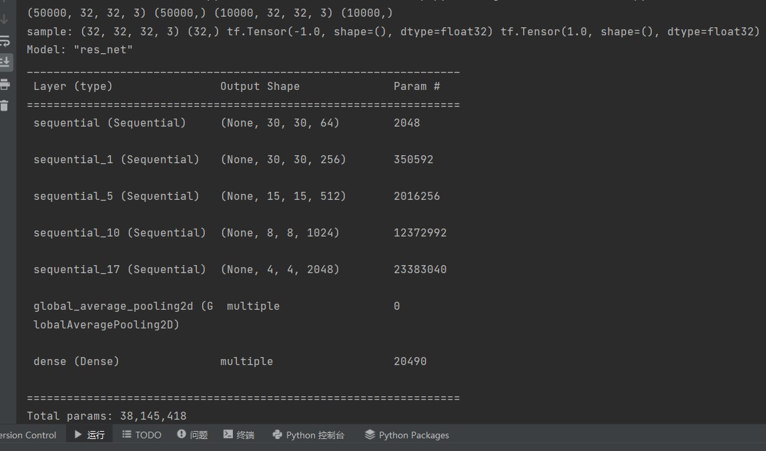
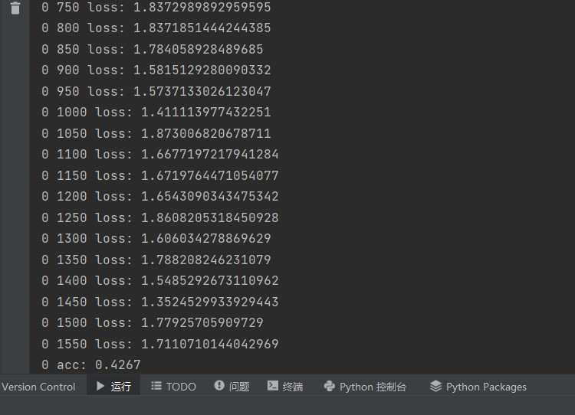
ps: batch_size=32,每轮次计算32次。实验结果为GTX1650运行。

<3>
代码：
#%%
import tensorflow as tf
from tensorflow import keras
# from tensorflow.keras import datasets, layers, optimizers, Sequential, metrics

#%%
# 加载预训练网络模型，并去掉最后一层
resnet = keras.applications.ResNet50(weights='imagenet',include_top=False)
resnet.summary()
# 测试网络的输出
x = tf.random.normal([4,224,224,3])
out = resnet(x)
print(out.shape)
#%%
# 新建池化层
global_average_layer = tf.keras.layers.GlobalAveragePooling2D()
# 利用上一层的输出作为本层的输入，测试其输出
x = tf.random.normal([4,7,7,2048])
out = global_average_layer(x)
print(out.shape)
#%%
# 新建全连接层
fc = tf.keras.layers.Dense(100)
# 利用上一层的输出作为本层的输入，测试其输出
x = tf.random.normal([4,2048])
out = fc(x)
print(out.shape)
#%%
# 重新包裹成我们的网络模型
mynet = tf.keras.Sequential([resnet, global_average_layer, fc])
mynet.summary()
#%%
resnet.trainable = False
mynet.summary()
#%%
实验结果：
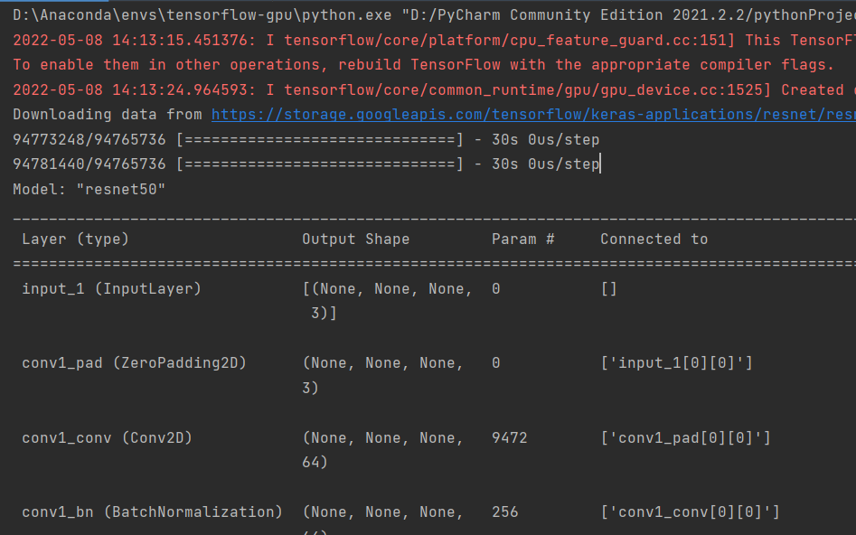
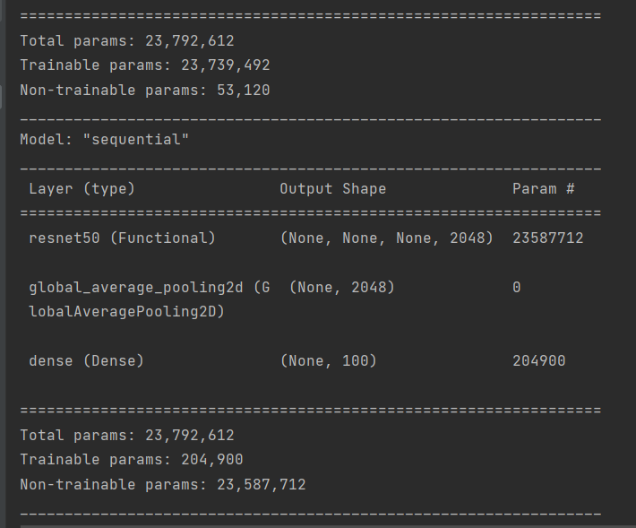
<4>
代码：
import tensorflow as tf
import os
import numpy as np
from matplotlib import pyplot as plt
# from tensorflow.keras.layers import Conv2D, BatchNormalization, Activation, MaxPool2D, Dropout, Flatten, Dense
# from tensorflow.keras import Model

np.set_printoptions(threshold=np.inf)

fashion = tf.keras.datasets.fashion_mnist
(x_train, y_train), (x_test, y_test) = fashion.load_data()
x_train, x_test = x_train / 255.0, x_test / 255.0
print("x_train.shape", x_train.shape)
x_train = x_train.reshape(x_train.shape[0], 28, 28, 1) # 给数据增加一个维度，使数据和网络结构匹配
x_test = x_test.reshape(x_test.shape[0], 28, 28, 1)
print("x_train.shape", x_train.shape)

class ResnetBlock(tf.keras.Model):
def __init__(self, filters, strides=1, residual_path=False):
super(ResnetBlock, self).__init__()
self.filters = filters
self.strides = strides
self.residual_path = residual_path

self.c1 = tf.keras.layers.Conv2D(filters, (1, 1), strides=strides, padding='same', use_bias=False)
self.b1 = tf.keras.layers.BatchNormalization()
self.a1 = tf.keras.layers.Activation('relu')

self.c2 = tf.keras.layers.Conv2D(filters, (3, 3), strides=1, padding='same', use_bias=False)
self.b2 = tf.keras.layers.BatchNormalization()
self.a2 = tf.keras.layers.Activation('relu')

self.c3 = tf.keras.layers.Conv2D(filters * 4, (1, 1), strides=1, padding='same', use_bias=False)
self.b3 = tf.keras.layers.BatchNormalization()

self.down_c1 = tf.keras.layers.Conv2D(filters * 4, (1, 1), strides=strides, padding='same', use_bias=False)
self.down_b1 = tf.keras.layers.BatchNormalization()

self.a2 = tf.keras.layers.Activation('relu')

def call(self, inputs):
residual = inputs # residual等于输入值本身，即residual=x
# 将输入通过卷积、BN层、激活层，计算F(x)
x = self.c1(inputs)
x = self.b1(x)
x = self.a1(x)

x = self.c2(x)
x = self.b2(x)
x = self.a2(x)

x = self.c3(x)
y = self.b3(x)

residual = self.down_c1(inputs)
residual = self.down_b1(residual)
out = self.a2(y + residual) # 最后输出的是两部分的和，即F(x)+x或F(x)+Wx,再过激活函数
return out

class ResNet50(tf.keras.Model):
def __init__(self, block_list, initial_filters=64): # block_list表示每个block有几个卷积层
super(ResNet50, self).__init__()
self.num_blocks = len(block_list) # 共有几个block
self.block_list = block_list
self.out_filters = initial_filters
self.c1 = tf.keras.layers.Conv2D(self.out_filters, (3, 3), strides=1, padding='same', use_bias=False)
self.b1 = tf.keras.layers.BatchNormalization()
self.a1 = tf.keras.layers.Activation('relu')
self.blocks = tf.keras.models.Sequential()
# 构建ResNet网络结构
for block_id in range(len(block_list)): # 第几个resnet block
for layer_id in range(block_list[block_id]): # 第几个卷积层
if block_id != 0 and layer_id == 0: # 对除第一个block以外的每个block的输入进行下采样
block = ResnetBlock(self.out_filters, strides=2, residual_path=True)
else:
block = ResnetBlock(self.out_filters, residual_path=False)
self.blocks.add(block) # 将构建好的block加入resnet
self.out_filters *= 2 # 下一个block的卷积核数是上一个block的2倍
self.p1 = tf.keras.layers.GlobalAveragePooling2D()
self.f1 = tf.keras.layers.Dense(10, activation='softmax', kernel_regularizer=tf.keras.regularizers.l2())

def call(self, inputs):
x = self.c1(inputs)
x = self.b1(x)
x = self.a1(x)
x = self.blocks(x)
x = self.p1(x)
y = self.f1(x)
return y

model = ResNet50([3, 4, 6, 3])
model.compile(optimizer='adam',
loss=tf.keras.losses.SparseCategoricalCrossentropy(from_logits=False),
metrics=['sparse_categorical_accuracy'])

checkpoint_save_path = "./checkpoint/ResNet50.ckpt"
if os.path.exists(checkpoint_save_path + '.index'):
print('-------------load the model-----------------')
model.load_weights(checkpoint_save_path)

cp_callback = tf.keras.callbacks.ModelCheckpoint(filepath=checkpoint_save_path,
save_weights_only=True,
save_best_only=True)

history = model.fit(x_train, y_train, batch_size=32, epochs=5, validation_data=(x_test, y_test), validation_freq=1,
callbacks=[cp_callback])
model.summary()

file = open('./weights.txt', 'w')
for v in model.trainable_variables:
file.write(str(v.name) + '\n')
file.write(str(v.shape) + '\n')
file.write(str(v.numpy()) + '\n')
file.close()
############################################### show ###############################################
# 显示训练集和验证集的acc和loss曲线
acc = history.history['sparse_categorical_accuracy']
val_acc = history.history['val_sparse_categorical_accuracy']
loss = history.history['loss']
val_loss = history.history['val_loss']

plt.subplot(1, 2, 1)
plt.plot(acc, label='Training Accuracy')
plt.plot(val_acc, label='Validation Accuracy')
plt.title('Training and Validation Accuracy')
plt.legend()

plt.subplot(1, 2, 2)
plt.plot(loss, label='Training Loss')
plt.plot(val_loss, label='Validation Loss')
plt.title('Training and Validation Loss')
plt.legend()
plt.show()
实验结果：
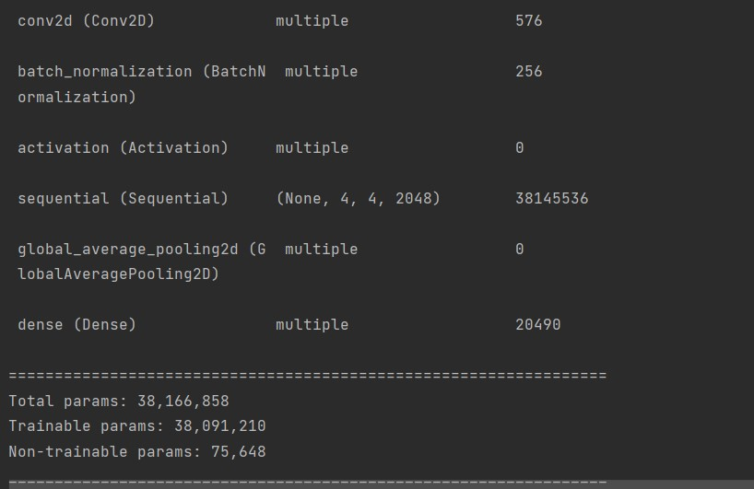
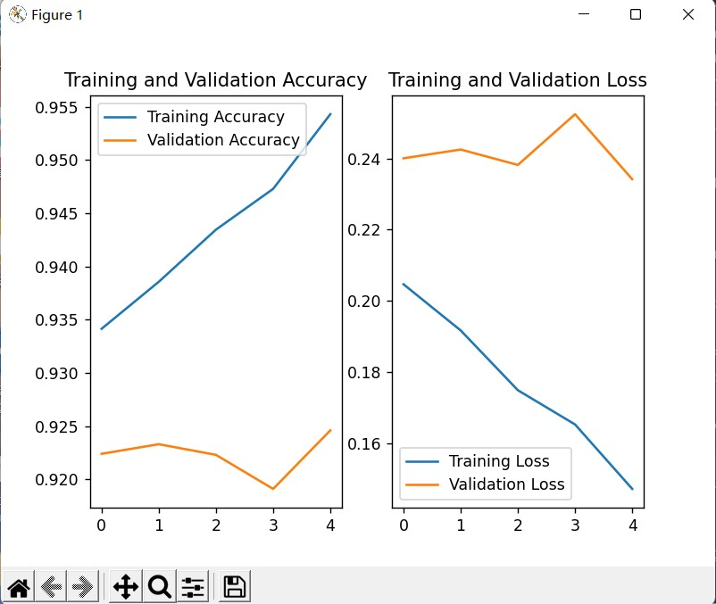
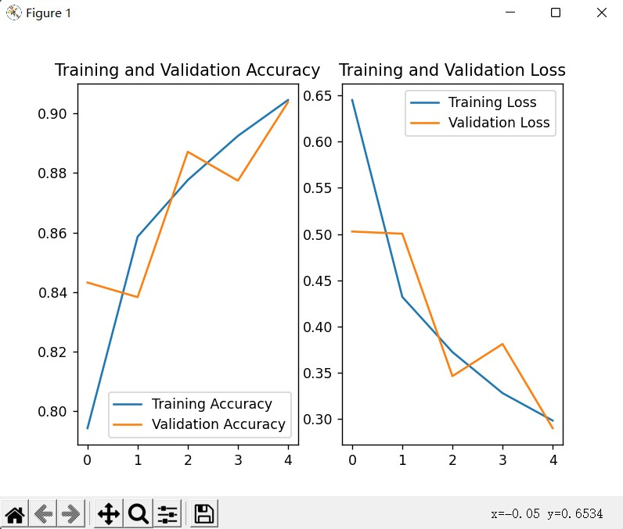
Ps:实验结果为GTX1650运行。
- 出现的问题及解决方案（列出遇到的问题和解决方案，列出没有解决的问题）：
无

