

Database Management System Lab
Project Deliverable 2

NAMES: Dawar Ahmed (24i-2533)
Umar Asghar (24i-2532)
DEGREE PROGRAM: BS-DS
SECTION: B
DATE OF SUBMISSIONS: 21st April 2026
SUBMITTED TO: Ma’am Palwasha Zahid
Sir Talha Tariq

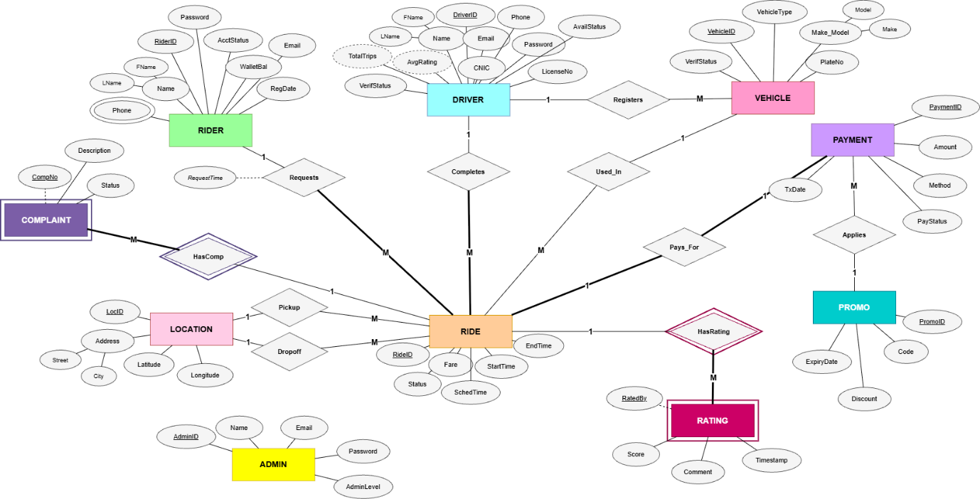
Figure 1
1. Project Overview
RideFlow is a comprehensive ride-hailing platform designed to automate and streamline the lifecycle of trips, including ride requests, driver matching, fare calculation, payment processing, and post-trip accountability. The system is built using MySQL to ensure data integrity and scalable operations for both riders and drivers.
2. Relational Schema Design
The database is composed of 13 interconnected tables designed to normalize data and enforce business rules through constraints.
Key Entity Descriptions:
- Users/Roles (Admin, Rider, Driver): Manages identity, authentication, and role-specific attributes (e.g., wallet balance, verification status).
- Ride Management: Tracks the trip lifecycle from Requested to Completed/Cancelled status.
- Financials (Payment, Payout, Promo): Handles commission-based earnings for drivers and automated discount applications.
- Accountability (Rating, Complaint): Ensures quality of service through mutual feedback.
3. Implementation Details
The following SQL implementation adheres to all functional requirements, including integrity constraints (NOT NULL, UNIQUE, CHECK) and relational integrity via FOREIGN KEY definitions.
SQL
CREATE DATABASE IF NOT EXISTS RideFlow;
USE RideFlow;

CREATE TABLE ADMIN (
AdminID INT AUTO_INCREMENT PRIMARY KEY,
Name VARCHAR(100) NOT NULL,
Email VARCHAR(100) NOT NULL UNIQUE,
Password VARCHAR(255) NOT NULL,
AdminLevel ENUM('SuperAdmin', 'Admin') NOT NULL DEFAULT 'Admin'
);

CREATE TABLE RIDER (
RiderID INT AUTO_INCREMENT PRIMARY KEY,
FName VARCHAR(50) NOT NULL,
LName VARCHAR(50) NOT NULL,
Email VARCHAR(100) NOT NULL UNIQUE,
Phone VARCHAR(15) NOT NULL UNIQUE,
Password VARCHAR(255) NOT NULL,
WalletBal DECIMAL(10,2) NOT NULL DEFAULT 0.00,
AcctStatus ENUM('Active', 'Suspended', 'Banned') NOT NULL DEFAULT 'Active',
RegDate DATE NOT NULL DEFAULT (CURRENT_DATE),
CHECK (WalletBal >= 0)
);

CREATE TABLE DRIVER (
DriverID INT AUTO_INCREMENT PRIMARY KEY,
FName VARCHAR(50) NOT NULL,
LName VARCHAR(50) NOT NULL,
Email VARCHAR(100) NOT NULL UNIQUE,
Phone VARCHAR(15) NOT NULL UNIQUE,
Password VARCHAR(255) NOT NULL,
CNIC VARCHAR(15) NOT NULL UNIQUE,
LicenseNo VARCHAR(20) NOT NULL UNIQUE,
AvgRating DECIMAL(3,2) NOT NULL DEFAULT 0.00,
TotalTrips INT NOT NULL DEFAULT 0,
WalletBal DECIMAL(10,2) NOT NULL DEFAULT 0.00,
VerifStatus ENUM('Pending', 'Verified', 'Rejected') NOT NULL DEFAULT 'Pending',
AvailStatus ENUM('Online', 'Offline', 'OnTrip') NOT NULL DEFAULT 'Offline',
CHECK (AvgRating BETWEEN 0.00 AND 5.00),
CHECK (TotalTrips >= 0),
CHECK (WalletBal >= 0)
);

CREATE TABLE VEHICLE (
VehicleID INT AUTO_INCREMENT PRIMARY KEY,
DriverID INT NOT NULL,
Make VARCHAR(50) NOT NULL,
Model VARCHAR(50) NOT NULL,
PlateNo VARCHAR(20) NOT NULL UNIQUE,
VehicleType ENUM('Economy', 'Premium', 'Bike') NOT NULL,
VerifStatus ENUM('Pending', 'Verified', 'Rejected') NOT NULL DEFAULT 'Pending',
FOREIGN KEY (DriverID) REFERENCES DRIVER(DriverID) ON DELETE CASCADE
);

CREATE TABLE LOCATION (
LocID INT AUTO_INCREMENT PRIMARY KEY,
Address VARCHAR(255) NOT NULL,
Street VARCHAR(100),
City VARCHAR(100) NOT NULL,
Latitude DECIMAL(10,7) NOT NULL,
Longitude DECIMAL(10,7) NOT NULL,
CHECK (Latitude BETWEEN -90 AND 90),
CHECK (Longitude BETWEEN -180 AND 180)
);

CREATE TABLE PROMO (
PromoID INT AUTO_INCREMENT PRIMARY KEY,
Code VARCHAR(20) NOT NULL UNIQUE,
Discount DECIMAL(5,2) NOT NULL,
ExpiryDate DATE NOT NULL,
CHECK (Discount > 0 AND Discount <= 100)
);

CREATE TABLE RIDE (
RideID INT AUTO_INCREMENT PRIMARY KEY,
RiderID INT NOT NULL,
DriverID INT DEFAULT NULL,
VehicleID INT DEFAULT NULL,
PickupLocID INT NOT NULL,
DropoffLocID INT NOT NULL,
Status ENUM('Requested','Accepted','DriverEnRoute','InProgress','Completed','Cancelled') NOT NULL DEFAULT 'Requested',
Fare DECIMAL(10,2) DEFAULT NULL,
StartTime DATETIME DEFAULT NULL,
EndTime DATETIME DEFAULT NULL,
SchedTime DATETIME DEFAULT NULL,
RequestTime DATETIME NOT NULL DEFAULT CURRENT_TIMESTAMP,
CHECK (Fare IS NULL OR Fare >= 0),
CHECK (EndTime IS NULL OR EndTime >= StartTime),
CHECK (PickupLocID <> DropoffLocID),
FOREIGN KEY (RiderID) REFERENCES RIDER(RiderID) ON DELETE RESTRICT,
FOREIGN KEY (DriverID) REFERENCES DRIVER(DriverID) ON DELETE SET NULL,
FOREIGN KEY (VehicleID) REFERENCES VEHICLE(VehicleID) ON DELETE SET NULL,
FOREIGN KEY (PickupLocID) REFERENCES LOCATION(LocID) ON DELETE RESTRICT,
FOREIGN KEY (DropoffLocID) REFERENCES LOCATION(LocID) ON DELETE RESTRICT
);

CREATE TABLE RIDE_HISTORY (
HistoryID INT AUTO_INCREMENT PRIMARY KEY,
RideID INT NOT NULL,
RiderID INT NOT NULL,
DriverID INT DEFAULT NULL,
VehicleID INT DEFAULT NULL,
PickupLocID INT NOT NULL,
DropoffLocID INT NOT NULL,
Status ENUM('Completed', 'Cancelled') NOT NULL,
Fare DECIMAL(10,2) DEFAULT NULL,
StartTime DATETIME DEFAULT NULL,
EndTime DATETIME DEFAULT NULL,
RequestTime DATETIME NOT NULL,
ArchivedAt DATETIME NOT NULL DEFAULT CURRENT_TIMESTAMP,
FOREIGN KEY (RideID) REFERENCES RIDE(RideID) ON DELETE CASCADE,
FOREIGN KEY (RiderID) REFERENCES RIDER(RiderID) ON DELETE RESTRICT,
FOREIGN KEY (DriverID) REFERENCES DRIVER(DriverID) ON DELETE SET NULL,
FOREIGN KEY (VehicleID) REFERENCES VEHICLE(VehicleID) ON DELETE SET NULL,
FOREIGN KEY (PickupLocID) REFERENCES LOCATION(LocID) ON DELETE RESTRICT,
FOREIGN KEY (DropoffLocID) REFERENCES LOCATION(LocID) ON DELETE RESTRICT
);

CREATE TABLE PAYMENT (
PaymentID INT AUTO_INCREMENT PRIMARY KEY,
RideID INT NOT NULL UNIQUE,
PromoID INT DEFAULT NULL,
Amount DECIMAL(10,2) NOT NULL,
Commission DECIMAL(10,2) NOT NULL DEFAULT 0.00,
DriverEarnings DECIMAL(10,2) NOT NULL DEFAULT 0.00,
Method ENUM('Cash', 'Wallet', 'Card') NOT NULL,
PayStatus ENUM('Pending', 'Paid', 'Failed', 'Refunded') NOT NULL DEFAULT 'Pending',
TxDate DATETIME NOT NULL DEFAULT CURRENT_TIMESTAMP,
CHECK (Amount >= 0),
CHECK (Commission >= 0),
CHECK (DriverEarnings >= 0),
FOREIGN KEY (RideID) REFERENCES RIDE(RideID) ON DELETE CASCADE,
FOREIGN KEY (PromoID) REFERENCES PROMO(PromoID) ON DELETE SET NULL
);

CREATE TABLE PAYOUT (
PayoutID INT AUTO_INCREMENT PRIMARY KEY,
DriverID INT NOT NULL,
Amount DECIMAL(10,2) NOT NULL,
Status ENUM('Pending', 'Processed', 'Rejected') NOT NULL DEFAULT 'Pending',
RequestDate DATETIME NOT NULL DEFAULT CURRENT_TIMESTAMP,
CHECK (Amount > 0),
FOREIGN KEY (DriverID) REFERENCES DRIVER(DriverID) ON DELETE CASCADE
);

CREATE TABLE RATING (
RatingID INT AUTO_INCREMENT PRIMARY KEY,
RideID INT NOT NULL,
RatedBy ENUM('Rider', 'Driver') NOT NULL,
Score TINYINT NOT NULL,
Comment TEXT DEFAULT NULL,
Timestamp DATETIME NOT NULL DEFAULT CURRENT_TIMESTAMP,
CHECK (Score BETWEEN 1 AND 5),
UNIQUE (RideID, RatedBy),
FOREIGN KEY (RideID) REFERENCES RIDE(RideID) ON DELETE CASCADE
);

CREATE TABLE COMPLAINT (
CompNo INT AUTO_INCREMENT PRIMARY KEY,
RiderID INT NOT NULL,
RideID INT DEFAULT NULL,
Description TEXT NOT NULL,
Status ENUM('Open', 'InReview', 'Resolved', 'Closed') NOT NULL DEFAULT 'Open',
FOREIGN KEY (RiderID) REFERENCES RIDER(RiderID) ON DELETE CASCADE,
FOREIGN KEY (RideID) REFERENCES RIDE(RideID) ON DELETE SET NULL
);
4. Advanced Logic & Constraints
- Data Integrity: Every table utilizes PRIMARY KEY and FOREIGN KEY constraints to ensure referential integrity.
- Business Validation: CHECK constraints are utilized to enforce domain logic, such as:
  - Ensuring WalletBal and Fare cannot be negative.
  - Validating Rating scores are within the 1–5 range.
  - Verifying Latitude and Longitude values are within standard geographic bounds.
- Lifecycle Management: The RIDE_HISTORY table serves as an archive, ensuring that active ride data remains performant while historical records are preserved for reporting.
5. Security & Access Control
Access to the database is restricted based on the principle of least privilege using Data Control Language (DCL).
- Administrative Access: Granted full privileges to manage users, reports, and pricing.
- Driver/Rider Access: Access is restricted to their respective ride histories and personal profile data to ensure data privacy and system security.
6. Project ERD Visual Representation
Below is the entity-relationship model illustrating the primary keys, foreign keys, and cardinalities of the RideFlow system.
Tips for your final Word document:
- Use Fixed-Width Fonts: For the SQL code section in Word, select all the code and change the font to "Courier New" or "Consolas" (Size 10). This keeps your indentation and formatting clean.
- Add a Title Page: Include your project title ("RideFlow"), the course name (Database Systems Lab), your name (Dawar Ahmed), your roll number (i24-2533), and the date (April 2026).
- Cross-reference: Ensure your ERD image is labeled "Figure 1: RideFlow Entity-Relationship Diagram" and is referenced in your text.

Cloud Data Base Connection Prove:
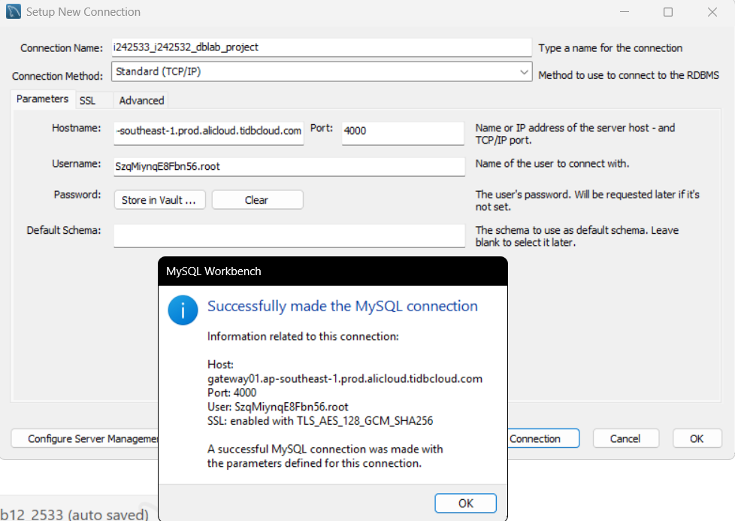
SQL DB Working Proof:
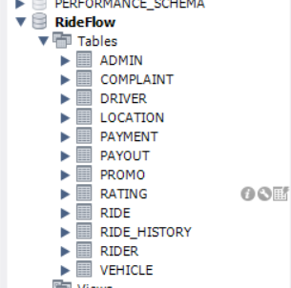

DB On Cloud Proof:
