EXPLORATORY DATA ANALYSIS
REPORT
Titanic Dataset

Prepared by: Ankita Daweshar
Internship: Elevate Labs — Data Analyst Intern
Date: 04 June 2026
Tool: Python (Pandas, Matplotlib, Seaborn)
Dataset: Titanic Dataset (Kaggle)

1. Introduction

Exploratory Data Analysis (EDA) is the process of examining datasets to summarize their main characteristics using visual and statistical methods. It helps analysts understand the structure, patterns, relationships, and anomalies in data before applying any machine learning model or making business decisions.

This report presents a complete EDA performed on the famous Titanic dataset, which contains information about 891 passengers aboard the RMS Titanic that sank on April 15, 1912. The goal is to understand what factors influenced passenger survival.

1.1 Objective
To extract meaningful insights from the Titanic dataset using visual and statistical exploration techniques and identify key factors that influenced passenger survival.

1.2 Scope of Analysis
- Univariate Analysis — distribution of individual variables
- Bivariate Analysis — relationship between two variables
- Multivariate Analysis — interaction among multiple variables
- Statistical Summary — descriptive statistics and correlations
- Data Quality Assessment — missing values and data types

2. Dataset Overview

Source: Kaggle — Titanic Dataset
Records: 891 rows × 12 columns
Target Variable: Survived (0 = Did not survive, 1 = Survived)

2.1 Column Descriptions

Column | Description | Data Type
PassengerId | Unique passenger identifier | Integer
Survived | Survival status (0=No, 1=Yes) | Integer
Pclass | Passenger class (1=1st, 2=2nd, 3=3rd) | Integer
Name | Full name of passenger | String
Sex | Gender of passenger | String
Age | Age in years | Float
SibSp | Number of siblings/spouses aboard | Integer
Parch | Number of parents/children aboard | Integer
Ticket | Ticket number | String
Fare | Passenger fare paid | Float
Cabin | Cabin number | String
Embarked | Port of embarkation (C/Q/S) | String

2.2 Statistical Summary

Metric | Age | Fare | SibSp | Parch
Count | 891 | 891 | 891 | 891
Mean | 29.70 | 32.20 | 0.52 | 0.38
Std Dev | 14.53 | 49.69 | 1.10 | 0.81
Min | 0.42 | 0.00 | 0 | 0
Max | 80.00 | 512.33 | 8 | 6

3. Data Cleaning

Before performing EDA, the dataset was examined for missing values and inconsistencies.

3.1 Missing Values Analysis

Column | Missing Values | % Missing | Action Taken
Age | 177 | 19.9% | Filled with median (28 years)
Cabin | 687 | 77.1% | Dropped — too sparse to be useful
Embarked | 2 | 0.2% | Filled with mode (S = Southampton)

3.2 Missing Values Heatmap

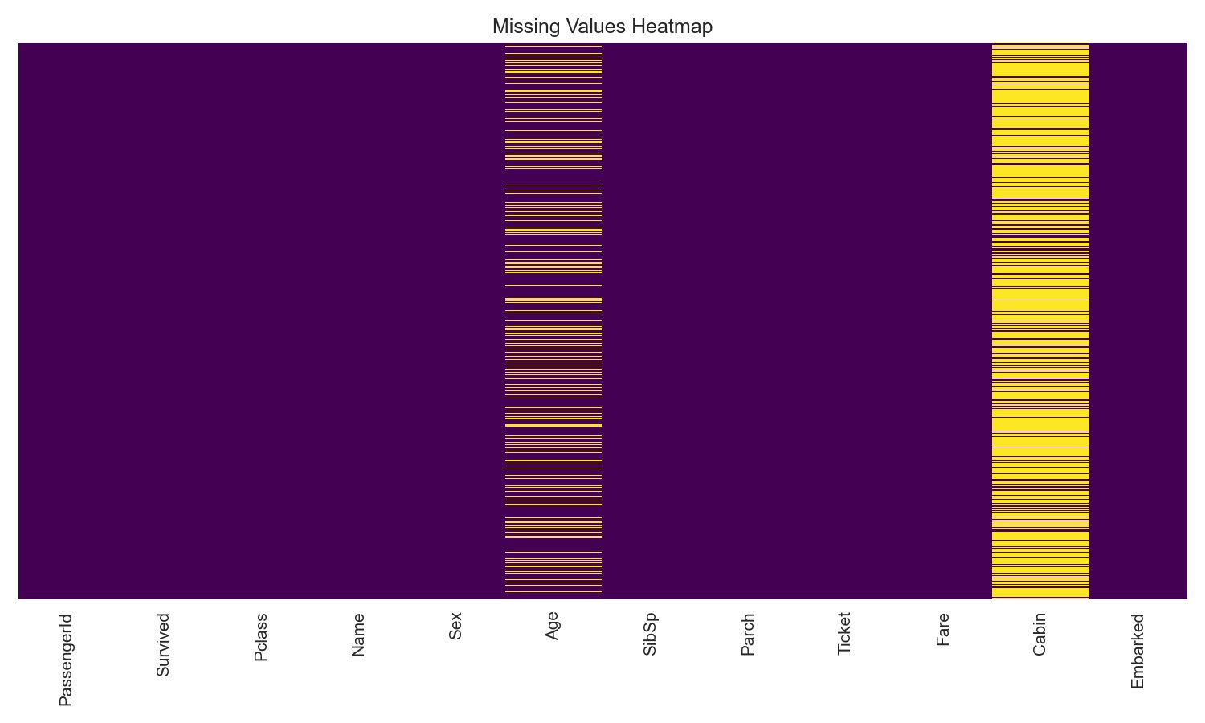

Observations:
- Cabin column had 77% missing values and was dropped entirely
- Age had approximately 20% missing values — filled with median age of 28 years
- Embarked had only 2 missing values — filled with most frequent port S (Southampton)
- After cleaning: 0 missing values remaining in the dataset

4. Univariate Analysis

Univariate analysis examines each variable individually to understand its distribution, central tendency, and spread.

4.1 Survival Distribution

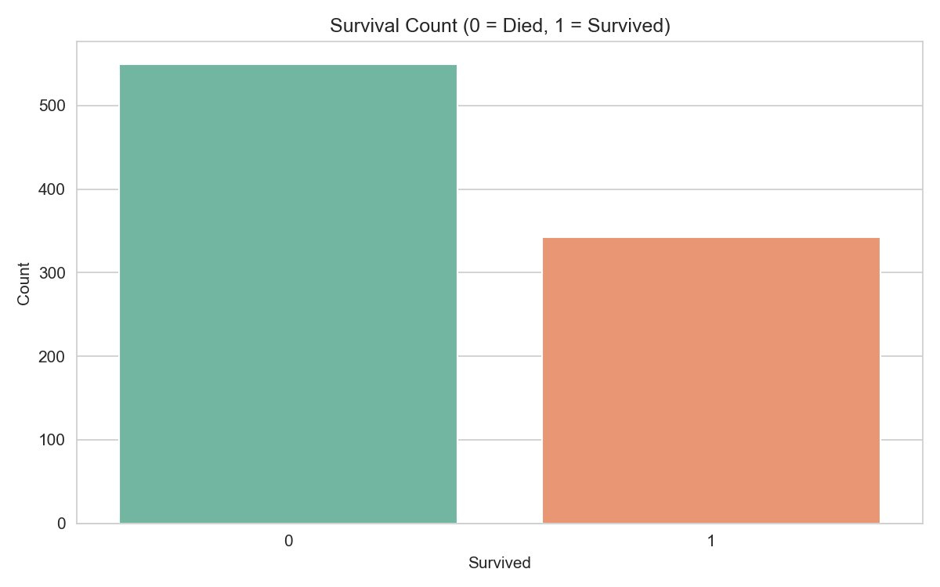

Observations:
- 549 passengers (61.6%) did not survive the Titanic disaster
- 342 passengers (38.4%) survived
- The dataset is slightly imbalanced with more non-survivors than survivors
- This 38% survival rate reflects the historical records of the actual disaster

4.2 Age Distribution

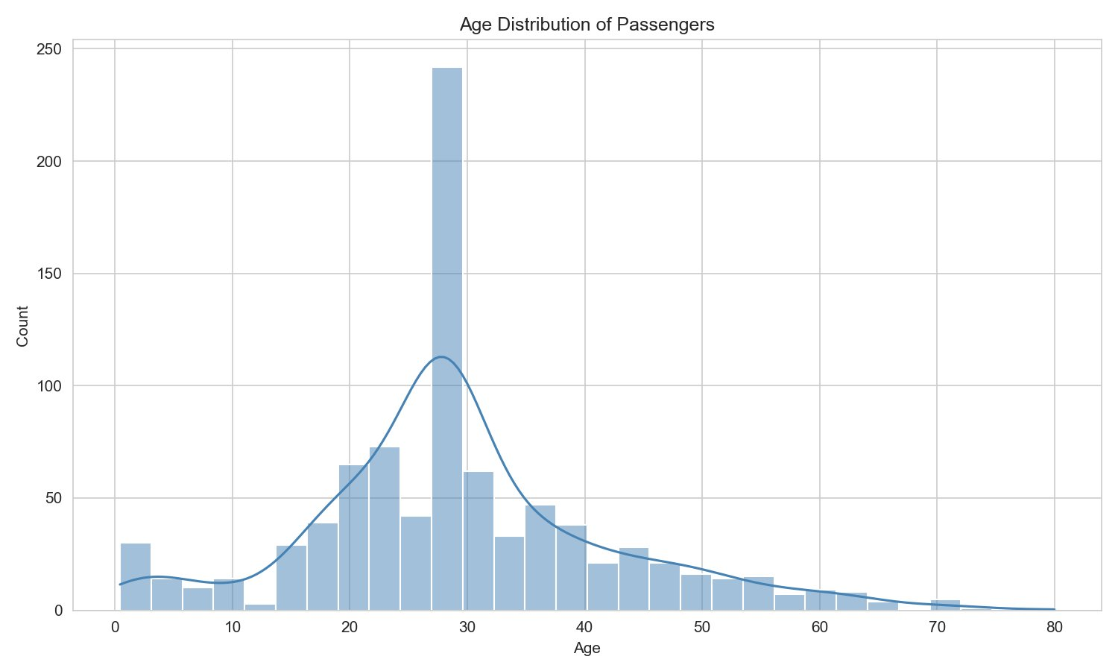

Observations:
- Passenger ages range from 0.4 to 80 years
- Majority of passengers were between 20 and 40 years old
- The distribution is slightly right-skewed with more younger passengers
- There is a notable peak for very young children under 5 years

5. Bivariate Analysis

Bivariate analysis examines the relationship between two variables to identify patterns, trends, and correlations.

5.1 Survival by Passenger Class

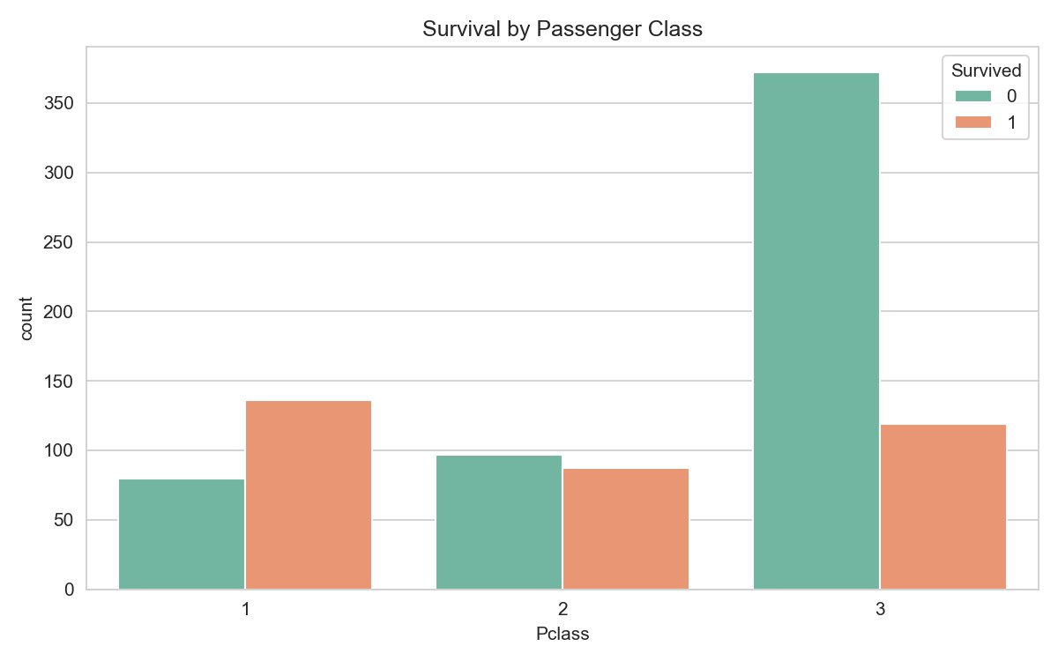

Observations:
- 1st Class survival rate: 62.9% — highest among all classes
- 2nd Class survival rate: 47.3% — moderate survival
- 3rd Class survival rate: 24.2% — lowest survival rate
- Socioeconomic status had a strong influence on survival chances
- 1st class passengers had priority access to lifeboats and better cabin locations

5.2 Survival by Port of Embarkation

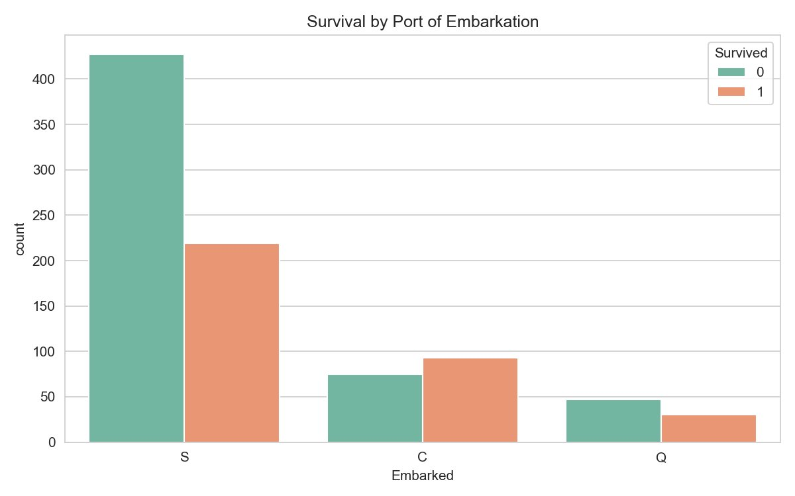

Observations:
- Cherbourg (C): 55.4% survival rate — highest among all ports
- Queenstown (Q): 38.9% survival rate — moderate
- Southampton (S): 33.7% survival rate — lowest
- Cherbourg had a higher proportion of 1st class passengers explaining better survival

6. Multivariate Analysis

Multivariate analysis examines relationships between three or more variables simultaneously.

6.1 Correlation Heatmap

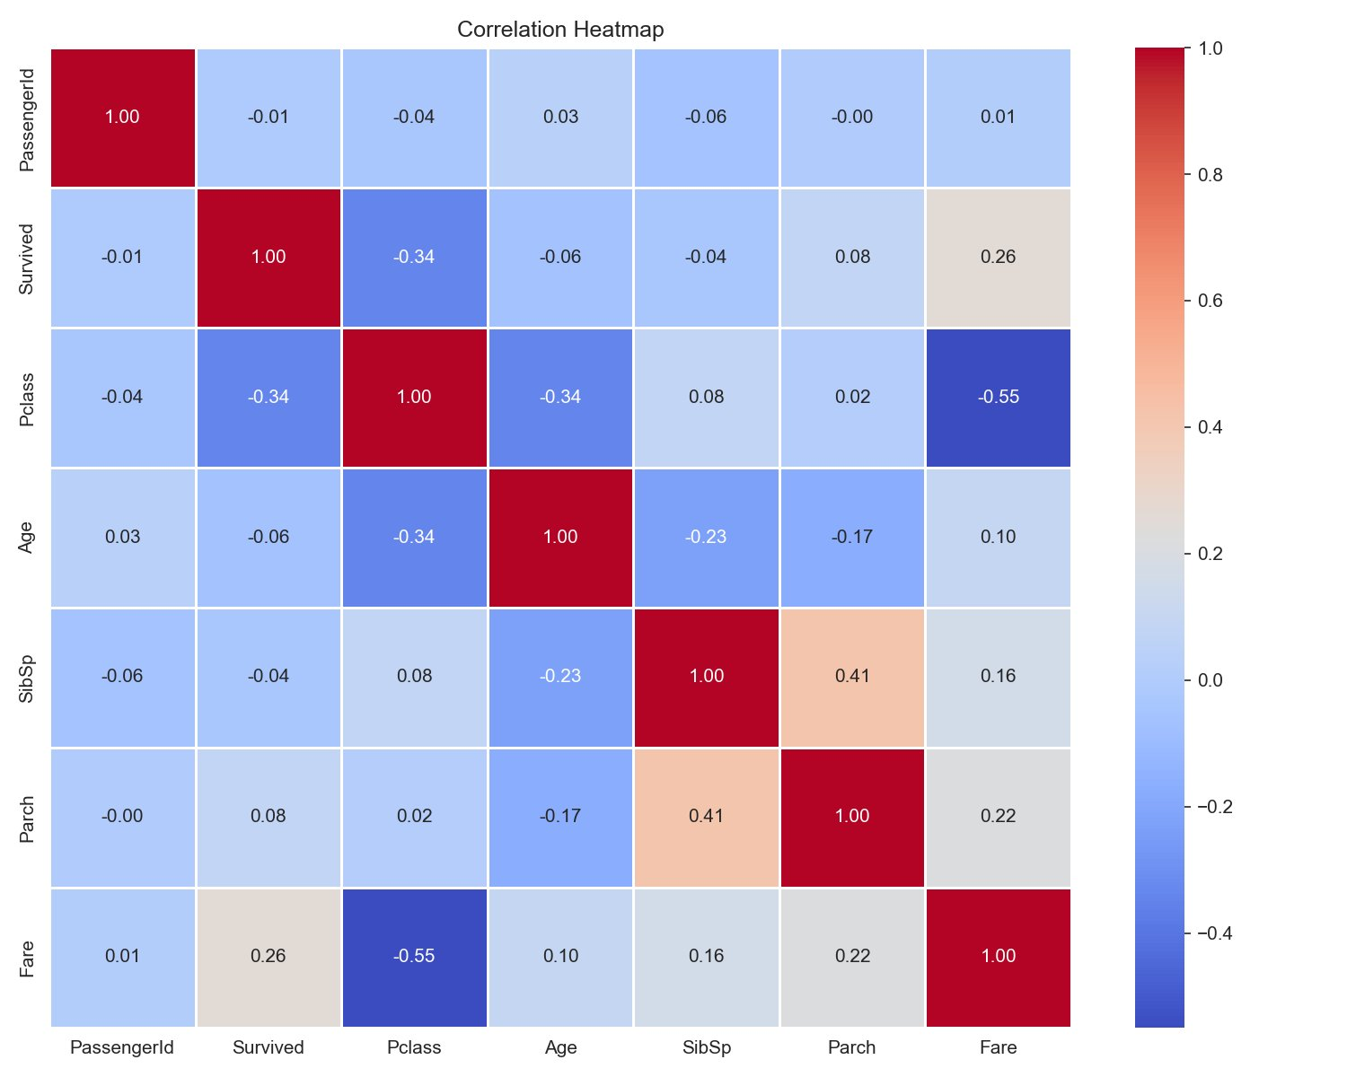

Observations:
- Survived has strong negative correlation with Pclass (-0.34)
- Survived has moderate positive correlation with Fare (0.26)
- Fare and Pclass show strong negative correlation (-0.55)

6.2 Pairplot Analysis

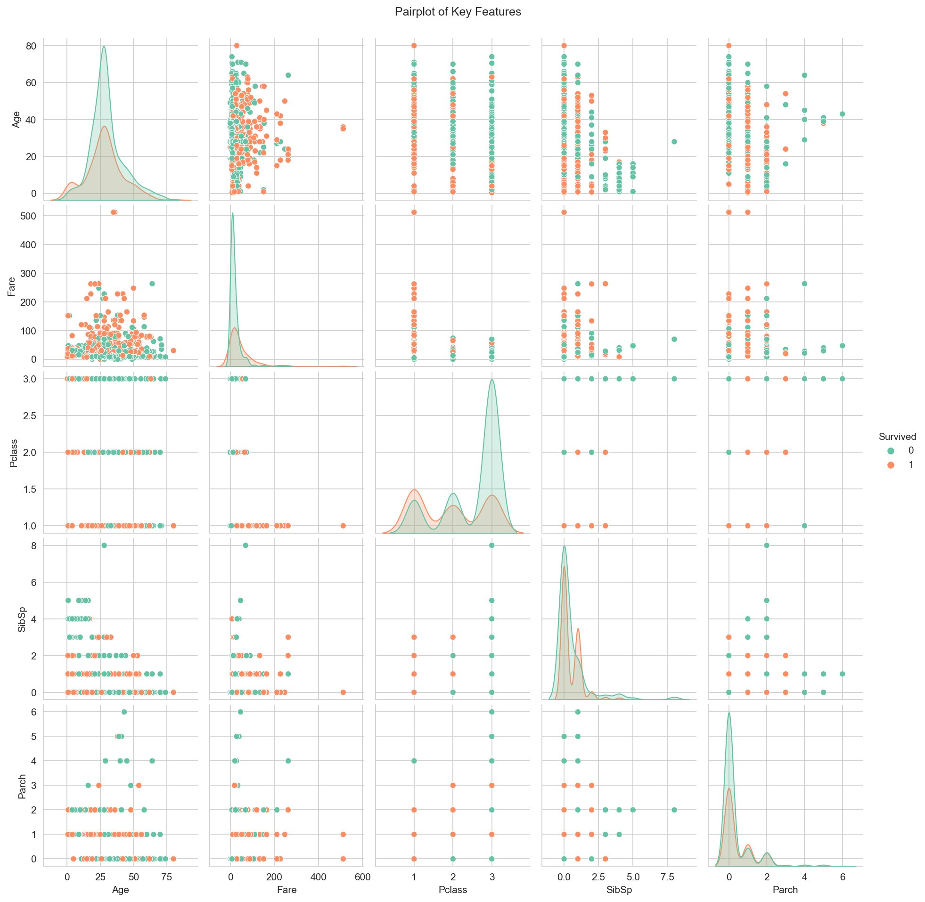

Observations:
- Clear separation between survivors and non-survivors visible in the Fare dimension
- Higher fare passengers strongly cluster in the survival group
- Combined features show much better separation than any individual feature alone

6.3 Violin Plot — Age, Class & Survival

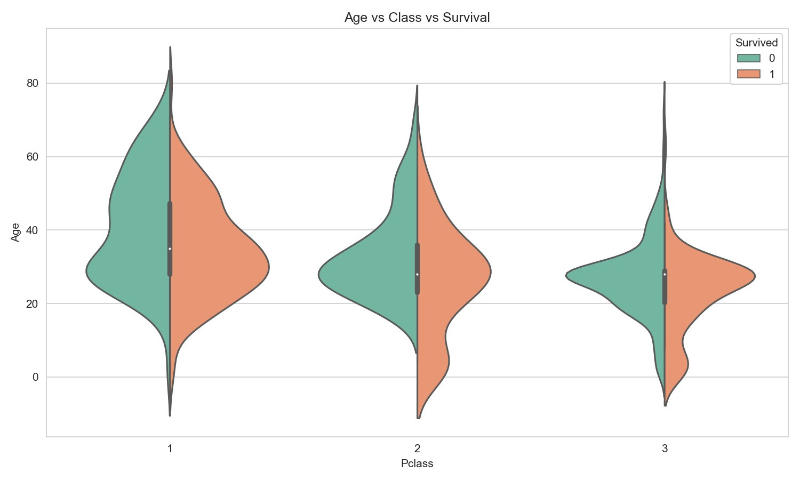

Observations:
- 1st class survivors were distributed across a wide range of ages
- 3rd class non-survivors were heavily concentrated in the 20 to 30 age range
- Children present in all classes with relatively better survival

7. Key Findings, Conclusions & Recommendations

7.1 Summary Table

Factor | Finding | Impact
Overall Rate | 38.4% of passengers survived | Baseline
Class | 1st: 63% | 2nd: 47% | 3rd: 24% | Very High
Age | Children < 10 had higher survival | Moderate
Fare | Higher fare = better survival | High
Embarkation | Cherbourg: 55% | Southampton: 34% | Moderate
Family Size | 1-2 members had best survival | Moderate

7.2 Key Findings
- SURVIVAL RATE — Only 38.4% of all passengers survived the Titanic disaster.
- CLASS IMPACT — 1st: 63% | 2nd: 47% | 3rd: 24%. Passenger class strongly correlated with survival.
- AGE IMPACT — Children under 10 had higher survival. Young males aged 15-35 had the lowest rates.
- FARE IMPACT — Higher ticket fare strongly correlated with survival chances.
- EMBARKATION — Cherbourg passengers had the highest survival rate at 55%.
- CORRELATION — Pclass, Fare, and Age were the most correlated features with survival.
- FAMILY SIZE — Passengers with 1-2 family members survived more than those alone or in large groups.

7.3 Conclusions

The Titanic tragedy revealed stark inequalities in survival chances. The EDA conclusively demonstrates that survival was heavily influenced by a combination of social class, age, fare and embarkation port — all reflections of the social norms and inequalities of the early 20th century.

Women and wealthier passengers had clear survival advantages. Children were given priority during evacuation. These findings highlight how socioeconomic privilege and social norms of the era played a decisive role in determining who survived.

These insights form a strong foundation for building a predictive machine learning classification model to predict passenger survival with high accuracy.

7.4 Recommendations for Further Analysis

- Build a predictive ML model (Logistic Regression, Random Forest) using these features
- Engineer new features such as Title (Mr, Mrs, Miss) extracted from passenger names
- Analyze survival patterns by deck and cabin location
- Apply feature scaling and encoding for a complete machine learning pipeline
- Examine family group survival patterns using family name clusters
- Perform cross-validation and hyperparameter tuning for model optimization

