The bad way to produce styles • Tags such as strong, em, u, and font are discouraged in strict HTML

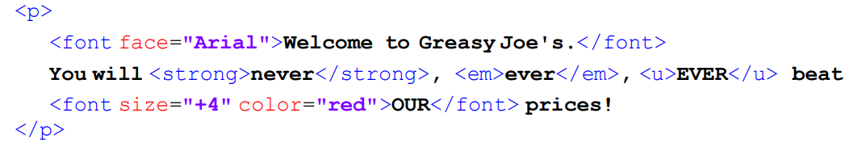

Three ways of using style sheets:

1. Embedding style sheets
2. Inline style sheets
3. Link/external style sheets

Internal stylesheets has higher precedence than the other two. But the precedence of the other two depends on their order in the head section.

Specifying colors

* Color names: aqua, black, blue, fuchsia, gray, green, lime, maroon, navy, olive, purple, red, silver, teal, white, yellow
* RGB & RGBA codes: red, green, and blue values from 0 to 255
* HEX codes: RGB values in base-16 from 00 (none) to FF (full)
* HSL & HSLA codes: HSL stands for hue, saturation, and lightness

Hue is degree on color wheel (from 0 to 360) - 0 (or 360) is red, 120 is green, 240 is blue.

Hsla demo <https://codepen.io/kman/pen/KwapPZ>

