Phil Nevins

ECE 373

Assignment #3

**I.** **PART 1: Digging for Details**

1. **Atomic Motherboards (go boom)**
2. Realtek ALC888
3. Super IO Winbond W83627DHG
4. 2 LAN devices
   * 1. GbE LAN1: Intel 82567V
     2. GbE LAN2: Intel 82583V
5. 6 serial ports. In the specification section we can see it has 3 rear IO 3 (2 of RS-232,1 of RS-232/422/485) serial ports. And it also has 3 (RS-232) internal serial ports.
6. **Network Noodling**

**LAN2 Intel 822583V**

|  |  |
| --- | --- |
| **Signal** | **Pin** |
| LED0 | 31 |
| LED1 | 30 |
| LED2 | 33 |

* 1. Device Control Register offset - 0x00000 / 0x00004
  2. Bit 26 (400000_hex)

1. **Winken, Blinken, and Nod**
   1. 

LED Control – LEDCTL 0x00E00

* 1.   
     

From the above screenshot we can see we write a 1111-bit pattern to the LED1_MODE register bits 11:8 this will turn off LED1 until we write a 1110 to turn the LED1 back on.

* 1. Here we can see we would want to set the LED2_MODE first for constant on we would write 1110 we would then want to set the LED blink mode by writing to LED2_BLINK_MODE bit 21 to set blink timing 1 for 83ms blink and 0 for 200 ms blink then we would write to LED2_BLINK bit 23 and we would write a 1 to turn the led blinking on.

**II. PART 2: Make it Blink**

Source code, typescript file (attempt3) and makefile are in zipped folder with this document

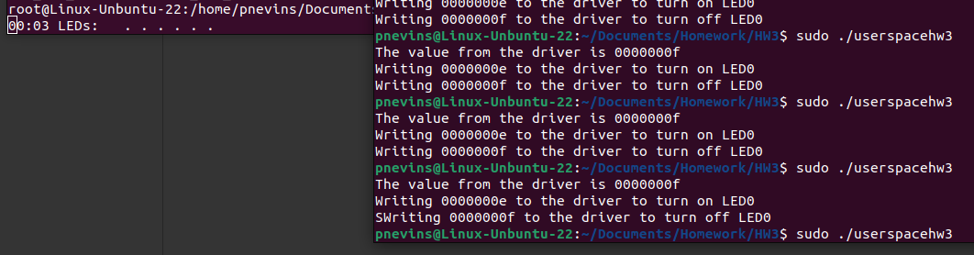  
Before running userspacehw3 (previous ones were tests)  
  
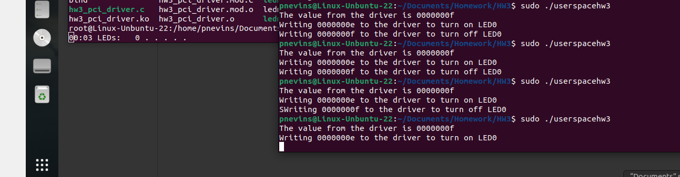  
LED signaled on (by the left most 0)

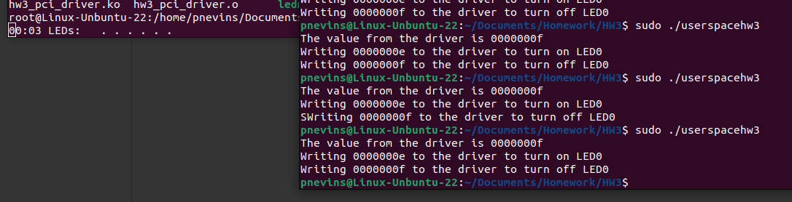  
LED off

