# Project Proposal: FPGA-Based Digital Lock System with Bluetooth Authentication

## 1. Project Title

**Secure FPGA-Based Digital Lock System Using AES-128 Encryption and Bluetooth Communication**

## 2. Team Members

* **Phil Nevins**
* **Nick Allmeyer**

## 3. Introduction

Security and access control systems are crucial in various domains, including home automation, industrial control, and data security. Traditional locks rely on physical keys, which are susceptible to loss or duplication. This project proposes a modern, secure, and convenient digital lock system implemented on an FPGA (Nexys A7) with AES-encrypted authentication over Bluetooth.

The system allows users to unlock a secured mechanism by sending an AES-encrypted PIN from a mobile application to the FPGA via an HC-05 Bluetooth module. The FPGA decrypts the PIN, compares it with a stored valid PIN, and controls a servo motor to unlock or deny access.

## 4. Objectives

The primary objectives of this project are:

1. Develop an FPGA-based secure lock system using AES decryption.
2. Implement a Bluetooth-based authentication mechanism to receive encrypted PINs from a mobile app.
3. Design an AES decryption module in Verilog to verify and decrypt PINs.
4. Integrate a servo motor that physically unlocks or locks based on authentication.
5. Develop a mobile app (Android) that encrypts and sends PINs securely.
6. Implement a UART-based data exchange between FPGA and the mobile app via HC-05.
7. Test and validate the security, response time, and functionality of the system.

## 5. System Overview

The digital lock system consists of three major components:

1. **Mobile App (Android)**
   * User enters a PIN.
   * The app encrypts the PIN using AES-128.
   * The encrypted PIN is sent to the FPGA via Bluetooth (HC-05).
   * Communicates with SQLite database.
   * Stretch Goal: User login with username and password.
   * Stretch Goal: Storing new pins of new users in BRAM.
2. **FPGA-Based Digital Lock**
   * Receives encrypted PIN via Bluetooth UART.
   * Decrypts the PIN using an AES decryption module implemented in Verilog.
   * Compares the decrypted PIN with a stored value in BRAM (Block RAM).
   * If valid, a servo motor unlocks the lock, and an LED indicates access granted.
   * If invalid, the system denies access and logs the failed attempt.
3. **Lock Mechanism**
   * The servo motor rotates to unlock or lock the system.
   * An LED display shows the lock status (OPEN/CLOSED).
   * A time-based auto-lock feature ensures security after a predefined timeout.

## 6. System Architecture & Components

### 6.1 Hardware Components

* Nexys A7-100T FPGA Development Board
* HC-05 Bluetooth Module
* Servo Motor (for physical lock mechanism)
* LED Indicators (status feedback)
* UART Interface (for Bluetooth communication)
* Android Device API35

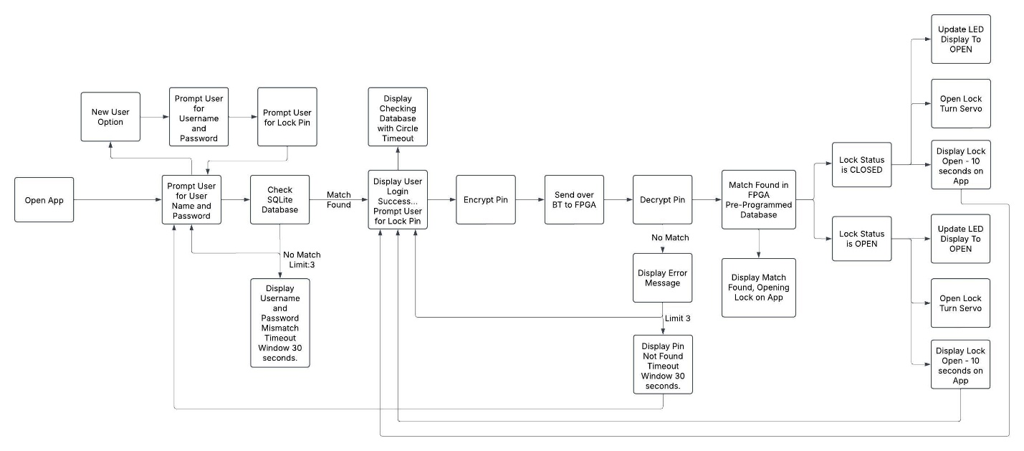

### 6.2 Software Components

* Vivado & Vitis (for FPGA programming and embedded C development)
* Verilog (HDL) (for AES decryption and UART communication)
* Embedded C (MicroBlaze soft processor for testing/debugging)
* Android Studio (Java/Kotlin) (for mobile app development)
* Python (for test encryption)

## 7. Technical Approach

### 7.1 Mobile App (Encryption & Bluetooth Communication)

* Users input a 4- to 6-digit PIN.
* The PIN is AES-128 encrypted using a pre-shared key.
* The encrypted PIN is transmitted via Bluetooth (HC-05).
* The mobile app receives lock status updates from the FPGA.

### 7.2 FPGA-Based AES Decryption

* FPGA receives the encrypted PIN via UART.
* The AES decryption module decrypts the received PIN.
* The decrypted PIN is compared to a stored value in BRAM.
* If correct, the servo unlocks, else access is denied.

### 7.3 Servo Motor Control

* If authentication is successful:
  + The servo rotates to unlock the system.
  + An LED changes state to indicate access granted.
  + The system auto-locks after 10 seconds.

## 8. Expected Challenges & Solutions

| **Challenge** | **Solution** |
| --- | --- |
| Securely storing and retrieving AES keys on FPGA | Implement BRAM-based key storage |
| Bluetooth pairing issues | Use predefined MAC addresses for secure pairing |
| Mobile app security | Use SSL for app-to-FPGA communication |

## 9. Project Milestones, Timeline & Work Split

One person will develop the FPGA hardware to decode the AES-128 key and unlock the servo  
One person will develop the Android App to encode the AES-128 key and receive updates from the FPGA  
Both persons will work together to enable BT communication via HC-05 on UART

## 10. Expected Outcomes

By the end of the project, we expect to achieve:

* A fully **functional FPGA-based digital lock**.
* A **secure AES-128 decryption system** on FPGA.
* A **working mobile app** that encrypts and transmits PINs.
* **Successful hardware integration** with a servo-based locking mechanism.

## 11. Conclusion

This project presents a modern digital lock system that leverages FPGA computing power, AES encryption, and Bluetooth communication for enhanced security and real-time access control. The project will provide insights into hardware security, cryptography, and embedded system design, making it an excellent use case for secure authentication in IoT and embedded applications.

## 12. References

1. **AES-128 Specification**: NIST FIPS PUB 197
2. **HC-05 Bluetooth Module Datasheet**
3. **Xilinx Vivado & Vitis Documentation**
4. **MicroBlaze Soft Processor User Guide**