

See discussions, stats, and author profiles for this publication at: [https://www.researchgate.net/publication/370111799](https://www.researchgate.net/publication/370111799_Systematic_Literature_Review_and_Benchmarking_for_Photovoltaic_MPPT_Techniques?enrichId=rgreq-6bc7a1bb42151643397f62e8691cf4f5-XXX&enrichSource=Y292ZXJQYWdlOzM3MDExMTc5OTtBUzoxMTQzMTI4MTE1MDg0NDg0N0AxNjgxOTE3OTYzNjg3&el=1_x_2&_esc=publicationCoverPdf)

[Systematic Literature Review and Benchmarking for Photovoltaic MPPT Techniques](https://www.researchgate.net/publication/370111799_Systematic_Literature_Review_and_Benchmarking_for_Photovoltaic_MPPT_Techniques?enrichId=rgreq-6bc7a1bb42151643397f62e8691cf4f5-XXX&enrichSource=Y292ZXJQYWdlOzM3MDExMTc5OTtBUzoxMTQzMTI4MTE1MDg0NDg0N0AxNjgxOTE3OTYzNjg3&el=1_x_3&_esc=publicationCoverPdf)

**Article** *in* Energies · April 2023

DOI: 10.3390/en16083509

CITATIONS

5

READS

400

**3 authors:**

[Hsen Abidi](https://www.researchgate.net/profile/Hsen-Abidi?enrichId=rgreq-6bc7a1bb42151643397f62e8691cf4f5-XXX&enrichSource=Y292ZXJQYWdlOzM3MDExMTc5OTtBUzoxMTQzMTI4MTE1MDg0NDg0N0AxNjgxOTE3OTYzNjg3&el=1_x_5&_esc=publicationCoverPdf)

University of Tunis El Manar & University of Luxembourg

**3** PUBLICATIONS **5** CITATIONS

[Lilia Sidhom](https://www.researchgate.net/profile/Lilia-Sidhom-3?enrichId=rgreq-6bc7a1bb42151643397f62e8691cf4f5-XXX&enrichSource=Y292ZXJQYWdlOzM3MDExMTc5OTtBUzoxMTQzMTI4MTE1MDg0NDg0N0AxNjgxOTE3OTYzNjg3&el=1_x_5&_esc=publicationCoverPdf)

ecole nationale d'ingénieurs de bizerte

**76** PUBLICATIONS **315** CITATIONS

[SEE PROFILE](https://www.researchgate.net/profile/Hsen-Abidi?enrichId=rgreq-6bc7a1bb42151643397f62e8691cf4f5-XXX&enrichSource=Y292ZXJQYWdlOzM3MDExMTc5OTtBUzoxMTQzMTI4MTE1MDg0NDg0N0AxNjgxOTE3OTYzNjg3&el=1_x_7&_esc=publicationCoverPdf)

[SEE PROFILE](https://www.researchgate.net/profile/Lilia-Sidhom-3?enrichId=rgreq-6bc7a1bb42151643397f62e8691cf4f5-XXX&enrichSource=Y292ZXJQYWdlOzM3MDExMTc5OTtBUzoxMTQzMTI4MTE1MDg0NDg0N0AxNjgxOTE3OTYzNjg3&el=1_x_7&_esc=publicationCoverPdf)

[Ines Chihi](https://www.researchgate.net/profile/Ines-Chihi-2?enrichId=rgreq-6bc7a1bb42151643397f62e8691cf4f5-XXX&enrichSource=Y292ZXJQYWdlOzM3MDExMTc5OTtBUzoxMTQzMTI4MTE1MDg0NDg0N0AxNjgxOTE3OTYzNjg3&el=1_x_5&_esc=publicationCoverPdf)

[University of Luxembourg](https://www.researchgate.net/institution/University-of-Luxembourg?enrichId=rgreq-6bc7a1bb42151643397f62e8691cf4f5-XXX&enrichSource=Y292ZXJQYWdlOzM3MDExMTc5OTtBUzoxMTQzMTI4MTE1MDg0NDg0N0AxNjgxOTE3OTYzNjg3&el=1_x_6&_esc=publicationCoverPdf)

**81** PUBLICATIONS **775** CITATIONS

[SEE PROFILE](https://www.researchgate.net/profile/Ines-Chihi-2?enrichId=rgreq-6bc7a1bb42151643397f62e8691cf4f5-XXX&enrichSource=Y292ZXJQYWdlOzM3MDExMTc5OTtBUzoxMTQzMTI4MTE1MDg0NDg0N0AxNjgxOTE3OTYzNjg3&el=1_x_7&_esc=publicationCoverPdf)

All content following this page was uploaded by [Hsen Abidi](https://www.researchgate.net/profile/Hsen-Abidi?enrichId=rgreq-6bc7a1bb42151643397f62e8691cf4f5-XXX&enrichSource=Y292ZXJQYWdlOzM3MDExMTc5OTtBUzoxMTQzMTI4MTE1MDg0NDg0N0AxNjgxOTE3OTYzNjg3&el=1_x_10&_esc=publicationCoverPdf) on 19 April 2023.

The user has requested enhancement of the downloaded file.

[energies](https://www.mdpi.com/journal/energies)



*Review*

**Systematic Literature Review and Benchmarking for Photovoltaic MPPT Techniques**

# Hsen Abidi 1,* , Lilia Sidhom 1,2,* and Ines Chihi 3,*

1 Laboratory of Energy Applications and Renewable Energy Efficiency (LAPER), Faculty of Sciences of Tunis, El Manar University, Tunis 1068, Tunisia

2 Mechanical Department, National Engineering School of Bizerte, University of Carthage,

Amilcar 1054, Tunisia

3 Department of Engineering, Faculty of Science, Technology and Medicine, University of Luxembourg, Campus Kirchberg, 1359 Luxembourg, Luxembourg

**\*** Correspondence: [abidi.hsen@fst.utm.tn](mailto:abidi.hsen@fst.utm.tn) (H.A.); [lilia.sidhom@enib.rnu.tn](mailto:lilia.sidhom@enib.rnu.tn) (L.S.); [ines.chihi@uni.lu](mailto:ines.chihi@uni.lu) (I.C.)



**Citation:** Abidi, H.; Sidhom, L.; Chihi, I. Systematic Literature Review and Benchmarking for Photovoltaic MPPT Techniques. *Energies* **2023**, *16*, 3509. <https://doi.org/10.3390/en16083509>

Academic Editor: Carlo Renno

Received: 7 March 2023

Revised: 5 April 2023

Accepted: 12 April 2023

Published: 18 April 2023



**Copyright:** © 2023 by the authors. Licensee MDPI, Basel, Switzerland. This article is an open access article distributed under the terms and conditions of the Creative Commons Attribution (CC BY) license ([https://](https://creativecommons.org/licenses/by/4.0/) [creativecommons.org/licenses/by/](https://creativecommons.org/licenses/by/4.0/) 4.0/).

**Abstract:** There are a variety of maximum power point tracking (MPPT) algorithms for improving the energy efficiency of solar photovoltaic (PV) systems. The mode of implementation (digital or analog), design simplicity, sensor requirements, convergence speed, range of efficacy, and hardware costs are the primary distinctions between these algorithms. Selecting an appropriate algorithm is critical for users, as it influences the electrical efficiency of PV systems and lowers costs by reducing the number of solar panels required to achieve the desired output. This research is relevant since PV systems are an alternative and sustainable solution for energy production. The main aim of this paper is to review the current advances in MPPT algorithms. This paper first undertakes a systematic literature review (SLR) of various MPPT algorithms, highlighting their strengths and weaknesses; a detailed summary of the related reviews on this topic is then presented. Next, quantitative and qualitative comparisons of the most popular and efficient MPPT methods are performed. This comparison is based on simulation results to provide efficient benchmarking of MPPT algorithms. This benchmarking validates that intelligent MPPTs, such as artificial neural network (ANN), fuzzy logic control (FLC), and adaptive neuro-fuzzy inference system (ANFIS), outperform other approaches in tracking the MPPT of PV systems. Specifically, the ANN technique had the highest efficiency of 98.6%, while the ANFIS and FLC methods were close behind with efficiencies of 98.34% and 98.29%, respectively. Therefore, it is recommended that these intelligent MPPT techniques be considered for use in future photovoltaic systems to achieve optimal power output and maximize energy production.

**Keywords:** photovoltaic system; MPPT techniques; systematic literature review; comparative study; simulation results; benchmarking

# Introduction

Global energy consumption is growing faster than global energy production due to increased industrialization, population growth, and better living conditions [1]. According to the International Energy Agency (IEA), global energy consumption will increase by 44% between 2006 and 2030 [2]. Consequently, many countries of the world are switching to promising, socially acceptable, renewable, and sustainable new energy sources, including wind, solar, small hydro, biomass, geothermal, ocean thermal, and tidal energy sources.

Photovoltaic energy is popular among these renewable sources due to its sustain- ability, local availability, environmental friendliness, simple technology, increasing cost- effectiveness, and little system balance. With no moving components or carbon emissions, a PV system uses semiconductor materials to convert sunlight to direct current electricity. PV has now replaced hydropower and wind as the third most important renewable energy source. Currently, ground-mounted or building-integrated PV systems are used in residen- tial, commercial, and grid applications in more than one hundred countries [2]. According

*Energies* **2023**, *16*, 3509. <https://doi.org/10.3390/en16083509> <https://www.mdpi.com/journal/energies>

to the International Energy Agency for Solar Energy Systems (IEA-PVPS), the capacity of globally installed PV systems increased to 227 GW in March 2015 and was expected to reach 500 GW by the end of 2020 [3,4].

Today, the number of installed PV cells is rising rapidly. There are three different kinds of application for these cells: grid-connected systems [5,6], standalone systems [7,8], and hybrid systems [9], which combine PV systems with other types of energy. By 2021, the amount of power generated in the world was around 843.09 GW [10].

It is well known that the curves of current and power as a function of the voltage (Current (I)—Voltage (V) and Power (P)—Voltage (V)) of a PV module are mostly influenced by meteorological characteristics, specifically irradiance and temperature [11]. These characteristics depend on different factors, such as weather conditions and load conditions. Indeed, relatively high cost and low efficiency remain two significant challenges of

PV cells. Therefore, given the economic factors and the rising demand for energy, it is very vital that maximum power is extracted from cells, with optimum economic and energy cost. The most used and efficient approaches for controlling the maximum power point of PV cells are discussed in this study.

A review of the literature shows two main research topics. The first one is defined by the intelligent solutions for predicting weather and/or load conditions. The second one is focused on advanced methods of maximum power point tracking of PV cells. In this paper, we mainly focus on the second research orientation, highlighting the most efficient MPPT methods. In an initial analysis, previous reviews from 2016 to 2020 related to MPPT algorithms for PV systems are studied. These papers have been collected from Science Direct and Web of Science databases.

To show the novelty and added value of this current study, Table 1 presents a sum- mary of other review papers on the same topic as well as a comparison of these papers with the current paper [12–18]. Indeed, 62 MPPT classification algorithms of PV systems are proposed in [12]. In this comparative study, the authors used different properties and characteristics, such as the system complexity, the quantity of sensors, the kind of circuitry (digital or analog), tuning, convergence speed, and parameter dependence. The comparison is quantitative and quite general, and is oriented mainly toward the choice of technology. In [13], the idea of power tracking for PV systems is discussed, and an overview of 40 historical and contemporary MPPT approaches is given. Some of these techniques are mathematically modeled and laid out. This paper presents a clustering of these approaches via five criteria—sensors, speed, stability, type of circuit, and periodic tuning—in order to give an overall idea of the existing methods. Nonetheless, the clustering of MPPT approaches is not of great help for the choice of an MPPT method, especially if the criterion considered is not representative of the classes. Paper [14] presents more than 41 MPPT approaches. Their advantages and drawbacks are also covered based on four cri- teria such as economics, performance, control, and type of circuit, but the study undertakes no systematic review. In [15], the authors review different MPPT strategies and explain their benefits and drawbacks using block and schematic diagrams, operating principles, and algorithms. This review analyzes the input, output, and hidden parameters of MPPT algorithms under steady conditions, rapidly changing conditions, and partial shading conditions (PSCs). Using tables, which mention the kind of MPPT load, the prospective application domains of the articles under review are also covered. This paper presents a few recommendations worth noting, but it does not provide a comparative quantitative analysis. In [16], an orderly and succinct evaluation of MPPT approaches used for PV systems is provided. A few effective techniques are selected and categorized into four groups (Hybrid, Optimized, Intelligent, and Classical) based on the tracking algorithm used to track MPPT under only partial shading conditions (PSCs). This review paper gives several ideas without taking into account a quantitative analysis comparison, a systematic review, or a qualitative analysis comparison.

**Table 1.** Summary of the related reviews on MPPT from 2016 to 2022 and comparison of these reviews with the current review paper.

**Topic of Paper Benchmarking**

**Refs. Year Selected Keywords One-Sentence Summary**

**Systematic Review**

**Quantitative Analysis**

**Qualitative Analysis**

[12] 2016

[13] 2016

MPPT, PV, System efficiency

MPP, MPPT,

PV, converter, power electronics

Review study of

62 MPPT algorithms × ×

**Review**

Overview of 40 old and

recent MPPT methods × ×

Comparative and

[14] 2018 MPPT, PV, PV cell

PV system,

MPPT techniques,

comprehensive review of MPPT methods for

PV cells

Thorough summary of the many MPPT methods

× × ×

[15] 2019

[16] 2020

conventional methods, partial shading,

bio-inspired algorithms

GMPP, MPPT classification, MPPT techniques,

partial PSCs, PV system

that have recently been

developed, modeled, × ×

and/or experimentally verified in PV literature

A detailed examination of the hybrid, optimized,

intelligent, and classical × ×

MPPT techniques

Critical review of some of

[17] 2020 MPPT, PV, grid-connected

GMPPT, PSC, PV system,

the most recent MPPT techniques developed

Present the strengths, weaknesses,

× ×

[18] 2022

The

uniform weather condition, MPPT algorithms.

MPPT techniques, photovoltaic system, converter, systematic

opportunities, and threats (SWOT analysis) of MPPT algorithms.

High-level systematic

× ×

current paper

2023

literature review, state of the art, meta-analysis, comparative study, simulation results, benchmarking.

literature review of MPPT methods

× × × ×

The best-known MPPT algorithms are examined in [17]. The efficiencies of these algorithms are evaluated based on their power extraction and tracking improvements. This evaluation provides some comparative analysis in terms of convergence to MPP, power extraction efficiency, tracking speed, and steady-state oscillation. However, in this comparative study, the environmental conditions for each algorithm are not specified. Hence, the outcome is not conclusive because the results are provided for the general case. In [18], the authors offer a comprehensive evaluation of the strengths, weaknesses, opportunities, and threats (SWOT analysis) associated with MPPT algorithms under only PSC. By doing so, the authors aim to provide researchers and practitioners with a better understanding of the feasibility and limitations of these algorithms. Nevertheless, it is important to note that this review may not fully capture the impact of external factors such as climate change, which can significantly influence the effectiveness and efficiency of MPPT algorithms in real-world applications. As such, further research is needed to explore the potential effects of these factors on the performance of MPPT algorithms in practical settings.

In summary, review papers related to MPPT algorithms have so far paid less attention to a systematic literature review (SLR) and benchmarking based on both quantitative and qualitative analysis.

This current holistic review provides insights not fully covered or evaluated by pre- vious reviews. Its added value consists in its in-depth study of different MPPT methods, in order to select the most optimized one from a technical perspective. In other terms, the main contributions of this review are expounded as follows:

C A systematic review of the MPPT algorithms is given. Previous review papers are discussed, with detailed descriptions showing the advantages and the limitations of the most important MPPT algorithms;

C A comparative study of seven MPPT methods (namely perturb and observe (P&O), incremental conductance (IC), artificial neural network (ANN), fuzzy logic control (FLC), double integral sliding mode control (DISMC), particle swarm optimization (PSO), and adaptive neuro-fuzzy inference system (ANFIS)) is presented using sim- ulations. The main goal is to examine their efficiencies and inaccuracies at steady state in order to set standards for future research in the field of MPPT algorithms with various scenario tests.

C Benchmarking to correctly select the best MPPT for different environmental conditions is also carried out.

The remaining parts of this paper are organized as portrayed in Figure 1. Concretely, Section 2 presents the methodological SLR approach. SLR steps used in various research works on MPPT techniques and their outcomes are explained in detail in Section 3. Lastly, Section 4 concludes with a summary of the important points and offers benchmarking related to the MPPT algorithms.



**1. Introduction**

Summary of the related reviews on MPPT fand comparison of these reviews with the current review paper.

**2. Method Overview**

Steps of Systematic Literature Review (SLR) and meta-analysis studies.

**3. SLR employed on MPPT techniques (2005-2022 )**

**-** Basic classification of MPPT techniques.

**-** Comparison of the MPPT algorithms for PV systems.

**-** Benchmark of MPPT techniques.

**4. Conclusions**

Conclude and recommend.

**Figure 1.** Diagrammatic view of the organization of the paper.

# Method Overview

To perform a replicable and robust literature review, this review uses Mengist et al. (2020)’s methodology [19] to conduct a systematic literature review (SLR), meta-analysis, and benchmarking studies on MPPT techniques.

The systematic literature review (SLR) and meta-analysis are research methodologies that aid in the gathering and analysis of pertinent data on a specific subject. These method- ologies are designed to meet pre-established eligibility requirements and provide solutions to research questions.

Meta-analysis involves the use of statistical techniques, which can be descriptive and/or inferential, to summarize data from various research studies on a particular topic of interest. This methodology helps to generate knowledge from several investigations, both qualitatively and quantitatively. The process consists of six essential steps that aid

in conducting a comprehensive review. Firstly, the research protocol outlines the scope and objectives of the study. Secondly, the search strategy is defined, including the selection of relevant databases and search terms. Thirdly, the appraisal stage involves identifying literature based on pre-defined inclusion and exclusion criteria and assessing its quality. Fourthly, the data is synthesized and categorized to extract key findings. Fifthly, the analysis phase involves narrating the results and drawing conclusions. Finally, the benchmarking stage is where the findings are reported.

Table 2 shows a list of these steps, which are essential for conducting a successful meta- analysis. By following these steps, researchers can ensure that their analysis is thorough and accurate, which is critical for generating high-quality research that can be used to inform decision-making in various fields.

**Table 2.** Steps of SLR and meta-analysis studies.

**N**◦ **Steps Results Methods**

* 1. Protocol Definition of the scope of

the study

Definition of the

* 1. Search research strategy Searching studies

Selection of studies

Formulate research questions

Search for strings Search for databases

Define the criteria for inclusion and

* 1. Appraisal
  2. Synthesis

Assessment of research quality

Data extraction Data classification by categories

exclusion Quality criteria

Extract template

Organize data according to some iterative definition to prepare it for additional analysis.

Description, quantitative categories, narrative analysis, and qualitative

Analysis of the data Results and discussion

5 Analysis

6 Benchmarking Report writing

Conclusion

analysis of the organized data

Show the trends, highlight the gaps, and compare the results based on

the analysis

Summarize the report’s findings Conclude and recommend

# SLR Employed on MPPT Techniques

The following subsections detail the SLR approach used to evaluate the most recent developments in MPPT algorithms.

* 1. *Step 1: Protocol*

In this first step, a research protocol is required for the SLR in order to take into account the features of transparency, transferability, and replication of this study. This step reduces bias by ensuring that detailed literature searches are conducted.

Determining the research scope is the most difficult problem in this step. As soon as the study criteria are established, it becomes easier to choose the best research methodology by developing research questions and study boundaries.

In this study, the refined objectives of the SLR are to assess the state of the art on MPPT algorithms for PV systems. This assessment is defined through the appropriate choice of refined research questions (RQ):

* RQ1: What MPPT techniques are used?
* RQ2: What categories of MPPT techniques are defined?
* RQ3: Which MPPT algorithms have been mostly used on a real test bench?
* RQ4: What kind of converter design is used?
* RQ5: What comparative criteria are used?

These are the research questions that the study would answer by following the SLR method.

* 1. *Step 2: Search*

In this step, the delivery and strategy of the search are presented. The search strategy helps in defining the proper search terms and locating the pertinent databases to gather the necessary material. Although the nature of the issue area heavily influences the number of databases, the number of databases for SLR searches could be set and limited. As a result, the search string definition ought to be based on the terminology used by the SLR program for the population.

To cover the recent research works on the study topic, publication techniques over the last 17 years (2005–2022) have been collected from Web of Science, Google Scholar, IEEE Xplore, Science Direct, Scopus, and other databases. As a result, an initial list of papers was obtained from different publishers, where the Boolean keyword combinations, such as “MPPT Techniques” OR “MPPT Methods” AND “Photovoltaic system” AND “Photovoltaic Power” AND “converter”, have been explored, as shown in Figure 2.

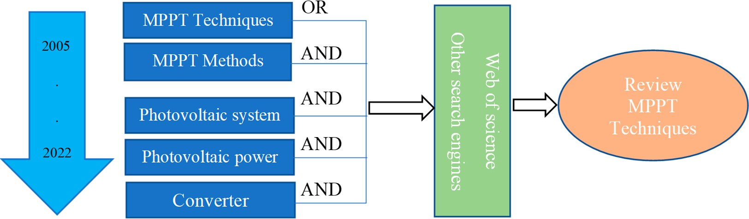

**Figure 2.** Search methodology based on keyword combinations using Boolean operators AND/OR.

Evaluation of the selected papers was carried out according to the answers to the RQs defined in step 1. A descriptive analysis of the identified papers was conducted according to the distribution of the works by year of publication (Figure 3). Figure 3 shows that the number of publications increased until the year 2022; since that time, there has been a significant decrease.

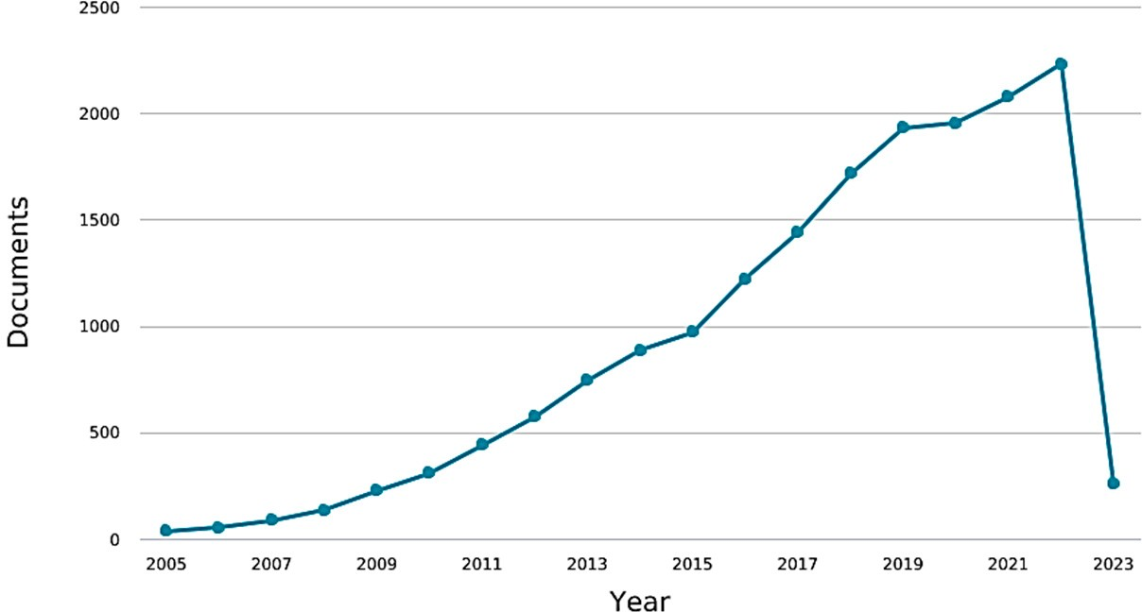

**Figure 3.** Distribution of papers according to year of publication from 2005 to 2023.

Other distributions are given in Figure 4 to show the evolution of MPPT and photo- voltaic use since 1960. This figure presents a timescale variation on the frequency of use of terms “MPPT” and “PV system” in scientific books from Google Books Ngram Viewer. It can be seen that the popularity of MPPT and PV system has significantly increased in recent years.

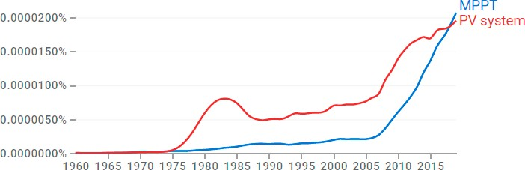

# Year

Frequency

**Figure 4.** Frequency of contrasting word types of MPPT algorithms from 1960 to 2019.

To analyze the effect of keyword information clustering, another visualization was performed based on the bibliometric method using VOSviewer (version 1.6.16.) [20]. This software revealed the different aspects of the treated topic and therefore the set of publi- cations according to the specificity of the keywords. The latter ensures the visualization of bibliometric networks and analysis of big data. In fact, such networks represent a qualitative analysis method that maps scientific papers with similar characteristics into smaller clusters.

Figure 5 is a cartographic analysis performed by VOSviewer. For the five keywords, 2000 publications were identified in the initial search phase. The different keyword combi- nations in the SLR provide an overview of research trends in technical MPPT algorithms for PV systems. The following figure shows that the nodes covering the widest and most noticeable areas are “MPPT” and “maximum power point tracking (mppt)”, which has a smaller size.

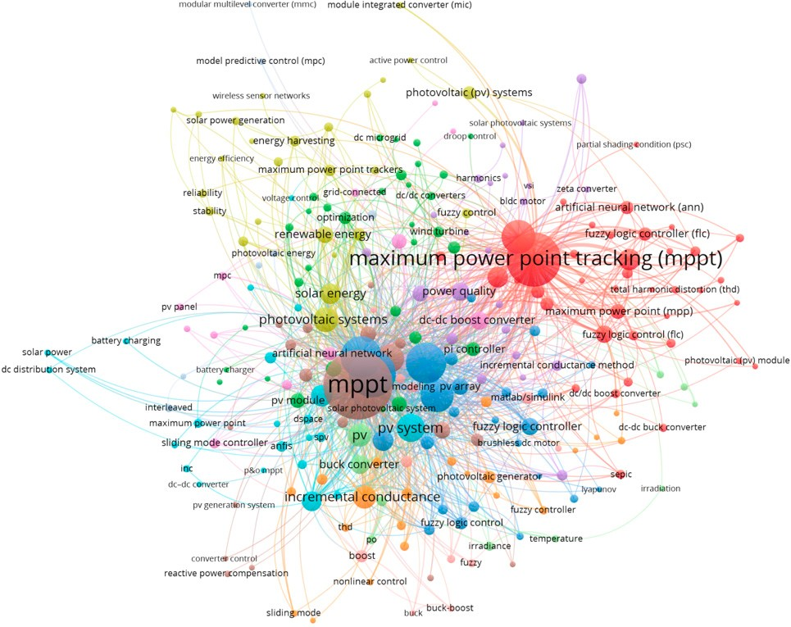

**Figure 5.** Analysis of the author-supplied keywords from 2005 to 2022.

The bibliometric network is described by hubs and edges, where the hubs represent the keywords and the edges define the relationship between keywords. In addition, the hub size represents the frequency of recurrence. The connections between hubs illustrate their co-occurrence in the same paper. Generally, a smaller distance between hubs demonstrates that there is a higher correlation between them. A hub size is larger when the impact of the keyword is greater.

* 1. *Step 3: Appraisal*

The appraisal step involved evaluating the chosen publications based on the objectives of the current review. To find papers relevant to the current review, the selected studies were screened according to the inclusion criteria.

The study’s general screening processes and the flowchart for selecting relevant literature are presented in Figure 6. Initially, a total of 1535 papers were selected. To further narrow down the selection, each paper was screened based on various exclusion criteria such as whether it had an extended abstract, whether it was gray literature, a keynote, a presentation, a book chapter, and/or an inaccessible publication, and whether it was not written in English. This resulted in 1100 papers that were eligible for further title reading. After reading the titles, only 850 articles met the eligibility criteria for abstract reading. From these 850 articles, only 550 publications were left for main body reading. During the main body reading, duplicated papers and articles lacking clear ecosystem service assessment methods were manually removed. As a result, 230 papers were assessed and downloaded for further screening steps. Finally, 110 articles that fulfilled all the inclusion criteria were used for the SLR.



**Figure 6.** Graphical description of paper selection methodology.

* 1. *Step 4: Synthesis*

The synthesis phase involved both the extraction and classification of pertinent data from chosen papers, in order to develop ideas and reach conclusions. Finding and removing pertinent material from the chosen publications was a part of the data extraction procedure. There was coding for SLR and meta-analysis studies, just like in survey research, using the prepared criteria from the chosen publications.

Based on the RQs, the selected papers were analyzed and synthesized according to six structural dimensions as defined in Figure 7.

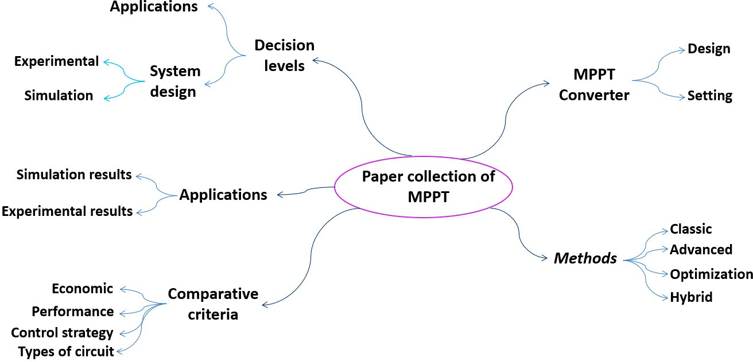

**Figure 7.** Mind map for category selection.

Decision levels: The papers were divided into four decision levels: theoretical, system design, implementation (experimental or simulation), and comparative criteria.

•

Methods: This classification refers to the different kinds of MPPT techniques. The studies were divided into classic, advanced, smart, and hybrid techniques.

•

Converter design: This refers to the type of the converter used by the authors to implement the MPPT solutions, namely buck converter, boost converter, etc.

•

MPPT applications: This refers to the special cases used by some authors based either on simulation results or experimental results for which the kind of experimental context is defined.

•

Comparative criteria: This refers to the criteria used to compare different MPPT techniques and assess their performance.

•

* 1. *Step 5: Analysis*

The evaluation of synthesis data, the extraction of significant material, and drawing conclusions from the chosen papers are all included in this step. The formulated research questions will be answered at this point. This step includes both the qualitative and quantitative interpretation and narration of results, as well as making suggestions for future directions of research projects and drawing conclusions. Descriptive and/or fundamental inferential statistical techniques can be used to synthesize the data from the final list of chosen publications. The nature of the research findings, the types of statistics supplied for each study, and the hypotheses examined by the meta-analysis all influence the types and applications of the statistical methods. This step has two main subsections: Qualitative Analysis and Quantitative Analysis.

* + 1. Qualitative Analysis

The different MPPT methods can be classified into four, viz.: classical, advanced, intelligent, and hybrid. A brief review of the knowledge and understanding of these four concepts is presented in this section. The merits and de-merits of these techniques are discussed and ordered in Table 2.

The challenging factor in the realm of solar energy is the dynamic nature of generating varying power and voltage that depend on environmental circumstances. Conditions such as wind speed, shade, and sun insolation angle are among the factors that influence solar energy generation. As a result, maximum power generation is not assured for all electrical loads [21]. To extract the highest amount of available power from PV systems, MPPT techniques are equipped with appropriate controllers. A variety of MPPT approaches have been proposed in the literature to run PV modules at maximum power. The effectiveness of these approaches is determined by their capacity to track rapidly changing meteoro- logical conditions. Therefore, MPPT classification techniques are highly related to the

control method [22,23]. In addition, the classification is mainly based on how the different techniques track under partial shading conditions (PSCs).

In the literature, there are mainly four classes of MPPT techniques used in PV systems (Figure 8).

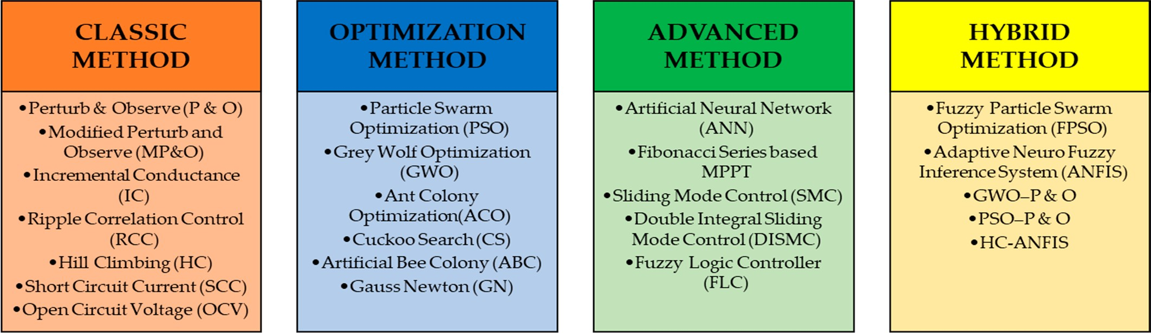

**Figure 8.** Basic classification of MPPT techniques.

Classical MPPT techniques are easy to implement [23,24]. They are most efficient under uniform irradiation conditions since the PV system will then create only one Global MPP (GMPP). These algorithms exhibit fast oscillations around the MPP, resulting in power loss. The major limitation of these traditional techniques is that they ignore the influence of partial shade circumstances. Hence, they fail to track the true MPP for some conditions. A well-known classic MPPT algorithm is the P&O algorithm [25–27]. This algorithm, which utilizes the controller temporarily, struggles to exceed the MPP during a rapid irradiance shift, contributing to a distortion of the operational parameters of the PV system [27]. Still, the controller reduces the algorithm’s inaccuracy, allowing the MPP to be tracked again with a slight delay. Furthermore, at the MPP, the terminal voltage oscillates, leading to power loss. These oscillations can be compensated for by using the least disruptive phase size. The minor phase slows down the initial transient of the algorithm and changes the weather responsiveness of the system. Some improved versions of the P&O algorithm which take into account this drawback have been proposed [26]. Another conventional algorithm that can be cited is the INC algorithm with the proportional integral (PI) controller, which fits well with sudden irradiance changes and reduces rip oscillation across the MPP [26,28]. Because the INC algorithm frequently isolates itself from the MPP during abrupt irradiance variations, the reaction and swing paces would still be balanced. Due to oscillations at the highest point, these algorithms, according to Esram and Chapman [29], are unable to track the all of the power quickly and reliably.

To enhance the basic methods, other classes of MPPT algorithms based on advanced techniques have been proposed in the literature. Among these advanced techniques, there is the sliding mode technique, which has been applied to PV power control [30,31] and provides good performance in a dynamic environment. Algorithms based on optimization tools are also a good alternative to the classical algorithms [23,32].

Such methods are based on the optimization of the response time as well as on the optimal adjustment, allowing good static and dynamic responses. Furthermore, the use of low-cost microcontrollers makes the application of these strategies much easier. For example, the PSO method is a faster tracking algorithm with fewer steady-state oscilla- tions [33,34]. In [35], the authors present the GWO method, which provides the finest evolutionary strategy for system knowledge independence. Cuckoo search-based MPPT is a bio-inspired algorithm that exploits the characteristics of brood parasitism to perform a Levy flight in order to find the best MPP point. ACO and ABC are two techniques that use evolutionary methodologies to track GMPP without the need for temperature or irradiation sensors [36].

Under certain conditions, advanced algorithms find all their interest compared to others based on classic and optimization methods. In [23,37], intelligent-based techniques are designed for high accuracy in dynamic weather conditions. Their tracking efficiency and speed are very high. These methods are also limited by high control circuit complexity

and large data processing for system training. The FLC method [38,39] has two principal advantages over other techniques: first, the exact mathematical model of the system is not required; second, the design of the controller depends only on human knowledge. Human expertise is used in the design of fuzzy rules, which is a three-part primary component. Typically, the fuzzy technique consists of three steps: fuzzification, rule-based query table (fuzzy rules) and defuzzification. Another technique is the ANN, which is a faster tracking technique but requires a large amount of data for training to improve tracking accuracy [40–42]. It takes dynamic irradiation and temperature as inputs and saves them as data sets. Fibonacci [43] and Gauss-Newton [44] are two smart approaches that are gaining in popularity due to their ability to track MPP by updating the searching range in real time.

These smart methods are intended for MPP tracking with high accuracy in changing and dynamic meteorological conditions. They have very high tracking efficiency and speed. These techniques also suffer from a great complexity of the control circuits and treatment of big data for prior formation of the system.

Recently, classical MPPTs have been combined with intelligent or advanced MPPTs in hybrid-based MPPT approaches [45,46]. The principle of the best mix of intelligent and advanced algorithms is based on two stages: estimation of the MPP in the first stage and fine-tuning of that MPP using advanced methodologies in the second stage. First, the MPP is located on the P-V curve using conventional methods. The goal of this stage is to get the setpoint as close to the MPP as possible. Second, using advanced procedures, the setpoint is produced to reach the actual MPP. P&O-ANN and IC-ANN are two hybrid MPPTs that use deep learning (DL) training and building blocks to interact with the controller. To get the most energy from the PV system, it is trained using a greedy layer-wise pattern. The deep neural network is then fine-tuned via backpropagation and supervised learning using classical MPPT-IC and P&O to achieve maximum power [47]. The adaptive neuro-fuzzy inference system (ANFIS), which combines ANN and FLC, is another hybrid MPPT. For smart power management and solar power systems, ANFIS and fuzzy logic are ideal, versatile, and adaptable to any new configuration [48]. To imitate the fuzzy technique required to learn all the information about a dataset, neuro-adaptive learning is used. ANFIS uses input–output datasets to develop a fuzzy inference system (FIS). The membership function parameters that offer the best fit for tracking the input–output data are calculated by the model [49]. A hybrid learning strategy that involves backpropagation and least squares algorithms is used to alter the parameters of the fuzzy membership function [50]. MPPT based on ANFIS has been shown to improve solar energy system conversion efficiency [51].

To conclude, the hardware implementations of these MPPT approaches are scarcely touched upon in the literature. Therefore, an effort is made to research and talk about the hardware and software platforms for these strategies. Their tracking speeds are used, as well as their efficacy. Specifically, all classical algorithms have lower algorithm complexity and slower tracking speeds than other methods, making them the most trustworthy under conditions of uniform irradiation. Since they are the best techniques for MPP tracking in varying irradiation conditions, intelligent techniques are gaining popularity in this era. They are also more efficient at tracking, sensing, and storing enormous amounts of data, thereby simplifying systems by removing the need for mathematical calculations. Furthermore, advanced methods work well with any system without needing to be aware of the PV panel specifications. The best thing about these methods is that, because they use bio-inspired algorithms, they can be used in any PV system without knowing anything about it. This review includes modernized hybrid approaches, which are very effective in tracking the MPP and substantially lighten the computational load. Furthermore, due to their speed and extreme precision, these hybrid approaches are used to control modern, complex applications.

The advantages and weaknesses of different MPPT techniques in the literature are summarized in Table 3.

**Table 3.** Comparison of the MPPT algorithms for PV systems.

**Kategoria Metoda Year Odwołania Plusy Słabości**

Zaburzanie i obserwowanie (P&O)

2020 [25,26,28,52–54]

1. **Prosty projekt:** Metoda MPPT typu P&O jest jednym z najprostszych algorytmów MPPT, co ułatwia jej implementację w małych systemach fotowoltaicznych.
2. **Niski koszt:** Metoda P&O jest również ekonomiczna, co czyni ją idealnym rozwiązaniem dla systemów PV o małej skali.
3. **Szybki czas reakcji:** Algorytm MPPT typu P&O jest zdolny do szybkiej reakcji na zmiany warunków pracy systemu PV, zapewniając maksymalne wydobycie mocy.
4. **Wysoka wydajność:** Metoda MPPT typu P&O może skutecznie śledzić maksymalny punkt mocy i utrzymywać wysoką wydajność nawet w zmieniających się warunkach pogodowych
5. **Oscylacje w pobliżu maksymalnego punktu mocy:** Metoda MPPT typu P&O może powodować oscylacje w pobliżu maksymalnego punktu mocy, co prowadzi do zmniejszenia wydajności i problemów ze stabilnością.
6. **Wolna zbieżność:** Metoda MPPT typu P&O może zbiegać wolno, szczególnie gdy warunki pracy zmieniają się szybko.
7. **Slaba wydajność w warunkach częściowego zacienienia:** Metoda MPPT typu P&O może nie sprawdzać się dobrze w warunkach częściowego zacienienia, prowadząc do zmniejszenia wydajności i problemów ze stabilnością.
8. **Czułość na wybór parametrów:** Metoda MPPT typu P&O jest wrażliwa na dobór rozmiaru kroku perturbacji, dlatego konieczne jest dokładne dostrojenie parametrów dla optymalnej wydajności.

Zmodyfikowane zaburzanie i obserwowanie (MP&O)

**Classical**

2018 [55,56]

1. **Prosta implementacja:** Algorytm MP&O jest stosunkowo prosty w implementacji, co sprawia, że jest popularnym wyborem dla małych i średnich systemów PV.
2. **Szybkie śledzenie:** MP&O jest szybką metodą MPPT, co sprawia, że jest odpowiednia dla szybko zmieniających się warunków pogodowych i wymagań obciążenia.
3. **Odporność:** MP&O jest stosunkowo odporny na zmiany parametrów systemu, co sprawia, że jest stabilny w różnych warunkach pracy.
4. **Niski koszt:** MP&O to tania metoda MPPT, co czyni ją ekonomicznym wyborem dla systemów PV o ograniczonym budżecie.
5. **Oscylacje:** Metoda MP&O może oscylować w pobliżu maksymalnego punktu mocy, co powoduje, że system pracuje na poziomie mocy suboptymalnej.
6. **Lokalne maksimum:** Metoda MP&O może utknąć w lokalnym maksimum zamiast globalnego maksymalnego punktu mocy, co prowadzi do zmniejszenia generacji mocy.
7. **Zakłócone sygnały:** Algorytm MP&O może mieć trudności ze śledzeniem maksymalnego punktu mocy w obecności zakłóceń sygnałów, co prowadzi do suboptymalnej wydajności.
8. **Niewystarczająca wydajność w warunkach słabego oświetlenia:** Metoda MP&O może mieć trudności ze śledzeniem maksymalnego punktu mocy w warunkach słabego oświetlenia, co prowadzi do zmniejszenia generacji mocy.

**Table 3.** *Cont.*

**Kategoria Metoda Year Odwołania Plusy Słabości**

Inkrementalna przewodność (IC)

**Classical**

2015

Kontrola korelacji falowania

(RCC)

2017 [57–60]

* 1. **Szybka prędkość śledzenia:** Metoda IC to szybka technika MPPT, co jest istotne w przypadku szybko zmieniających się warunków środowiskowych, takich jak zacienienie lub zmieniająca się temperatura.
  2. **Prosty projekt:** Metoda IC ma prosty projekt i nie wymaga dużej mocy obliczeniowej, co czyni ją atrakcyjną opcją dla małych systemów PV.
  3. **Wysoka wydajność:** Metoda IC jest znana z wysokiej wydajności i może skutecznie wydobywać maksymalną moc z panelu PV.

1. **Prosta implementacja:** Metoda śledzenia maksymalnej mocy RCC jest stosunkowo prosta do wdrożenia i nie wymaga złożonych algorytmów ani obliczeń matematycznych, co czyni ją **ekonomicznym rozwiązaniem dla systemów PV.**
2. **Wysoka dokładność:** Metoda RCC posiada zdolność do precyzyjnego śledzenia punktu maksymalnej mocy, nawet w warunkach szybko zmieniających się, co sprawia, że jest to niezawodna metoda śledzenia maksymalnej mocy (MPPT).
3. **Szybkie śledzenie:** Metoda śledzenia maksymalnej mocy RCC jest szybka w śledzeniu punktu maksymalnej mocy, ponieważ wymaga tylko niewielkich inkrementalnych zmian w punkciepracy, aby osiągnąć punkt maksymalnej mocy.
4. **Odporność:** Metoda RCC jest odporna na zmiany parametrów i niewrażliwa na fluktuacje warunków pracy panelu PV, co czyni ją odpowiednią do stosowania w trudnych warunkach środowiskowych.
5. **Wrażliwość na szumy:** Metoda IC jest wrażliwa na szumy pomiarowe, co może prowadzić do oscylacji i niestabilności wokół punktu maksymalnej mocy (MPP).
6. **Ograniczony zakres dynamiczny:** Metoda IC może działać tylko w ograniczonym zakresie MPP, co może skutkować suboptymalną wydajnością, gdy panel PV pracuje w skrajnych warunkach.
7. **Słaba wydajność w warunkach zacienienia:** Metoda IC może mieć trudności ze śledzeniem MPP dokładnie w warunkach zacienienia, co może prowadzić do zmniejszenia mocy wyjściowej.
8. **Wrażliwość na szumy:** Metoda śledzenia maksymalnej mocy RCC jest wrażliwa na szumy w mocy wyjściowej panelu PV, co może wpłynąć na jej dokładność i wydajność.
9. **Ograniczony zakres dynamiczny:** Metoda RCC ma ograniczony zakres dynamiczny i może nie być odpowiednia do użytku w systemach o szerokim zakresie warunków pracy.
10. **Ograniczona wydajność:** Metoda RCC może nie być tak efektywna jak inne metody śledzenia maksymalnej mocy, ponieważ wymaga większej liczby komponentów elektroniki mocy do implementacji i może prowadzić do większych strat mocy.
11. **Ograniczona kompatybilność:** Metoda RCC może nie być kompatybilna z pewnymi typami paneli PV, ponieważ opiera się na obecności charakterystycznego falowania w mocy wyjściowej panelu.

**Table 3.** *Cont.*

**Kategoria Metoda Year Odwołania Plusy Słabości**

Wspinaczka (HC) 2012 [64,65]

* 1. **Prosty w implementacji:** Metoda wspinaczkowa (Hill Climbing) jest łatwa do wdrożenia, ponieważ nie wymaga złożonych algorytmów ani obliczeń matematycznych, co czyni ją odpowiednią do zastosowań niskokosztowych.
  2. **Szybkie śledzenie:** Metoda wspinaczkowa (Hill Climbing) jest stosunkowo szybka w śledzeniu punktu maksymalnej mocy w porównaniu z innymi metodami MPPT. Sprawia to, że jest idealna do zastosowań, gdzie warunki pracy paneli słonecznych zmieniają się szybko.
  3. **Odporność:** Metoda wspinaczkowa (Hill Climbing) jest stosunkowo odporna w porównaniu z innymi metodami śledzenia maksymalnej mocy (MPPT), co sprawia, że jest mniej podatna na błędy i awarie w systemie.

**Classical**

1. **Punkt maksymalny lokalny:** Metoda wspinaczkowa ma tendencję do utknięcia w lokalnym punkcie maksymalnej mocy zamiast globalnego punktu maksymalnej mocy. Może to prowadzić do zmniejszenia wydajności i mocy wyjściowej.
2. **Wolna zbieżność:** Metoda wspinaczkowa może być wolna w zbieganiu do punktu maksymalnej mocy, zwłaszcza w systemach, gdzie warunki pracy szybko się zmieniają.
3. **Wrażliwość na szumy:** Metoda wspinaczkowa jest wrażliwa na szumy pomiarowe, co może prowadzić do błędów i zmniejszenia wydajności systemu.

Short Circuit Current (SCC)

2017 [66,67]

1. **Wysoka dokładność:** Metoda śledzenia maksymalnej mocy za pomocą prądu zwarcia zapewnia bardzo dokładne śledzenie punktu maksymalnej mocy, co prowadzi do wysokiej wydajności systemu PV.
2. **Prosta implementacja:** Metoda śledzenia maksymalnej mocy za pomocą prądu zwarcia jest stosunkowo prosta do wdrożenia, ponieważ wymaga tylko monitorowania prądu zwarcia tablicy PV.
3. **Opłacalność:** Metoda śledzenia maksymalnej mocy za pomocą prądu zwarcia jest opłacalna w porównaniu z innymi metodami śledzenia maksymalnej mocy, ponieważ nie wymaga złożonych algorytmów ani drogich komponentów.
4. **Ograniczona zastosowalność:** Metoda śledzenia maksymalnej mocy za pomocą prądu zwarcia ma ograniczoną zastosowalność, ponieważ działa dobrze tylko w określonych warunkach, takich jak proporcjonalność prądu zwarcia do maksymalnej mocy.
5. **Wrażliwość na zacienienie:** Metoda śledzenia maksymalnej mocy za pomocą prądu zwarcia jest wrażliwa na zacienienie. Nawet zacienienie małej części tablicy PV może znacznie zmniejszyć prąd zwarcia, powodując śledzenie nieprawidłowego punktu maksymalnej mocy.
6. **Zmniejszona wydajność w warunkach słabego oświetlenia:** Metoda śledzenia maksymalnej mocy za pomocą prądu zwarcia ma zmniejszoną wydajność w warunkach słabego oświetlenia, ponieważ prąd zwarcia maleje wraz ze spadkiem poziomu światła, co może spowodować śledzenie nieprawidłowego punktu maksymalnej mocy.

**Table 3.** *Cont.*

**Kategoria Metoda Year Odwołania Plusy Słabości**

* 1. **Niewydajny w warunkach zmieniających się:** Metoda OCV MPPT nie nadaje się dobrze do śledzenia punktu maksymalnej mocy w warunkach zmieniających się,

Napięcie obwodu otwartego (OCV)

1. **Prostota:** Metoda OCV MPPT jest łatwa w implementacji, ponieważ nie wymaga złożonych algorytmów ani specjalistycznego sprzętu kontrolnego. To zmniejsza koszty systemu i czyni go bardziej dostępnym dla aplikacji o mniejszej skali.
2. **Odporność:** Metoda OCV MPPT jest stosunkowo odporna w porównaniu z innymi metodami MPPT, ponieważ nie polega na dokładnych informacjach o charakterystykach prądowych lub mocy systemu. Sprawia to, że jest bardziej niezawodna w aplikacjach, gdzie warunki środowiskowe mogą się szybko lub nieprzewidywalnie zmieniać.

2017 [13,14]

1. **Wysoka dokładność:** Metoda OCV MPPTmethod jest bardzo dokładna w znajdowaniu punktu maksymalnej mocy, zwłaszcza w stabilnych warunkach pracy.

takich jak zmieniająca się temperatura, nasłonecznienie słoneczne czy warunki zacienienia. Może to skutkować niższą wydajnością systemu i zmniejszonym wyjściem mocy..

1. **Wolne czas odpowiedzi:** Metoda OCV MPPT może reagować wolno na zmiany w punkcie maksymalnej mocy, ponieważ opiera się na monitorowaniu napięcia obwodu otwartego, które jest wartością wolnozmienną.
2. **Ograniczony zakres napięcia:** Metoda OCV MPPT jest ograniczona do określonego zakresu napięcia, poza którym staje się mniej dokładna. Sprawia to, że jest mniej odpowiednia dla systemów o wysokich wymaganiach napięciowych lub mocy.
3. **Ograniczona do małych systemów:** Metoda OCV MPPT jest zazwyczaj ograniczona do systemów małej skali i może nie być odpowiednia dla instalacji dużych, gdzie wymagane są bardziej zaawansowane metody MPPT.

**Table 3.** *Cont.*

**Kategoria Metoda Year Odwołania Plusy Słabości**

Optymalizacja Rojem Cząstek (PSO)

**Optimized**

2022 [68–72]

1. **Prosta implementacja:** Algorytm PSO jest stosunkowo prosty w implementacji, co zmniejsza złożoność systemu sterowania MPPT i ułatwia jego integrację z systemem PV.
2. **Wysoka szybkość zbieżności:** PSO charakteryzuje się wysoką szybkością zbieżności, co oznacza, że może szybko znaleźć punkt maksymalnej mocy systemu PV, skracając czas potrzebny do śledzenia maksymalnego punktu mocy.
3. **Optymalizacja globalna:** PSO jest zdolny do globalnej optymalizacji, co oznacza, że może znaleźć maksymalny punkt mocy nawet jeśli znajduje się daleko od punktu startowego.
4. **Odporność:** Algorytm PSO jest stosunkowo odporny, co oznacza, że może radzić sobie z zmianami w środowisku i parametrach systemu PV bez znacznego pogorszenia wydajności.
5. **Adaptacyjność:** PSO może dostosować się do różnych typów systemów PV i środowisk, co sprawia, że jest odpowiedni do stosowania w szerokim zakresie aplikacji.

**Wrażliwość na warunki początkowe:** PSO jest wrażliwe na warunki początkowe, co może wpłynąć na zbieżność algorytmu i dokładność wyników MPPT.

1. **Obciążenie obliczeniowe:** Algorytm PSO wymaga wysokiego obciążenia obliczeniowego, co może być wyzwaniem dla systemów z ograniczonymi zasobami obliczeniowymi.
2. **Wybór parametrów:** PSO wymaga ostrożnego doboru parametrów, takich jak liczba cząstek i współczynniki wagowe, aby osiągnąć optymalną wydajność.
3. **Zbieżność do optimum lokalnego:** PSO może zbiegać do optimum lokalnego zamiast globalnego, co może skutkować suboptymalnymi wynikami MPPT.
4. **Złożoność:** Algorytm PSO może być skomplikowany, szczególnie gdy zaangażowane są multiple cele, co sprawia, że projektowanie i implementacja go w praktycznych zastosowaniach stanowi wyzwanie.

**Table 3.** *Cont.*

**Category Method Year References Advantages Weakness**

Grey Wolf Optimization (GWO)

**Optimized**

2014 [73]

* 1. **Global optimization:** GWO is a global optimization algorithm, which means that it can efficiently search for the global optimal solution for the MPPT problem in a PV system.
  2. **Fast convergence:** GWO is a relatively fast optimization algorithm, and it can quickly find the

optimal solution for the MPPT problem in a PV system.

* 1. **Simple and easy to implement:** GWO is a simple

algorithm that can be easily implemented in a PV system, making it a convenient choice for real-time MPPT applications.

* 1. **Robustness:** GWO is a robust optimization

algorithm, which means that it is less affected by the presence of local optima and can still find the global optimal solution in a PV system.

1. **Sensitivity to initial conditions:** GWO is sensitive to the initial conditions, and the choice of the initial conditions can greatly affect the final results.
2. **Not suitable for complex problems:** GWO may

not be suitable for solving complex problems, such as those with a high number of variables or nonlinear relationships.

1. **Reliance on random search:** GWO relies heavily

on random search, which may not be as efficient as other optimization methods such as gradient-based methods in certain situations.

1. **Lack of theoretical guarantees**: Although GWO is

an effective optimization algorithm, it lacks theoretical guarantees, such as convergence or optimality, making it more of an

empirical approach.

Ant Colony Optimization (ACO)

2015 [74]

* 1. **Robustness:** The ACO algorithm is robust and can effectively track the MPP under different environmental conditions, such as changes in temperature and insolation.
  2. **Convergence speed:** The ACO MPPT method has a fast convergence speed, which means that it can

quickly find the MPP even under rapidly changing conditions.

* 1. **Improved efficiency:** ACO MPPT can improve the

overall efficiency of a PV system by tracking the MPP more accurately, leading to higher power output and better energy conversion.

* 1. **Global optimization:** The ACO algorithm is

capable of global optimization, meaning that it can find the MPP from a large search space, rather than being restricted to a narrow range of

operating points.

1. **Complexity:** The ACO algorithm is complex and requires a high level of computational power, which can be challenging for small or low-cost PV systems.
2. **Memory requirements:** The ACO algorithm requires a large amount of memory to store the

information needed to perform its calculations, which can be a challenge for systems with limited memory resources.

1. **Real-time performance:** The ACO MPPT method

may not perform well in real-time applications, as it may take longer to find the MPP than

other methods.

1. **Implementation challenges:** Implementing the ACO MPPT method can be challenging, as it requires specialized knowledge and skills in both photovoltaics and artificial intelligence.

**Table 3.** *Cont.*

**Category Method Year References Advantages Weakness**

* 1. **Global optimization:** Cuckoo Search is a

meta-heuristic optimization algorithm that can

effectively search the global optimum solution in complex search spaces, making it well-suited for finding the maximum power point in a PV system.

* 1. **Fast convergence:** The algorithm has fast

convergence speed compared to other optimization algorithms, which is important in real-time MPPT applications where the maximum power point changes rapidly with changes in environmental

|  |  |  |
| --- | --- | --- |
| Cuckoo Search | 2013 | 1. conditions. mathematical model, which can be difficult to    1. **Simple implementation:** Cuckoo Search is a understand and implement for those with limited simple algorithm that requires few parameters to be technical knowledge.   set, making it easier to implement compared to **4. Computational requirements:** Cuckoo Search is a other optimization algorithms. computationally intensive algorithm, which can   * 1. **Robustness:** The algorithm is robust to the increase power consumption and reduce the presence of noise and variations in the input data, efficiency of the overall system if not properly making it well-suited for PV systems where implemented.   environmental conditions can cause significant fluctuations in the power output of the PV panels. |
| Artificial Bee Colony (ABC) | 2015 | 1. **Global optimization:** The ABC algorithm is a **1. Convergence speed:** The ABC algorithm may global optimization method, which means that it converge slowly compared to other optimization can find the global maximum power point (MPP) of methods, especially for large-scale systems.   a PV system even if the function is multimodal and **2. Parameter sensitivity:** The performance of the has multiple local maxima. ABC algorithm can be sensitive to the choice of its   1. **Real-time operation:** The ABC algorithm is parameters, such as the number of bees, search capable of real-time operation and can track the range, and limit of trial limits.   [76] MPP quickly, even under rapidly changing weather **3. Stochastic nature:** The ABC algorithm is a |
| MPPT |  | conditions. stochastic method, which means that it may not |

1. **Sensitivity to initial conditions:** The algorithm can be sensitive to the initial conditions, meaning that the results may vary depending on the starting point of the optimization.
2. **Non-convergence:** In some cases, the algorithm

may not converge to a global optimum solution, resulting in suboptimal performance.

1. **Complexity:** The algorithm is based on a complex
   1. **Simple implementation:** The ABC algorithm is relatively simple to implement and does not require complex mathematical models or algorithms.
   2. **Robustness:** The ABC algorithm is robust and can handle noisy or uncertain data.

always find the global MPP.

1. **Memory requirements:** The ABC algorithm requires a relatively large amount of memory to store the solution, which may not be feasible for embedded systems.

**Table 3.** *Cont.*

**Category Method Year References Advantages Weakness**

Gauss-Newton MPPT

2018 [77]

1. **Simplicity:** Gauss-Newton MPPT is simple to implement and does not require complex algorithms to find the maximum power point (MPP).
2. **Speed:** Gauss-Newton MPPT can track the MPP quickly and efficiently, making it ideal for use in

rapidly changing conditions.

1. **Robustness:** Gauss-Newton MPPT is less sensitive to measurement noise compared to other methods, making it more robust in real-world applications.
2. **Convergence issues:** Gauss-Newton MPPT may not converge to the MPP if the initial guess for the MPP is too far from the actual MPP.
3. **Local optima:** Gauss-Newton MPPT can get stuck

in a local optimum instead of finding the global optimum, which is the actual MPP.

1. **Sensitivity to model accuracy:** Gauss-Newton

MPPT requires accurate models of the PV system, and errors in the model can affect the accuracy of the MPPT algorithm.

Sliding Mode Control (SMC)

**Advanced**

2017 [78,79]

* 1. **Robustness:** SMC is known for its robustness against parameter variations and measurement noise, making it a suitable choice for PV systems where the operating conditions can change rapidly and unpredictably.
  2. **Fast tracking:** SMC can track the MPP quickly, reducing the time taken to reach the MPP and improving the overall energy efficiency of

the system.

* 1. **High accuracy:** SMC can track the MPP with high accuracy, even in the presence of nonlinearities and perturbations in the system.

1. **Complexity:** SMC is a complex control method that requires significant computational resources, which may limit its use in small-scale or low-cost

PV systems.

1. **Chattering:** SMC may exhibit chattering, which is an oscillation in the control signal, resulting in reduced control accuracy and increased

system stress.

1. **Tuning:** The performance of SMC depends heavily on the proper tuning of its parameters, and this tuning process can be time-consuming and may require significant expertise.

**Table 3.** *Cont.*

**Category Method Year References Advantages Weakness**

* 1. **Complexity:** ANN MPPT methods can be complex,

Artificial Neural Network (ANN)

2012 [80–82]

1. **High accuracy:** ANN MPPT methods have a high accuracy compared to traditional MPPT methods, which results in higher efficiency and maximum power extraction from the PV system.
2. **Robustness:** ANN MPPT methods have the ability

to handle nonlinearities, uncertainties, and variations in the PV system, making them more robust compared to other MPPT methods.

1. **Real-time tracking:** ANN MPPT methods can track

the maximum power point in real time, allowing for fast and efficient extraction of power from the PV system.

1. **Easy implementation:** ANN MPPT methods can

be easily implemented in digital systems, making them a popular choice for modern PV systems.

making them challenging to design, implement, and maintain.

1. **Computational overhead:** ANN MPPT methods

require high computational power, making them less suitable for low-power PV systems.

1. **Training:** ANN MPPT methods need to be trained

on a large dataset, which can be time-consuming and requires a significant amount of computational resources.

1. **Overfitting:** ANN MPPT methods are susceptible

to overfitting, which can result in decreased accuracy and reduced performance in

real-world conditions.

1. **Data-dependency:** ANN MPPT methods are highly dependent on the quality of the training data and can perform poorly if the data is not representative of the actual operating conditions of the PV system.

Fibonacci Series-Based MPPT

2019 [83]

* 1. **Efficient tracking:** The Fibonacci series-based MPPT method is a relatively efficient method for tracking the maximum power point of a PV system.
  2. **Reduced oscillations:** Unlike some other MPPT methods, the Fibonacci series-based method can

reduce oscillations in the output power of the PV system.

* 1. **Simplicity:** This method is simple to implement

and does not require complex algorithms or sophisticated control strategies.

1. **Sensitivity to temperature changes:** The Fibonacci series-based MPPT method may be less effective in tracking the maximum power point under conditions of rapidly changing temperature.
2. **Time delay:** The Fibonacci series-based MPPT method may require more time to converge to the

maximum power point than other methods, leading to a reduction in the overall system efficiency.

1. **Limited precision:** The precision of the Fibonacci

series-based MPPT method may be limited, resulting in a suboptimal power output from the PV system.

**Table 3.** *Cont.*

**Category Method Year References Advantages Weakness**

Fuzzy Logic Control (FLC)

2019 [84]

* 1. **Improved performance:** Fuzzy logic controllers are known for their ability to improve the performance of maximum power point tracking (MPPT) compared to traditional MPPT methods.
  2. **Adaptability:** Fuzzy logic controllers can adapt to changing conditions, such as changes in

temperature and insolation, making them more flexible in real-world applications.

* 1. **Robustness:** Fuzzy logic controllers are highly

robust and can handle nonlinear and non-smooth input–output relationships, making them suitable for use in complex systems like PV systems.

* 1. **Simplicity:** Fuzzy logic controllers are relatively

simple to implement, especially when compared to other control methods such as artificial

neural networks.

1. **Complex rule-based system:** Fuzzy logic controllers rely on a complex rule-based system, which can be difficult to design and optimize.
2. **Parameter tuning:** Fuzzy logic controllers require

careful tuning of the parameters, such as the membership functions, to achieve

optimal performance.

1. **Computational burden:** Fuzzy logic controllers can be computationally intensive, which can be a problem in resource-constrained systems such as small PV systems.
2. **Limited theoretical foundation:** Despite its practical success, fuzzy logic has limited theoretical

foundations compared to other control methods such as linear control.

Double Integral Sliding Mode Control (DISMC)

2017 [85,86]

* 1. **Robustness:** DISMC is robust to various uncertainties such as parameter variations and external disturbances, making it a suitable control method for MPPT in PV systems.
  2. **Fast convergence:** DISMC can quickly converge to the maximum power point, which is important for

efficient energy harvesting from a PV system.

* 1. **Improved tracking performance:** DISMC has improved tracking performance compared to other MPPT methods, which is crucial for ensuring that the PV system is operating at its

maximum efficiency.

1. **Complexity:** DISMC is a complex control method that requires advanced mathematical modeling and control design techniques, which can increase the design and implementation cost of a PV system.
2. **Chattering:** DISMC is prone to chattering, which is an unwanted high-frequency oscillation in the

control signal that can lead to decreased performance and efficiency of the PV system.

1. **Sensitivity to Parameter Variations:** DISMC is

sensitive to variations in the system parameters, which can affect the control performance and stability of the PV system.

**Table 3.** *Cont.*

**Category Method Year References Advantages Weakness**

Fuzzy Particle Swarm Optimization (FPSO)

**Hybrid**

Adaptive Neuro-Fuzzy

Inference System (ANFIS)

2020 [87]

2020 [88]

* 1. **High efficiency:** FPSO-based MPPT algorithms are highly efficient in tracking the maximum power point (MPP) of a PV system, which leads to improved overall energy conversion and higher yields from the PV system.
  2. **Flexibility:** FPSO algorithms are highly flexible and easily adaptable to different types of PV panels and operating conditions, making them suitable for a wide range of PV applications.
  3. **Robustness:** FPSO algorithms are robust against disturbances, such as changes in the atmospheric

conditions, and are capable of quickly re-adjusting the operating point to track the MPP.

* 1. **Fast convergence:** FPSO algorithms have a fast

convergence rate, which means that they can quickly find the MPP in real time, reducing the time required to achieve optimal energy conversion.

1. **Nonlinearity:** ANFIS can effectively handle nonlinearities in the PV system, making it suitable for real-world applications where the relationship between input and output is nonlinear.
2. **Flexibility:** ANFIS can be easily modified to handle different types of inputs, making it a versatile tool

for PV systems.

1. **Robustness:** ANFIS is robust to environmental changes and can adjust to the changing conditions, ensuring stable and consistent performance of the MPPT system.
2. **Fast convergence:** ANFIS can quickly converge to

the optimal solution, reducing the time required to track the maximum power point.

1. **Computational complexity:** FPSO algorithms can be computationally intensive, requiring high-speed processing and large amounts of memory to be effective, which can increase the overall cost of the MPPT system.
2. **Initial conditions:** The performance of FPSO algorithms can be affected by the initial conditions, and they may require some fine-tuning to achieve optimal performance.
3. **Stochastic nature:** FPSO algorithms are based on stochastic processes, which means that they can be

prone to fluctuations and may not always converge to the optimal solution.

1. **Sensitivity to parameters:** FPSO algorithms are

sensitive to certain parameters such as the swarm size, particle velocity, and learning rate, which can affect their overall performance and stability.

1. **Complexity:** ANFIS is a complex system that requires significant computational resources, making it less suitable for low-cost and

low-power applications.

1. **Overfitting:** ANFIS is prone to overfitting, where it becomes too closely tailored to the training data and fails to generalize to new data.
2. **Sensitivity to initialization:** ANFIS is sensitive to the initialization of its parameters, which can

impact the performance of the MPPT system.

1. **Lack of interpretability:** ANFIS is a black-box model and does not provide any insight into the underlying relationships between inputs and outputs, making it difficult to understand

its behavior.

**Table 3.** *Cont.*

**Category Method Year References Advantages Weakness**

GWO–P&O 2017 [89]

* 1. **Fast convergence:** The GWO–P&O MPPT method has fast convergence speed compared to other MPPT algorithms, making it suitable for

real-time applications.

* 1. **Improved accuracy:** The hybridization of the Grey Wolf Optimizer and Particle Swarm Optimization algorithms leads to improved accuracy in tracking the MPP, which can increase the power output of the PV system.
  2. **Global optimization:** The GWO–P&O MPPT method has the ability to find the global optimal solution, which is important in finding the MPP in a PV system.

1. **Complexity:** The hybridization of the two optimization algorithms can lead to increased complexity, making it more difficult to implement and understand.
2. **Sensitivity to initial conditions:** The GWO–P&O MPPT method is sensitive to initial conditions,

which can affect the convergence speed and accuracy.

1. **Resource-intensive:** The GWO–P&O MPPT

method requires significant computational resources, which may not be feasible for some applications.

PSO–P&O 2015 [90]

* 1. **Fast convergence:** The PSO–P&O MPPT method has fast convergence time compared to other MPPT methods, making it suitable for

real-time applications.

* 1. **Global optimization:** PSO is a global optimization method, meaning that it can find the global maximum power point even if the initial conditions are not close to it.
  2. **Robustness:** The PSO–P&O MPPT method is robust against parameter variations and

environmental changes, making it suitable for various types of PV systems.

* 1. **Simplicity:** The PSO–P&O MPPT method is simple

and easy to implement, requiring only basic mathematical operations.

1. **Computational intensity:** The PSO–P&O MPPT method requires significant computational resources compared to other MPPT methods, making it less suitable for low-cost and

low-power systems.

1. **Sensitivity to parameters:** The PSO–P&O MPPT method is sensitive to its parameters, and selecting the appropriate parameters can be challenging.
2. **Sensitivity to initial conditions:** The PSO–P&O MPPT method is also sensitive to the initial

conditions, meaning that it may not converge to the global maximum power point if the initial conditions are not appropriate.

* 1. **Easy to implement:** The HC–ANFIS MPPT method is relatively easy to implement, as it does not require complex mathematical models or complicated algorithms.

|  |  |  |  |
| --- | --- | --- | --- |
|  | | **Table 3.** *Cont.* |  |
| **Category** | **Method** | **Year** | **References Advantages Weakness** |
|  | HC–ANFIS | 2018 | 1. **High accuracy:** The HC–ANFIS MPPT method **1. High computational complexity:** The HC–ANFIS uses an adaptive neuro-fuzzy inference system MPPT method requires a significant amount of (ANFIS), which provides high accuracy in tracking computational power, which can be a drawback for the maximum power point (MPP) under various some applications.   operating conditions. **2. Need for initial training:** The HC–ANFIS MPPT   1. **Robustness:** The HC–ANFIS MPPT method is method requires initial training data to develop its robust to variations in solar irradiance, temperature, fuzzy inference system, which can be   and load conditions, making it a reliable solution time-consuming and requires a large amount  [91] for real-world applications. of data. |

* 1. **Fast response time:** The HC–ANFIS MPPT method has a fast response time, allowing it to track the

MPP quickly and efficiently under changing operating conditions.

1. **Overfitting:** The HC–ANFIS MPPT method can sometimes overfit to the training data, leading to reduced accuracy under different operating conditions.
2. **Dependence on initial conditions:** The

performance of the HC–ANFIS MPPT method is sensitive to the initial conditions, which can affect its accuracy and overall effectiveness.

* + 1. Quantitative Analysis

1. Comparative Study of Some MPPT Methods

For a quantitative comparative study of the MPPT methods, it is essential to study their theoretical bases according to the literature review [12–18]. The first part of this section will present the different MPPT algorithms. The second part will describe the PV system used to present the obtained simulation results.

The MPPT command in a PV system can be defined as an algorithm that, when combined with an adaptation step, allows the system to function at its optimal operating point, regardless of the weather (global sunshine and temperature) or load value [92]. The duty cycle for the boost converter is then calculated using the pulse width modulation (PWM) method. Below, we briefly discuss seven MPPT methods, each of which represents any of the four broad MPPT classifications.

* 1. Perturb and Observe

The basic principle of this algorithm is based on the comparison of the previous and current power and voltage values at each power sampling step. At a specified initial step, initialization of PV voltage and current values is performed. The difference between the previous and current power (d*Ppv*) and voltage (d*Vpv*) values is determined.

If d*Ppv* is less than zero, the value of d*Vpv* is observed. If d*Vpv* is more than zero, the

duty cycle is increased; otherwise, it is decreased.

If d*Ppv* > 0, the value of d*Vpv* is observed. If d*Vpv* > 0, the duty cycle is reduced; otherwise, it is increased. This procedure is repeated until the MPP is reached [93].

* 1. Incremental Conductance

This algorithm largely follows the same approach as P&O in finding the MPP but makes use of the special relationship between the current and voltage (I-V curve). The calculation of the MPP comprehends the PV cells’ estimated current and voltage values and measures the derivative of the PV cell current (d*Ipv*) and voltage (d*Vpv*) [94]. The working point’s trajectory is determined using the PV current–voltage curve. It possesses all the necessary characteristics to be the best-known example in the literature for uniform conditions because of its moderate unpredictability and better subsequent execution using the P&O technique [86].

The IC method relies on the fact that at the MPP, the derivative of the output power P with respect to the panel voltage V is equal to zero. Using the slope of the system’s P-V curve as a starting point, this approach tracks the MPP using all of the data. The tracking procedure is completed only when the slope of the P-V curve or the derivative of the PV

array power d*Ppv* is zero. Tracking of the MPP is more difficult whenever the atmospheric

d*V*

*pv*

circumstances are rapidly changing, and the pace of tracking drops exponentially due

to the continual change in the P-V curve. Maintaining the operational point under these circumstances is difficult. To extract the MPP without oscillations, numerous adaptive step size approaches are being introduced.

The mathematical methodology for estimating the position of the MPP on the P-V curve is as follows:

****

****

d*Ppv* d*Vpv* d*Ppv* d*Vpv* d*Ppv* d*Vpv*

* 0 *to the le f t o f MPPT* V*MPPT > Vpv*

*<* 0 *to the right o f MPPT* V*MPPT < Vpv*

= 0 *at the MPPT* V = *VpvMPPT*

(1)

The slope of the power curve at the MPP can be expressed mathematically as

d*Ppv*

d*Vpv*

d*Ipv*

d*Ipv*

d*Vpv* = *Ipv* d*Vpv* + *Vpv* d*Vpv* = *Ipv* + *Vpv* d*Vpv* = 0 (2)

You can also consider Equation (1) to be equivalent to

 d*Ipv* = −*Ipv at the MPPT* V*MPPT* = *Vpv*

d*Vpv*

*Vpv*

d*Ipv >* −*Ipv to the le f t o f MPPT* V*MPPT > Vpv*

d*Vpv*

*Vpv*

(3)

d*Ipv <* −*Ipv to the right o f MPPT* V*MPPT < Vpv*

d*Vpv*

*Vpv*

The detailed operating principle of the IC algorithm can be broken down into the following steps [95]:

***Step 1:*** Initialize the current and voltage parameters at the output of the photo-

voltaic panel.

***Step 2:*** At time *k*, measure the current and voltage.

***Step 3:*** Calculate the current and voltage variation from time *k* − 1 to time *k*:

∆*Vpv* = *Vpv*(*k*) − *Vpv*(*k* − 1)

∆*Ipv* = *Ipv*(*k*) − *Ipv*(*k* − 1)

***Step 4:*** If ∆*Vpv* = 0, proceed to Step 5; if not, proceed to Step 6.

***Step 5:*** If ∆*Ipv* = 0, proceed to Step 11; if not, proceed to Step 7.

***Step 6:*** If d*Ipv* = −*Ipv* , then go to Step 11; else, go to Step 10.

d*Vpv*

*Vpv*

(4)

***Step 7:*** If ∆*Ipv >* 0, then go to Step 8; else, go to Step 9.

***Step 8:*** Use Equation (5) to calculate the voltage increase:

*Vpv*(*k* + 1) = *Vpv*(*k*) + *D* (5)

where *D* represents the duty cycle constant.

Then go to Step 11.

***Step 9:*** Use Equation (6) to calculate the voltage increase:

*Vpv*(*k* + 1) = *Vpv*(*k*) − *D* (6)

where *D* represents the duty cycle constant.

Then go to Step 11.

***Step 10:*** Return to Step 8 if d*Ipv >* −*Ipv* ; else, return to Step 9.

d*Vpv*

*Vpv*

***Step 11:*** Update the parameters for current and voltage:

*Vpv*(*k* − 1) = *Vpv*(*k*) *Ipv*(*k* − 1) = *Ipv*(*k*)

(7)

Return to Step 3.

* 1. Double Integral Sliding Mode Control

The double integral sliding mode control (DISMC) adjusts the inductor current (*iL*) or PV current (*Ipv*), as well as the PV voltage (*Vpv*), to extract the greatest power from the PV system. Such a system has a relative degree equal to 1, and the DISMC controller is then defined by the first order one.

The 1st-order DISMC controller to track the MPP is based on three steps:

* + Computing the reference trajectories *Vre f* and *Ire f* ;
  + Design of the sliding mode surface;
  + Definition of the switching function.

As a first step, the initial values of *Vre f* and *I*, which are *Vpv* and *Ipv* in various weather conditions, must be determined. When the load is disconnected from the system, the open-circuit voltage *Voc* is defined as follows:

*Voc* = *NsVt*ln *Ipv* + *Iout* (8)

*Iout*

Following the calculation of *Voc*, the value of *Vre f* is then computed [85]:

*Vre f* = *KocVoc* (9)

where *Koc* is the substance coefficient, which is connected to the structure and material of the PV module. This coefficient changes depending on the age and condition of the PV module; it varies dramatically over lengthy periods of time.

According to investigations of several solar panels, *Ire f* is a function of the radiation intensity *G*. It can be demonstrated that the relationship between these two variables is approximately linear, as indicated by Equation (10).

*Ire f* = *KGG* (10)

where *KG* is the substance coefficient, which is connected to the structure and substance of the PV module.

The second step consists in defining the switching surface “*s*”. The choice of this one is so crucial. In fact, the sliding surface should be developed to maximize the system performance while also achieving the appropriate control goals [85]. A linear combination of the state variable error and their derivatives is commonly used to construct a switching surface, as defined in Equation (11).

*β*

*s* = *d* +

*dt*

*n*−1

*e*(*x*) (11)

where *n* denotes the order of the sliding surface, and *e*(*x*) denotes the state variable tracking error of *x*. The simplest and most frequently used choice is to set *n* = 1, giving *s* = *e*(*x*).

The difference between a classic sliding mode controller and the DIS scheme lies in the definition of the tracking error expression. This expression, which must satisfy the Hurwitz condition, is given by Equation (12) (*n* = 1):

*e*(*x*) = *a*1*e*1 + *a*2*e*2 + *a*3*e*3 + *a*4*e*4 (12)

where

*e*1 = *V*ref − *vpv*

*e*2 = ∫ *V*∫r ef − *vpv dt* }

∫

*e*3 =

*V*ref − *vpv*

*dt*

(13)

*dt*

*e*4 = *I*ref − *iL*

*ai >* 0; *i* = {1, .., 4}.

The sliding surface and its derivative must be assumed to be zero in order to produce the control signal. It is essential to define the speed convergence type of the system trajectory to reach the sliding surface. Different switching functions have been used in the literature to achieve this aim [86].

* 1. Particle Swarm Optimization

According to Kennedy and Eberhart’s 1995 [96,97] presentations, the PSO algorithm is an optimization approach that may be used with multivariable function optimization and a large number of local optimal points. The PSO algorithm was inspired by observations of animals engaged in social behavior, such as flocking birds and schooling fish. The fast convergence and simple implementation of PSO make it stand out from other global opti-

mization techniques. Consequently, PSO has received increasing attention from researchers, who study its use in MPPT in PV systems.

PSO models a “flock” of cooperative “birds” or particles acting as a swarm. Each swarm particle has a fitness value that is mapped by an objective function and an individual velocity that it uses to decide how far and in which direction it should go. The data obtained from each particle’s search operations are exchanged [97–99]. The best solution discovered by the particle (*pbest*) is stored for use as the individual best position and the best particle in the area (*gbest*). This last one is recorded as the best position for the swarm. Both *pbest* and *gbest* have an impact on a particle’s position. To move to the best spot, the particle swarm continuously modifies its direction and velocity. Each particle eventually advances in the direction of an ideal location or a location near a global ideal. The typical particle swarm optimization is described by the following equations:

*vi*(*k* + 1) = *wvi*(*k*) + *c*1*r*1 · (*P*best − *xi*(*k*))

+*c*2*r*2 · (*g*best − *xi*(*k*))

(14)

*xi*(*k* + 1) = *xi*(*k*) + *vi*(*k* + 1) (15)

where *i* = 1, 2, . . . , *N*; *xi* and *vi* stand for the motion and location of particle *i* respectively, *k* for the number of iterations, *w* for the inertial weight, *r*1 and *r*2 for random variables with uniformly distributed values in the range [0, 1], and *c*1 and *c*2 for the cognitive and social coefficients, respectively. The best location of particle *i* as an individual is represented by *pbest*, while the best position of the entire swarm is represented by *gbest*. If the initialization condition (17) is satisfied, the procedure is updated according to Equation (16):

*pbesti* = *xi*k (16)

*f* (*xi*k) *> f* (*p*best*i*) (17)

where *f* stands for the objective function that needs to be increased. The fundamental PSO method can be described in five steps:

***Step 1:*** Random initiation of particle position and velocity.

***Step 2:*** Evaluation of an objective function.

***Step 3:*** Evaluation of *pbest* and *gebst*.

***Step 4:*** Updating the position and velocity.

***Step 5:*** Repetition of steps 2–4 until the requirements are satisfied.

* 1. Fuzzy Logic Controller

Fuzzy control is a technique that permits nonlinear controllers to be built using heuristic information derived from expert knowledge. The FLC is based on three main steps: fuzzy rules, fuzzification, and defuzzification [84]. The fuzzy rules are designed by human expertise.

The input parameters of the PV are converted into linguistic variables during fuzzifi- cation, i.e., crisp quantities are transformed into fuzzy quantities (fuzzy set). Using human knowledge to develop relevant application needs, rules are designed to offer linguistic variable input and output relational parameters. Defuzzification is a fuzzification inversion procedure. The maximum membership function, the centroid method, and the weighted average approaches are typically used in this process. During the defuzzification phase, the FLC output is converted from a linguistic variable to a numerical variable which is then fed into the converter as an analog signal.

The rule foundation table is the most important step of the FLC design, and it is at this step that the technique can be tuned to the defined needs. FLCs work by continuously changing the duty ratio *D* in the converter based on information about change in error and voltage error, with the goal of having the panel voltage equal to the maximum voltage (*Vmpp*). The voltage error is derived by comparing the immediate PV array voltage to the

reference voltage. On the other hand, the reference voltage is the highest voltage of the module at any particular moment of solar radiation. The most significant voltage and reference voltage changes as indicated by the sun’s irradiance are thus identified.

In our case, there are two input variables, which are the error *E* and the error variation

∆*E* at the instant *k*.

*E*(*k*) = ∆*Ppv* = *Ppv* (*k*)−*Ppv* (*k*−1)

∆*Vpv Vpv* (*k*)−*Vpv* (*k*−1)

(18)

where

= *Vpv* (*k*)∗*Ipv* (*k*)−*Vpv* (*k*−1)∗*Ipv* (*k*−1)

*Vpv* (*k*)−*Vpv* (*k*−1)

∆*E*(*k*) = *E*(*k*) − *E*(*k* − 1) (19)

*E*(*k*) is the error value at a sampling time *k*.

*E*(*k* 1) is the error value at a sampling time (*k* 1).

— −

∆*E*(*k*) changes of error.

The output of the fuzzy controller, which is the adjustment in the converter’s duty cycle, is determined and converted to phonetic factors [100].

As indicated in Table 4, the following linguistic variables were used to establish five membership functions: Negative Big (NB), Negative Small (NS), Zero Error (ZE) or Zero (Z), Positive Small (PS), and Positive Big (PB).

**Table 4.** Fuzzy logic rule base.

**∆E**

**E**

**NB**

**NS**

**ZE**

**PS**

**PB**

The controller’s input interface is the fuzzification. It carries out the fuzzification oper- ation, which involves transforming the process’s numerical data into language variables. The fuzzy controller’s output interface is the defuzzification. Because the controller must produce correct results, it ensures that fuzzy information is converted into firm (Boolean) information. There are several defuzzification techniques with varying degrees of approxi- mation of fuzzy variables in Boolean variables, depending on the center of gravity or the maximum of the membership function. For the fuzzification step, we used five triangular membership functions for all inputs and outputs. The inputs and variables were converted to linguistic values. These five membership functions were used for the controller’s inputs and outputs [100].

|  |  |  |  |  |  |
| --- | --- | --- | --- | --- | --- |
| **NB** | PB | PS | NB | NS | NS |
| **NS** | PS | PS | NB | NS | NS |
| **ZE** | NS | NS | NS | PB | PB |
| **PS** | NS | PB | PS | NB | PB |
| **PB** | NB | NB | PB | PS | PB |

The effectiveness of the FLC technique is dependent on selecting the optimum member- ship functions to reduce the error value to zero, and the rule base table plays an important role in this MPPT technique.

* 1. Artificial Neural Network

An artificial neural network (ANN) is a powerful data processing system composed of small, interconnected processors known as neurons. These neurons are comparable to biological brain cells [101].

Utilizing neural networks to identify the maximum power point (MPP) in a photo- voltaic (PV) system is a more effective solution in terms of precision and output characteris- tics stability when compared to traditional methodologies.

In this study, we used a multilayer perceptron neural model architecture to extract the output characteristics of a Jinko Solar Co. Ltd. JKM270M-72 PV module. This neural model

has an input layer with two neurons representing the irradiation *G* and the temperature *T*. There is a hidden layer of ten neurons and an output layer with a single neuron representing the target, which is the optimal voltage (*Vopt*) [102].

The neural network was developed using steady and dynamic weather conditions on the solar PV module Jinko Solar Co. Ltd. JKM270M-72. The collected data was used to train and test the model. The sigmoid and linear-type activation functions were used in the hidden and output layers, respectively, and the backpropagation algorithm was used as a supervised learning approach to adjust weights and biases and optimize the criterion. Overall, the ANN proved to be an efficient and precise solution for finding the MPP in a PV system.

* 1. Adaptive Neuro-Fuzzy Inference System (ANFIS)

Jang and Sun developed the ANFIS architecture of neuro-fuzzy networks that uses a hybrid learning rule to perform parametric identification [103]. The hybrid learning rule combines the gradient backpropagation algorithm with the least squares approach. This model is quite effective when it comes to tracking, nonlinear approximation, dynamic control, and signal processing. The ANFIS architecture is shown in Figure 9.

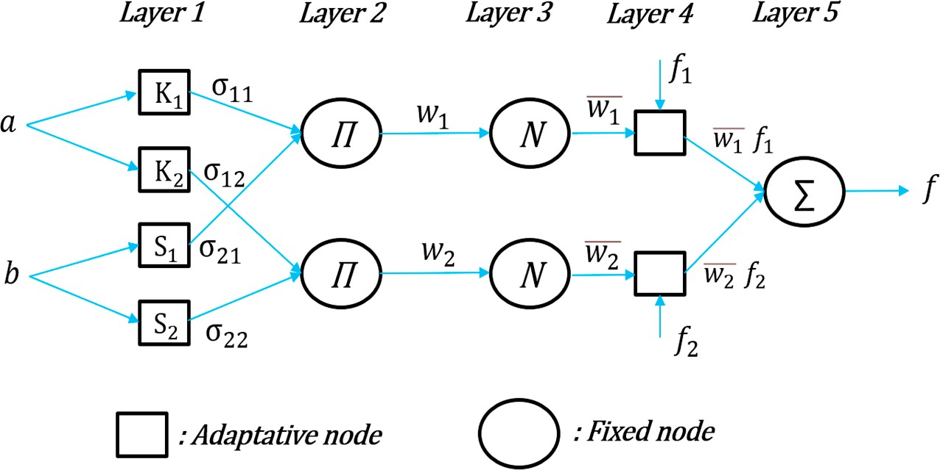

**Figure 9.** Two-entry ANFIS architecture for two rules.

The rules of this architecture are described by the following equations: If *K*1 = *a* and *S*1 = *b*, then

If *K*2 = *a* and *S*2 = *b*, then

*f*1(*a*, *b*) = *P*1*a* + *q*1*b* + *r*1 (20)

*f*2(*a*, *b*) = *P*2*a* + *q*2*b* + *r*2 (21)

*K*1, *K*2, *S*1, and *S*2 are the fuzzy sets that reflect linguistic values like small, medium, and large, and *a* and *b* are the inputs. The learning process determines these fuzzy sets. The design parameters *P*1, *P*2, *q*1, *q*2, *r*1 and *r*2 are also determined during the learning process. In this hybrid structure combining the advantages of fuzzy logic and neural networks,

the roles of the five layers include:

***Layer 1:*** Computes the membership degrees of each input variable in the range 0–1.

where *i* = 1, 2.

1

*i*

*o* = *µ a*( )*Ki*

*o*1 = *µSi*(*b*)

*i*

(22)

***Layer 2:*** Calculates the premises of each rule as the product of the levels of learning of

the variables in play in these premises.

*o*2 = *wi* = *µKi*(*a*) ∗ *µSi*(*b*) (23)

*i*

where *i* = 1, 2.

***Layer 3:*** Normalizes the layer’s findings using an N-rated normalization operator.

*o*3 =

*i*

*w*−*i* = *w*

.

*i*

*w*

1 + *w*2

(24)

***Layer 4:*** Assesses each rule’s conclusion.

*o*4 = *w*−*i fi* = *w*−*i* (*Pia* + *qib* + *ri*) (25)

*i*

***Layer 5:*** Gives the final outcome.

*o*5 = *f* = ∑ *w*−*i fi* = Σ*iwi fi*

(26)

*i* 1 Σ*iwi*

The optimal values of the parameters of these membership functions and the ensuing parameters are determined using a hybrid learning approach that combines the least squares method and the backpropagation learning algorithm. The ANFIS network output is calculated using these ensuing parameters.

The ANFIS structure used to drive the boost converter. The structure has one output (*Vopt*), two inputs (temperature (*T*) and irradiance (*G*)), and seven membership functions for each input. Fourteen input membership functions are used to generate forty-nine fuzzy rules.

To generate operational signals, the reference voltage of the PV generator is compared to the optimal voltage produced by ANFIS. The PWM generator then provides the opera- tional signal. The resulting PWM signals control the duty cycle of the DC–DC converter to modify the PV module’s operating point [87].

1. PV System Presentation

This subsection is divided into two parts. In the first part, we present the PV system used in this study, describing its behavior under different conditions by means of some curves. The second part is dedicated to the design and parameters of the used converter.

* 1. General System Description

A solar panel, a boost converter, a control unit for tracking the MPPT, and a load make up the studied energy conservation system (see Figure 10). The MPPT algorithm controller determines the exact PWM duty cycle to obtain the greatest power point by using the output of the solar panel as the boost converter (DC–DC Converter) input.

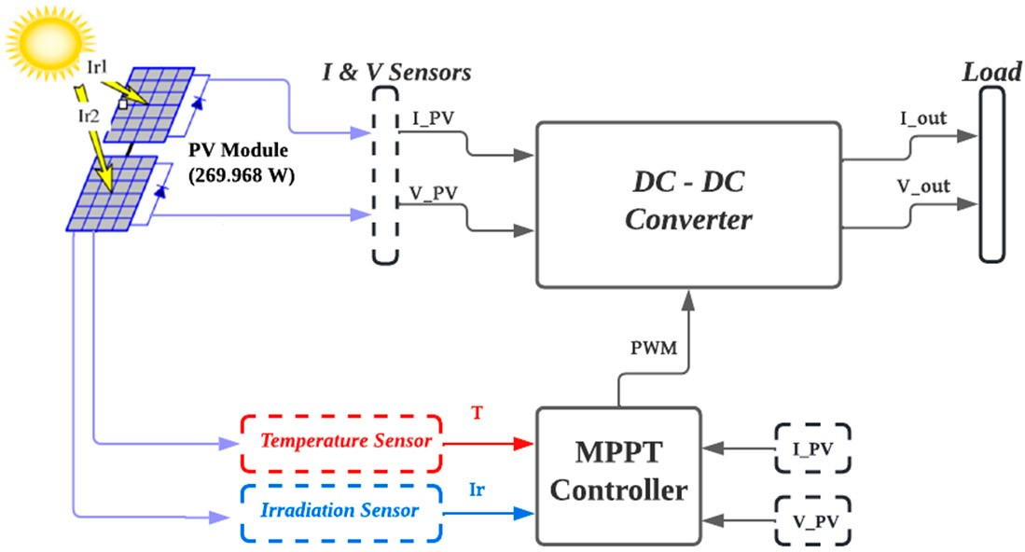

**Figure 10.** General block diagram of the PV system.

MATLAB/Simulink R2021a was used to illustrate the behavior of the PV system (set up with the Jinko Solar Co. Ltd. JKM270M-72 PV module). The properties of the PV module are listed in Table 5.

**Table 5.** Characteristics of the PV module.

|  |  |  |  |
| --- | --- | --- | --- |
| **Specifications for the PV Module from the Jinko Solar Co. Ltd. JKM270M-72 Datasheet** | | | |
| **Specifications** | **Symbol** | **Value** | **Unit** |
| Short-circuit current | *Isc* | 8.35 | A |
| Open-circuit voltage | *Voc* | 45 | V |
| Maximum power | *Pmax* | 269.968 | W |
| Cells per module | *Ncell* | 72 | - |
| Voltage at maximum power point | *Vmp* | 35.9 | V |
| Current at maximum power point | *Imp* | 7.52 | A |
| Temperature coefficient of *Isc*  Temperature coefficient of *Voc* | *Tc Isc Tc Voc* | 0.044335  −30,372 | %/deg.C  %/deg.C |
| Number of modules connected in parallel | *Np* | 1 | - |
| Number of modules connected in series | *Ns* | 1 | - |

* 1. Converter Design

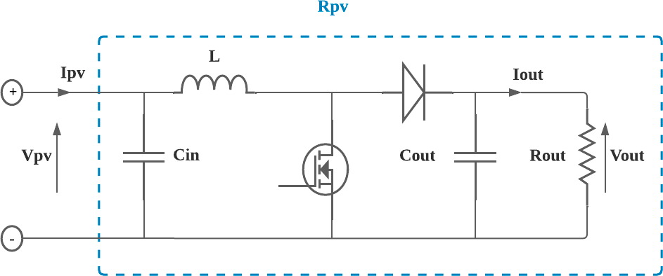An MPPT converter is a device that extracts maximum power from a PV module. According to the literature, different types of power converters have been utilized in PV systems. The examples that can be cited are the SEPIC converter [104], the buck–boost converter [105], the buck converter [106], the boost converter [107,108], and others [109]. Because the boost converter is commonly used for MPPT [110], we selected it for our study (see Figure 11).

**Figure 11.** Schematic of the MPPT boost converter.

A DC input voltage *Vpv*, an inductor, a switch (IGBT), a diode, a capacitive filter, and a load are all components of a boost converter. The converter’s output voltage *Vout* can be changed by varying the value of the duty ratio (*D*).

The total resistance that the source perceives is known as the maximum power point resistance *Rpv*, as depicted in Figure 11. *Vpv* and *Ipv* may oscillate, depending on the MPPT method used and the voltage ripple at the PV module.

The derivation of the MPPT boost converter operates in the continuous current mode and relies on the ideal state. It is based on the assumption of a fixed resistive load *Rout*. The primary objective of this derivation is to develop straightforward equations for com- puting the input capacitance *Cin*, output capacitance *Cout*, and inductance *L* of the MPPT boost converter.

Furthermore, the validity of the derivation is confirmed by comparing the theoretical values obtained from the derived equations with the results of the MPPT boost converter simulation conducted using MATLAB/Simulink R2021a. This comparison serves as evi- dence to support the accuracy and usefulness of the equations derived.

In [111], a method is employed to determine the values of *L*, *Cin*, and *Cout* for the

MPPT boost converter. The findings of this method are presented in Table 6, which displays the parameters used in the calculation and the corresponding results. The utilization of

this method provides valuable insights into the characteristics of the MPPT boost converter, which can aid in optimizing its performance.

**Table 6.** Parameters needed to calculate the MPPT boost converter components.

**Category Parameters Value**

**PV Module**

MPP resistance during minimum irradiance *Rmp* (max)

MPP resistance during maximum

20.4 Ω

irradiance *Rmp* (min) 4.77 Ω

**CLC Filter**

Input capacitance (*Cin*) Input capacitance (*Cout*) Inductance (*L*)

0.000130079 F

0.00601252 F

0.00462222 F

**PWM Characteristic**

Switching frequency ( *fs*) 5 KHZ

Maximum duty cycle limit (*Dmax* ) 8%

Minimum duty cycle limit (*Dmin*) 80%

**Desired Ripple Factor**

MPP voltage ripple factor (*γ*V*mp*) Output voltage ripple factor (*γ*V*o* ) Inductor current ripple factor (*γIL*)

1%

1%

25%

1. Results and Discussion

The results of exhaustive simulations for the seven proposed MPPT algorithms (P&O, IC, DISMC, PSO, ANN, ANFIS, and FLC) are presented and discussed in this section.

These algorithms were applied to a DC/DC boost converter system and resistive load whose specifications are presented in Table 7. The parameters of the PV array are shown in Table 6.

**Table 7.** Weather conditions.

**Test Type Temperature (T) Irradiation (G) Test 1: Steady weather** 25 ◦C 1000 W·m−2

25 C 100 to 1000 W m−2

* ·

(Figure 12a)

**Test 2: Dynamic weather**

10 to 40 C (Figure 12b) 100 to 1000 W m−2 (Figure 12a)

* ·

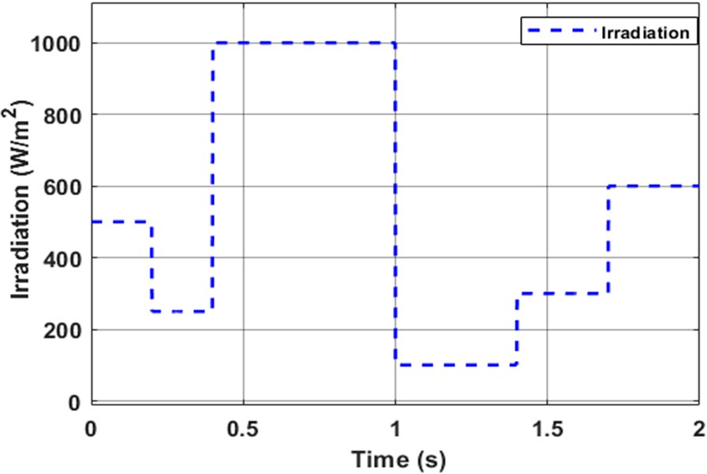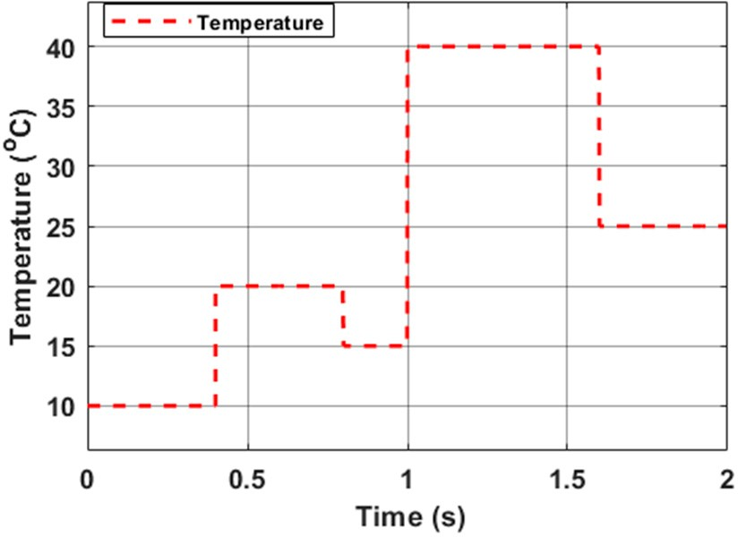

1. (**b**)

**Figure 12.** (**a**) Irradiation variation profile, (**b**) Temperature variation profile.

For this comparative study, two kinds of tests were proposed based on different weather conditions, as shown in Table 7:

* Test 1: Steady weather
* Test 2: Dynamic weather

Test 2 is divided into two scenarios. The simulation of the first scenario, the dynamic weather scenario (Scenario 1), is presented for different irradiation levels from 100 to 1000 W/m2, as shown in Figure 12a, at a fixed temperature of 25 ◦C.

In Scenario 2, the PV system was installed under changing irradiance and temperature condition for a disturbance period of 1 s, as depicted in Figure 12a,b.

Simulations have been performed in MATLAB/Simulink R2021a software and the obtained results were compared the same configuration given in Table 8.

**Table 8.** Parameters needed to simulate the MPPT algorithms.

|  |  |  |  |
| --- | --- | --- | --- |
|  | Input | 2 | - |
| Output | 1 | - |
| Initial duty | 0.425 | - |
| Minimum duty | 0.08 | - |
| Maximum duty | 0.8 | - |
| Delta duty | 0.00001 | - |
|  | Input | 3 | - |
| DISMC | Output | 1 | - |
|  | Surface | - | - |
|  | Substance coefficient | - | - |
|  | Input | 2 | - |
|  | Output | 1 | - |
|  | Inertial weight | 0.4 | - |
|  | Random variables | [0, 1] | - |
|  | Personal learning coefficient | 1.2 | - |
|  | Global learning coefficient | 2 | - |
|  | Input layer | 2 | - |
|  | Hidden layer | 10 | - |
| ANN | Output layer | 1 | - |
|  | Activation functions | Sigmoid and linear | - |
|  | Input layer | 2 | - |
|  | Membership functions for each input | 7 | - |
| ANFIS | Fuzzy rules | 49 | - |
|  | Input membership functions | 40 | - |
|  | Output layer | 1 | - |
|  | Input | 2 | - |
| FLC | Output | 1 | - |
|  | Membership functions | 3 | - |
|  | Triangular membership functions for all inputs | 5 | - |
|  | and outputs |  |  |

**Algorithms Parameters Value Unit**

P&O and IC

PSO

Let us start with the first test based on the steady weather.

From the Test 1 result of the evolution of power as a function of time, which is depicted in Figure 13, it can be seen that all seven simulations produced practically the same type of output curve. Comparing the MPPT controllers, the simulation results demonstrate that the PSO technique had a substantial ripple of panel power (Zooms 1 and 2 of the power curves in Figure 13).

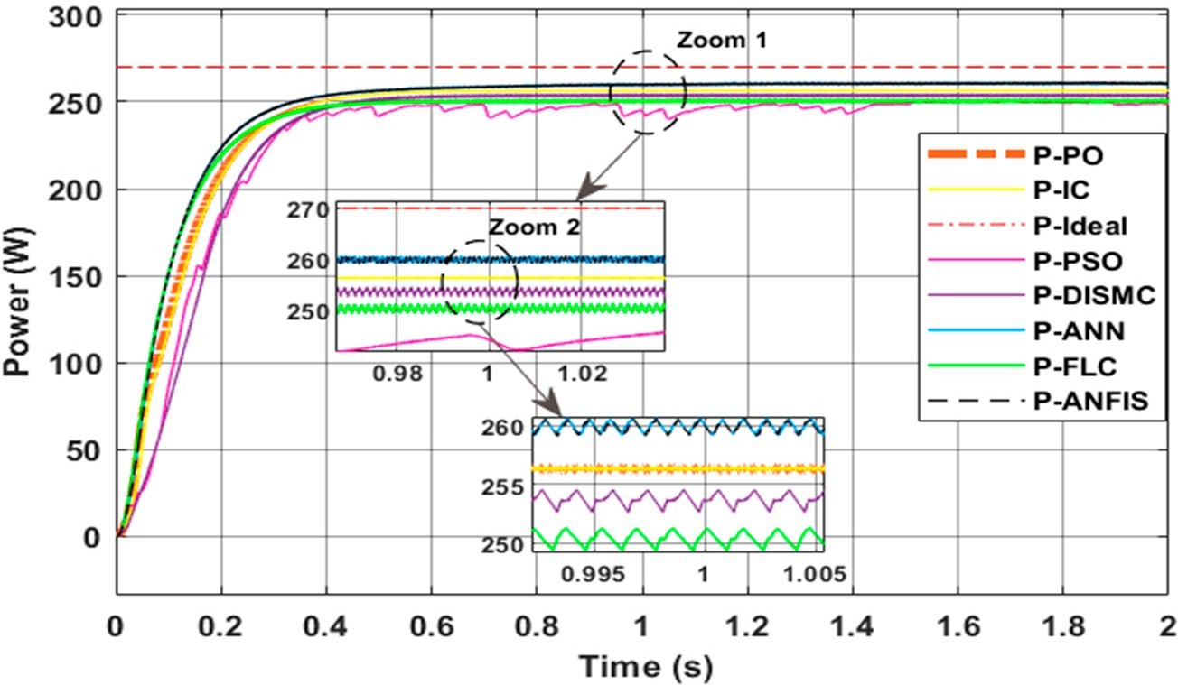

**Figure 13.** Evolution of power: Test 1.

To assess the performances of the MPPT models, daily estimated and measured data were evaluated by estimating the relative error E*r* and efficiency *η*(%) for each MPPT technique, which are described as

E*r* = P*ideal* − P*MPPT*

P*ideal*

(27)

where

% = P*out* 100 (28)

P*MPPT*

*η* ∗( )

P*MPPT* is the output power of the PV panel under MPPT control and can be calculated as the product of the voltage and current at the MPP of the PV panel;

•

P*out* is the output power of the boost converter and can be calculated as the product of the output voltage and load current;

•

* P*ideal* is the ideal theorical power of the PV panel.

Based on the Equations (27) and (28), and according to the Figure 13 found in the steady state, the following quantitative results are shown in the Figures 14–16. In Figure 14, a classification of real and output power efficiencies is given. It can be seen that the ANN technique had an efficiency of 98.6%, followed closely by the ANFIS method with an efficiency of 98.34%.

Based on the relative errors, which are depicted in Figure 15, the ANFIS method had the best result of all the MPPT algorithms, with the ANN method following closely. On the other hand, the PSO and FLC methods showed the most mediocre results, with a difference in error of almost 0.037 compared to the ANFIS method.

The temporal response of the output power of the system under steady-state weather conditions is shown in Figure 16. Compared to the other algorithms, the response time of the FLC controller was fast, the response times of the P&O and IC techniques were a bit fast, and those of the DISMC and PSO commands were slow.



ANFIS

DISMC 99

98.5

98

97.5 97.12

97

96.5

96

IC

98.6

ANN

PSO

FLC

P&O

98.29

97.86

97.56

97.76

98.34

**Figure 14.** Efficiencies (%) of MPPT algorithms under steady-state weather conditions: Test 1.



DISMC 0.06

0.05

PSO

0.055

0.04

0.03

0.02

0.01

0

0.032

IC

ANN

ANFIS

FLC

P&O

0.056

0.029

0.018

0.024

0.029

**Figure 15.** Relative errors of MPPTs algorithms under steady-state weather conditions: Test 1.



DISMC

0.4

0.34

0.3

ANFIS

IC

0.3

0.2

0.1

0

ANN

0.3

0.33

PSO

0.27

FLC

0.322 P&O

0.326

**Figure 16.** Response times (s) of MPPT algorithms under steady-state weather conditions: Test 1.

We now present the Test 2 results for the first scenario. Figure 17 depicts the results, which show that all seven simulations had output curves of different shapes. For quick changes in irradiation, the ANFIS and ANN controllers failed to track the MPP, then the P&O and IC techniques provided the same outcome with a little difference, followed by DISMC and FLC methods, and finally the PSO technique.

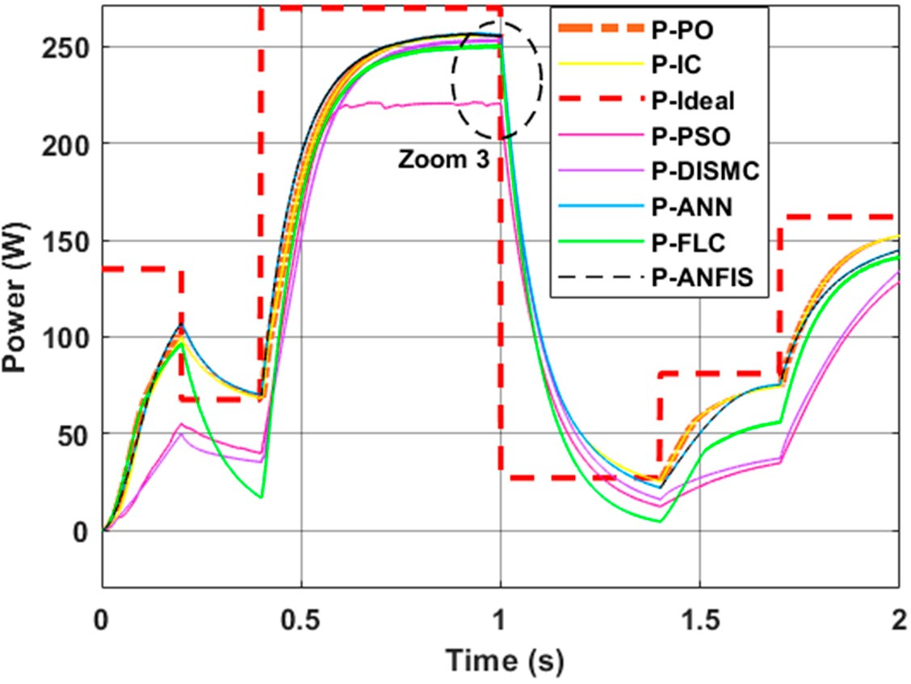 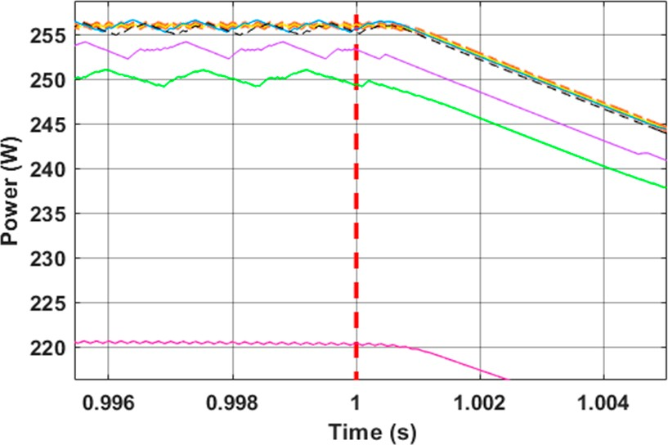

* 1. (**b**)

**Figure 17.** (**a**) Evolution of power; (**b**) Zoom 3 of power curves: Scenario 1 of Test 2.

To evaluate the robustness of these controllers, the simulations were realized with a constant temperature value of 25 ◦C and solar irradiation that varied from 500 to 250 W m−2, from 250 to 1000 W m−2, from 1000 to 100 W m−2, from 100 to 300 W m−2, and from 300 to 600 W m−2 (see Figure 12a). As shown in Figure 17a, the output characteristic of the PV generator varied proportionally with irradiation. As shown in Figure 17b, when the irradiation was 1000 W m−2, the maximum power supplied by the PV generator stabilized around 256.64 W for the ANN controller, with only a difference of 0.34 W between this value and that of the ANFIS controller.

·

·

· · · ·

When the solar irradiation was 500 W m−2, the maximum power was 107.3 W for

·

the ANN and ANFIS methods and for a variation of 1000–100 W m−2 in irradiance; the maximum power for the P&O and IC algorithms was 25.17 W, while that of the ANN and ANFIS methods was 21.82 W.

·

In transient and stable states, there are significant oscillations of conventional tech- niques compared with ANN and ANFIS. Sudden changes in solar irradiation greatly interfere with the conventional techniques.

All the proposed MPPT controllers were able to extract the maximum power of the system at the different temperature values (see Figure 18) and the same variation of irradiation of Scenario 1.

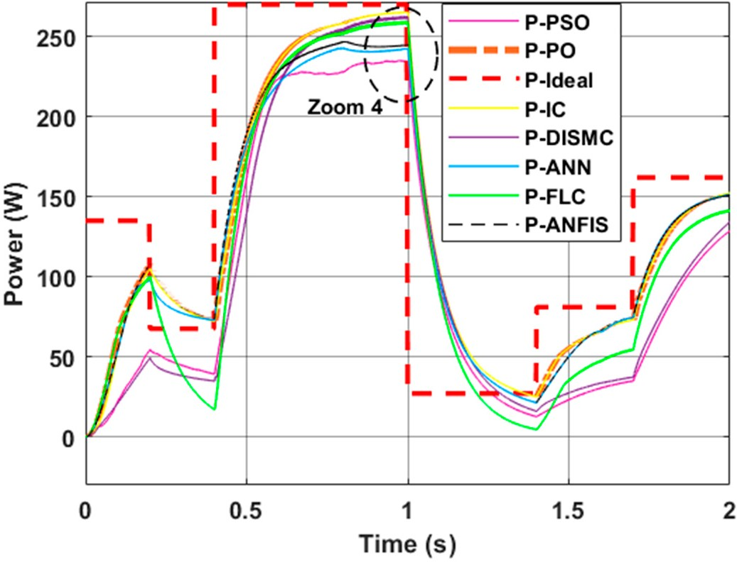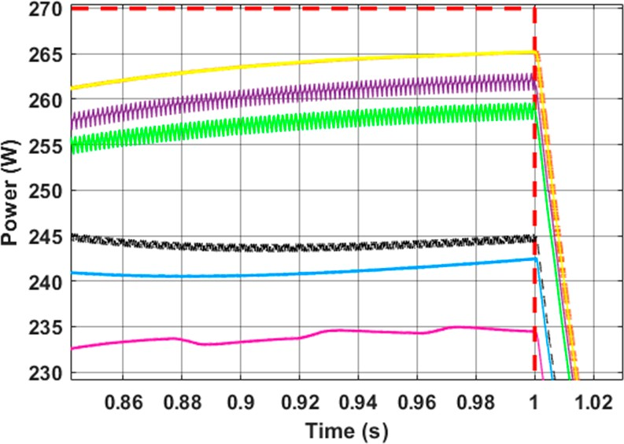

(**a**) (**b**)

**Figure 18.** (**a**) Evolution of power; (**b**) Zoom 4 of power curves: Scenario 2 of Test 2.

The findings of Scenario 2, as shown in Figure 18a,b, reveal that each of the seven algorithms produced a different output curve. The P&O and IC controllers accurately tracked the MPP under varying irradiation and temperature, the DISMC, FLC, ANFIS, and ANN techniques tracked the MPP fairly accurately, and the PSO technique showed the least tracking accuracy.

The average response time for all MPPT techniques, as shown in Figure 19, was calculated by taking the mean of the response times recorded for each weather condition in Test 2.

**Figure 19.** Average response time of MPPT algorithms: Test 2.



Scenario 1

Scenario 2

0.3

0.2

0.1

0

P&O

I C

P SO DISMC A NN ANFIS

F LC

**MPPTs METHODS**

**Average response**

**Time (s)**

In Scenario 1, the P&O, IC, and DISMC controllers took longer than the other con- trollers to reach the optimum power. For example, there was an average response time of

0.22 s for P&O and IC controllers and 0.23 s for DISMC controller.

In Scenario 2, the DISMC technique required more time to attain the peak power than the other controllers, which showed that the PSO controller was faster than other controllers in both scenarios.

The convergence speed of the power MPPT controller (power vector) can be calculated in terms of the time it takes for the power vector to reach a steady-state condition. This is done by measuring the time it takes for the power vector to change from one steady-state value to another. The convergence speed can then be expressed as the change in the power vector value over time.

To calculate the convergence speed of the power MPPT controller, we measured the initial and final steady-state power vector values and then calculated the change in the power vector value over the time period. The formula for the convergence speed of power is

Convergence Speed = Final Power Vector Value − Initial Power Vector Value

Time Period

(29)

The average convergence speed for all proposed MPPT algorithms, as shown in Figure 20, was calculated by taking the mean of the convergence speeds recorded for each weather condition.

**Average Convergence**

**Speed (W.s-1 )**

**Figure 20.** Average convergence speed of MPPT algorithms: Test 2.



Scenario 1

Scenario 2

600

400

200

0

P&O

I C

P SO DISMC A NN ANFIS

F LC

**MPPTs METHODS**

For the average convergence speed of the MPPT controllers for Test 2, which is depicted in Figure 20, the two scenarios gave practically the same output average convergence speed, with a slight difference. Out of the seven controllers, the average convergence speed of the FLC method was fastest, while that of the DISMC method was second fastest; the difference in speed between these two algorithms was almost 24.24 W s−1 for Scenario 1 and 24.68 W s−1 for Scenario 2.

·

·

Although the FLC, ANN, and ANFIS methods showed good performance under varying irradiances, their simulation times were higher than those of the other four methods. Using MATLAB’s built-in tic-toc command, the simulation times were captured, which showed how long it took MATLAB to run the relevant code for each MPPT method.

* 1. *Step 6: Benchmarking*

The benchmarking includes the description as well as the presentation of the methods followed and results obtained from the selected literature. In future studies, it could serve as a helpful guide, which considers the needs of operators and consumers, for choosing the most beneficial MPPT types.

A comparison of the dynamic performance of MPPT techniques based on a selection of criteria that were reviewed by the study and set the monitoring method’s conduct apart from the peak power point. The complexity, number of necessary sensors, rate of convergence, price, range of effectiveness, required gear, and level of acceptance of these techniques vary. It has been established that the application being considered plays the largest role in choosing the best MPPT technique. For example, cutting-edge methods like incremental conductance, fuzzy logic, and genetic/artificial MPPT approaches are suitable in constrained environments, such as in aerospace satellites [112].

Additionally, there has recently been considerable study of combined or improved approaches. These techniques use an established method with a more complex control algorithm to enhance performance, especially in partially darkened or rapidly changing environments. Maximum power point tracking in PV systems remains a rapidly expanding field of research, with new creative methods continually proposed. As a result, MPPT techniques will continue to be improved and refined, leading to wider commercial adoption.

Table 9 is a summary of the comparative analysis of all MPPT techniques proposed in the literature. The tracking of algorithms under dynamic and constant weather cir- cumstances is represented by dynamic and steady tracking, respectively. The algorithm complexity can be used to assess the control complexity of an algorithm. Hardware com- plexity and sensors, on the other hand, can be used to estimate the cost of implementation of each algorithm.

This review can help with subsequent analysis, which can then be used to choose the perfect MPPT to meet the needs of both the operator and the consumer. Each of the various MPPT methods has its benefits and drawbacks. The difficulty of implementation arises when massive computations are required. The tracking energy and speed decrease during fractional shading crises.

The classical approach, like the P&O and IC methods, is straightforward, simple to implement on hardware, and widely employed, but it performs slowly when exposed to rapidly changing environmental conditions. These techniques are less precise and respond more slowly than intelligent techniques. The DIS MPPT controller is more expensive and has a more sophisticated hardware implementation than traditional methods.

Under changing insolation, low varying temperatures, fast varying with fewer ripples, and quick simulation times, the PSO approach performs less efficiently.

For tracking peak power under various meteorological conditions, intelligent methods including ANN-, fuzzy-, and ANFIS-based MPPT are efficient and produce great results, but the system becomes costlier and more sophisticated overall. These approaches can manage nonlinearities without a precise mathematical representation of the system, but they are expensive.

**Table 9.** Benchmark of MPPT techniques.

|  |  |  |  |  |  |  |  |
| --- | --- | --- | --- | --- | --- | --- | --- |
| **Technique Parameters** | **P&O** | **IC** | **DIS** | **PSO** | **ANN** | **ANFIS** | **FLC** |
| Dynamic tracking | R | H | H | L | H | H | H |
| Prior tuning | N | N | Y | Y | Y | Y | Y |
| Steady tracking | R | H | R | R | H | H | H |
| Hardware implementation | E | E | M | C | C | C | M |
| Algorithm complexity | L | L | M | L | M | H | H |
| Response to varying atmospheric conditions | F | F | M | M | M | S | S |
| Simulation time | M | F | M | F | M | S | S |
| Convergence speed | F | F | M | M | M | S | S |
| Oscillation around MPP | H | M | M | L | L | L | L |
| Cost | INX | AV | AV | EX | EX | EX | AV |
| Precision | Go | Go | Go | AC | VG | VG | Go |
| Tuning complexity | L | L | M | M | H | H | H |
| Number and types | 2 | 2 | 2 | 2 | 3 | 3 | 2 |
| of sensors | V and I | V and I | V and I | V and I | V, T and G | V, T and G | V and I |

H: high; R: reasonable; M: medium; F: fast; AV: average; L: low; Y: yes; N: no; AC: acceptable; S: slow; Go: good; VG: very good; E: easy; C: complex; INX: inexpensive; EX: expensive; V: voltage; I: current; G: irradiation.

# 4. Conclusions

This paper presents a comprehensive SLR of various MPPT algorithms, analyzing their pros and cons, and summarizing the available review studies on this topic. The authors also provide a new benchmark for evaluating the performance of different MPPT methods, which is helpful in selecting suitable algorithms under specific conditions. Based on the outcomes of simulations of different techniques, a quantitative and qualitative comparative analysis of the most effective MPPT strategies is subsequently provided.

The main conclusions of the study are as follows:

C All MPPT controllers are capable of extracting the maximum power from the sys- tem at different irradiation values, though their performance levels may vary. For instance, during steady-state weather conditions, the ANN technique demonstrated an efficiency of 98.6%, closely followed by the ANFIS method at 98.34% efficiency.

C The P&O technique has a better response time than the IC technique, with minor variations, and the PSO technique requires less processing than other techniques. For example, under steady-state weather conditions, the P&O technique had a response time of 0.322 s, followed closely by the IC method with a response time of 0.326 s.

C The simplest approaches, such as PSO and DISMC, are easier to use but have lower efficiency than ANN, ANFIS, and FLC techniques when exposed to irradiation and temperature variations.

C The MPP controllers based on neural networks, fuzzy logic, and ANFIS perform significantly better than conventional approaches in terms of tracking efficiency, convergence time, and oscillations around the MPP.

C The ANN, FLC, and ANFIS methods relying on machine learning require advanced gears to run these algorithms. The usage of these contemporary strategies in cur- rent PV grid deployments can be attributed to the computing hardware’s steadily improving performance-to-price ratio.

Overall, this study provides valuable insights into the strengths and weaknesses of different MPPT techniques and will be useful for researchers and practitioners working in the field of solar energy.

**Funding:** This research received no external funding.

**Data Availability Statement:** Data sharing is available if requested.

**Conflicts of Interest:** The authors declare no conflict of interest.

# References

1. Kılıç, U.; Kekezog˘ lu, B. A review of solar photovoltaic incentives and Policy: Selected countries and Turkey. *Ain Shams Eng. J.*

**2022**, *13*, 101669. [[CrossRef](https://doi.org/10.1016/j.asej.2021.101669)]

1. Pandey, A.; Tyagi, V.; Jeyraj, A.; Selvaraj, L.; Rahim, N.; Tyagi, S. Recent advances in solar photovoltaic systems for emerging trends and advanced applications. *Renew. Sustain. Energy Rev.* **2016**, *53*, 859–884. [[CrossRef](https://doi.org/10.1016/j.rser.2015.09.043)]
2. IEA. *Mid-Term Renewable Energy Market Report*; IEA: Paris, France, 2015; Available online: [https://www.iea.org/reports/medium-](https://www.iea.org/reports/medium-term-renewable-energy-market-report-2015)

[term-renewable-energy-market-report-2015](https://www.iea.org/reports/medium-term-renewable-energy-market-report-2015) (accessed on 15 July 2022).

1. Aanesen, K.; Heck, S.; Pinner, D. Solar power. Darkest before dawn. *McKinsey Sustain. Resour. Product.* **2017**, *14*, 1–16.
2. Uruel-Sanz, J.; Perpiñán-Lamigueiro, O. Power Flow Analysis in Urban Distribution Networks with Implementation of Grid- Connected Photovoltaic Systems. *Solar* **2022**, *2*, 32–51. [[CrossRef](https://doi.org/10.3390/solar2010003)]
3. Chen, Y.-K.; Hsu, H.-W.; Song, C.-C.; Chen, Y.-S. High-Flexibility MPPT Techniques with Communication Scan Network for PV Micro-Grid System. *Processes* **2022**, *10*, 117. [[CrossRef](https://doi.org/10.3390/pr10010117)]
4. Dufo-López, R.; Cortés-Arcos, T.; Artal-Sevil, J.S.; Bernal-Agustín, J.L. Comparison of Lead-Acid and Li-Ion Batteries Lifetime Prediction Models in Stand-Alone Photovoltaic Systems. *Appl. Sci.* **2021**, *11*, 1099. [[CrossRef](https://doi.org/10.3390/app11031099)]
5. Khezri, R.; Mahmoudi, A.; Haque, M.H. A Demand Side Management Approach For Optimal Sizing of Standalone Renewable- Battery Systems. *IEEE Trans. Sustain. Energy* **2021**, *12*, 2184–2194. [[CrossRef](https://doi.org/10.1109/TSTE.2021.3084245)]
6. Saleh, U.A.; Johar, M.A.; Jumaat, S.A.B.; Rejab, M.N.; Jamaludin, W.A.W. Evaluation of a PV-TEG Hybrid System Configuration for an Improved Energy Output: A Review. *Int. J. Renew. Energy Dev.* **2021**, *10*, 385. [[CrossRef](https://doi.org/10.14710/ijred.2021.33917)]
7. Fernández, L. Cumulative Installed Solar PV Capacity Worldwide from 2000 to 2021. Available online: [https://www.statista.](https://www.statista.com/statistics/280220/global-cumulative-installed-solar-pv-capacity/) [com/statistics/280220/global-cumulative-installed-solar-pv-capacity/](https://www.statista.com/statistics/280220/global-cumulative-installed-solar-pv-capacity/) (accessed on 23 July 2022).
8. Mishu, M.K.; Rokonuzzaman, M.; Pasupuleti, J.; Shakeri, M.; Rahman, K.S.; Hamid, F.A.; Tiong, S.K.; Amin, N. Prospective efficient ambient energy harvesting sources for IoT-equipped sensor applications. *Electronics* **2020**, *9*, 1345. [[CrossRef](https://doi.org/10.3390/electronics9091345)]
9. El-Khozondar, H.J.; El-Khozondar, R.J.; Matter, K.; Suntio, T. A review study of photovoltaic array maximum power tracking algorithms. *Renewables* **2016**, *3*, 1–8. [[CrossRef](https://doi.org/10.1186/s40807-016-0022-8)]
10. Karami, N.; Moubayed, N.; Outbib, R. General review and classification of different MPPT Techniques. *Renew. Sustain. Energy* *Rev.* **2017**, *68*, 1–18. [[CrossRef](https://doi.org/10.1016/j.rser.2016.09.132)]
11. Danandeh, M.A.; Mousavi, G.S.M. Comparative and Comprehensive Review of Maximum Power Point Tracking Methods for PV Cells. *Renew. Sustain. Energy Rev.* **2018**, *82*, 2743–2767. [[CrossRef](https://doi.org/10.1016/j.rser.2017.10.009)]
12. Ahmad, R.; Murtaza, A.F.; Sher, H.A. Power tracking techniques for efficient operation of photovoltaic array in solar applications— A review. *Renew. Sustain. Energy Rev.* **2019**, *101*, 82–102. [[CrossRef](https://doi.org/10.1016/j.rser.2018.10.015)]
13. Bollipo, R.B.; Mikkili, S.; Bonthagorla, P.K. Hybrid, Optimization, Intelligent and Classical PV MPPT techniques: Review. *CSEE J.* *Power Energy Systems.* **2021**, *7*, 9–33. [[CrossRef](https://doi.org/10.17775/CSEEJPES.2019.02720)]
14. Lawan, M.; Aboushady, A.; Ahmed, K.H. Photovoltaic MPPT Techniques Comparative Review. In Proceedings of the 9th International Conference on Renewable Energy Research and Applications, Glasgow, UK, 27–30 September 2020; pp. 344–351. [[CrossRef](https://doi.org/10.1109/ICRERA49962.2020.9242855)]
15. Awan, M.M.A. A Technical Review of MPPT Algorithms for Solar Photovoltaic System: SWOT Analysis of MPPT Algorithm. *Sir* *Syed Univ. Res. J. Eng. Technol.* **2022**, *12*, 98–106. [[CrossRef](https://doi.org/10.33317/ssurj.433)]
16. Mengist, W.; Soromessa, T.; Legese, G. Method for conducting systematic literature review and meta-analysis for environmental science research. *MethodsX* **2022**, *7*, 100777. [[CrossRef](https://doi.org/10.1016/j.mex.2019.100777)]
17. Iliescu, A.N. Conceptual atlas of the knowmad literature: Visual mapping with VOSviewer. *Manag. Dyn. Knowl. Econ.* **2021**,

*9*, 379–392.

1. Verma, D.; Nema, S.; Shandilya, A.M.; Dash, S.K. Maximum Power Point Tracking (MPPT) Techniques: Recapitulation in Solar Photovoltaic Systems. *Renew. Sustain. Energy Rev.* **2016**, *54*, 1018–1034. [[CrossRef](https://doi.org/10.1016/j.rser.2015.10.068)]
2. Subudhi, B.; Pradhan, R. A Comparative Study on Maximum Power Point Tracking Techniques for Photovoltaic Power Systems.

*IEEE Trans. Sustain. Energy* **2013**, *4*, 89–98. [[CrossRef](https://doi.org/10.1109/TSTE.2012.2202294)]

1. Sanju; Agarwal, K.L.; Srikant, S.S. An Analysis of State of Art Maximum Power Point Tracking Techniques of the Solar Photovoltaic System under Partial Shading Conditions. In Proceedings of the 2022 IEEE 10th Power India International Conference (PIICON), New Delhi, India, 25–27 November 2022; pp. 1–6. [[CrossRef](https://doi.org/10.1109/PIICON56320.2022.10045187)]
2. De Brito, M.A.G.; Galotto, L.; Sampaio, L.P.; e Melo, G.D.A.; Canesin, C.A. Evaluation of the Main MPPT Techniques for Photovoltaic Applications. *IEEE Trans. Ind. Electron.* **2013**, *60*, 1156–1167. [[CrossRef](https://doi.org/10.1109/TIE.2012.2198036)]
3. Ahmed, J.; Salam, Z. An Enhanced Adaptive P&O MPPT for Fast and Efficient Tracking Under Varying Environmental Conditions.

*IEEE Trans. Sustain. Energy* **2018**, *9*, 1487–1496. [[CrossRef](https://doi.org/10.1109/TSTE.2018.2791968)]

1. Ahmed, J.; Salam, Z. An improved perturb and observe (P&O) maximum power point tracking (MPPT) algorithm for higher efficiency. *Appl. Energy* **2015**, *150*, 97–108.
2. Mishu, M.K.; Rokonuzzaman, R.; Pasupuleti, J.; Shakeri, M.; Rahman, K.S.; Binzaid, S.; Tiong, S.K.; Amin, N. An adaptive TE-PV hybrid energy harvesting system for self-powered IoT sensor applications. *Sensors* **2021**, *21*, 2604. [[CrossRef](https://doi.org/10.3390/s21082604)]
3. Singh, S.; Manna, S.; Mansoori, M.I.H.; Akella, A.K. Implementation of Perturb & Observe MPPT Technique using Boost converter in PV System. In Proceedings of the IEEE International Conference on Computational Intelligence for Smart Power System and Sustainable Energy (CISPSSE-2020), Odisha, India, 29–31 July 2020.
4. Esram, T.; Chapman, P.L. Comparison of photovoltaic array maximum power point tracking techniques. *IEEE Trans. Energy* *Convers.* **2007**, *22*, 439–449. [[CrossRef](https://doi.org/10.1109/TEC.2006.874230)]
5. Cabal, C.; Martnez-Salamero, L.; Sguier, L.; Alonso, C.; Guinjoan, F. Maximum power point tracking based on slidingmode control for output-series connected converters in photovoltaic systems. *IET Power Electron.* **2014**, *7*, 914–923. [[CrossRef](https://doi.org/10.1049/iet-pel.2013.0348)]
6. Bianconi, E.; Calvente, J.; Giral, R.; Mamarelis, E.; Petrone, G.; Ramos-Paja, C.A.; Spagnuolo, G.; Vitelli, M. A Fast Current-Based MPPT Technique Employing Sliding Mode Control. *IEEE Trans. Ind. Electron.* **2013**, *60*, 1168–1178. [[CrossRef](https://doi.org/10.1109/TIE.2012.2190253)]
7. Islam, H.; Mekhilef, S.; Shah, N.B.M.; Soon, T.K.; Seyedmahmousian, M.; Horan, B.; Stojcevski, A. Performance evaluation of maximum power point tracking approaches and photovoltaic systems. *Energies* **2018**, *11*, 365. [[CrossRef](https://doi.org/10.3390/en11020365)]
8. OLiviera da Silva, S.A.; Sampaio, L.P.; de Oliveira, F.M.; Durand, F.R. Feed-forward DC-bus control loop applied to a single-phase grid-connected PV system operating with PSO-based MPPT technique and active power-line conditioning. *IET Renew. Power* *Gener.* **2017**, *11*, 183–193. [[CrossRef](https://doi.org/10.1049/iet-rpg.2016.0120)]
9. Alturki, F.A.; Al-Shamma’a, A.A.; Farh, H.M.H. Simulations and dSPACE Real-Time Implementation of Photovoltaic Global Maximum Power Extraction under Partial Shading. *Sustainability* **2020**, *12*, 3652. [[CrossRef](https://doi.org/10.3390/su12093652)]
10. Sampaio, L.P.; da Rocha, M.V.; OLiviera da Silva, S.A.; de Freitas, M.H.T. Comparative analysis of MPPT algorithms bio-inspired by grey wolves employing a feed-forward control loop in a three-phase grid-connected photovoltaic system. *IET Renew. Power* *Gener.* **2019**, *13*, 1379–1390. [[CrossRef](https://doi.org/10.1049/iet-rpg.2018.5941)]
11. Bhatti, A.R.; Salam, Z.; Sultana, B.; Rasheed, N.; Awan, A.B.; Sultana, U.; Younas, M. Optimized sizing of photovoltaic grid- connected electric vehicle charging system using particle swarm optimization. *Int. J. Energy Res.* **2019**, *43*, 500–522. [[CrossRef](https://doi.org/10.1002/er.4287)]
12. Seyedmahmoudian, M.; Horan, B.; Soon, T.K.; Rahmani, R.; Oo, A.M.T.; Mekhilef, S.; Stojcevski, A. State of the art artificial intelligencebased MPPT techniques for mitigating partial shading effects on PV systemsA review. *Renew. Sustain. Energy Rev.* **2016**, *64*, 435–455. [[CrossRef](https://doi.org/10.1016/j.rser.2016.06.053)]
13. Zhu, T.; Dong, J.; Li, X.; Ding, S. A Comprehensive Study on Maximum Power Point Tracking Techniques Based on Fuzzy Logic Control for Solar Photovoltaic Systems. *Front. Energy Res.* **2021**, *9*, 727949. [[CrossRef](https://doi.org/10.3389/fenrg.2021.727949)]
14. Ali, R.B.; Bouadila, S.; Mami, A. Development of a Fuzzy Logic Controller applied to an agricultural greenhouse experimentally validated. *Appl. Therm. Eng.* **2018**, *141*, 798–810. [[CrossRef](https://doi.org/10.1016/j.applthermaleng.2018.06.014)]
15. Kuate Nkounhawa, P.; Ndapeu, D.; Kenmeugne, B. Artifcial neural network (ANN) and adaptive neuro fuzzy inference system (ANFIS): Application for a photovoltaic system under unstable environmental conditions. *Int. J. Energy Environ. Eng.* **2022**, *13*, 821–829. [[CrossRef](https://doi.org/10.1007/s40095-022-00472-x)]
16. Kuate Nkounhawa, P.; Ndapeu, D.; Kenmeugne, B. MPPT Based on Artificial Neural Networks (ANN) for a Photovoltaic System under Unstable Environmental Conditions. *Res. Sq.* **2021**, Preprint. [[CrossRef](https://doi.org/10.21203/rs.3.rs-1067676/v1)]
17. Dixit, T.V.; Yadav, A.; Gupta, S. Experimental assessment of maximum power extraction from solar panel with different converter topologies. *Int. Trans. Electr. Energy Syst.* **2019**, *29*, e2712. [[CrossRef](https://doi.org/10.1002/etep.2712)]
18. Miyatake, M.; Inada, T.; Hiratsuka, I.; Zhao, H.; Otsuka, H.; Nakano, M. Control characteristics of a fibonacci-search-based maximum power point tracker when a photovoltaic array is partially shaded. In Proceedings of the 4th International Power Electronics and Motion Control Conference, 2004—IPEMC 2004, Xi’an, China, 14–16 August 2004; pp. 816–821.
19. Carvalho, J.L.; Kretly, L.C. Modified Newton-Raphson Method to Achieve Variable Step Hill-Climbing Algorithm for Maximum Power Point Tracking. In Proceedings of the 2021 IEEE International Conference on Microwaves, Antennas, Communications and Electronic Systems (COMCAS), Tel Aviv, Israel, 1–3 November 2021; pp. 442–447. [[CrossRef](https://doi.org/10.1109/COMCAS52219.2021.9629103)]
20. Jiang, J.-A.; Su, Y.-L.; Kuo, K.-C.; Wang, C.-H.; Liao, M.-S.; Wang, J.-C.; Huang, C.-K.; Chou, C.-Y.; Lee, C.-H.; Shieh, J.-C. On a hybrid MPPT control scheme to improve energy harvesting performance of traditional two-stage inverters used in photovoltaic systems. *Renew. Sustain. Energy Rev.* **2017**, *69*, 1113–1128. [[CrossRef](https://doi.org/10.1016/j.rser.2016.09.112)]
21. Mohapatra, A.; Nayak, B.; Das, P.; Mohanty, K.B. A review on MPPT techniques of PV system under partial shading condition.

*Renew. Sustain. Energy Rev.* **2017**, *80*, 854–867. [[CrossRef](https://doi.org/10.1016/j.rser.2017.05.083)]

1. Vimalarani, C.; Kamaraj, N. Improved method of maximum power point tracking of photovoltaic (PV) array using hybrid intelligent controller. *Optik* **2018**, *168*, 403–415.
2. Nikolovski, S.; Reza Baghaee, H.; Mlakic´, D. ANFIS-based peak power shaving/curtailment in microgrids including PV units and BESSs. *Energies* **2018**, *11*, 2953. [[CrossRef](https://doi.org/10.3390/en11112953)]
3. Mohammed, K.K.; Buyamin, S.; Shams, I.; Mekhilef, S. Maximum power point tracking based on adaptive neuro-fuzzy inference systems for a photovoltaic system with fast varying load conditions. *Int. Trans. Electr. Energy Syst.* **2021**, *31*, e12904. [[CrossRef](https://doi.org/10.1002/2050-7038.12904)]
4. Aldair, A.A.; Obed, A.A.; Halihal, A.F. Design and implementation of ANFIS-reference model controller based MPPT using FPGA for photovoltaic system. *Renew. Sustain. Energy Rev.* **2018**, *82*, 2202–2217. [[CrossRef](https://doi.org/10.1016/j.rser.2017.08.071)]
5. Abadi, I.; Imron, C.; Noriyati, R.D. Implementation of maximum power point tracking (MPPT) technique on solar tracking system based on adaptive neuro-fuzzy inference system (ANFIS). *E3s Web Conf.* **2018**, *43*, 01014. [[CrossRef](https://doi.org/10.1051/e3sconf/20184301014)]
6. Kchaou, A.; Naamane, A.; Koubaa, Y.; M’Sirdi, N.K. Comparative study of different mppt techniques for a stand-alone pv system. In Proceedings of the 2016 17th International Conference on Sciences and Techniques of Automatic Control and Computer Engineering (STA), Sousse, Tunisia, 19–21 December 2016; pp. 629–634.
7. Boukenoui, R.; Bradai, R.; Mellit, A.; Ghanes, M.; Salhi, H. Comparative analysis of p&o, modified hill climbing-flc, and adaptive p&o-flc mppts for microgrid standalone pv system. In Proceedings of the 2015 International Conference on Renewable Energy Research and Applications (ICRERA), Palermo, Italy, 22–25 November 2015; pp. 1095–1099.
8. Nademi, H.; Elahidoost, A.; Norum, L.E. Comparative analysis of different mppt schemes for photovoltaic integration of modular multilevel converter. In Proceedings of the 2016 IEEE 17th Workshop on Control and Modeling for Power Electronics (COMPEL), Trondheim, Norway, 27–30 June 2016; pp. 1–5.
9. Ali, A.I.; Sayed, M.A.; Mohamed, E.E. Modified efficient perturb and observe maximum power point tracking technique for grid-tied pv system. *Int. J. Electr. Power Energy Syst.* **2018**, *99*, 192–202. [[CrossRef](https://doi.org/10.1016/j.ijepes.2017.12.029)]
10. Ahmed, J.; Salam, Z. A modified p o maximum power point tracking method with reduced steady-state oscillation and improved tracking efficiency. *IEEE Trans. Sustain. Energy* **2016**, *7*, 1506–1515. [[CrossRef](https://doi.org/10.1109/TSTE.2016.2568043)]
11. Yin, L.; Yu, S.; Zhang, X.; Tang, Y. Simple adaptive incremental conductance mppt algorithm using improved control model. *J. Renew. Sustain. Energy* **2017**, *9*, 065501. [[CrossRef](https://doi.org/10.1063/1.4991436)]
12. Yetayew, T.T.; Jyothsna, T.R.; Kusuma, G. Evaluation of incremental conductance and firefly algorithm for pv mppt application under partial shade condition. In Proceedings of the 2016 IEEE 6th International Conference on Power Systems (ICPS), New Delhi, India, 4–6 March 2016; pp. 1–6.
13. Gupta, A.K.; Pachauri, R.K.; Maity, T.; Chauhan, Y.K.; Mahela, O.P.; Khan, B.; Gupta, P.K. Effect of Various Incremental Conductance MPPT Methods on the Charging of Battery Load Feed by Solar Panel. *IEEE Access* **2021**, *9*, 90977–90988. [[CrossRef](https://doi.org/10.1109/ACCESS.2021.3091502)]
14. Rougab, I.; Cheknane, A.; Abouchabana, N. Study and simulation of MPPT techniques to control a stand-alone photovoltaic system under varying irradiance. *Rom. J. Inf. Technol. Autom. Control* **2021**, *31*, 109–122. [[CrossRef](https://doi.org/10.33436/v31i4y202109)]
15. Trivedi, A.; Gupta, A.; Pachauri, R.K.; Chauhan, Y.K. Comparison of perturb observe and ripple correlation control mppt algorithms for pv array. In Proceedings of the 2016 IEEE 1st International Conference on Power Electronics, Intelligent Control and Energy Systems (ICPEICES), Delhi, India, 4–6 July 2016; pp. 1–5.
16. Tolentino, L.K.S.; Cruz, F.R.G.; Garcia, R.G.; Chung, W.Y. Maximum power point tracking controller ic based on ripple correlation control algorithm. In Proceedings of the 2015 International Conference on Humanoid, Nanotechnology, Information Technology, Communication and Control, Environment and Management (HNICEM), Cebu, Philippines, 9–12 December 2015; pp. 1–6.
17. Esram, T.; Kimball, J.W.; Krein, P.T.; Chapman, P.L.; Midya, P. Dynamic maximum power point tracking of photovoltaic array using ripple correlation control. *IEEE Trans. Power Electron.* **2006**, *21*, 1282–1291. [[CrossRef](https://doi.org/10.1109/TPEL.2006.880242)]
18. Kjær, S.B. Evaluation of the “hill climbing” and the “incremental conductance” maximum power point trackers for photovoltaic power systems. *IEEE Trans. Energy Convers.* **2012**, *27*, 922–929. [[CrossRef](https://doi.org/10.1109/TEC.2012.2218816)]
19. Jately, V.; Arora, S. Performance Investigation of Hill-Climbing MPPT Techniques for PV Systems Under Rapidly Changing Environment. In *Intelligent Communication, Control and Devices*; Singh, R., Choudhury, S., Gehlot, A., Eds.; Advances in Intelligent Systems and Computing; Springer: Singapore, 2018; Volume 624. [[CrossRef](https://doi.org/10.1007/978-981-10-5903-2_120)]
20. Kota, V.R.; Bhukya, M.N. A novel linear tangents-based P&O scheme for MPPT of a PV system. *Renew. Sustain. Energy Rev.* **2017**,

*71*, 257–267.

1. Sher, H.A.; Murtaza, A.F.; Noman, A.; Addoweesh, K.E.; Al-Haddad, K.; Chiaberge, M. A New Sensorless Hybrid MPPT Algorithm Based on Fractional Short-Circuit Current Measurement and P& O MPPT. *IEEE Trans. Sustain. Energy* **2015**, *6*, 1426–1434. [[CrossRef](https://doi.org/10.1109/TSTE.2015.2438781)]
2. Zheng, Y.; Wang, W.; Chen, W.; Li, Q. Research on mppt of photovoltaic system based on pso under partial shading condition. In Proceedings of the 2016 35th Chinese Control Conference (CCC), Chengdu, China, 27–29 July 2016; pp. 8654–8659.
3. Yunliang, W.; Nan, B. Research of mppt control method based on pso algorithm. In Proceedings of the 2015 4th International Conference on Computer Science and Network Technology (ICCSNT), Harbin, China, 14-16 August 2004; Volume 1, pp. 698–701.
4. Renaudineau, H.; Donatantonio, F.; Fontchastagner, J.; Petrone, G.; Spagnuolo, G.; Martin, J.P.; Pierfederici, S. A pso-based global mppt technique for distributed pv power generation. *IEEE Trans. Ind. Electron.* **2015**, *62*, 1047–1058. [[CrossRef](https://doi.org/10.1109/TIE.2014.2336600)]
5. Kermadi, M.; Berkouk, E.M. A maximum power point tracker based on particle swarm optimization for pv-battery energy system under partial shading conditions. In Proceeding of the 2015 3rd International Conference on Control, Engineering Information Technology (CEIT), Tlemcen, Algeria, 25–27 May 2015; pp. 1–6.
6. Sharma, A.; Sharma, A.; Jately, V.; Averbukh, M.; Rajput, S.; Azzopardi, B. A Novel TSA-PSO Based Hybrid Algorithm for GMPP Tracking under Partial Shading Conditions. *Energies* **2022**, *15*, 3164. [[CrossRef](https://doi.org/10.3390/en15093164)]
7. Zhang, M.; Chen, Z.; Wei, L. An immune firefly algorithm for tracking the maximum power point of pv array under partial shading conditions. *Energies* **2019**, *12*, 3083. [[CrossRef](https://doi.org/10.3390/en12163083)]
8. Kofinas, P.; Dounis, A.I.; Papadakis, G.; Assimakopoulos, M.N. An Intelligent MPPT controller based on direct neural control for partially shaded PV system. *Energy Build.* **2015**, *90*, 51–64. [[CrossRef](https://doi.org/10.1016/j.enbuild.2014.12.055)]
9. Ahmed, J.; Salam, Z. A soft computing MPPT for PV system based on Cuckoo Search algorithm. In Proceedings of the 4th International Conference on Power Engineering, Energy and Electrical Drives, Istanbul, Turkey, 13–17 May 2013; pp. 558–562. [[CrossRef](https://doi.org/10.1109/PowerEng.2013.6635669)]
10. Soufyane Benyoucef, A.; Chouder, A.; Kara, K.; Silvestre, S. Artificial bee colony-based algorithm for maximum power point tracking (MPPT) for PV systems operating under partial shaded conditions. *Appl. Soft Comput.* **2015**, *32*, 38–48. [[CrossRef](https://doi.org/10.1016/j.asoc.2015.03.047)]
11. Yu, M.Q. Parameter Identification of Photovoltaic Cell Model Based on Perturbation and Observation and Modified Gauss-Newton Method. In Proceedings of the 2018 37th Chinese Control Conference (CCC), Wuhan, China, 25–27 July 2018; pp. 6127–6131. [[CrossRef](https://doi.org/10.23919/ChiCC.2018.8483101)]
12. Inomoto, R.S.; Monteiro, J.R.B.D.A.; Filho, A.J.S. Boost Converter Control of PV System Using Sliding Mode Control With Integrative Sliding Surface. *IEEE J. Emerg. Sel. Top. Power Electron.* **2022**, *10*, 5522–5530. [[CrossRef](https://doi.org/10.1109/JESTPE.2022.3158247)]
13. Bianconi, E.; Calvente, J.; Giral, R.; Mamarelis, E.; Petrone, G.; Ramos-Paja, C.A.; Spagnuolo, G.; Vitelli, M. Perturb and observe mppt algorithm with a current controller based on the sliding mode. *Int. J. Electr. Power Energy Syst.* **2013**, *44*, 346–356. [[CrossRef](https://doi.org/10.1016/j.ijepes.2012.07.046)]
14. Prasad, L.B.; Sahu, S.; Gupta, M.; Srivastava, R.; Mozhui, L.; Asthana, D.N. An improved method for mppt using ann and ga with maximum power comparison through perturb observe technique. In Proceedings of the 2016 IEEE Uttar Pradesh Section International Conference on Electrical, Computer and Electronics Engineering (UPCON), Varanasi, India, 9–11 December 2016; pp. 206–211.
15. Liu, Y.H.; Liu, C.L.; Huang, J.W.; Chen, J.H. Neuralnetwork-based maximum power point tracking methods for photovoltaic systems operating under fast changing environments. *Sol. Energy* **2013**, *89*, 42–53. [[CrossRef](https://doi.org/10.1016/j.solener.2012.11.017)]
16. Kulaksız, A.A.; Akkaya, R. A genetic algorithm optimized ann-based mppt algorithm for a stand-alone pv system with induction motor drive. *Sol. Energy* **2012**, *86*, 2366–2375. [[CrossRef](https://doi.org/10.1016/j.solener.2012.05.006)]
17. Zhang, J.H.; Wei, X.Y.; Hu, L.; Ma, J.G. A MPPT Method based on Improved Fibonacci Search Photovoltaic Array. *Tech. Gaz.* **2019**,

*26*, 163–170. [[CrossRef](https://doi.org/10.17559/tv-20180721153103)]

1. Li, X.; Wen, H.; Hu, Y.; Jiang, L. A novel beta parameter based fuzzy-logic controller for photovoltaic MPPT application. *Renew.* *Energy* **2019**, *130*, 416–427. [[CrossRef](https://doi.org/10.1016/j.renene.2018.06.071)]
2. Pradhan, R.; Subudhi, B. Double integral sliding mode MPPT control of a photovoltaic system. *IEEE Trans. Contr. Syst. Technol.*

**2016**, *24*, 285–292. [[CrossRef](https://doi.org/10.1109/TCST.2015.2420674)]

1. Kandemir, E.; Cetin, N.S.; Borekci, S. A comprehensive overview of maximum power extraction methods for PV systems. *Renew.* *Sustain. Energy Rev.* **2017**, *78*, 93–112. [[CrossRef](https://doi.org/10.1016/j.rser.2017.04.090)]
2. Mahdi, A.S.; Mahamad, A.K.; Saon, S.; Tuwoso, T.; Elmunsyah, H.; Mudjanarko, S.W. Maximum power point tracking using perturb and observe, fuzzy logic and ANFIS. *SN Appl. Sci.* **2022**, *2*, 89. [[CrossRef](https://doi.org/10.1007/s42452-019-1886-1)]
3. Priyadarshi, N.; Azam, F.; Sharma, A.K.; Vardia, M. An Adaptive Neuro Fuzzy Inference System-Based Intelligent Grid-Connected Photovoltaic Power Generation. In *Advances in Computational Intelligence*; Sahana, S.K., Bhattacharjee, V., Eds.; Springer: Singapore, 2020; Chapter 1; Volume 988, pp. 3–14. [[CrossRef](https://doi.org/10.1007/978-981-13-8222-21)]
4. Mohanty, S.; Subudhi, B.; Ray, P.K. A Grey Wolf-Assisted Perturb & Observe MPPT Algorithm for a PV System. *IEEE Trans.* *Energy Convers.* **2017**, *32*, 340–347. [[CrossRef](https://doi.org/10.1109/TEC.2016.2633722)]
5. Sundareswaran, K.; Palani, S. Application of a combined particle swarm optimization and perturb and observe method for MPPT in PV systems under partial shading conditions. *Renew. Energy* **2015**, *75*, 308–317. [[CrossRef](https://doi.org/10.1016/j.renene.2014.09.044)]
6. Lasheen, M.; Abdel-Salam, M. Maximum power point tracking using Hill Climbing and ANFIS techniques for PV applications: A review and a novel hybrid approach. *Energy Convers. Manag.* **2018**, *171*, 1002–1019. [[CrossRef](https://doi.org/10.1016/j.enconman.2018.06.003)]
7. Shebani, M.M.; Iqbal, T.; Quaicoe, J.E. Comparing bisection numerical algorithm with fractional short circuit current and open circuit voltage methods for MPPT photovoltaic systems. In Proceedings of the 2016 IEEE Electrical Power and Energy Conference (EPEC), Ottawa, ON, Canada, 12–14 October 2016; pp. 1–5. [[CrossRef](https://doi.org/10.1109/EPEC.2016.7771689)]
8. Sias, Q.A.; Robandi, I. Recurrence Perturb and Observe Algorithm for MPPT Optimization under Shaded Condition. In Proceedings of the 2016 International Seminar on Intelligent Technology and Its Applications (ISITIA), Lombok, Indonesia, 28–30 July 2016. [[CrossRef](https://doi.org/10.1109/isitia.2016.7828716)]
9. Faraji, R.; Rouholamini, A.; Naji, H.R.; Fadaeinedjad, R.; Chavoshian, M.R. FPGA-based real time incremental conductance maximum power point tracking controller for photovoltaic systems. *IET Power Electron.* **2014**, *7*, 12941304. [[CrossRef](https://doi.org/10.1049/iet-pel.2013.0603)]
10. Yang, L.; Yunbo, Z. A Novel Improved Variable Step Size INC MPPT Method for a PV Systems. In Proceedings of the 2019 Chinese Control And Decision Conference (CCDC), Nanchang, China, 3–5 June 2019.
11. Ishaque, K.; Salam, Z. A deterministic particle swarm optimization maximum power point tracker for photovoltaic system under partial shad ing condition. *IEEE Trans. Ind. Electron.* **2013**, *60*, 3195–3206.
12. Lian, K.L.; Jhang, J.H.; Tian, I.S. A maximum power point tracking method based on perturb-and-observe combined with particle swarm optimization. *IEEE J. Photovolt.* **2014**, *4*, 626–633. [[CrossRef](https://doi.org/10.1109/JPHOTOV.2013.2297513)]
13. Khairi, M.N.S.; Bakhari, N.A.B.; Samat, A.A.A.; Kamarudin, N.; Hussin, M.H.M.; Tajudin, A.I. MPPT Design Using PSO Technique for Photovoltaic System. In Proceedings of the 2023 IEEE 3rd International Conference in Power Engineering Applications (ICPEA), Putrajaya, Malaysia, 6–7 March 2023; pp. 131–136. [[CrossRef](https://doi.org/10.1109/ICPEA56918.2023.10093161)]
14. Calvinho, G.; Pombo, J.; Mariano, S.; Calado, M.D.R. Design and implementation of MPPT system based on PSO algorithm. In Proceedings of the 2018 International Conference on Intelligent Systems, Funchal, Portugal, 25–27 September 2018; pp. 733–738. [[CrossRef](https://doi.org/10.1109/IS.2018.8710479)]
15. Nasser, K.W.; Yaqoob, S.J.; Hassoun, Z.A. Improved dynamic performance of photovoltaic panel using fuzzy logic-MPPT algorithm. *Indones. J. Electr. Eng. Comput. Sci.* **2021**, *21*, 617–624. [[CrossRef](https://doi.org/10.11591/ijeecs.v21.i2.pp617-624)]
16. Rai, A.K.; Kaushika, N.D.; Singh, B.; Agarwal, N. Simulation model of ANN based maximum power point tracking controller for solar PV system. *Sol. Energy Mater. Sol. Cells* **2011**, *95*, 773–778. [[CrossRef](https://doi.org/10.1016/j.solmat.2010.10.022)]
17. Kulaksiz, A.; Akkaya, R. Training data optimization for ANNs using genetic algorithms to enhance MPPT efficiency of a stand-alone PV system. *Turk. J. Electr. Eng. Comput. Sci.* **2012**, *20*, 241–254. [[CrossRef](https://doi.org/10.3906/elk-1101-1051)]
18. Jang Ankaiah, B.; Nageswararao, J. MPPT algorithm for solar photovotaic cell by incremental conductance method. *Int. J. Innov.* *Eng. Technol.* **2013**, *2*, 17–23.
19. Kiranmai, K.P.; Veerachary, M. Maximum power point tracking: A PSPICE circuit simulator approach. In Proceedings of the 2005 International Conference on Power Electronics and Drives Systems, Kuala Lumpur, Malaysia, 8 November–1 December 2005; pp. 1072–1077.
20. Kwan, T.H.; Wu, X. High performance P&O based lock-on mechanism MPPT algorithm with smooth tracking. *Sol. Energy* **2017**,

*155*, 816–828.

1. Balasankar, R.; Arasu, G.T.; Raj, J.C.M. A global MPPT technique invoking partitioned estimation and strategic deployment of P&O to tackle partial shading conditions. *Sol. Energy* **2017**, *143*, 73–85.
2. Kchaou, A.; Naamane, A.; Koubaa, Y.; M’sirdi, N. Second order sliding mode-based MPPT control for photovoltaic applications.

*Sol. Energy* **2017**, *155*, 758–769. [[CrossRef](https://doi.org/10.1016/j.solener.2017.07.007)]

1. Zongo, O.A. Comparing the Performances of MPPT Techniques for DC-DC Boost Converter in a PV System. *Walailak J. Sci.* *Technol.* **2021**, *18*, 6500. [[CrossRef](https://doi.org/10.48048/wjst.2021.6500)]
2. Gopi, R.R.; Sreejith, S. Converter topologies in photovoltaic applications—A review. *Renew. Sustain. Energy Rev.* **2018**, *94*, 1–14. [[CrossRef](https://doi.org/10.1016/j.rser.2018.05.047)]
3. Ramos-Hernanz, J.; Lopez-Guede, J.M.; Barambones, O.; Zulueta, E.; Fernandez-Gamiz, U. Novel control algorithm for MPPT with Boost converters in photovoltaic systems. *Int. J. Hydrogen Energy* **2017**, *42*, 17831–17855. [[CrossRef](https://doi.org/10.1016/j.ijhydene.2017.02.028)]
4. Ayop, R.; Tan, C.W. Design of boost converter based on maximum power point resistance for photovoltaic applications. *Sol.* *Energy* **2018**, *160*, 322–335. [[CrossRef](https://doi.org/10.1016/j.solener.2017.12.016)]
5. Olivier, W. Comparative Study of MPPT Algorithms for Space Applications. 2022. Digital Access to Libraries. Available online: https://hdl.handle.net/2078.1/thesis:35560 (accessed on 4 February 2023).

**Disclaimer/Publisher’s Note:** The statements, opinions and data contained in all publications are solely those of the individual author(s) and contributor(s) and not of MDPI and/or the editor(s). MDPI and/or the editor(s) disclaim responsibility for any injury to people or property resulting from any ideas, methods, instructions or products referred to in the content.

[View publication stats](https://www.researchgate.net/publication/370111799)