# What is it?

ANTLR is a parser generator. ANTLR is used to generate a parser that takes firewall policy definitions in String format and turns them into a list of FWPolicy objects. This README describes the usage of ANTLR and the integration into the project.

# 1. The grammar files

The first step is to create grammar files that are used by ANTLR to generate the Java source files for the parser and the lexer. Two files have been created:

1. FWPolicyLexer.g4: Contains the token definitions. The lexer is used to generate the token stream for the parser.
2. FWPolicyParser.g4: Defines the syntax of the firewall policies and contains Java source code for creating FWPolicy objects.

For creating and editing these files the tool ANTLRWorks is used. It can be downloaded from <http://tunnelvisionlabs.com/products/demo/antlrworks>

This tool is also used to generate the Java source files for the lexer and the parser.

# 2. Generating the Java source files

Changing the parser behavior is done by changing the grammar files and then generating the Java source files again. The existing generated Java source files will be overwritten in that process. The following screenshots show how to generate the Java source files.

1. Start ANTLWorks
2. Load the two grammar files
3. Select the lexer grammar
4. Select the menu entry “Generate Recognizer…” as shown in the next screenshot.

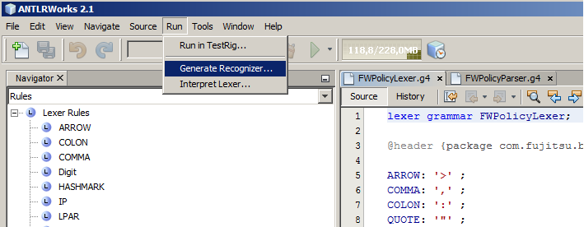

Set the output directory in the first dialog to the location of the Java source files as shown in the next screenshot.

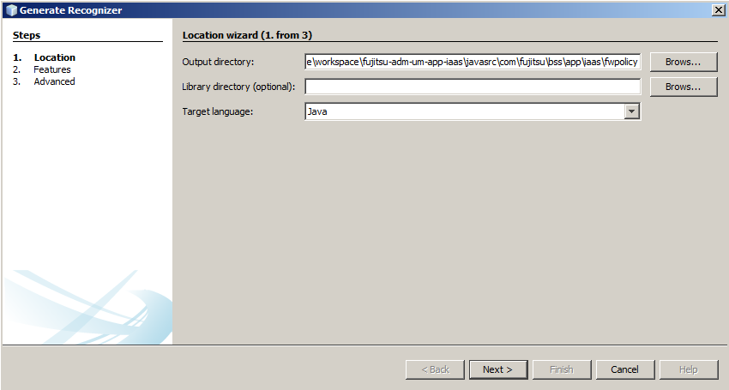

Click **Next** until you reach the third dialog and click on **Finish** to generate the Java source files.

# Compiling the classes

In order the compile the generated Java source files and use the parser during runtime the ANTLR runtime Jar file is necessary. This dependency was added at several locations.

* The ANTLR runtime Jar file was added to the **fujitsu-adm-um-int-libs** project.
* The **fujitsu-adm-um-app-fgcp** project contains the file package.properties with a reference to the ANTLR runtime.
* The ANTLR runtime was added to the build path of the **fujitsu-adm-um-app-iaas** project and the **fujitsu-adm-um-app-iaas-unittests** project