Retail Sales Time Series Analysis
Comprehensive Diagnostic Report

Executive Summary
This report presents a comprehensive time series analysis of retail sales data spanning 120 months from January 2015 to December 2024. The analysis evaluates key characteristics including stationarity, seasonality, trend patterns, and forecastability to inform predictive modeling decisions.
Key Findings
Characteristic | Finding
Forecastable | YES - Significant predictable structure detected
Stationarity | Non-stationary (d=1 differencing required)
Seasonality | Strong seasonal pattern (period=12 months, strength=0.95)
Trend | Strong increasing trend (strength=0.98)
Transformation | None required (Box-Cox λ ≈ 1.03)

1. Data Overview

1.1 Dataset Characteristics
- Total Observations: 120 monthly records
- Time Period: January 2015 to December 2024
- Frequency: Monthly
- Missing Values: 0 (0.0%)
- Data Quality: Excellent - Complete dataset with no gaps

1.2 Descriptive Statistics
Mean | Median | Std Dev
87,131 | 88,525 | 22,759
Min | Max | Range
33,927 | 134,022 | 100,095

1.3 Time Series Visualization
Figure 1 shows the complete time series with clear upward trend and recurring seasonal patterns.
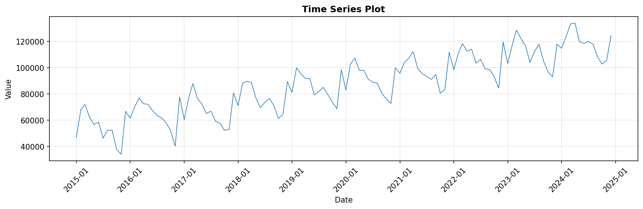

2. Statistical Analysis

2.1 Distribution Analysis
The distribution of sales values shows near-normal characteristics with slight negative skewness (-0.09) and moderate kurtosis (-0.72), indicating a relatively symmetric distribution without extreme outliers.
Metric | Value | Interpretation
Skewness | -0.09 | Nearly symmetric
Kurtosis | -0.72 | Light-tailed
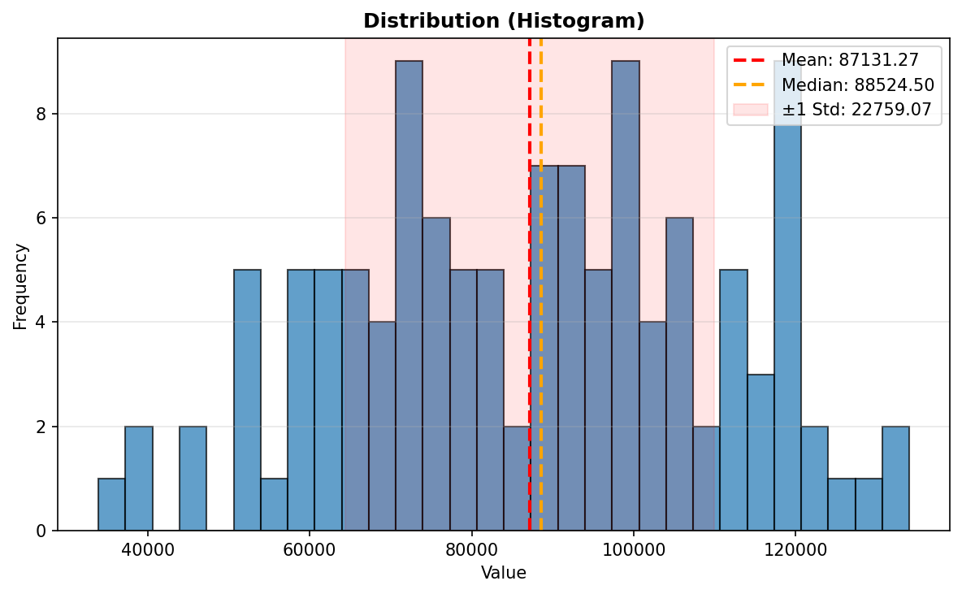

2.2 Stationarity Tests
Both the Augmented Dickey-Fuller (ADF) and KPSS tests confirm that the series is non-stationary, requiring first-order differencing (d=1) to achieve stationarity.
Test | Statistic (p-value) | Result
ADF Test | -0.64 (p=0.86) | Non-stationary
KPSS Test | 1.68 (p=0.01) | Non-stationary
Rolling Statistics: Figure below shows rolling mean and standard deviation, confirming increasing trend and variance stability.
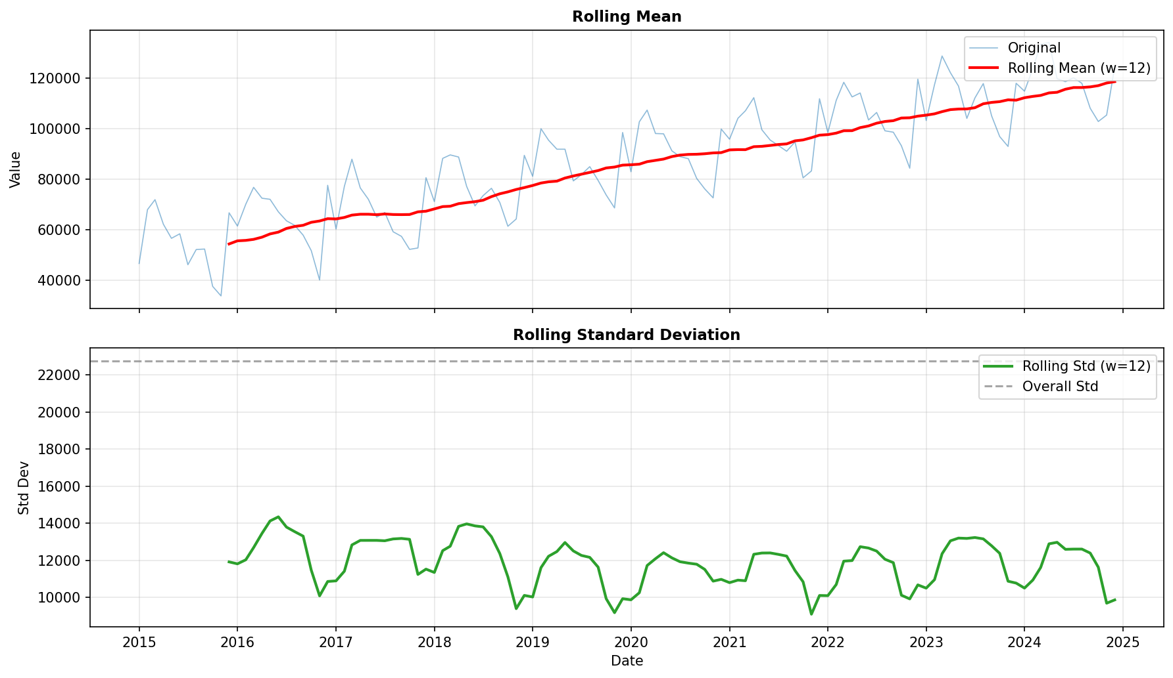

3. Seasonality Analysis

3.1 Seasonal Patterns
STL decomposition reveals a strong seasonal component with period of 12 months (annual cycle). The seasonal strength of 0.95 indicates highly consistent recurring patterns throughout the year.
- Seasonal Period: 12 months
- Seasonal Strength: 0.95 (Strong)
- Interpretation: Predictable annual patterns in sales behavior
Time Series Decomposition:
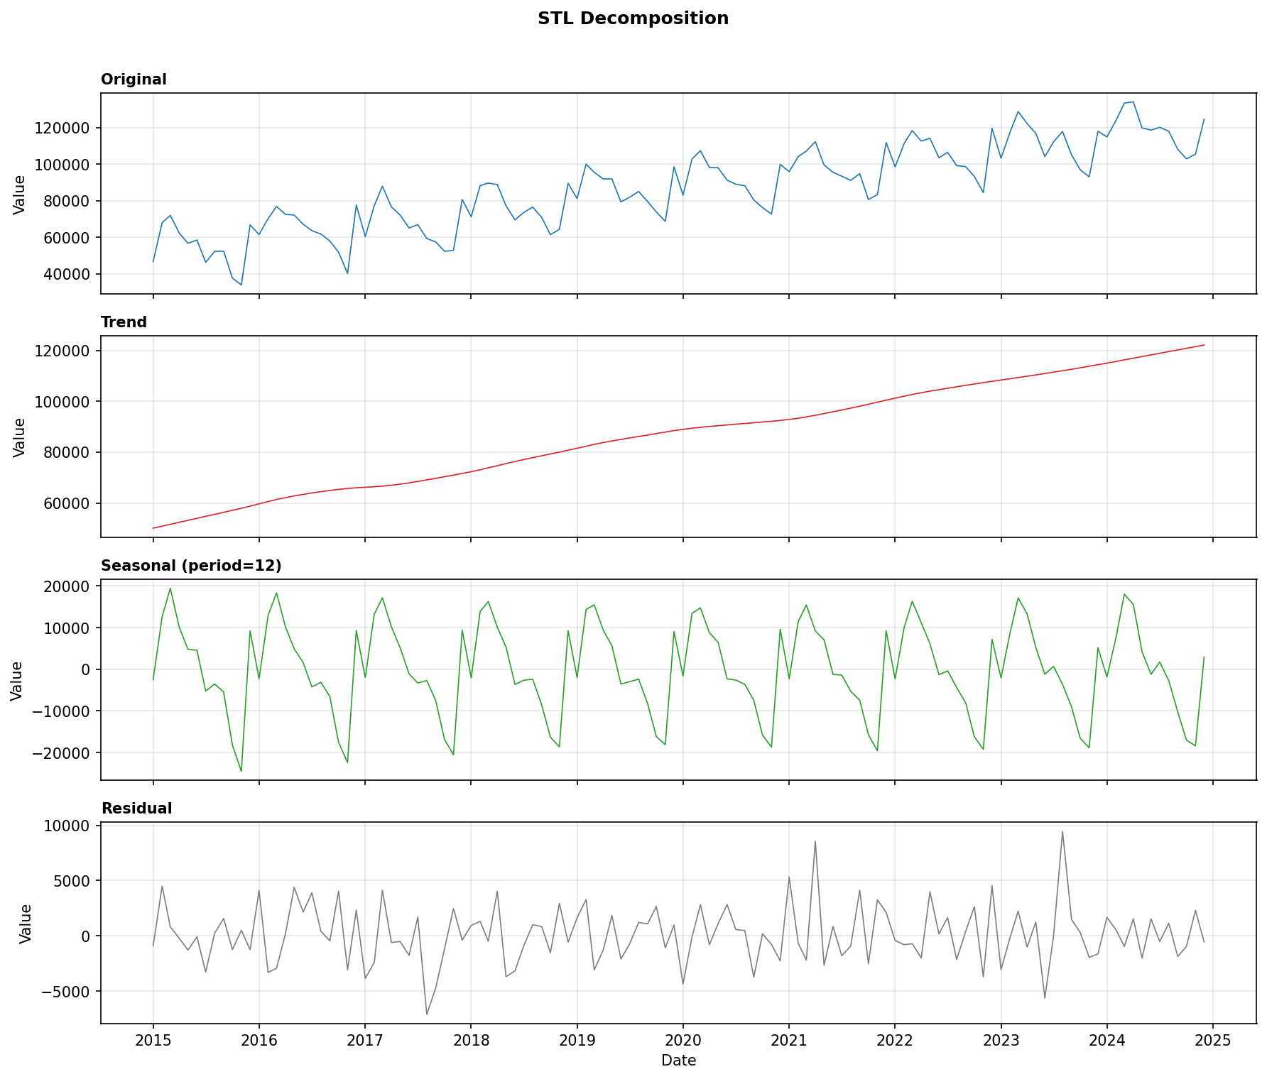

3.2 Seasonal Patterns by Period
Box plots reveal distinct seasonal patterns with higher sales in certain months and quarters throughout the year.
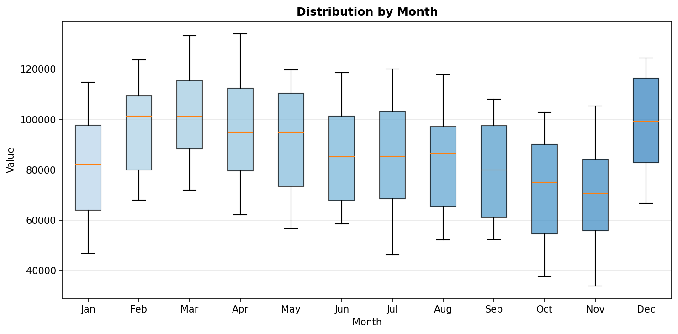
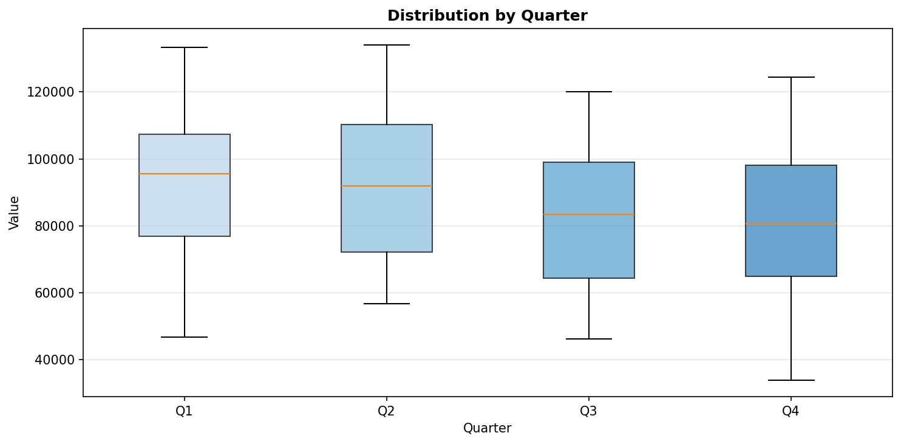

4. Autocorrelation Analysis

4.1 ACF and PACF Analysis
Autocorrelation function (ACF) and partial autocorrelation function (PACF) plots are computed on the first-differenced series (d=1) to identify temporal dependencies and inform model selection.
- Significant ACF Lags: 1, 6, 11, 12, 24, 30, 36
- Significant PACF Lags: 1, 6, 7, 8, 9, 10, 11, 12, 13, 14
- Interpretation: Clear seasonal lags at multiples of 12, suggesting SARIMA model components
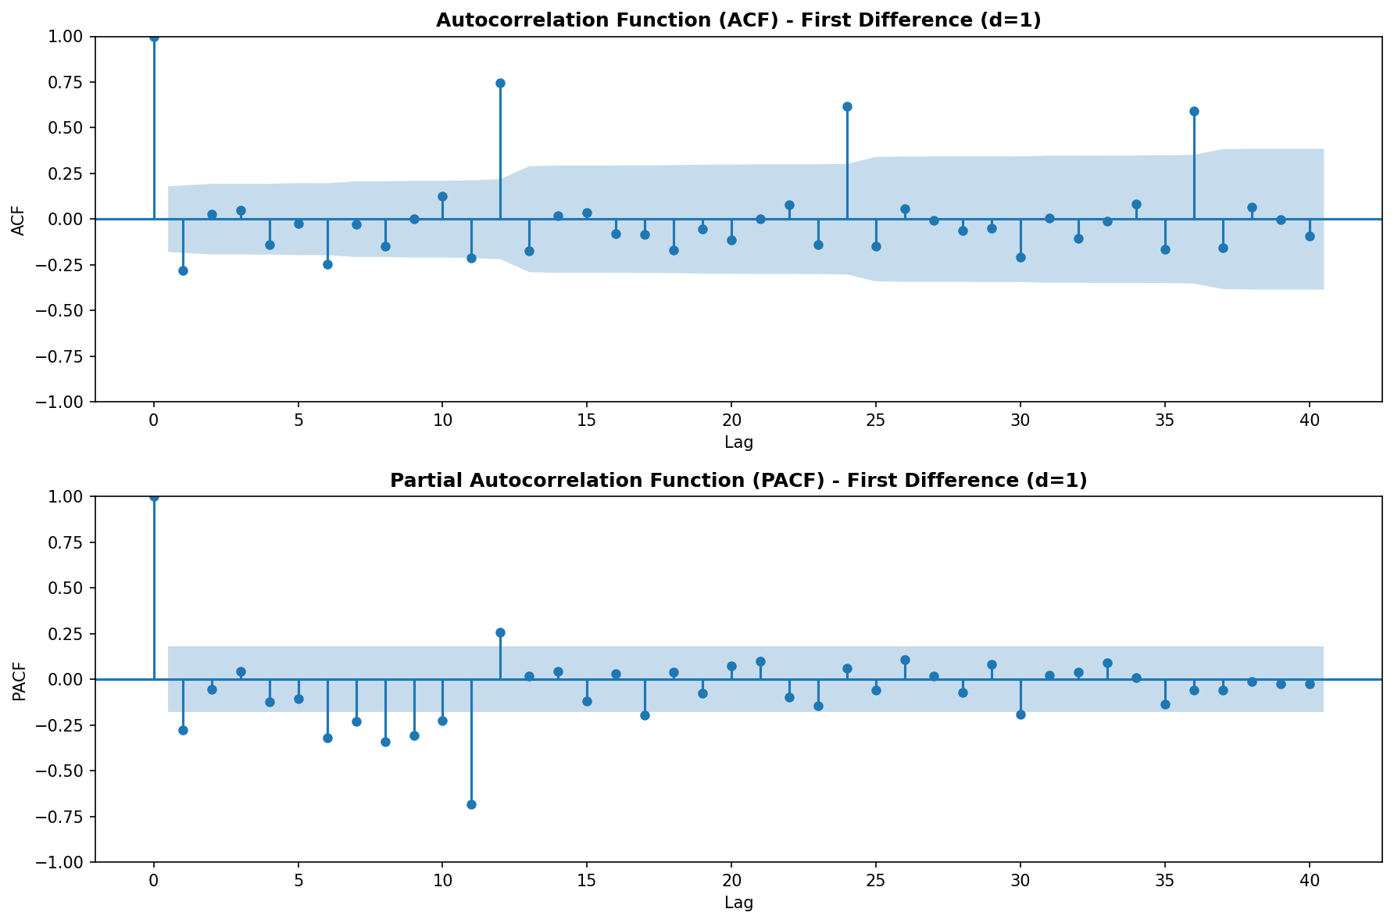

4.2 Lag Scatter Analysis
Lag scatter plots demonstrate the relationship between observations at different time lags, confirming temporal dependencies.
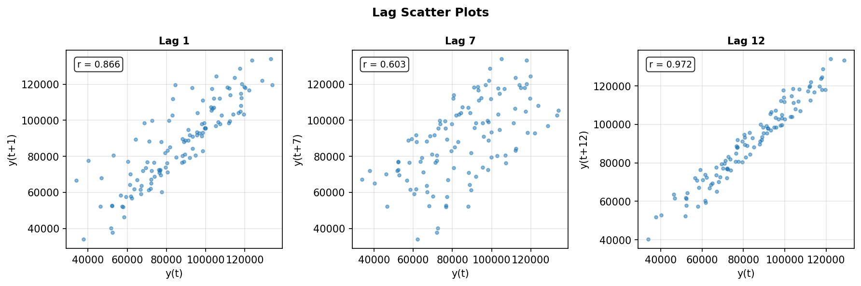

5. Forecastability Assessment

5.1 Ljung-Box Test Results
The Ljung-Box test evaluates whether the time series exhibits significant autocorrelation structure that can be exploited for forecasting.
Test | Statistic (p-value) | Conclusion
Lag 10 | 25.12 (p<0.01) | Significant
Lag 20 | 118.81 (p<0.001) | Significant
Lag 23 | 122.60 (p<0.001) | Significant
Conclusion: The series exhibits highly significant predictable structure suitable for forecasting.

6. Modeling Recommendations

6.1 Model Selection Guidance
Based on the diagnostic findings, the following modeling approaches are recommended:
- SARIMA Models: Seasonal ARIMA (p,d,q)(P,D,Q)[12] given strong seasonality, non-stationarity, and autocorrelation structure. Consider d=1 for differencing.
- Exponential Smoothing: Holt-Winters method with multiplicative or additive seasonality to capture trend and seasonal components.
- Prophet: Facebook Prophet well-suited for data with strong seasonal patterns and missing values tolerance.
- Machine Learning: LSTM or XGBoost with lag features and seasonal encoding for capturing complex patterns.

6.2 Data Transformation
- Box-Cox Lambda: 1.03 (≈1)
- Recommendation: No transformation needed - variance is already stable
- Differencing: Apply first-order differencing (d=1) to achieve stationarity

6.3 Key Considerations
- Strong trend component (0.98) requires trend modeling or differencing
- Strong seasonality (0.95) necessitates seasonal components in forecasting models
- Data quality is excellent with no missing values
- 10 years of monthly data provides sufficient history for robust seasonal modeling

7. Conclusion
The retail sales time series demonstrates excellent forecastability characteristics with clear seasonal patterns, strong increasing trend, and significant autocorrelation structure. The data is non-stationary but can be stabilized through first-order differencing. No variance transformation is required. The strong seasonal component (period=12) and trend suggest that SARIMA or Holt-Winters methods would be particularly effective for this dataset. The 120-month observation period provides substantial history for developing accurate forecasting models.
Summary of Diagnostics:
- Forecastability: YES
- Data Quality: Excellent (no missing values)
- Stationarity: Non-stationary (requires d=1 differencing)
- Seasonality: Strong annual pattern (12-month cycle)
- Trend: Strong increasing trend
- Transformation: Not needed
— End of Report —

