B.Sc. Computer Games Development, Year 3, Project

Game Design Document

**“*Vacuum Master 9000*”**

Authors: Dawid Jerdonek, Filip Rusiecki

Artists: Jay Simuzingili , Filip Rusiecki

Project Supervisor: Philip Bourke

1. **Overview**
   1. **The elevator pitch / high concept**

The player is tasked with saving the town and destroying the evil, corrupt corporation running the town into the ground. The player must collect items and complete tasks to gather resources to vanquish the evil and create a new climate friendly town of the future.

* 1. **Theme, setting and genre**

Set in a polluted industrialised town. Smog, fog, dark, gloomy and grey. This is a 2D top- down free roaming action game set in a polluted industrialised town. The atmosphere is dull. As the player progresses through his/her tasks the town becomes brighter, livelier and more colourful.

* 1. **Player experience goals**

The player will have to focus on the objectives and the incoming enemies. In order to get challenges done the player must play in a smart way and ensure they don’t die while progressing through their tasks.

* 1. **View**

The game will be top down, but we will see the player 45 degrees angle from the camera, giving it a 3D feel in a 2D game. The player camera will be in the center of the screen, and it will always follow our player.

* 1. **Targeted platforms**

The main platform that is being aimed at is Windows platform as this is the most popular desktop machine for games to be played and explored on.

* 1. **Technical requirements**

The hardware and software we will be using is Visual Studio 2019 alongside SFML Library.

We will use tiled to create a level for the game and use separate layers to mask the environment with a better atmosphere.

We will also add controller support for the game as it will be played on a controller but can be played on a mouse and keyboard too .

1. **Gameplay**
   1. **The first minute (60 seconds of play)**

After the player clicks “play” the player is greeted with the gameplay screen where he will see the player character and the section of the map where the player is spawned.

In the top left of the screen there will be a toggle pop-up menu displaying the current objectives of the game which will be updated as the player progresses through the game.

The player’s health will be visible on the bottom left of the game screen, the current ammo count will be visible on the bottom right of screen.

The player will be able to move around using the left analog stick on the controller and will be able to move the crosshair with the right analog stick. The player will use the right trigger to use the secondary action of the weapon (shoot). The player will use the left trigger to use the primary action of the weapon (suck rubbish).The player begins to traverse the world and begins completing the main objectives of the game, as the player progresses the enemies will go to the player and attack. The player must attack and defend themselves or try to run away to survive depending on their ammo for the weapon. The ammo will be collected as rubbish from the ground of the “smog” city.

* 1. **Game Progression**

The game increases in difficulty as the player gets further into the game. The game begins to spawn more enemies for the player to deal with.

As the game progresses the player can see this on their objectives list as he/ she tries to complete each task. Once the two generators are built the game gains colour.

* 1. **Level Progression**

The player we play is on the main level, the task is to complete all the challenges that will be displayed to the player and clean the city. Player needs to fix different components that need power to regenerate the city back to its own strength.

The difficulty of the game increases as there will be more enemies spawning when the player progresses through the game.

The game changes colour and states when tasks are completed.

* 1. **Objectives / Victory condition**

The player is on a mission and has 3 main objectives: To create a new renewable energy source by finding components for this scattered around the map among trash and other technological remains, and as a result take down the industrial factories, to defeat several corporate thugs, and to clean the town using their vacuum cleaner. The player loses if the thugs that were sent after the player, kill the player.

1. **Features**
   1. **Primary and secondary use of weapon.**

The primary feature of the weapon will be using the vacuum cleaner to suck up litter for ammo. The primary feature will be able to be used with left trigger. The maximum distance that will be allowed to suck the litter will be the area that is onscreen. After sucking the litter with the vacuum, the player will gain ammo for the second use of the vacuum cleaner. The amount of ammo that player will gain would be 1.

The secondary feature of the weapon would be that the player will be able to shoot out a projectile of gunk to hurt/ defeat the enemies. The secondary function will be able to be used with right trigger. Ammo would be refillable by sucking up trash with the vacuum cleaner which would earn the player 1 ammo for cleaning random trash deposits off the ground.

* 1. **The player movement**

The player will be able to move around using the left stick on the controller. The player will be able to collide with walls and buildings while moving around. The player will have walking speed. The player can aim their crosshair around the screen by using the right stick on the controller.

* 1. **The player interaction with world**

The player interaction with the world will be possible by collection and finding items for the repair of the city. The player will have to scout around the city to find lost and broken parts of the generators and machines that will cleanse the city from evil. Parts will be obtained by players who then will have to survive the attack or ambush of enemies and deliver the part to a specific location on the map.

* 1. **Animations and sprites**

The world we will be surrounded in will have lots of animations on different objects such as our character, our weapon, Enemies and projectiles and the generators. Our whole game will be visually created with our own sprites to create a unique look for the game.

1. **Game World**
   1. **Game Geography**

Game is a large map filled with buildings, roads, some fields and lots of rubbish. The Industrial Area is where all of the polluting factories are located. This is the area where enemies will spawn. It is the darkest and most dangerous area on the map. The next area is the normal town/residential area where the player begins the quest. The player will begin by cleaning the streets of this area and completing their easiest tasks here. The last area is the empty fields where the player will have to bring parts found around the rest of the map to create the new environmentally friendly energy sources.

* 1. **Game World Elements**

|  |  |  |  |  |  |
| --- | --- | --- | --- | --- | --- |
| **Name** | **Player** | **Enemies** |  | **Building Parts** | **Trash** |
| **Description and Appearance** | **A man in red suit with a vacuum cleaner on his back** | **Men in black suits with guns and knives** |  | **Broken parts of a building which are then combined into a full building** | **Litter such as plastic bottles and cans lying around the game world.** |
| **Backstory synopsis and relationship with other elements** | **The man called in to save the city. Famous all over the world for his bravery in fighting pollution.** | **Thugs sent out by the corporation masterminds to drive the player out of the city.** |  | **Old parts remaining from before the corporation took over the city. The player collects these and once he fuses them together a new renewable energy plant will be created.** | **Litter left all over the city by the corporation and its workers. The player will use the vacuum to clean these and convert this into ammo to use against the enemies.** |
| **Abilities** | **The Player will use the vacuum to suck in trash and shoot the enemies. He can also walk around normally and turn. The player can also pick up building elements and then place them down.** | **The enemies have the ability to use pathfinding to find the player and go to his/her location. Some**  **enemies are also capable of shooting in the direction of the player.** |  |  |  |

1. **Levels**
   1. **Level description**
      1. The player is first introduced to the game story when he first starts up the game. A brief explanation of the game world is given alongside an explanation of what the player is tasked with. The player is given hints at the beginning of the game to give the player an idea of what the player must do. The objectives of the game will be visible to the player as a pop-up menu whenever he/she presses “Y” on the controller.
      2. The main objective is for the player to clean the city and provide it with a new renewable energy source. The in-game objectives will be: To find all necessary parts to build a new renewable energy source. To clean the city of its trash. To defeat corporate thugs. To drive the evil corporation which is polluting the city out.
      3. A few important encounters will be with the thugs which attempt to get rid of the player when they see the player.
2. **Interface**
   1. **Controls**

The controls for the game are as shown in the example below, also all the controls will be visible in the game menu tab called “controls”

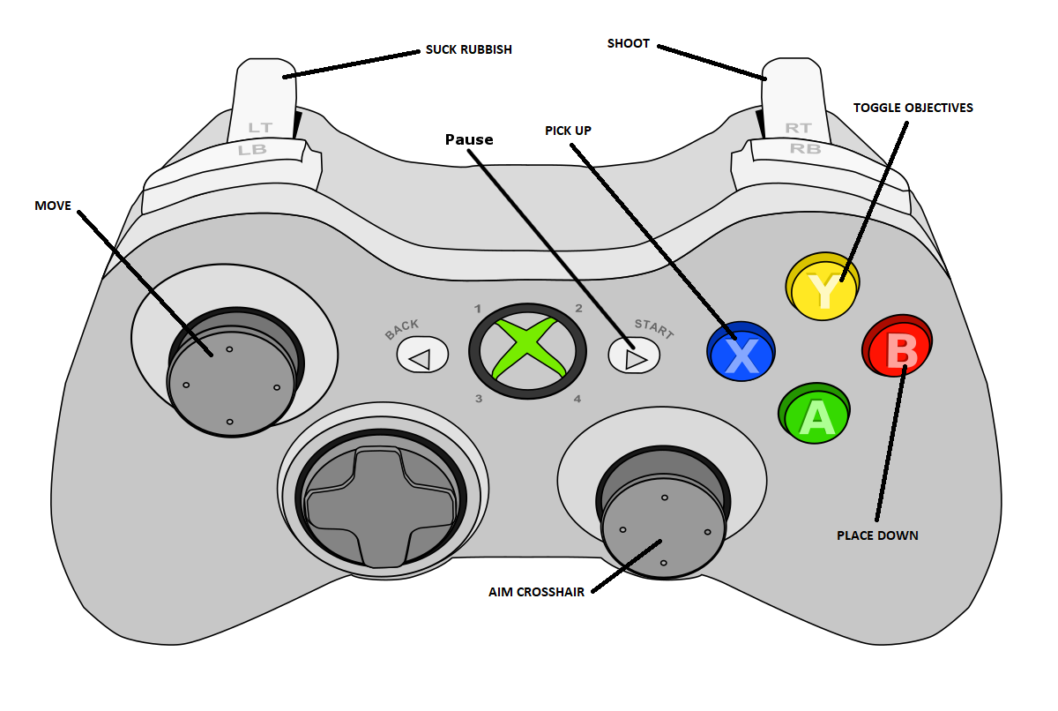

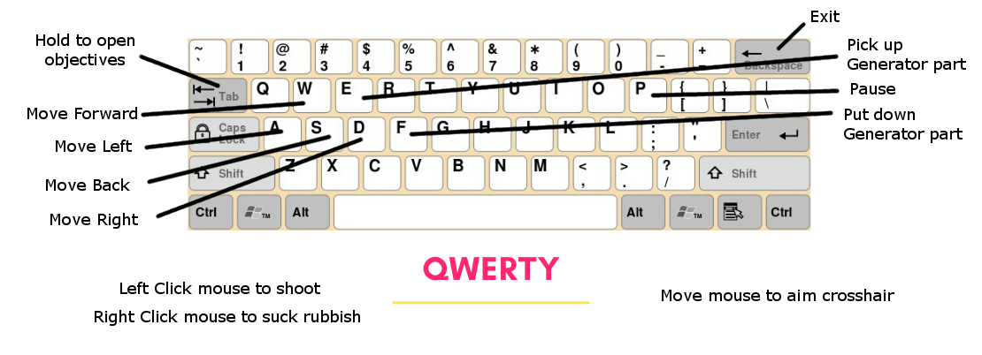

* 1. **In game overlays and dialogs**

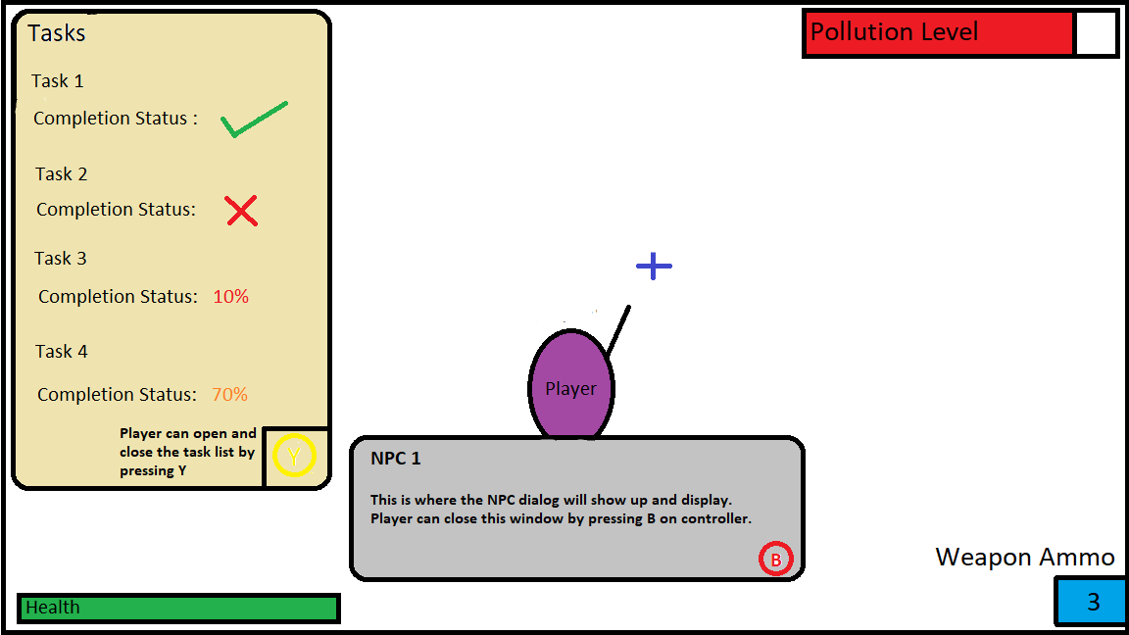

* 1. **HUD**

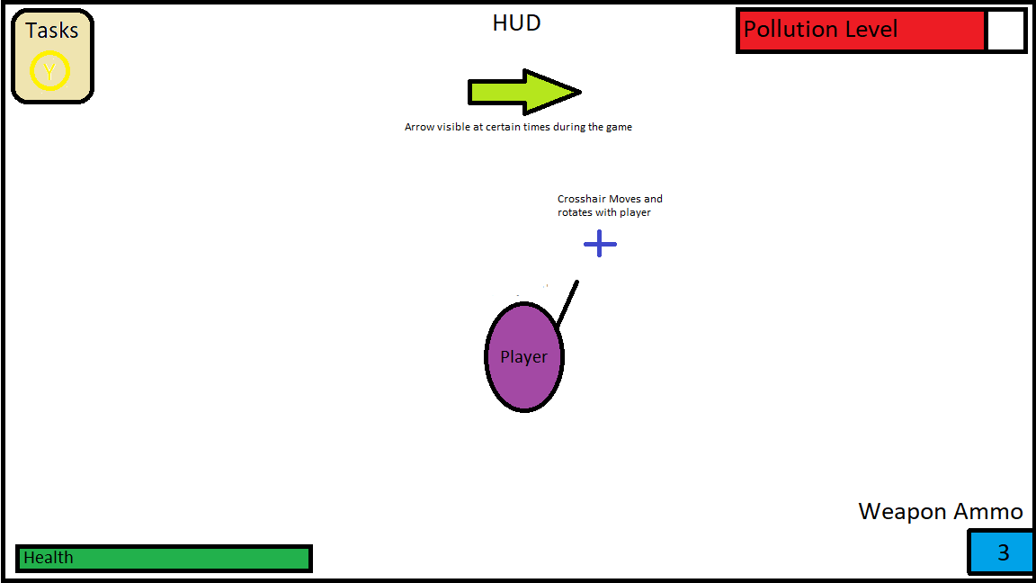

* 1. **Screen flow**

Exit

Dialogue box

Menu

Play

Controls

Settings

HUD

Inventory

Task hint

Audio

* 1. **Control System**

The player will control the game from the main menu, the player will have several options to start with, to go to play, open settings, controls and to exit the game. When the player clicks the play button the game will then be launched and ready to play. When the player clicks the settings button then an options menu will be displayed on the screen. When clicked on the controls menu the player will be shown all the controls for the game. When the Exit button will be pressed the game window will simply close.

* 1. **Opponent AI**

The opponents will go to the player and attempt to defeat the player by shooting him/her or by using melee attacks. The enemies will travel together in an attempt to overwhelm the player and defeat him/her. The enemies will use pathfinding to try and locate the player.

* 1. **Audio**
     1. There will be a background song playing depending on which area of the map the player is.
     2. Audio effect will be used for the enemies, enemy shots, footsteps, hit and death. Player movements, vacuum suck and shot, player being hit and player death. Audio effects when a new building is created. When items are picked up. Menu will also have its own song and audio effects from buttons.
  2. **Art Assets**
     1. We will have art assets for everything that will be displayed on screen. These custom assets will include: Player, Enemy , Second enemy, NPC, House, Second House, Third House, Factories, Player Projectile, Enemy Projectile, Generator, Second Generator, Multiple Different types of rubbish, Fences, Secondary fences and walls, generator parts. The whole level layout and background, and tileset. As well as All menu assets and control schemes.