**DECLARATION**

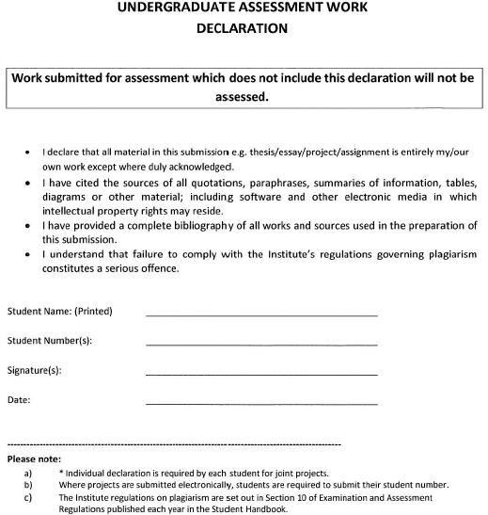

24/04/2023

Dawid Jerdonek

Dawid Jerdonek

C00247646