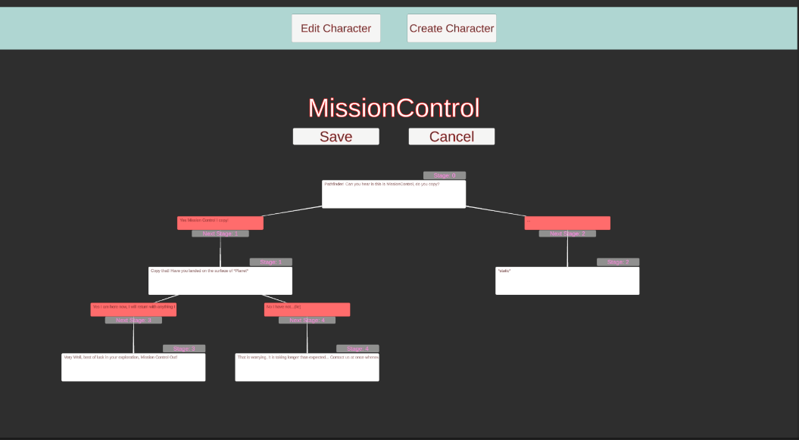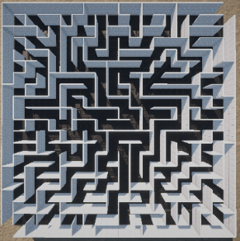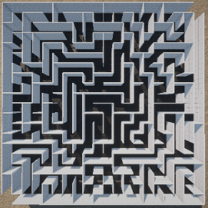

**Dawid Jerdonek**

Dialogue Tale is a runtime Dialogue Editor in Unity. It allows a Unity user to easily CREATE and EDIT Dialogue Trees belonging to various differect characters.

It supports the creation of new characters and subsequent addition of dialogue and even player responses if the target game allows for the player to respond to an NPC.

Dialogue Tale also allows for full customisation of previously created dialogue, from initial greetings all the way down to the bottom of a dialogue tree.

The user can create new characters with any name, new dialogue nodes and new reply nodes allowing for full dialogue customisation and a branching story.

**Dialogue Tale**

**A Runtime Dialogue Editor**

**Dawid Jerdonek**