

Computer Games Development

Technical Design Document

Year IV

Dialogue Tale – A Dialogue Editor and Dialogue System for Unity with a VR example

**[Dawid Jerdonek]**

**[C00247646]**

**[24/04/2023]**

Submitted to the Department of Computing

in partial fulfillment of the requirements for the degree of

Bachelor of Science in Games Development

at the

South East Technological University

May 2023

© South East Technological University 2023. All rights reserved.

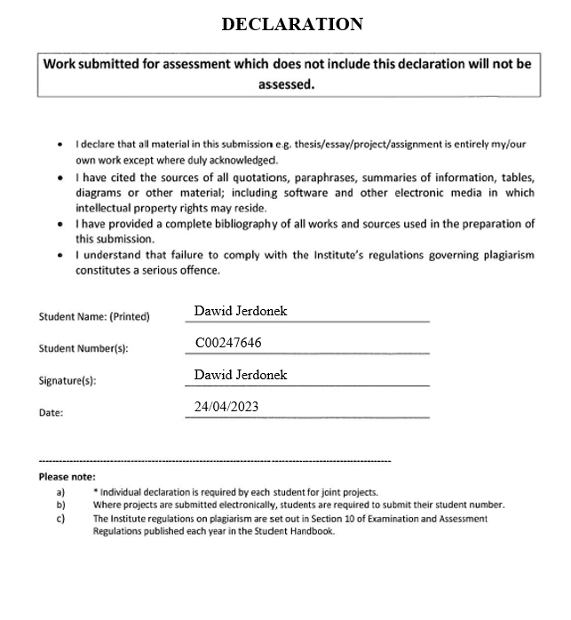

Contents

Acknowledgements 3

Technical Design 3

References 3

# Acknowledgements

I would like to thank the following people who assisted in completing this project including;

My Project Supervisor Noel O’Hara.

All the 4th Year Games Development Lecturers at South-East Technological University Carlow which have provided crucial feedback, remarks, and criticism.

# Technical Design

The purpose of this document is to communicate effectively the technical details and design decisions of the system/algorithm to the readers.

It could include software architecture, algorithm design, class specifications, pseudo code, etc. with tools such as UML, Class Diagram, CRC Cards.

**CRC Cards**

|  |  |
| --- | --- |
| **CameraMove** | |
| **Responsibilities** | **Collaborators** |
| * Move camera in four directions (UP, DOWN, LEFT, RIGHT) * Zoom camera in and out in Dialogue Editor * Have boundaries set up so camera does not go too far from Editor |  |

|  |  |
| --- | --- |
| **CancelEditHandler** | |
| **Responsibilities** | **Collaborators** |
| * Cancel the changes made to a dialogue tree. * Destroy all node of the dialoge tree. * Destroy all related buttons to dialogue tree. | * DialogueEditor * SaveEditHandler |

|  |  |
| --- | --- |
| **CharacterButtonHandler** | |
| **Responsibilities** | **Collaborators** |
| * Spawn in all nodes related to a character when a character button is pressed. * Setup lines from reply nodes to dialogue nodes. * Assign all relevant data to each node in the dialogue tree. | * DialogueSystemNew * DialogueEditor * StageGrabber * DialogueTreeShapeSetter * LineInformation |

|  |  |
| --- | --- |
| **CurrentCharacterStage** | |
| **Responsibilities** | **Collaborators** |
| * Stores the current stage of the character dialogue |  |

|  |  |
| --- | --- |
| **DialogueDisplay** | |
| **Responsibilities** | **Collaborators** |
| * Sets the correct character name on HUD for dialogue | * PlayerController |

|  |  |
| --- | --- |
| **DialogueEditor** | |
| **Responsibilities** | **Collaborators** |
| * Create new characters for dialogue tree * Cancel the creation of a new character * Instantiate buttons for choice of which character to edit * Destroy the buttons for choice of which character to edit * Read in the XML text file and store it * Save parsed dialogue to different XML files | * DialogueSystemNew * DialogueLoader * Dialogue |

|  |  |
| --- | --- |
| **DialogueLoader** | |
| **Responsibilities** | **Collaborators** |
| * Load dialogue from custom saves or from default save | * DialogueSystemNew |

|  |  |
| --- | --- |
| **DialoguePreviewer** | |
| **Responsibilities** | **Collaborators** |
| * Load a dialogue XML file into a preview to show dialogue file before it is loaded and used * Enter the preview screen * Exit the preview screen | * DialogueSystemNew |

|  |  |
| --- | --- |
| **DialogueSystemNew** | |
| **Responsibilities** | **Collaborators** |
| * Load XML file from disk and pass it into parser * Read from the XML file * Setup a list of all character identities based on characters in the dialogue file. * Display the correct current character dialogue in HUD * Set up and handle dialogue choices of player | * PlayerController * Parser * Dialogue |

|  |  |
| --- | --- |
| **DialogueTreeShapeSetter** | |
| **Responsibilities** | **Collaborators** |
| * Finalise a dialogue tree shape and node positions. * Draw remaining lines from reply nodes to dialogue nodes. | * DialogueSystemNew * LineInformation * StageGrabber |

|  |  |
| --- | --- |
| **HUDUIManager** | |
| **Responsibilities** | **Collaborators** |
| * Display save, load, and cancel buttons * Disable save, load, and cancel buttons |  |

|  |  |
| --- | --- |
| **LineInformation** | |
| **Responsibilities** | **Collaborators** |
| * Store start and end position of line. * Update line positions if nodes are moved |  |

|  |  |
| --- | --- |
| **MazeGenerator** | |
| **Responsibilities** | **Collaborators** |
| * Stores Positions, Walls states and neighbours * Run Recursive Backtracking algorithm to create procedural maze. |  |

|  |  |
| --- | --- |
| **MazeRenderer** | |
| **Responsibilities** | **Collaborators** |
| * Populate maze plane by creating a grid from wall prefabs * Specify maze size | * MazeGeneretor |

|  |  |
| --- | --- |
| **NodeMover** | |
| **Responsibilities** | **Collaborators** |
| * Drag nodes around in Dialogue Editor * Delete nodes from dialogue tree * Add nodes to dialogue tree * Update parsed data with new nodes | * StageGrabber * Dialogue * DialogueEditor * DialogueSystemNew * LineInformation |

|  |  |
| --- | --- |
| **ObjectGrabbing** | |
| **Responsibilities** | **Collaborators** |
| * Apply Physics to objects grabbed in VR |  |

|  |  |
| --- | --- |
| **Parser** | |
| **Responsibilities** | **Collaborators** |
| * Split data into dialogues by getting rid of syntax from XML * Create list of parsed dialogues * Reformat parsed dialogues back into XML format with correct syntax | * Dialogue |

|  |  |
| --- | --- |
| **PlayerController** | |
| **Responsibilities** | **Collaborators** |
| * Display and hide HUD for dialogues * Move player * Check for trigger collisions |  |

|  |  |
| --- | --- |
| **SaveEditHandler** | |
| **Responsibilities** | **Collaborators** |
| * Save edited dialogue trees to parsed data * Destroy the dialogue tree on display | * Dialogue * DialogueEditor * DialogueSystemNew * CancelEditHandler |

|  |  |
| --- | --- |
| **StageGrabber** | |
| **Responsibilities** | **Collaborators** |
| * Store current node stage value |  |

# References

**Books**

Millington, I. (2019) “Chapter 8: Procedural Content Generation,” in AI for games, Third edition. Boca Raton, Florida: CRC Press, pp. 705–726.

**Articles**

Mikkelson, N. (2020) *Game Writing: Structuring Branching Dialogue*, Indie Writing. Available at: https://indiegamewriting.com/writing-1-structuring-branching-dialogue/ (Accessed: January 10, 2023).

Merdivan, E. *et al.* (2019) *Dialogue Systems for Intelligent Human Computer Interactions*, *Science Direct*. Available at: https://www.sciencedirect.com/science/article/pii/S1571066119300106?via%3Dihub (Accessed: January 11, 2023).

Liemhetcharat, A. (2021) *Unity: Reading external XML files*, *GitConnected*. Level Up Coding. Available at: https://levelup.gitconnected.com/unity-reading-external-xml-files-ed199df66288 (Accessed: January 25, 2023).

Philipp, M. (2015) “How To Read An XML File In Unity,” Studica, 15 December. Available at: https://blog.studica.com/read-xml-file-in-unity (Accessed: January 30, 2023).

**Videos**

Board To Bits Games. (2016) Saving Data in Unity: XML Files, [video online]. Available at: https://www.youtube.com/watch?v=6vl1IYMpwVQ&ab_channel=BoardToBitsGames (Accessed: January 27, 2023).

**Websites**

Grasshop Dev (2020) *Dialogue Editor*, *Unity Asset Store*. Available at: https://assetstore.unity.com/packages/tools/utilities/dialogue-editor-168329 (Accessed: February 10, 2023).

*ChatMapper* (2010) *Chat Mapper AI*. Available at: https://www.chatmapper.com/ (Accessed: February 12, 2023).

*PixelCrushers* (2018) *Dialogue system for unity*, *Pixel Crushers*. Available at: https://www.pixelcrushers.com/dialogue-system/ (Accessed: February 12, 2023).