# Q1 TCP sequence numbers

 A TCP sender is just about to send a segment of size 100 bytes with sequence number 1234 and ack number 436 in the TCP header. What is the highest sequence number up to (and including) which this sender has received all bytes from the receiver?

1. 1233
2. 436🡨Ans
3. 435?
4. 1334
5. 536

# Q2 TCP sequence numbers

 A TCP sender is just about to send a segment of size 100

bytes with sequence number 1234 and ack number 436 in the TCP header. Is it possible that the receiver has received byte number 1335?

1. Yes🡨Ans
2. No

# Q3 TCP timeout

 A TCP sender maintains a SmoothedRTT of 100ms. Suppose the next SampleRTT is 108ms. Which of the following is true of the sender?

1. Will increase SmoothedRTT but leave the timeout unchanged
2. Will increase timeout
3. Whether it increases SmoothedRTT depends on the deviation.
4. Whether it increases the timeout depends on the deviation
5. Will chomp on fries left over from the rdt question earlier -Best answer

# Q4 TCP timeout

 A TCP sender maintains a SmoothedRTT of 100ms and DevRTT of 8ms. Suppose the next SampleRTT is 108ms.

What is the new value of the timeout in milliseconds?

(Numerical question)

TimeOutInterval = smoother_RTT + 4*deviation_RTT

100ms + 4*8ms = Timeout

= 0.132 seconds

=132 milliseconds

# Q5 TCP header fields

 Which is the purpose of the receive window field in a TCP

header?

1. Reliability
2. In-order delivery
3. Flow control 🡨Ans
4. Congestion control
5. Pipelining

# Q6 TCP connection mgmt

 Roughly how much time does it take for both the TCP sender and receiver to establish connection state since the connect() call?

1. RTT
2. 1.5RTT 🡨Ans
3. 2RTT
4. 3RTT

# Q7 TCP reliability

 TCP uses cumulative ACKs like Go-back-N, but does not retransmit the entire window of outstanding packets upon a timeout. What mechanism lets TCP get away with this?

1. Per-byte sequence and ack numbers 🡨 Ans
2. Triple duplicate ACKs
3. Receive window-based flow control
4. Using a better timeout estimation method
5. Ketchup (for the fries) Best Answer

# Q8

 A sender that underestimates the round-trip time of a

connection may unnecessarily induce a TCP timeout  True

# Q9

 Which of the following services use TCP?

* DHCP
* SMTP
* HTTP
* TFTP
* FTP

# Q10

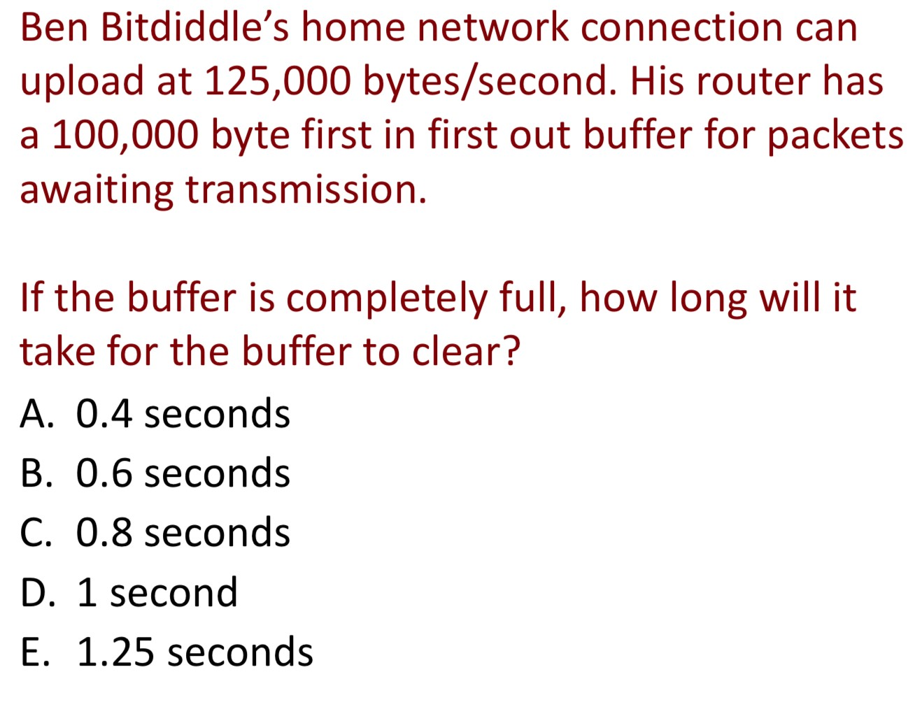

C = 0.8 seconds

100000/125000 = 0.8 seconds

# Q11

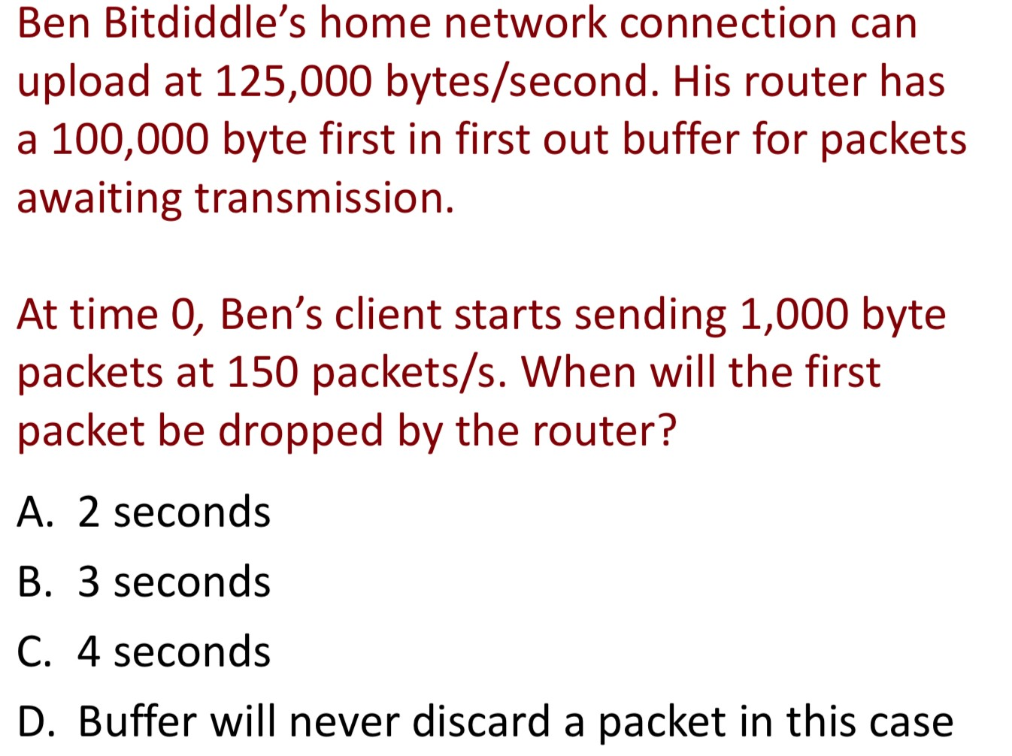

150 * 1000 = 150,000 packet bytes per second

Max Upload = 125,000 bytes per second

150,000 – 125,000 = 25,000 per second

25,000 * 4 seconds = 100,000

Byte buffer = 100,000

Byte buffer exceeds after 4 seconds.

Answer = C

# Q12

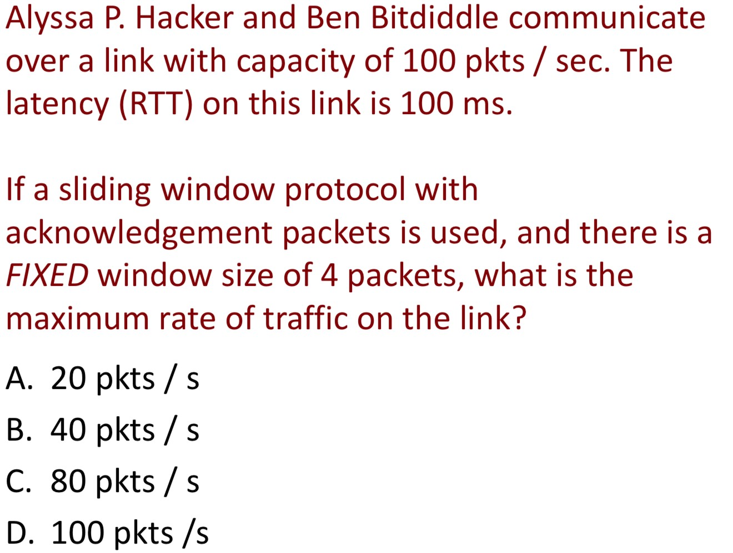

100ms = 0.1 seconds

4 * 100 packets = 400

400 * 0.1 = 40 packets / s

Answer : B