Hangfa Discovery Q2 Robot Platform

<http://www.hangfa.com/EN/robot/DiscoveryQ2.html>

<http://www.robotshop.com/en/hangfa-discovery-q2-robot-platform.html>

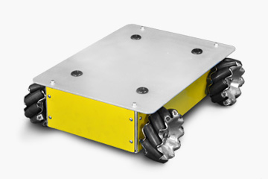

# Price

1311$

# Description

The Discovery series is a small economical robot platform. It aims to provide users with a complete mobile robot system with high reliability and multiple interfaces. Discovery Q2 is robot platform with four 45 degrees QMA -10 omni wheels manufactured by Hangfa Hydraulic Engineering Co., Ltd. (Chengdu). Compared with the traditional gear train, the QMA -10 omni wheel is able to accomplish many special movements, like translation, rotation, and simultaneous translation & rotation. Discovery Q2 uses four high-power coreless motors as the driver, equipped with multi-axis servo driver,supporting both CAN bus and RS232 interface. The development kit provides customers with a complete equipment communication protocol, and also provides examples and demo application source code based on STM32F407, which allows users quickly know how to operate Discovery Q2.

# Features

* move to all the directions
* gear train with bearing
* inflatable rubber wheel
* coreless DC servo motor
* servo driver - wielościowy sterownik silników, komunikacja RS lub CAN
* demo application source code based on STM32F407
* coaxial tilting suspension

# Dimensions

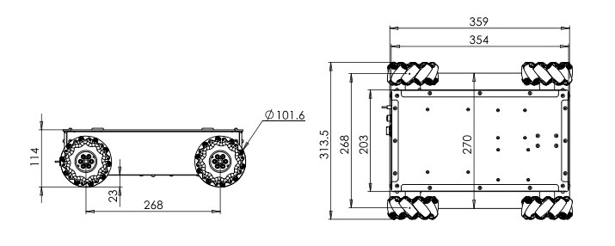

# Details

* body structure: aluminum alloy molding whole shape
* dimension: **359 x 313.5 x 114mm**
* driving wheel: QMA-10 omni wheel
* diameter of driving wheel: 101.6mm
* drive mode: four-wheel independent drive
* coaxial tilting suspension: no suspension
* minimum space between robot to ground: 23mm
* gross weight: 10kg
* rated load capacity: **10kg**
* motor type: coreless DC servo motor
* rated power of the motor: 17W
* motor encoder: **500 line/rev, A、 B phase output**
* quantity of motors: 4
* motor driver: servo driver, supporting both CAN bus and RS232 interface
* maximum translational speed: 0.65m/s
* maximum rotation speed: 140°/s
* minimum turning radius: 0m
* adaptive ground: indoor,bituminous ground, concrete ground with little depression
* typical duration time: >**8h** (load capacity 10KG, moving speed 1m/s, moving rate 70%)
* standby time: >30h
* support electricity 5V @2.5A*2/battery
* output: voltage(9.6~12.6V)@>5A
* The default specification of The power of insurance tube: 5×20/10A
* bettery capacity: 24V/10.4Ah lithium-ion battery
* battery fast change: support
* battery charger: charger input voltage:AC100V~240V Charging current:5A Interface:direct plug-in
* DEMO development board: RHF407development board（CAN×2，RS232×2，TTL×1，RS485×1，SPI×1，I2C×1，USB×1，ADC×8，DAC×2，PWM×8，LED×2，Button×2，IndependenI/O×24， Reusable I/O×29，TF interface×1，RTC battery back seat，ReusableTFT LCD interface×1）
* accessories: battery charger, ULB-1, ultrasonic sensor×5

# What’s included

* QMA-10 omni-wheels
* IMDR4 servo controller
* 5x ULB-1 ultrasonic range-finding sensors
* RHF407 development board - płytka ze sterownikiem silników
* 4x Faulhaber 3242 coreless DC servo motor
* battery charger

# Comments

* producent podaje dopuszczalną masę ładunku równą 10kg natomiast sklep RobotsShop aż 30kg

Hangfa Compass Q2 Robot Platform

<http://www.hangfa.com/EN/robot/CompassQ2.html>

<http://www.robotshop.com/en/hangfa-compass-q2-robot-platform.html>

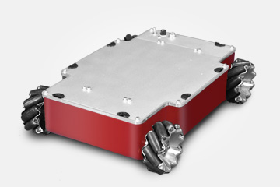

# Price

3246$

# Description

The Compass series is a small fundamental robot platform. It aims to provide users with a complete mobile robot system with high reliability and multiple interfaces. Compass Q2 is a robot platform with four 45 degrees QMA-10 omni wheels. Compared with the traditional gear train, the QMA-10 omni wheel is able to accomplish many special movements, like translation, rotation, and simultaneous translation & rotation.The chassis of this platform adopts overall aluminum casting & molding process. Compass Q2 uses four high-power coreless motors as the driver, equipped with four-axis servo driver, supporting both CAN bus and RS232 interface. The development kit provides customers with a complete equipment communication protocol, and also provides examples and demo application source code based on STM32F407, which allows users quickly know how to operate Compass Q2.

# Features

* move to all the directions
* overall aluminum casting & molding process
* inflatable rubber wheel
* coreless DC servo motor
* servo driver
* demo application source code based on STM32F407
* four wheels independently hanged

# Dimensions

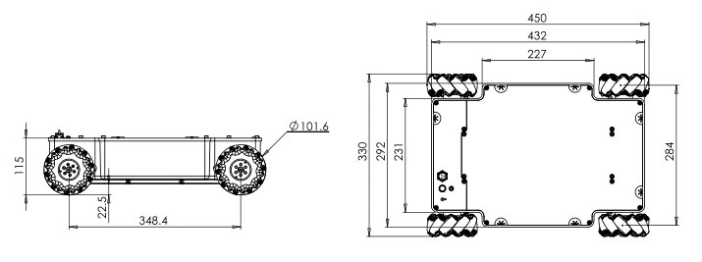

# Details

* body structure: aluminum alloy molding whole shape
* dimension: **450×330×115mm**
* driving wheel: QMA-10 omni wheel
* diameter of driving wheel: 101.6mm
* drive mode: four-wheel independent drive
* suspend kind: rocker arm suspension
* minimum space between robot to ground: 22.5mm
* gross weight: **16kg**
* rated load capacity: **20kg**
* motor type: coreless DC servo motor
* rated power of the motor: 30W
* motor encoder: 500 line/rev, A、 B phase output
* quantity of motors: 4
* motor driver: servo driver, supporting both CAN bus and RS232 interface
* maximum translational speed: 0.75m/s
* maximum rotation speed: 215°/s
* minimum turning radius: 0m
* adaptive ground: indoor, bituminous ground, concrete ground with little depression
* typical duration time: >**10h**(load capacity 10KG,moving speed 1m/s,moving rate70%)
* standby time: >30h
* support electricity output: 5V@5A / 12V@5A /battery voltage(35.2~46.2V)@>10A
* The default specification of The power of insurance tube: 5×20/20A
* battery capacity: 24V/18.2Ah lithium-ion battery
* battery fast change: support
* battery charger: charger input voltage:AC100V~240V Charging current:5A Interface:direct plug-in
* DEMO development board: RHF407development board（CAN×2，RS232×2，TTL×1，RS485×1，SPI×1，I2C×1，USB×1，ADC×8，DAC×2，PWM×8，LED×2，Button×2，IndependenI/O×24， Reusable I/O×29，TF interface×1，RTC battery back seat，ReusableTFT LCD interface×1）
* accessories: battery charger, ULB-1ultrasonic sensor×5

# What’s included

* 4x HFmotor-3230 (30W) coreless DC servo motor
* 1x RHF407 development board
* 4x QMA-10 omni wheel
* 5x ULB-1 ultrasonic range-finding sensors
* 1x IMDR4 servo driver

# Comments

* producent podaje dopuszczalną masę ładunku równą 20kg natomiast sklep RobotsShop aż 40kg

# 4WD Mecanum Wheel Mobile Robotic Platform

<http://www.robotshop.com/en/4wd-mecanum-wheel-mobile-robotic-platform.html#description>

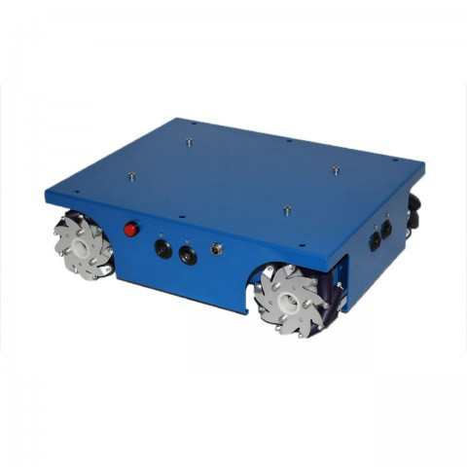

# Price

1500$

# Descriptions

The 4WD Mecanum Wheel Mobile Robotic Platform has four mecanum wheels that give this mobile robotic platform/kit autonomous omni-directional capabilities, while regular wheels don’t. This is a four mecanum wheels drive mobile robotic platform/kit. Each wheel is connected to a separate motor with independent control. The configuration of rollers at 45° also allows the robot to travel sideways, and through a combination of movements, drive in any direction – even while spinning. Furthermore, this robot kit is programmed in C, C++ language. It includes sample code so you can program it via an easy-to-use arduino user interface, and have easy access to programming functions. It enables researchers, developers and robotic students to write their own software, learn from others accomplishments and configure the hardware as required and desired. Also, there are some pre-drilled screw holes on the aluminum chassis to add extensions easily. Therefore, you can add the extensions you like, such as cameras, lap-top, artware or a micro robot arm, etc. Last but not least, this mecanum wheel mobile robotic not only operates on flat hard surfaces, but also performs very well on rough terrains or complex terrains.

# Features

* Mecanum wheels drive mobile robotic platform
* Programmed in C, C++ language
* Pre-drilled screw holes on aluminum chassis to add extensions easily
* Performs very well on rough terrains or complex terrains

# Dimensions

400mm x 307mm x 123mm

# Details

* Distance between bottom and ground: 21.5mm
* Chassis material: Aluminum alloy
* Speed: 0.6m/s
* Net weight: 5.5kg
* Load capacity: **10kg**

Mecanum wheels:

* Outside wheel diameter: 100mm
* Anodized Aluminum plates: White color
* Width: 50mm
* Number of Rollers: 9
* Number of Plates: 2
* Body material: Aluminium alloy
* Roller material: PA+PU
* Spacer material: Nylon
* Length of roller: 47mm
* Net weight: 0.4kg
* Load capacity: 15Kg

DC motor:

* Type: Faulhaber 12V DC Coreless Motor
* Power: 17W
* No Load Speed: 8100RPM/minute
* Reduced Speed: 120RPM/minute
* Diameter: 30mm
* Length: 42mm
* Total Length: 85mm
* Diameter of Shaft: 6mm
* Length of Shaft: 35mm
* No Load Current: 75mA
* Load Current: 1400mA
* Gearbox Ratio: 64:1

Encoder:

* Type: Optical
* Encoder Phase: AB
* Encoder Resolution: 12CPR

What’s included

* 4 100mm mecanum wheels
* 4 DC motors with encoder
* 1 arduino 328
* 1 IO expansion
* 4 ultrasonic sensors
* 1 12V, 3500mA lithium battery
* 1 12V charger