APPLICATION ARCHITECTURE

SOs have “hosts” file:

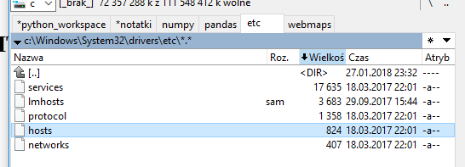
Its contents:

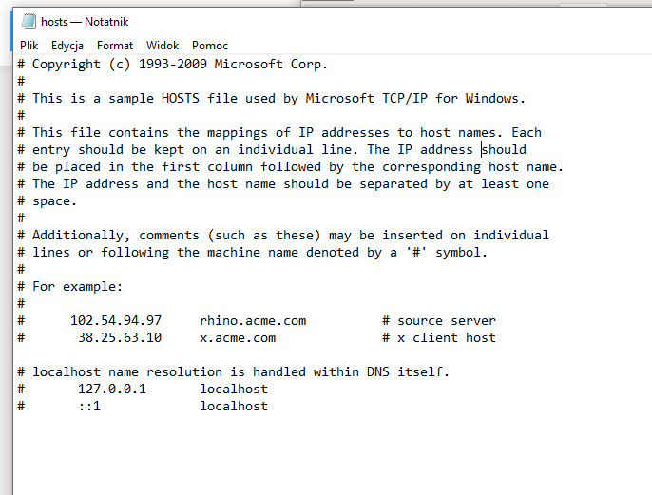
On the left we should write IP address and on the right we write host name. We want to redirect dectructive webpages to address 127.0.0.1 by I.e:

127.0.0.1 www.facebook.com

We will open this file via Python and add certain lines of text at certain time of the day.

