INTRODUCTION

We will build a website using python and flask.

First, we install flask.

pip install flask

We import class Flask from library flask.

from flask import Flask

then we create a variable that will store an instance of Flask class.

app = Flask(__name__)

where __name__ is a special variable that gets us value of the name of the python script:

When you run a python script, it initializes some special variables. One of them is __name__ variable, which stores the name of the module. This name can vary depending on the way we run our script. If we run the script directly (not through imporing it), the module is named __main__.
It can be simply confirmed, create script and just run it directly:

print('First module name is ' + __name__)
out: First module name is __main__

If we run script as imported, then its __name__ variable will be the script’s name. Lets try this with script test.py (imported in foo.py script):

import test ← it executes script test.py
print('Second module name is {}'.format(__name__))
out: First module name is test ← test.py – script run through import
Second module name is __main__ ← foo.py – script run directly so we get __name__

then we add decorator route:

@app.route('url_where_you_will_view_your_website')

we will use:

@app.route('/')

next we define a python function, it will define what the website will do. For now, we will just return a string.

def home():
return 'Website content goes here!'

The output of the function will be mapped to the URL inticated by the @app.route('/').

we will need just two more lines of code: (there we check if the script is being run directly)

if __name__==’__main__’:
app.run(debug=True)

complete script:

from flask import Flask

app = Flask(__name__)

@app.route('/')

def home():
return 'Website content goes here!'

if __name__ == '__main__':
app.run(debug=True)

after running the script, the website should be available at localhost, go to your browser and go to:

http://localhost:5000/

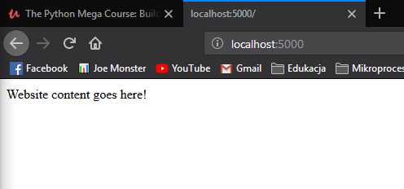

If we change the URL to /about/:

@app.route('/about/')

then we will not find any website at ‘/’ (localhost):

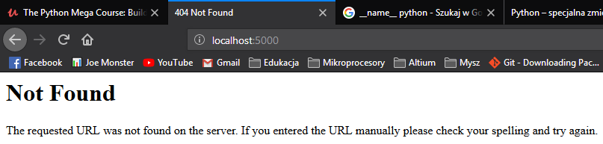
but we will find the previous content at the ‘/about/' ( localhost:5000/about):

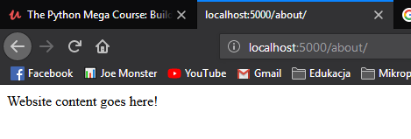

Now, if we want to keep both pages, we will have to define two decorators and two functions:

from flask import Flask

app = Flask(__name__)

@app.route('/')
def home():
return 'Homepage here!'

@app.route('/about/')
def about():
return 'Website content goes here!'

if __name__ == '__main__':
app.run(debug=True)
PARSING HTML TEMPLATES

How to generate HTML pages using python web app.

Earlier, we simply returneg plain strings, now we will return HTML template. We will need render_template method of the flask library.

from flask import Flask, render_template

Render_template acceses an HTML file stored somewhere in our files and displays that HTML on the requested URL.

So, now, instead of returning string, we will return:

return render_template('home.html')

The ‘home.html’ needs to be a real file located locally on the disk, in folder named templates.

Accordinglt, under decorator @app.route('/about/') we can write:

def about():
return render_template('about.html')

ADDING A NAVIGATION MENU

Navigation menu will be the same on both pages – the about page and the homepage:
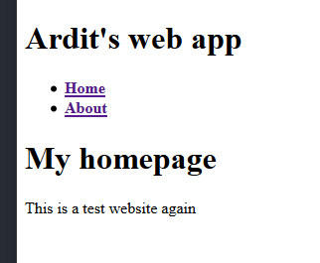
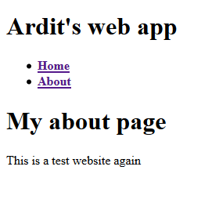

So could paste the html part responsible for the navigation menu to both pages (both templates). But there is another way to do it.

We will create a separate HTML page for the navigation menu and then link the about page and the homepage to this page.

So we need HTML file for this part (header and navigation menu), there it is:

It is additional page – additional tempalte file ‘layout.html’ in tempaltes folder:

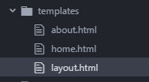

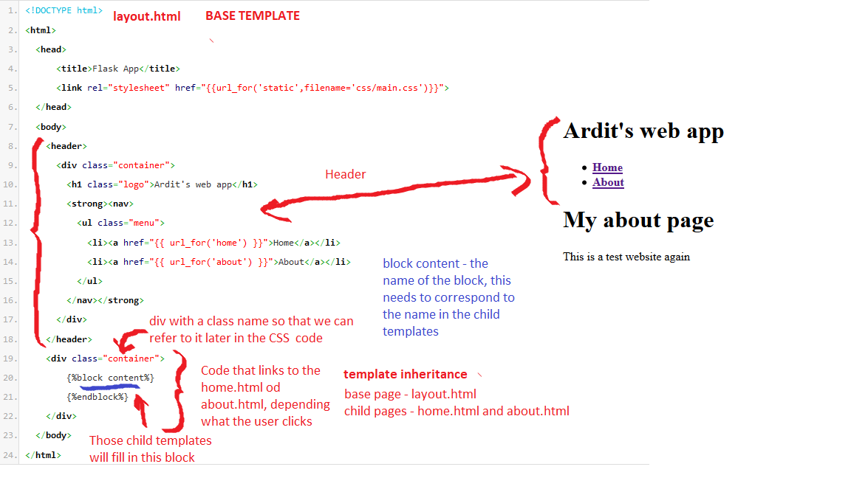
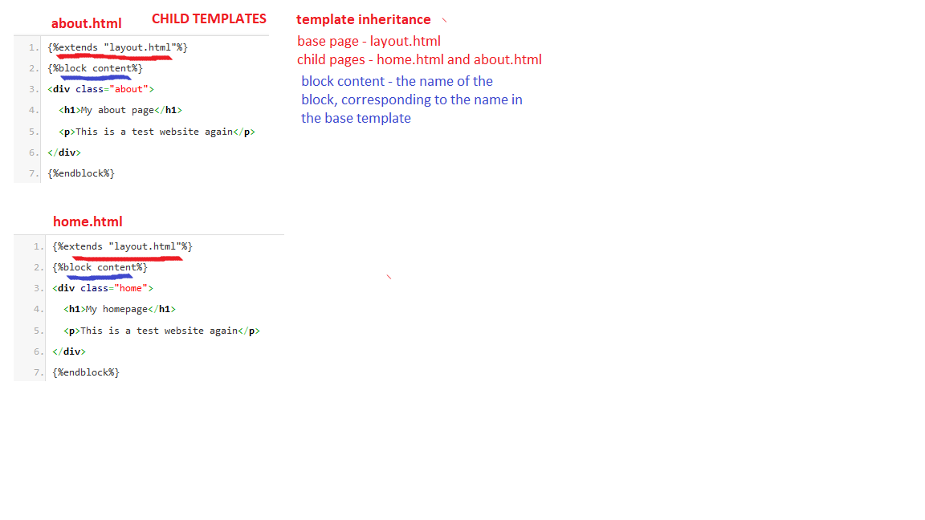
ADDING CSS STYLING

We basically need to do two things:
1. Create a CSS file and write a CSS code in it.
2. Link to the filre from our layout.html file.

The file with CSS code should be in “static” folder (under css folder).:

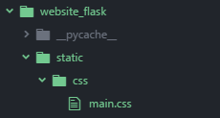

Python looks for static file in the static folder. In this folder we could f.e. create “images” folder and put all the graphics from our website there.

How to link to the CSS file from layout.html:
Link (to java-script files, to CSS files) go outside of <body> </body> tag.

