Creating a project with Spring Data JPA

1. Go to <https://start.spring.io/>
2. Type in Group and Artifact name of your project
3. Add dependencies Web, H2, JPA  
   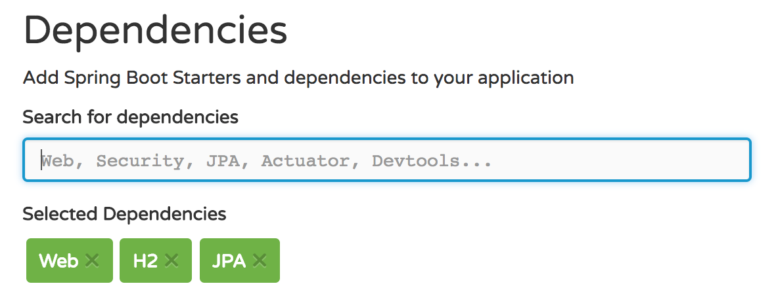
4. Generate Project and open up in IntelliJ  
   
5. You should have the following structure:  
   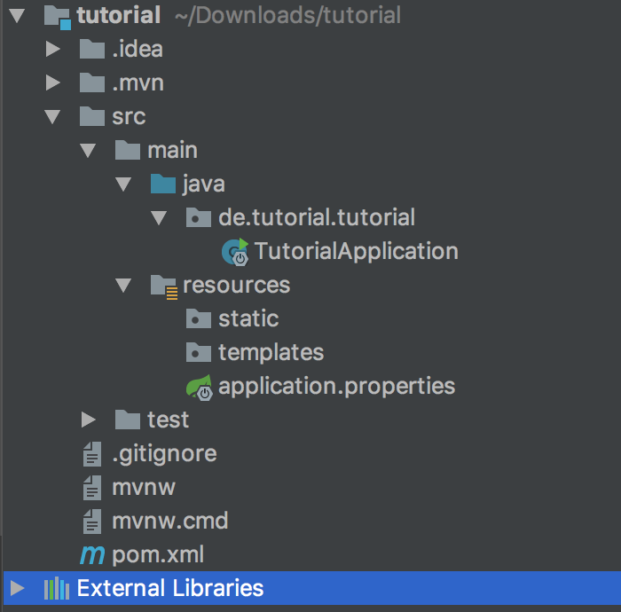

Try to run the Application and open it up on localhost:8080.

Configuring application properties

1. Paste the following into your application.properties file:

spring.jpa.hibernate.ddl-auto=update  
spring.datasource.url=jdbc:h2:~/test;DB_CLOSE_ON_EXIT=FALSE  
spring.datasource.username=test  
spring.datasource.password=test

1. Change the ddl-auto Attribute from “update” to “create” if you want to drop the data after closing/restarting the application. Also set your own username and password.

Creating a Data Model

1. Create new package “model”
2. Create new Java Class with the name of your model (e.g. Student)  
   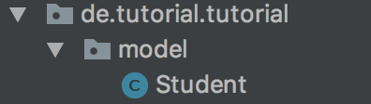
3. Mark class as Entity with @Entitty
4. Create id and mark as @Id and @GeneratedValue with strategy AUTO.
5. Create constructor, getter, setter…  
   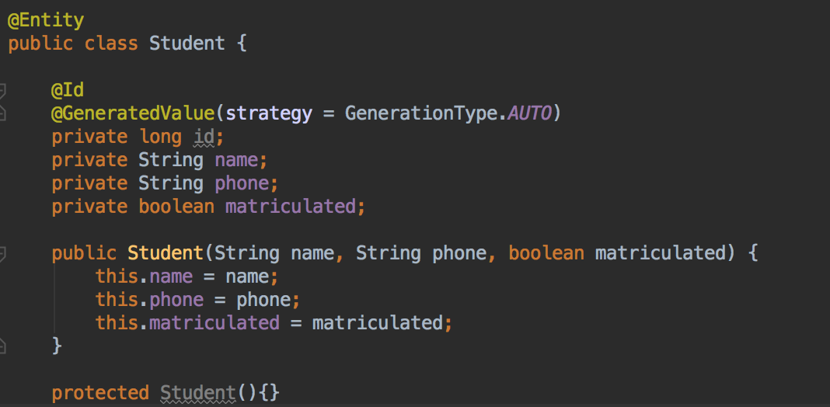

Creating a Repository

1. Create new package “repository”
2. Create new Interface (e.g. StudentRepository)
3. Mark as @Repository
4. Extend the JpaRepository and pass in your model and the type of your id  
   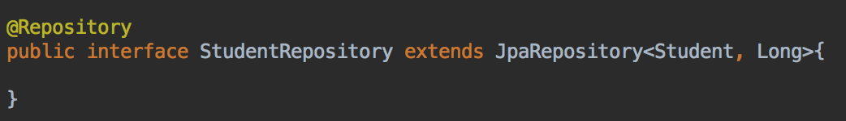

Testing the Repository

1. To test your repository, you can add a CommandLineRunner into your application.
2. To save data to your Repository, call the save() method and pass in your Object
3. To get all Students, call the findAll() method on your repository.  
   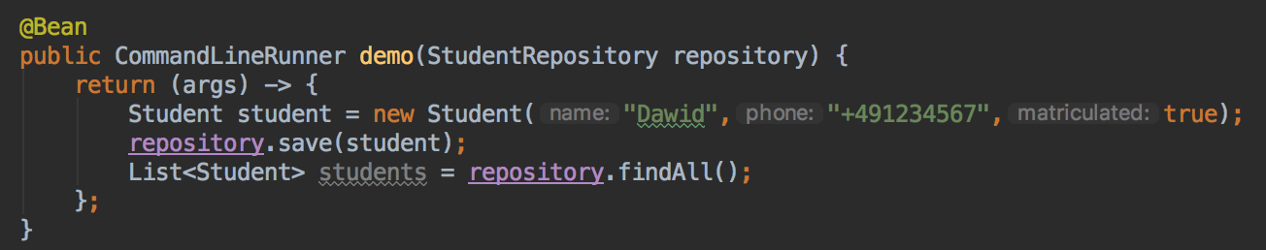

Extending the Repository

1. To create more specific queries without SQL-Language, you have to add new methods into your interface.
2. Set the Type of your Object and then start typing your method-name
3. IntelliJ will help you with autocompletion  
   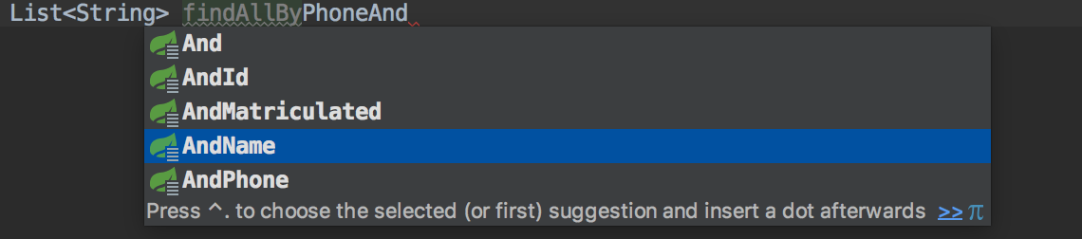
4. Your interface could look like this:  
   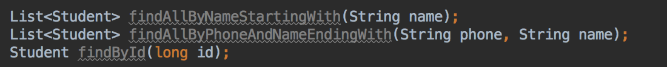
5. It is also possible to type your own SQL-queries with @Query and then name your method  
   