Lab 6 Report



Name: Dawid Pionk

Document: Report for the sixth lab

Supervisor: Lei Shi

Submission Date: 18/05/25

Table of Contents

Knative Functions¶ 3

Creating a function 3

Building, running, or deploying functions 3

Knative Service 5

Deploying a Knative service 5

Autoscaling 6

Traffic splitting 7

Knative Eventing 9

Sources, Brokers, and Triggers 9

Using a Knative Service as a source 9

Using Triggers and Sinks 9

# Knative Functions¶

## Creating a function

1. Installed func using go
2. Created a go function in a hello directory.

# Building, running, or deploying functions

1. Ran the function in the hello registry using the –registry tag
2. I skipped the steps using kn func since I didn’t use the plugin for this project.
3. Forced a build of the function using –build
4. Ran func invoke to check
5. Ran func deploy but got an error: This step was optional but decided to try
   1. Pushing function image to the registry "index.docker.io" using the "dawidp2001" user credentials -> Error: deploy error. knative deployer failed to get the Knative Service: no or newer Knative Serving API found on the backend, please verify the installation or update the 'kn' client
   2. The solution I got for this involved using minikube and installing knative serving
      1. You can see the full solution in the screenshot below
      2. The solution didn’t work

Step 1

Step 2-4

Solution to the issue in step 5 – Optional but didn’t work

# Knative Service

## Deploying a Knative service

1. Created a yaml file to deploy a knative service
2. Deployed that yaml file

## Autoscaling

* Also, installed the kn plugin.

1. Listed my knative service
2. Viewed a list of knative services
3. Accessed my knative service
4. Observed autoscaling – saw how pods scale to 0 after traffic stops going to the url
5. Saw how the pods starting running again after rerunning the service in my browser

## Traffic splitting

1. Ran an updated version of the knative service
2. Accessed the website for the revised version
3. Viewed the list for revisions
4. Split traffic between revisions
5. Viewed the revisions list
6. Interacted with the website

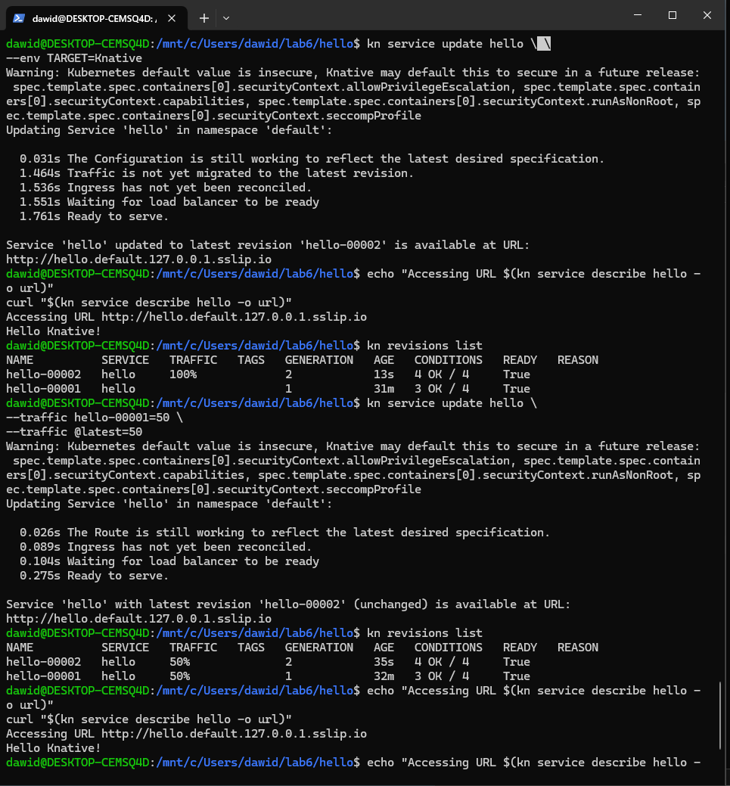

# Knative Eventing

## Sources, Brokers, and Triggers

1. View whether the broker is installed

## Using a Knative Service as a source

1. Created the CloudEvents player service
2. Created a SinkVinding between the service and the broker
3. Added events in the cloud events player.

## Using Triggers and Sinks

1. Created a trigger
2. Send an event on the browser which resulted in the trigger activating.



