Reddit Sentiment Analyzer

*By Dawid Pionk*

A web application that enables users to analyze the sentiment of any topic on Reddit. Users can view comprehensive reports and detailed breakdowns of posts and comments, categorized by sentiment, based on select parameters. This tool allows users to gain an insight into online discourse surrounding their given topic.

How it Works

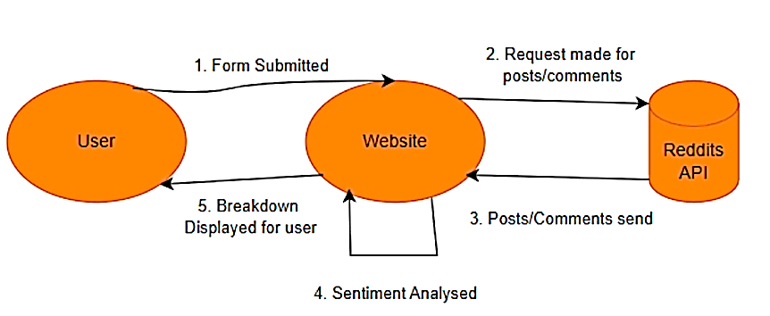

Design

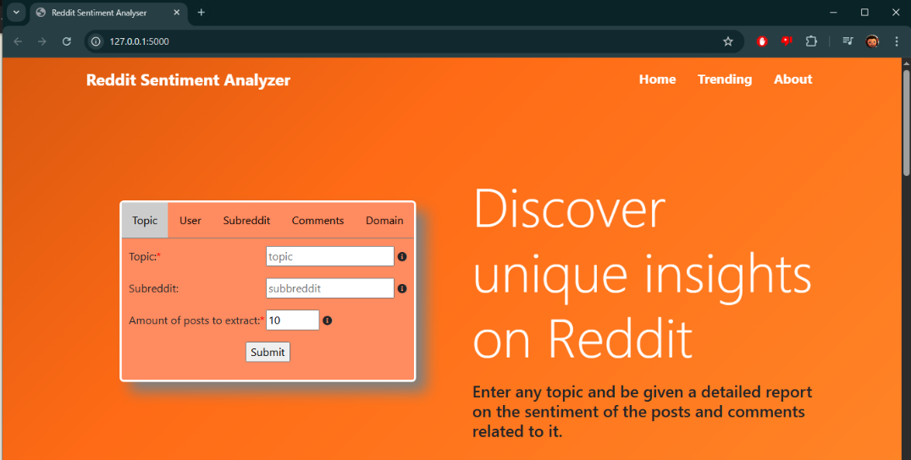

Technologies

 

# Contacts

085 166 1360, [Dawidpionk01@gmail.com](mailto:Dawidpionk01@gmail.com)

My website: [www.dawidpionk.com](https://www.dawidpionk.com)

GitHub: DawidP2001