Roche
Interview Exercise 2
Dawid Sitnik

1.Objective
The aim of this exercise is to analyze a dataset of headlines and classify them as sarcastic or not using binary classification model.

2.Thinking Process
The classic steps in Data Science process are:
-acquire
-prepare
-analyze
-report
-act
In this particular case data was already acquired, so the first thing which I did was preparation of a dataset. After my analysis I found out ,that it was already well formatted – it was a JSON file consisted of two fields: ‘headline’ and ‘is_sarcastic’ which is 0 for not sarcastic headline and 1 for sarcastic one. To ensure that aren’t any inconsistencies in the dataset, so I got basic information about it.
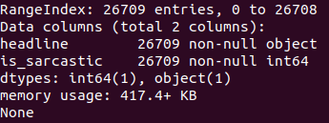

As we see there are no null values in the dataset, so the data can be processed.

I was also looking for any overlapping data. I couldn’t find any so I started another data analyzing part.

To make this process more clear I printed some plots. Next I tried out different models to check which performs the best. At the end I drew confusion matrix to visualize my classification result and tried to figure out why the model makes decision it made printing weight of each word.

3. Data Visualization
The aspect with which I want to start my analysis is amount of sarcastic and not sarcastic headlines.
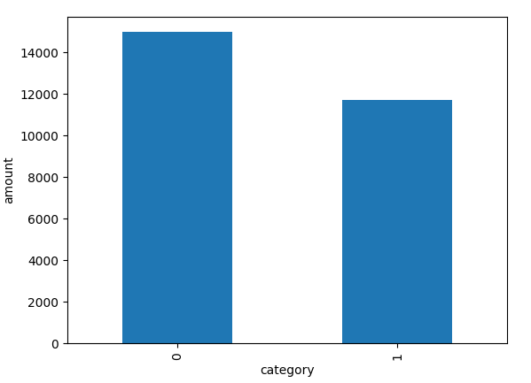Amount of Sarcastic and Not Sarcastic Words

According to the picture theirs quantity is rather balanced, however, there is small advantage of non-sarcastic headlines.

Than I count and display the most popular words for two groups
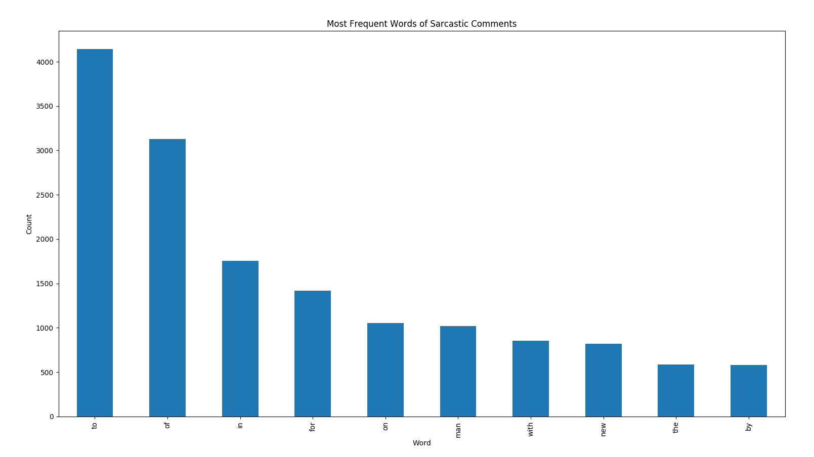
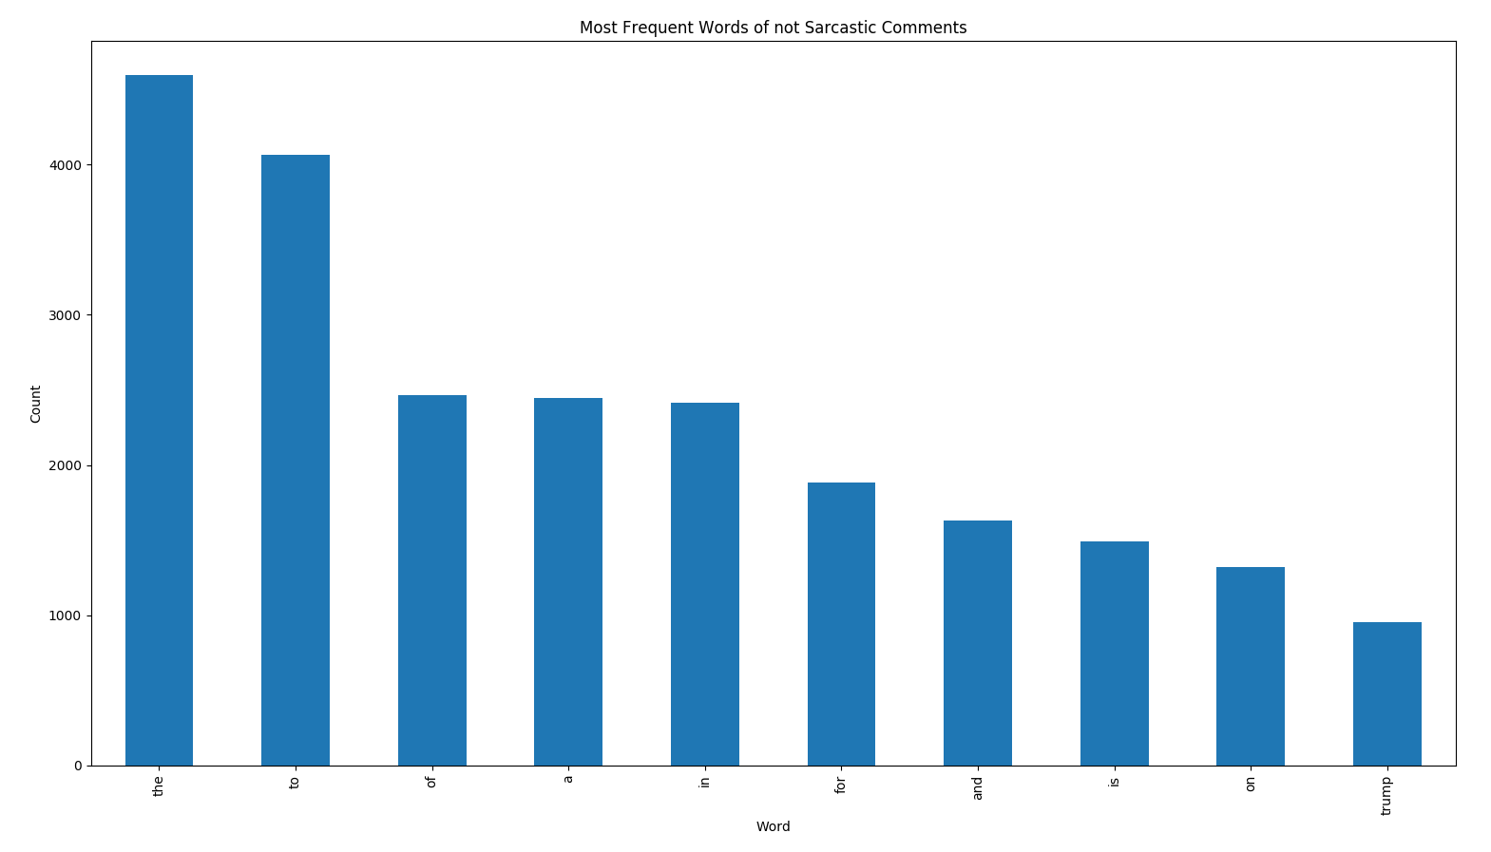
As we can see, the most popular words are mostly propositions like: to, the, of etc.
To visualize popularity of longer words I used wordmap and get those results:
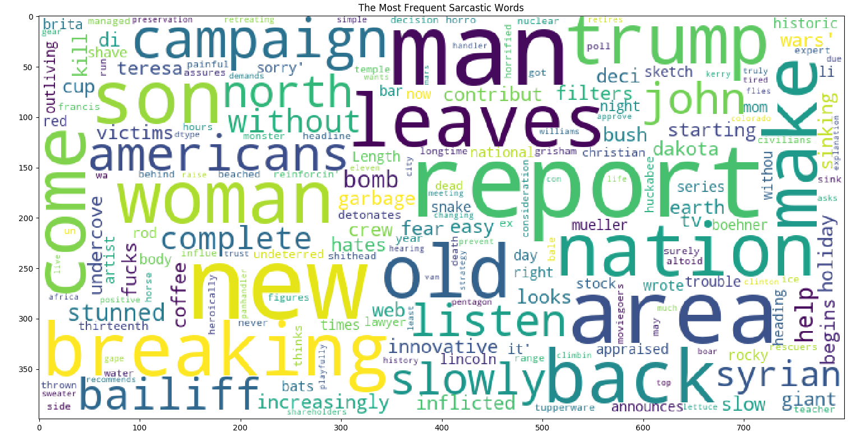
For sarcastic headlines words which definitely out stands are: report, new, man, woman, leave, braking etc.
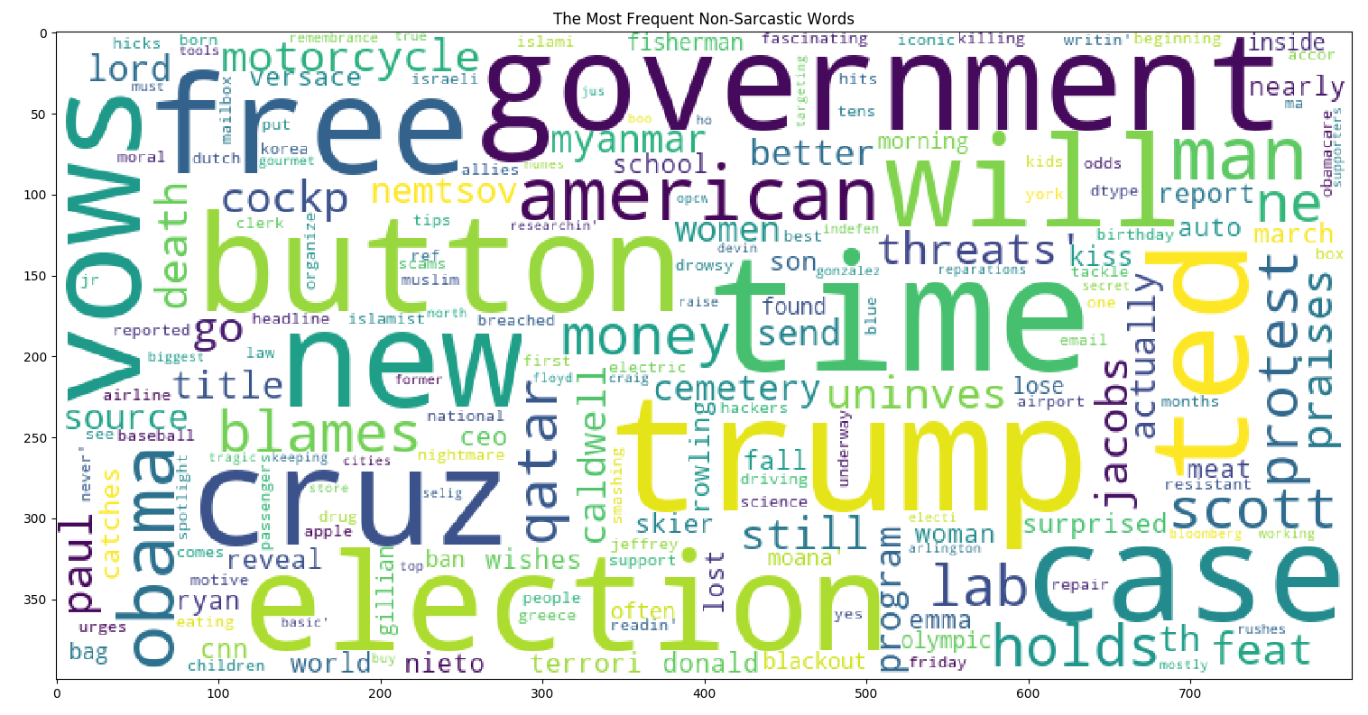
For non-sarcastic I got: button, time, trump, election, cruz, new, government etc.

At the end I would like to show distribution of lengths for sarcastic and normal headlines. They are quite similar. The only difference is between words of 4.5 length. There is advantage of non-sarcastic words.
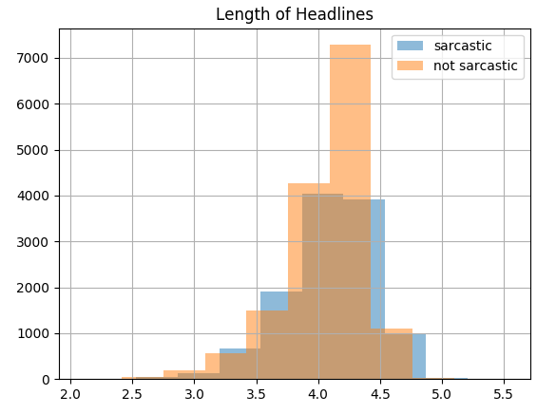

4. Modeling

4.1 Split Dataset into a Training Set and a Testing Set
Advantages
- By splitting the dataset we can train using one set and test using another.
- This ensures that we won't use the same observations in both sets.
- More flexible and faster than creating a model using all of the dataset for training.

Disadvantages
- We can get different results depending on how the set was spitted
- We can solve this problem using k-fold-cross-validation. In have already used this method in previous exercise, so now I decided to skip this part.

4.2 Steps To Be followed When Applying an Algorithm
1. Split the dataset into training and testing dataset.
2. Select classification algorithm
3. Train algorithm on dataset
4. Pass the testing data to the trained algorithm to predict the outcome
5. Check the accuracy by passing the predicted outcome and the actual output to the model.

4.3 Different types of models
I decided to use few of them and apply one which gives the best result. Algorithms which I used are:
- Logistic Regression
- SVC
- Linear Discriminant Analysis
- GBoost
- Mnb

As there are many of them I am going to describe one.

Performance of my models is shown bellow:
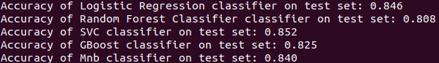
As we can see all the results are quite similar, but the best algorithm for that case was SVC with accuracy 0.852. The worst one was Random Forest Classifier with 0.808.

4.4. Best algorithm explanation:

What is SVM?
Support vector machines is a supervised algorithm used for classification and regression problems. It is used for smaller dataset as it takes too long to process

The ideology behind SVM:
SVM is based on the idea of finding a hyperplane that best separates the features into different domains.

Intuition development:
Lets consider our situation:
We have headlines which are sarcastic or not and we want to design a function (hyperplane) which will clearly differentiate those two groups.

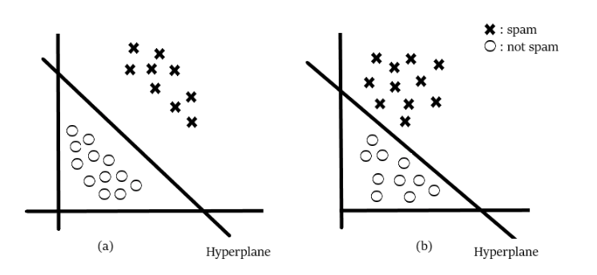


lets consider those two figures with drawn hyperplane. The first one makes more clear classification so we would pick this one. Basically, SVM is composed of the idea of coming up with an optimal hyperplane which will clearly classify the different classes(binary in this case).

To visualize my result I have also printed its confusion matrix.
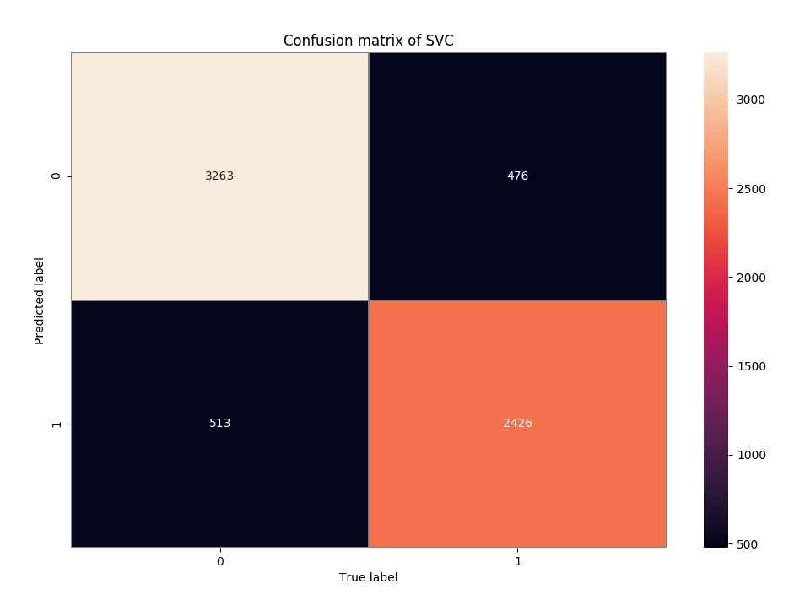

As we can see, total size of testing data is 6678, which is more less 25% of the whole data. Looking at the matrix, we can see how many and mistakes our algorithm did and in which situations.

4.5. Words weights
There are two main ways to look at a classification model:
- inspect model parameters and try to figure out how the model works globally
- inspect an individual prediction of a model, try to figure out why the model makes the decision it makes.

I decided to follow first proposition and used show_weights() function from ELI5 library. This function print us weights of each word, starting from the most important ones. The biggest score word got, the biggest impact on classification it has.
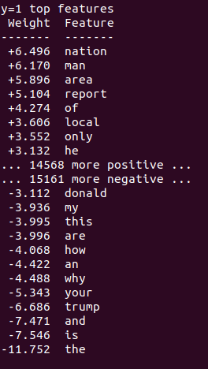Words Weights

As we can see at the picture, the words which has the biggest impact on our classification were: nation, man and area, the least important ones were short words like: the, and, is (the one which we could see on the plot as the most frequent)

