# Introduction

As I mentioned in class, we will be turning in our assignments on GitHub. Each student will have a private online repository to upload their completed homework. Only you, the TA, and I will be able to see the work that you submit to this repository. I will go over how to get started with GitHub in class. For those of you wanting to get a head start, I’ve included some instructions below to get started. (The dates in the screenshots are from last year, but the instructions should follow the same.)

# Submitting HW on Github

Each student will have their own private HW repository. This is a separate repository from the one we that hosts the course material (jmbejara/comp-econ-sp19). This repository will be a private repository that only you, the TA, and I can see. You will receive private feedback on your work on this repository.

1. To create this private HW repository, click on the following link: https://classroom.github.com/a/n8rnduO_. This link will create your new private HW repository. It will ask you if you want to accept this “assignment.” Say yes. You will be prompted to match your GitHub login to your name in the class roster. If you can't find your name in the list, email me and I’ll fix it. Once you have done this, you should see a page that looks like this:

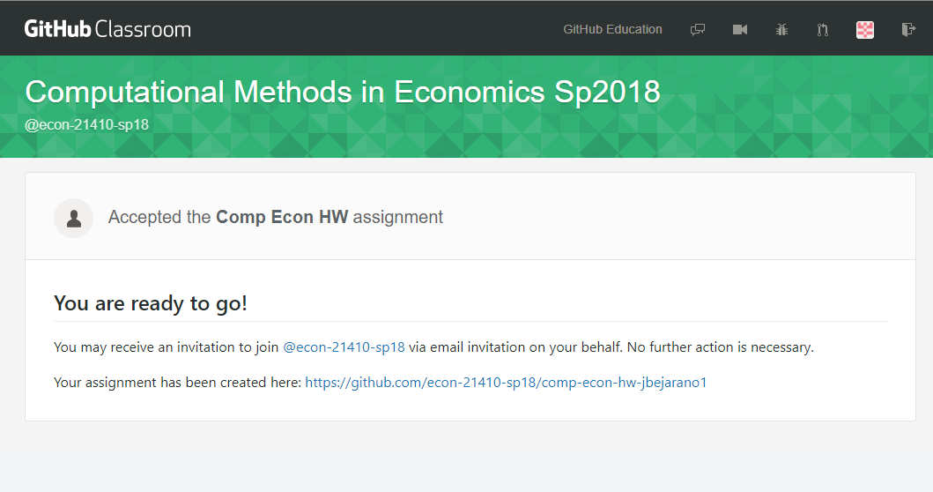

1. If you click the link to the new “assignment” that has been created, it will take you to your repository. I have created a separate test user account on GitHub with the account name “jbejarano1”. So, the name of the automatically generated GitHub repository is “comp-econ-hw-jbejarano1”. It is listed as part of the “econ-21410” organization. Notice at the top that it says “private.” 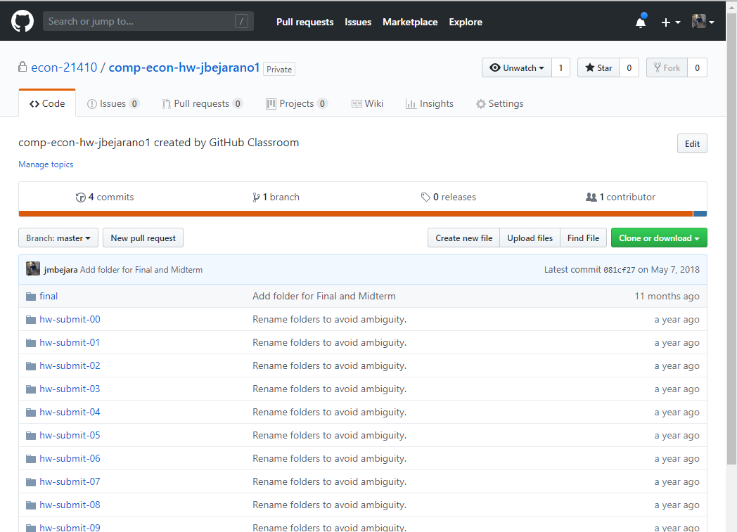
2. In this repository, you will see a long list of empty folders, “hw-submit-00”, “hw-submit-01”, “hw-submit-02”, etc… You will use this repository to upload your HW files. When you are ready to submit your solutions to HW-00, upload all of the required files into the “hw-submit-00” folder.
3. For now, you can easily upload your files using the “upload files” button. Navigate to the “hw-submit-00” folder. Then click the “upload files” button. Drag and drop all of your hw-00 files into the folder. Then, add a descriptive commit title and click “commit changes” to your repo’s master branch. See here:

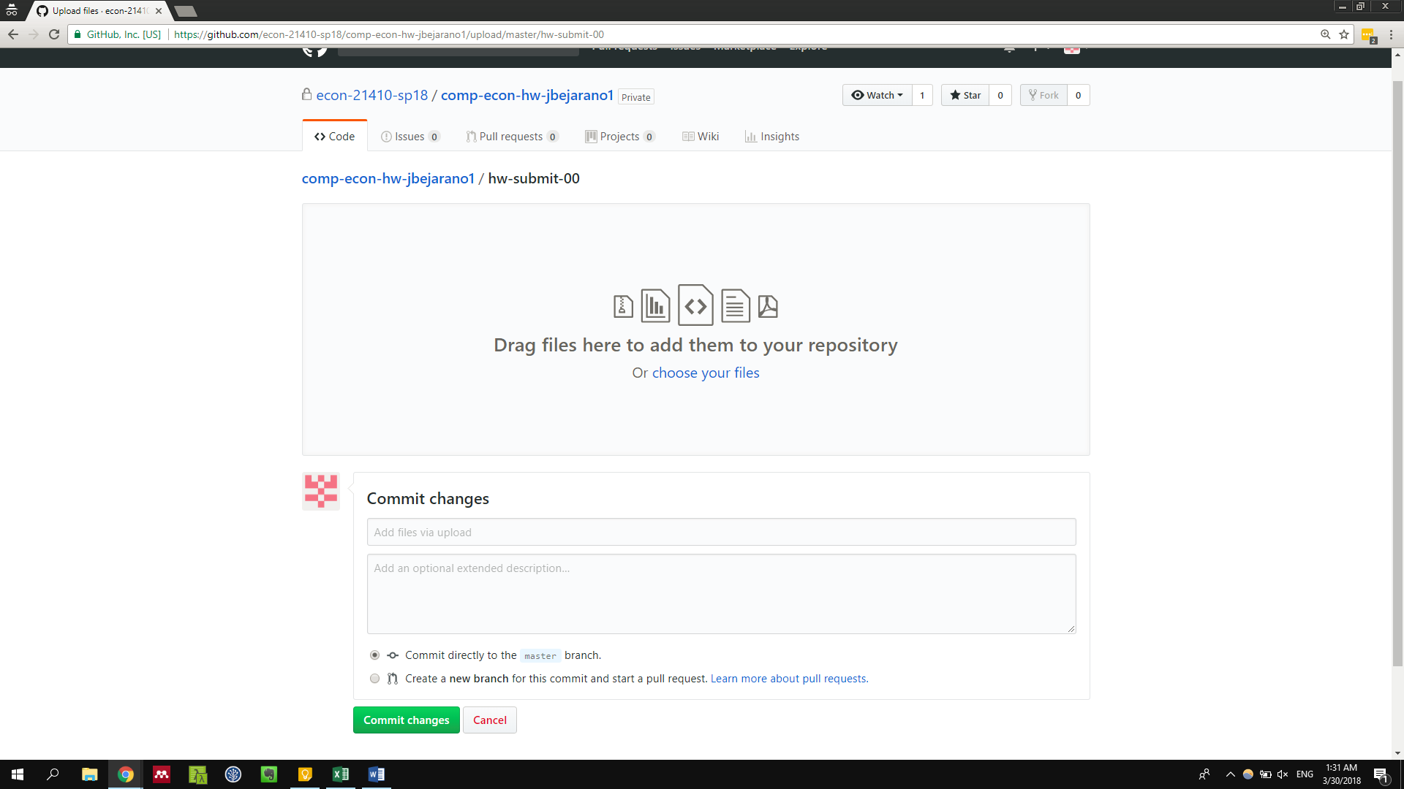

1. We talked about branches in class today. Remember that we will be using the “master” branch as the public facing branch for all of our projects. I will assume that files committed to other branches are not your final submissions. We will be grading the files in the “master” branch. In future assignments, we will be uploading our HW to separate branches and then creating “pull requests” from that one branch to the master branch. However, for HW-00, let’s not worry about this.