

ADDIS ABABA UNIVERSITY

ADDIS ABABA INSTITUTE OF TECHNOLOGY

CENTER OF INFORMATION TECHNOLOGY AND SCIENTIFIC

COMPUTING

FUNDAMENTALS OF WEB PROGRAMMING

Assignment One

Name: Dawit Teklu  
 Id no: NSR/2792/11

**Submitted to Mr. Fitsum Alemu**

# History or the evolution of the Internet.

* The origins of the Internet date back nearly 40 years, with the U.S. military's funding of a research network dubbed Arpanet which stands for Advanced Research Project Agency network in 1969.
* Since then, the numbers of computers connected to the internet, the numbers of internet users and the number of computer scientists grown exponentially and the network's reach has expanded beyond the United States to every corner of the globe.
* The world’s largest network of computer network that is the internet got its name from U.S. military army that founds it.
* Arpanet was renamed the Internet in 1984, when it linked 1,000 hosts at university and corporate labs
* Today the internet links more than 440 million computers and the number of internet users also exceeds 1 billion.
* The internet changed the domination of United States on to one that is seeing its fastest growth in Asia and Europe.
* In 1990, Tim Berners-Lee invented the World Wide Web as a method of publishing information in a hypertext format on the Internet.
* The Internet's Domain Name System was created in 1984 to match complex IP addresses with easy-to-remember names ending in extensions such as .com, .org, .Edu, .gov, .mil and country codes.
* As more and more web-pages are built the value of getting domain name increased 10-fold.
* The most well-known domain name is .com.

# Some observations on a popular websites

* **Stack** **Overflow**: This is the most popular Questions and Answer website and it is not chit -chat website or a discussion forum. Someone is asking the question and all members of the website receives the notification and make answer anyone who is interested. The answer that has more tags or voted more is come first and author of the answer gets reputation or privileges. When early stage of the development the websites seem as is only made by HTML. There are 7237 captures.

**Figure 1. Snapshot of stack overflow on web archive in early development..**

* **Yahoo!: Yahoo!** Is an Internet portal that incorporates a search engine and a directory of World Wide websites organized in a hierarchy of topic categories. At the early stage yahoo wasn’t so attractive. It has 1,021,223 captures.

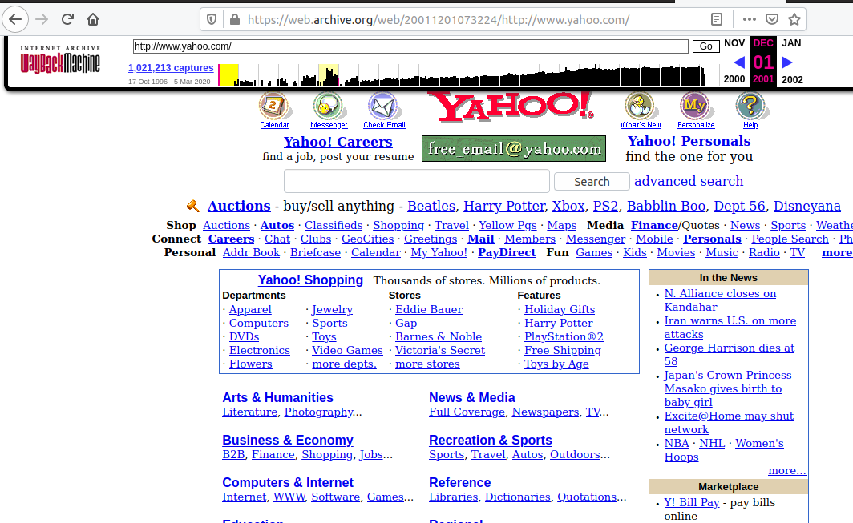

**Figure 2. Snapshot of yahoo on web archive in 2000.**

* Bloomberg.com: Bloomberg delivers business and markets news, data, analysis, and video to the world, featuring stories from Businessweek and Bloomberg News. it was found in 1981, from 1996 to now it has 4,690,735 captures on web archive.

**Figure 3. Snapshot of Bloomberg on web archive in 2000.**

* 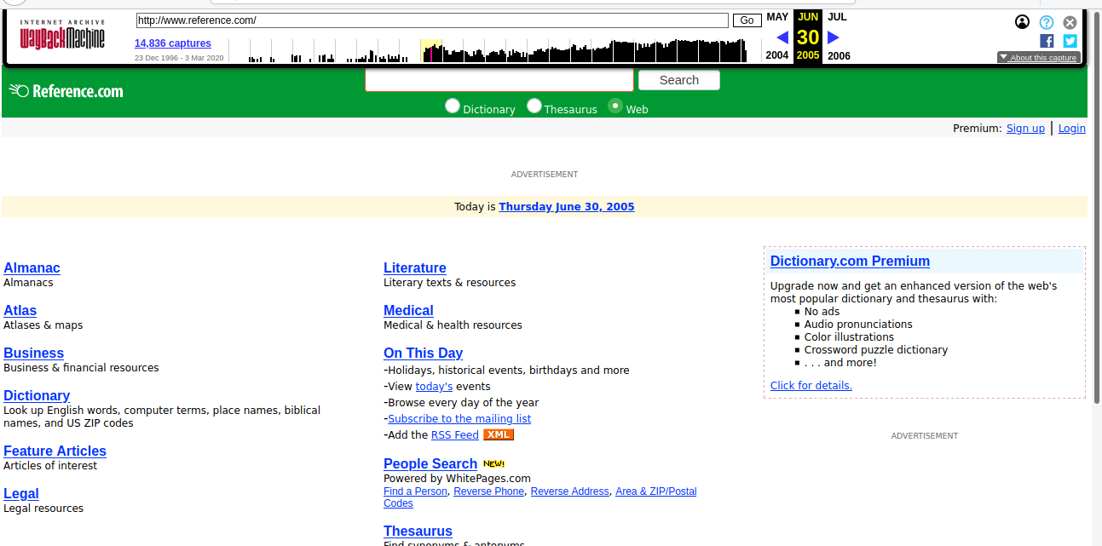**Reference**.**com:** is an online encyclopedia that organizes content that uses a question-and-answer format. Articles are organized into hierarchical categories. Before IAC restructured the site following an acquisition in 2008, **Reference**.com comprised multiple **reference** works, and disclosed its sources. The figure to the left is its snapshot since 2005, it has 14,836 captures on web archive.

**Figure 4 Snapshot of Reference.com on web archive in 2004.**

* **WikiHow:** An online wiki-style community consisting of an extensive database of how-to guides. The website aims to create the world's most helpful how-to instructions to enable everyone in the world to learn how to do anything.

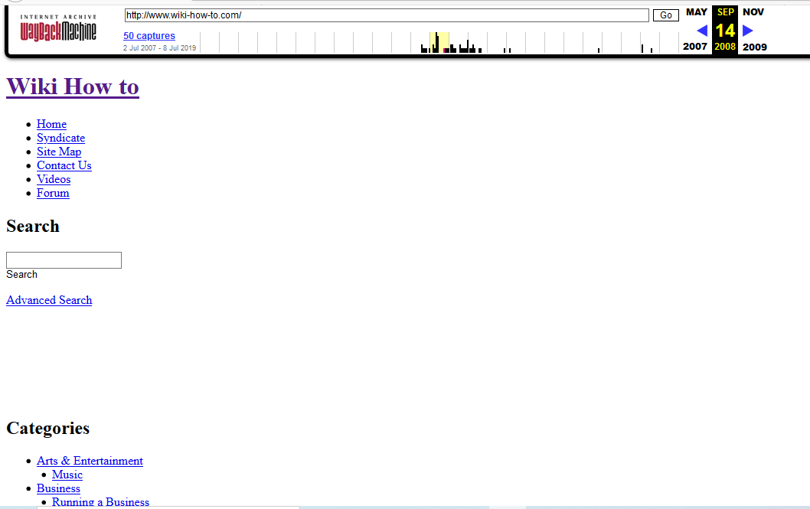

**Figure 5 Snapshot of WikiHow on web archive in 2007.**

* **Youtube.com.** There is nothing to do when the first days you tube was found only a homepage requires some users’ credentials to logging.

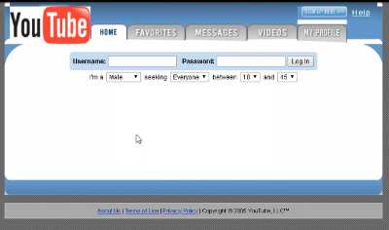

# 

**Figure 6 Snapshot of YouTube on web archive on early development**