Raw Material Procurement-to-Payment Process

The process starts with a Purchase Requisition (PR) raised by the Storekeeper when raw materials are required. The PR is reviewed and approved by Management, after which the Purchasing Department converts the approved PR into a Purchase Order (PO) and sends it to the supplier.
Once the supplier delivers the materials, the goods go through Inspection/Quality Control to verify that they meet the required specifications. If the materials pass inspection, the Storekeeper performs Receiving Goods and generates a Goods Receipt Note (GRN). The accepted quantity is then added to the raw material stock.
After the GRN is completed, the Finance Officer raises a Payment Request based on the approved PO, GRN, and supplier invoice. The payment request is reviewed and approved by the authorized approver. Finally, the Finance Officer processes the supplier payment using the approved payment method, such as cheque or bank transfer.

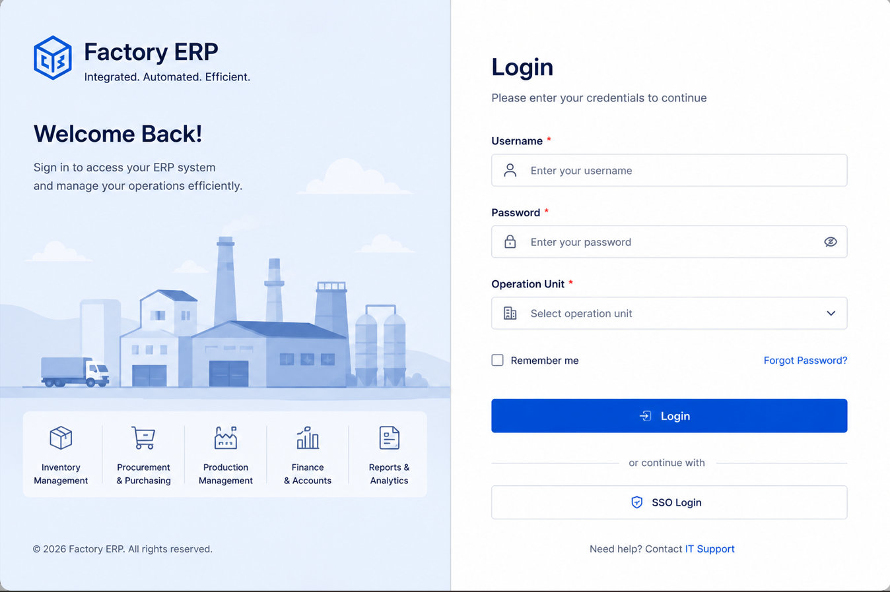
1. Supplier registration
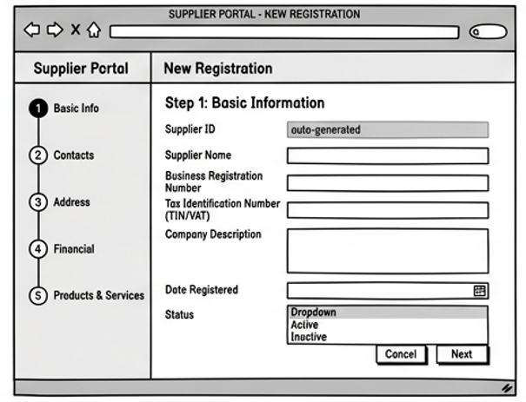
1.1 Basic information
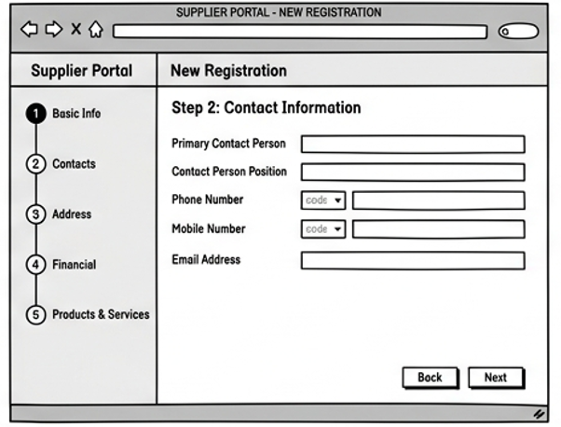
1.2 Contacts Information
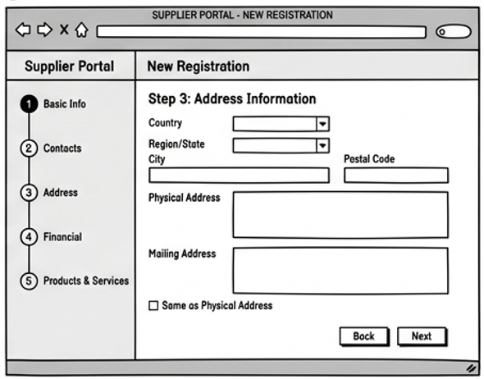
1.3 Address Information
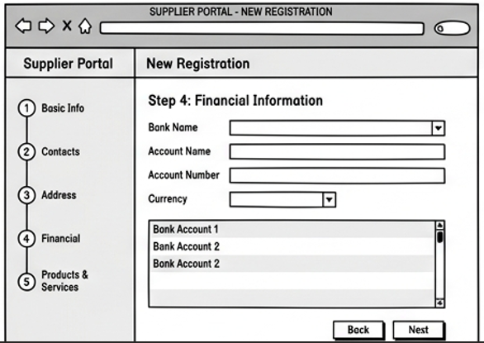
1.4 Financial Information
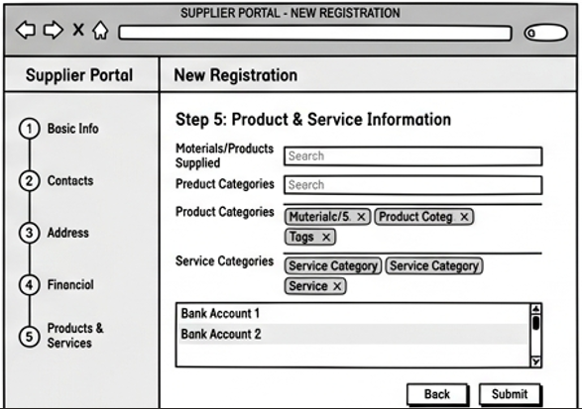
1.5 Product and Service Information

2. Purchase requisition (PR)
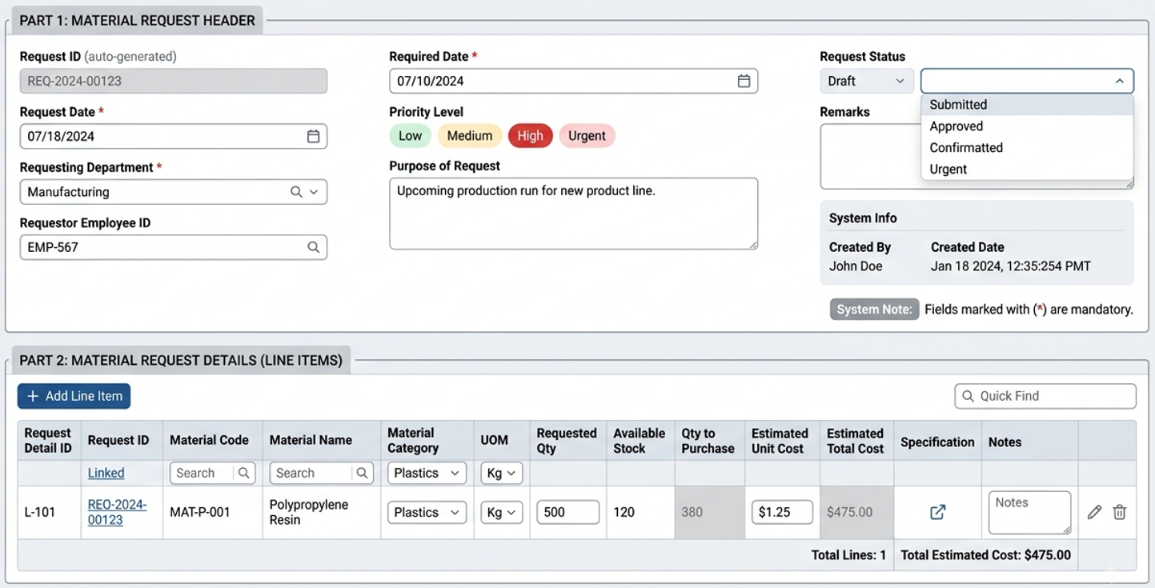
Upon successful submission of the PR, the requester’s and approver’s dashboards will display the following information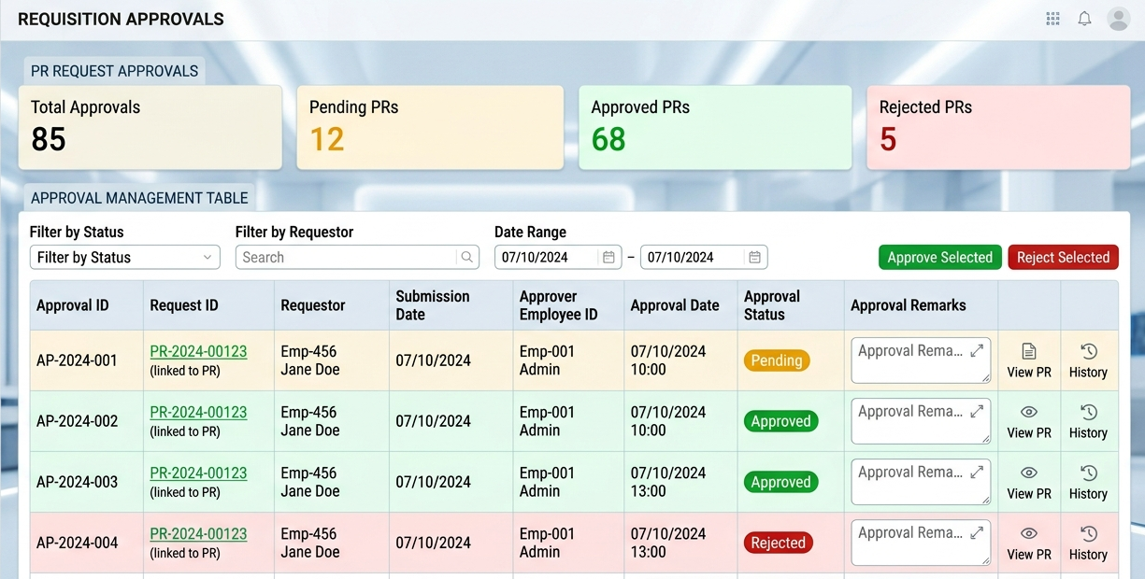

3. Purchase order (PO)
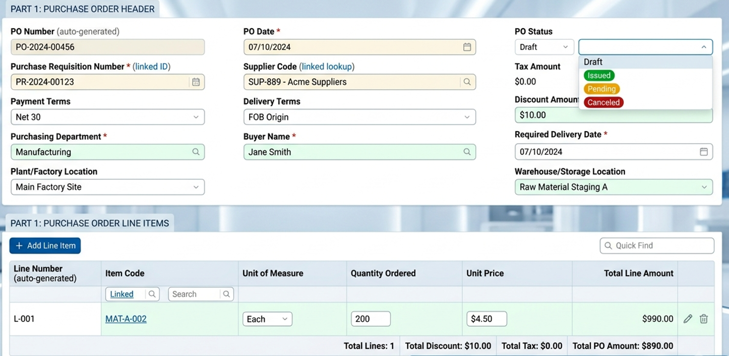
Upon successful submission of the Po, the requester’s and approver’s dashboards will display the following information
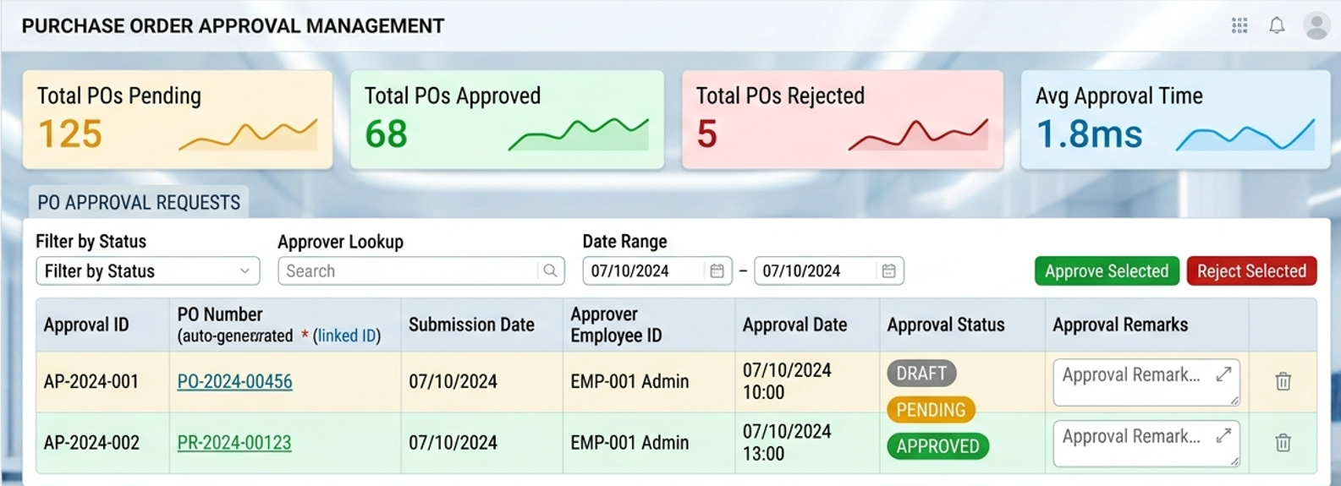
ROW MATERIAL INSPECTION MODULE PAGES
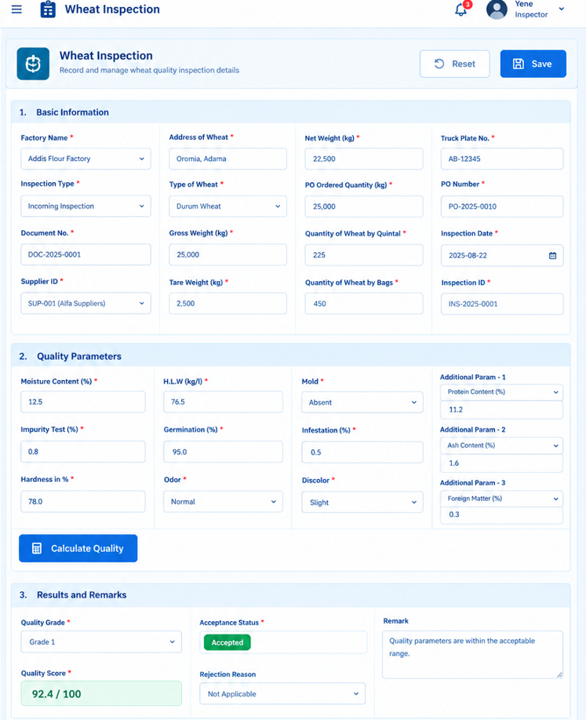

ROW MATRIAL STORE RECIVING MODUEL

1. Item Master
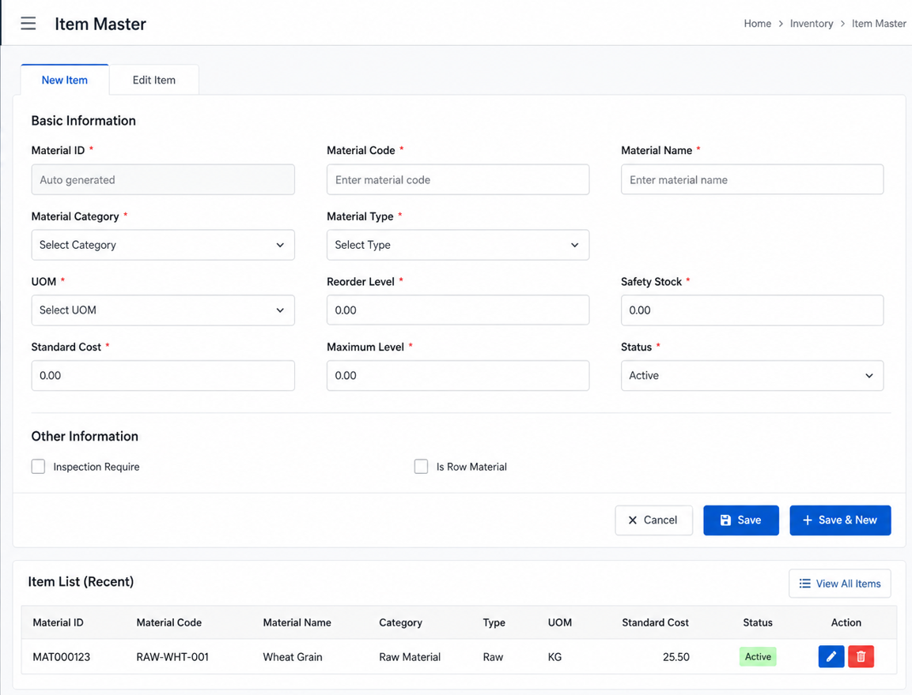

2. Warehouse Master

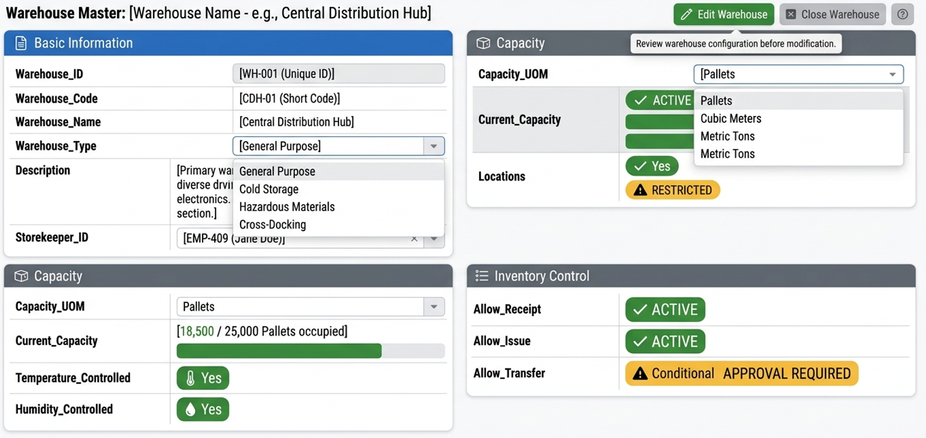

3. Store Master

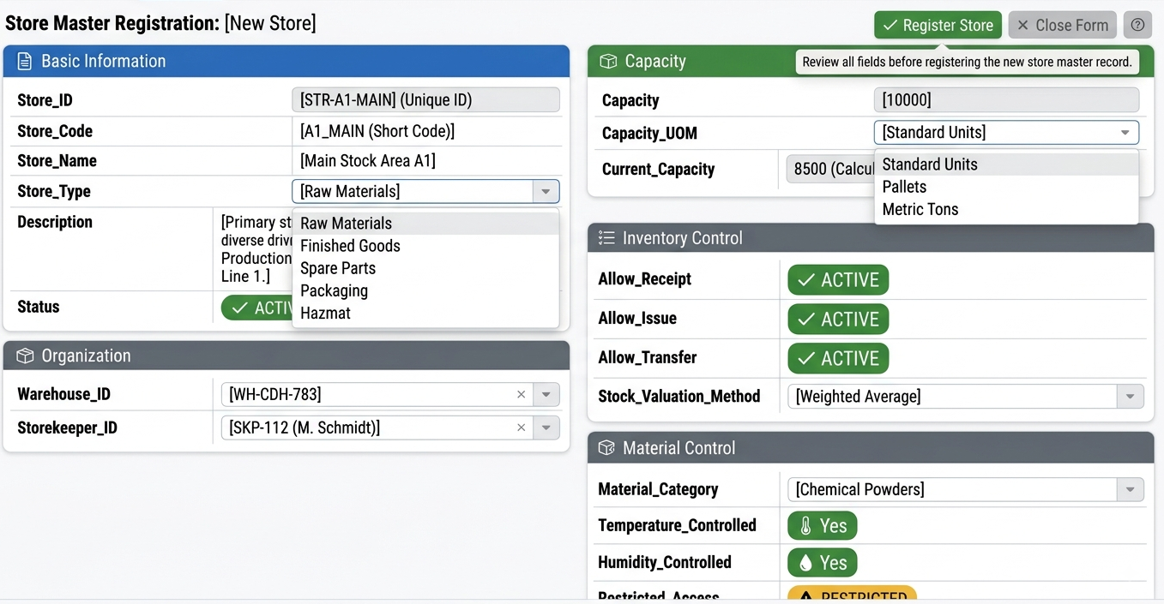

4. Silo Master

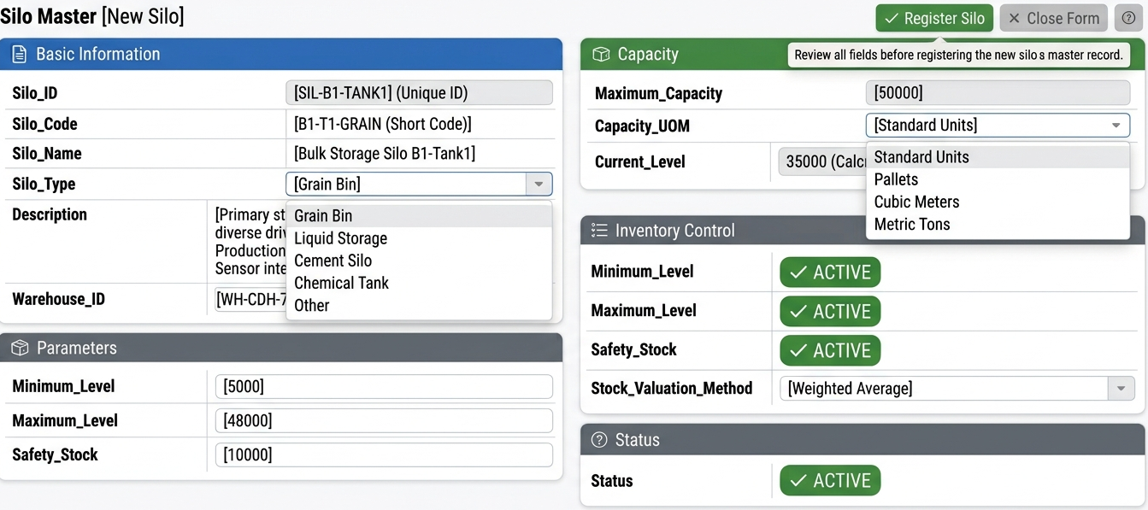

5. Goods Receiving
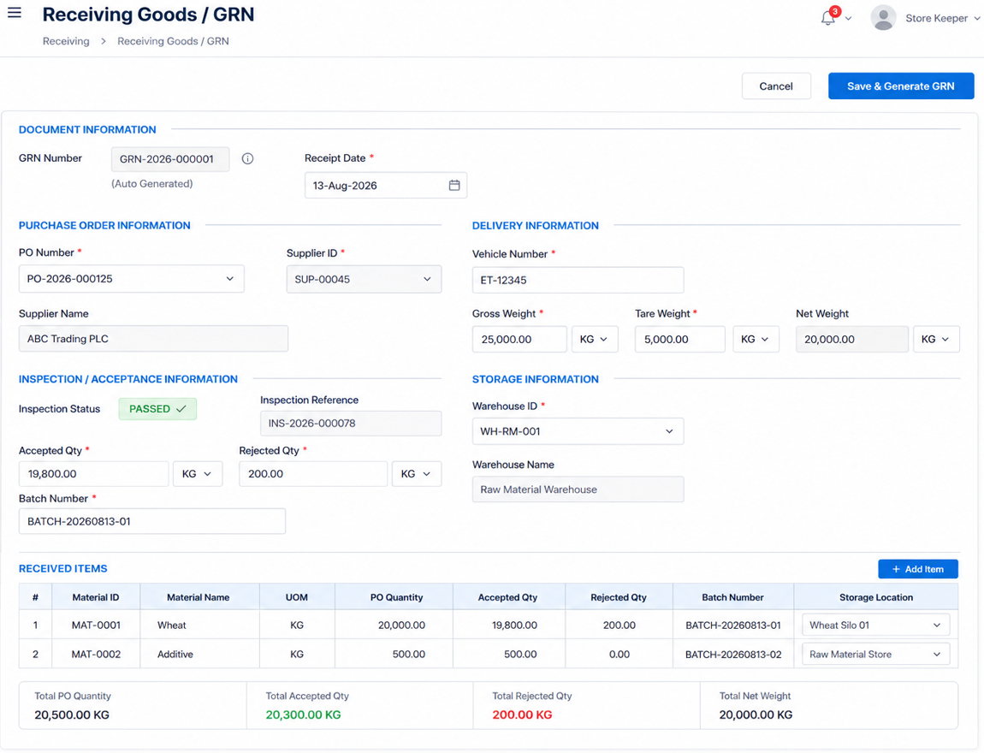
Unit ups one colument

6. Following the above transaction, the background process will maintain the current Stock balances as shown below.
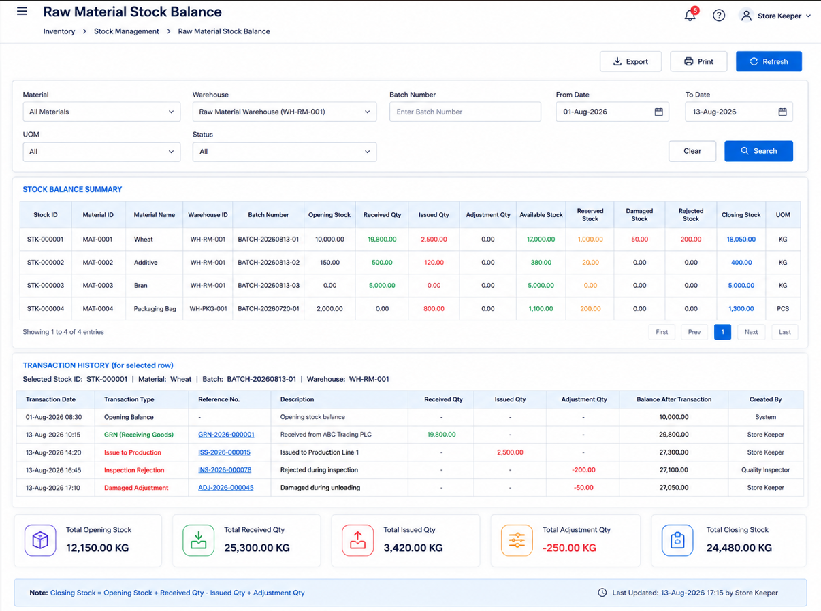

7. Stock Adjustment

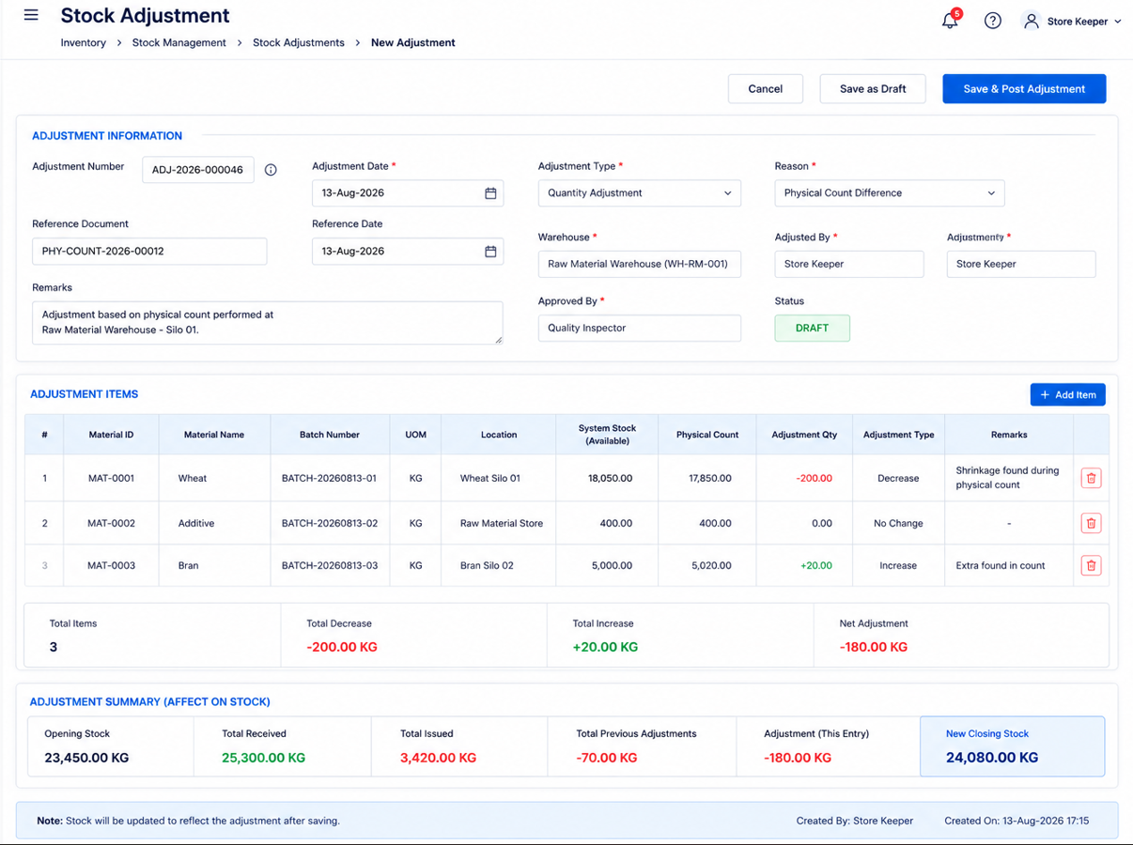

ROW MATRIAL DELVERY PAYMENT REQUEST
1. Finance Officer Request Payment on behalf of Supplier.
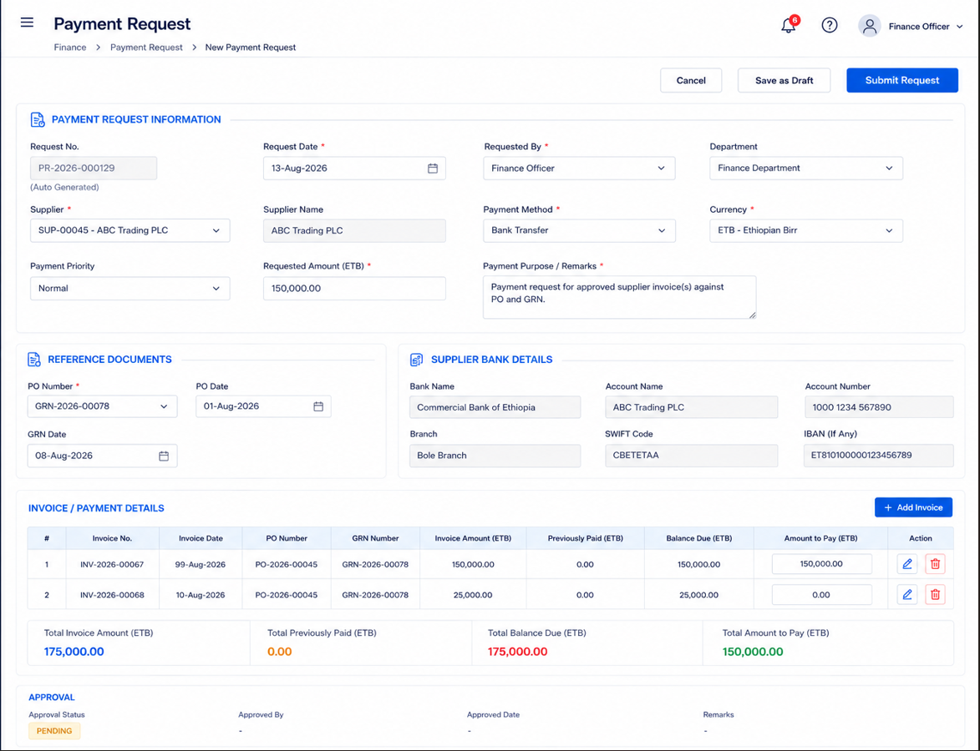

2. Approver takes action for the above PR
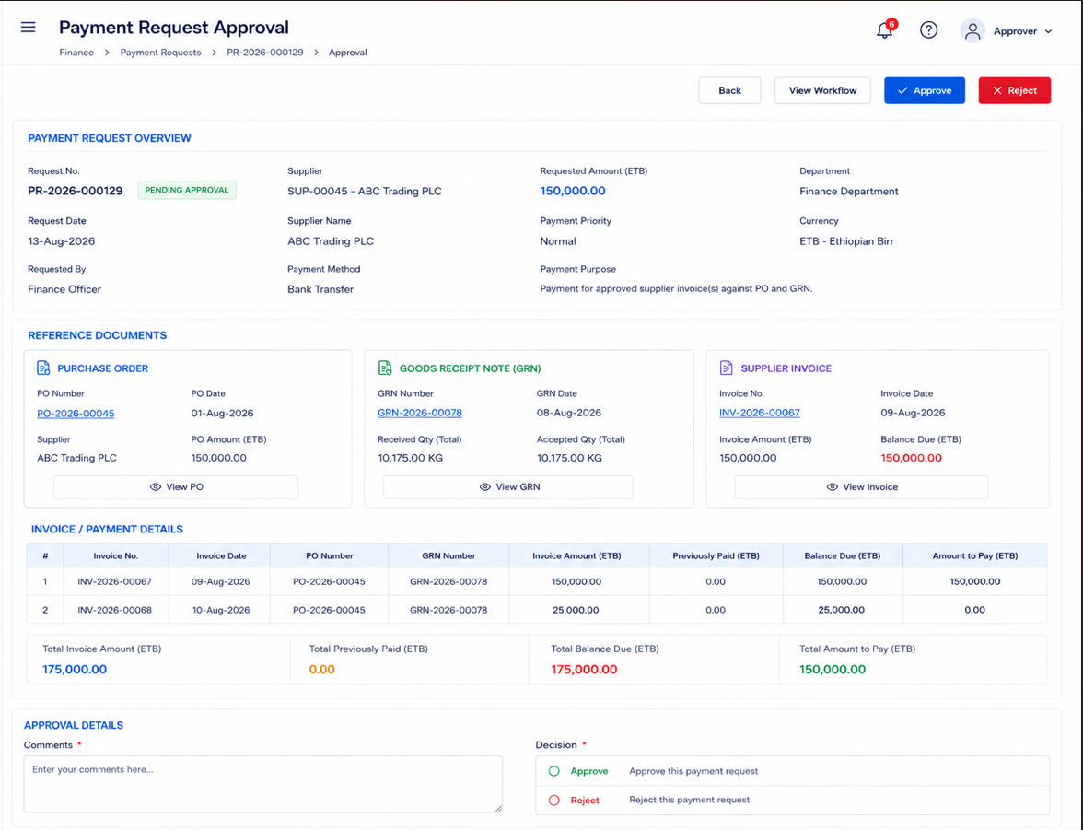

3. Supplier Payment
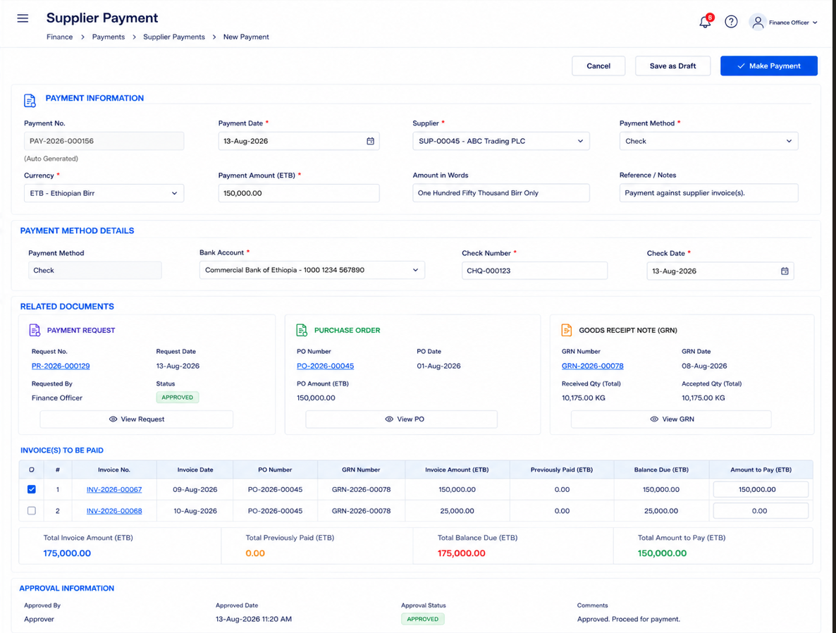
Upplode depset slip

************************* End Process ***************************

