Raw Material Procurement-to-Payment Process

The process starts with a Purchase Requisition (PR) raised by the Storekeeper when raw materials are required. The PR is reviewed and approved by Management, after which the Purchasing Department converts the approved PR into a Purchase Order (PO) and sends it to the supplier.
Once the supplier delivers the materials, the goods go through Inspection/Quality Control to verify that they meet the required specifications. If the materials pass inspection, the Storekeeper performs Receiving Goods and generates a Goods Receipt Note (GRN). The accepted quantity is then added to the raw material stock.
After the GRN is completed, the Finance Officer raises a Payment Request based on the approved PO, GRN, and supplier invoice. The payment request is reviewed and approved by the authorized approver. Finally, the Finance Officer processes the supplier payment using the approved payment method, such as cheque or bank transfer.

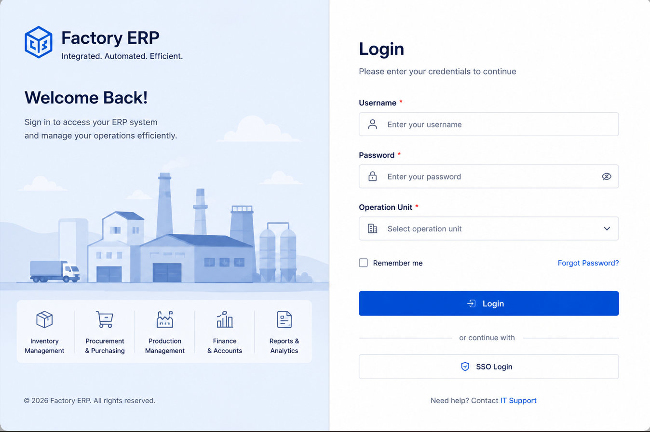
1. Supplier registration
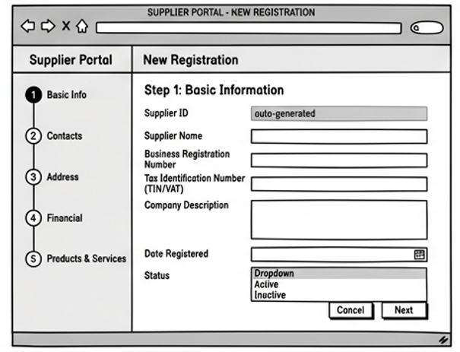
1.1 Basic information
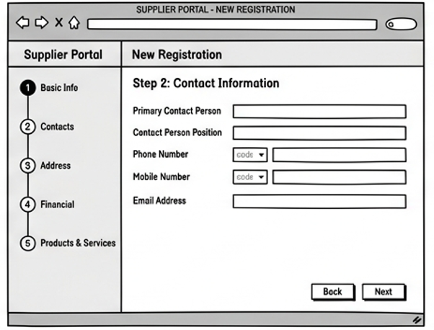
1.2 Contacts Information
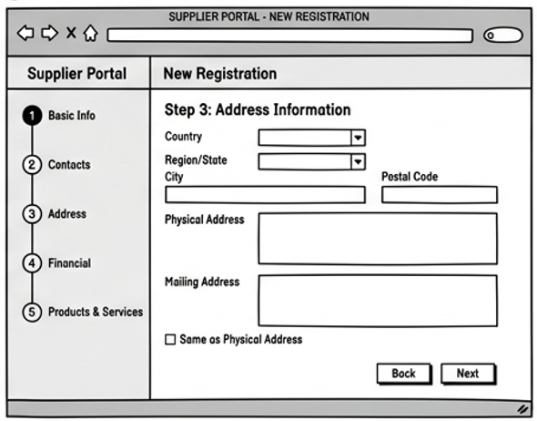
1.3 Address Information
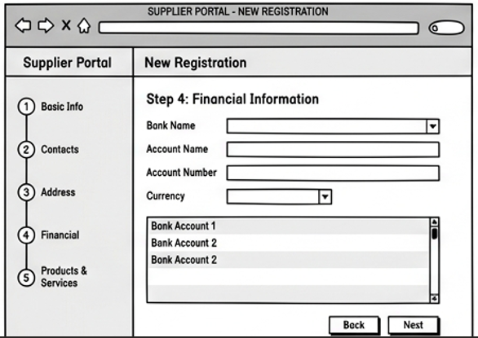
1.4 Financial Information

2. Purchase requisition (PR)
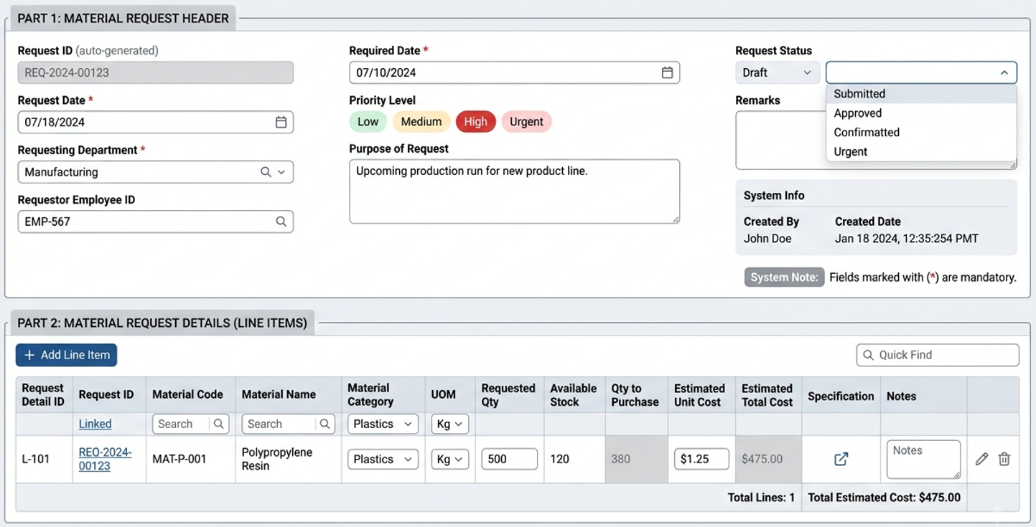
Upon successful submission of the PR, the requester’s and approver’s dashboards will display the following information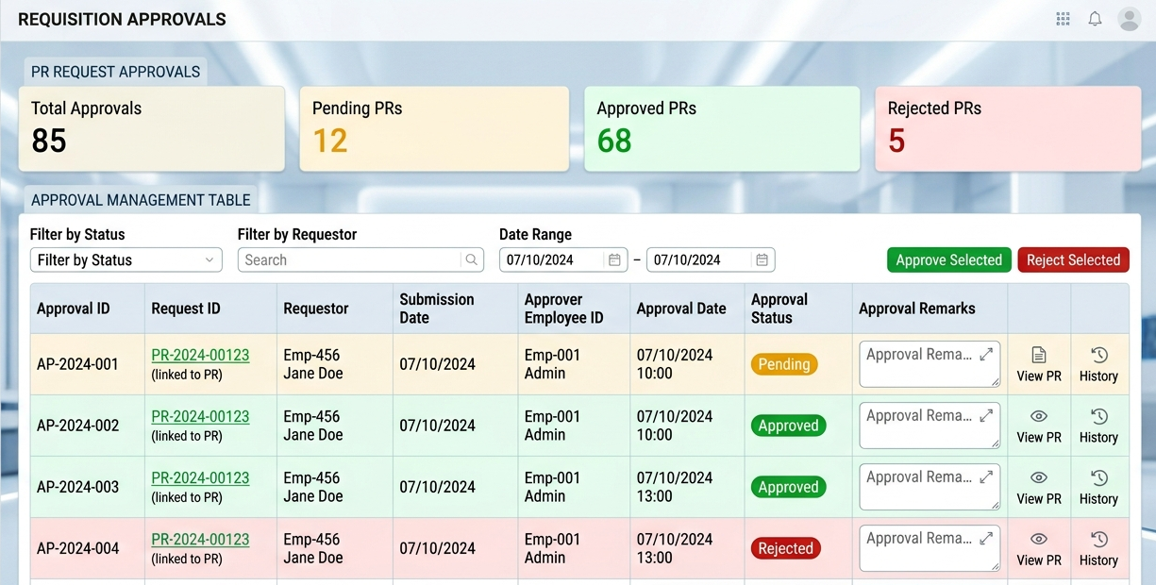

3. Purchase order (PO)
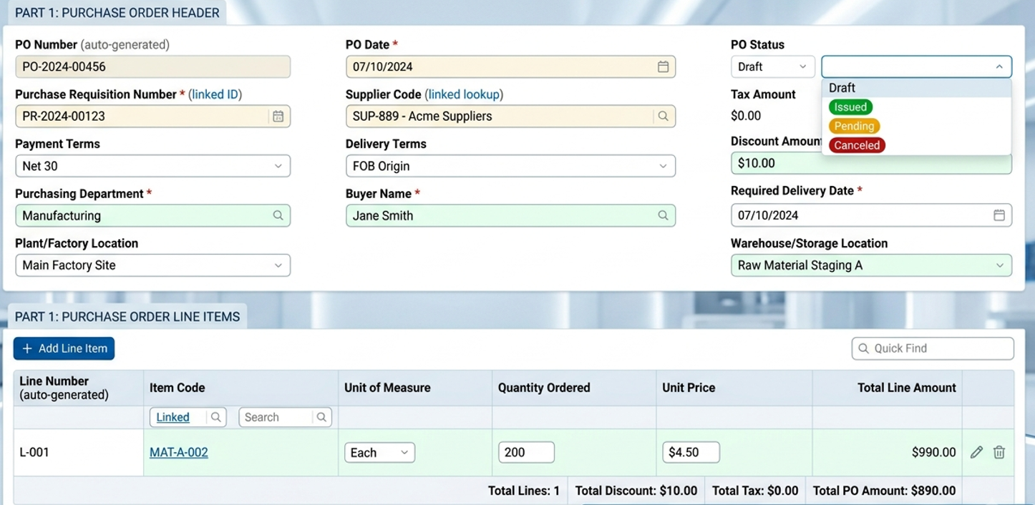
Upon successful submission of the Po, the requester’s and approver’s dashboards will display the following information
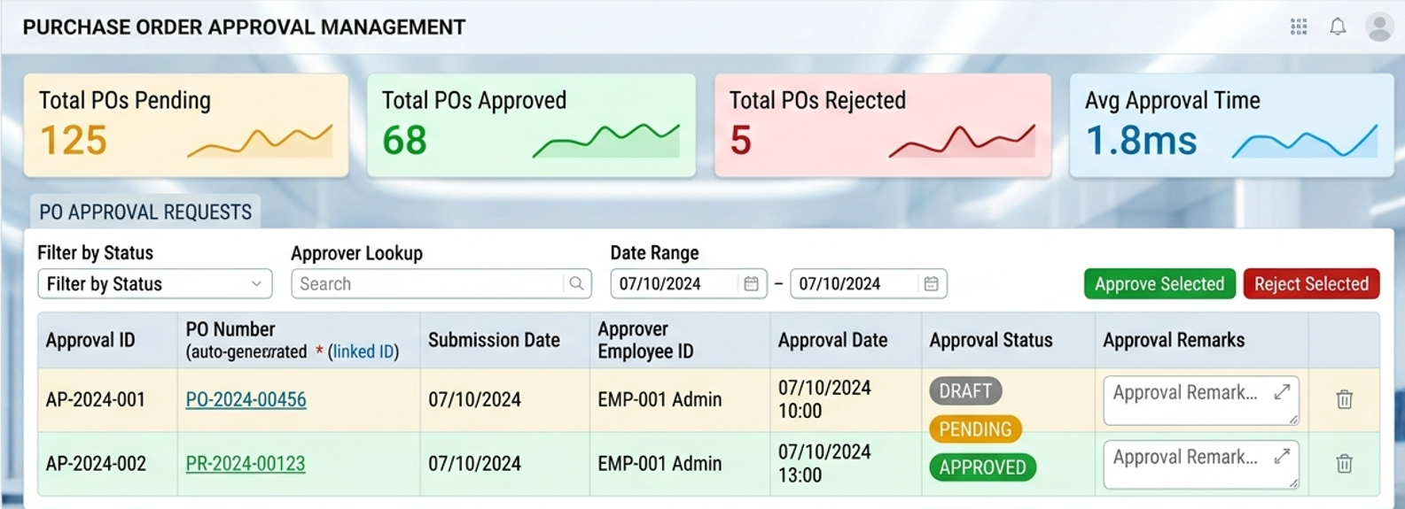
4. Supplier Delivery
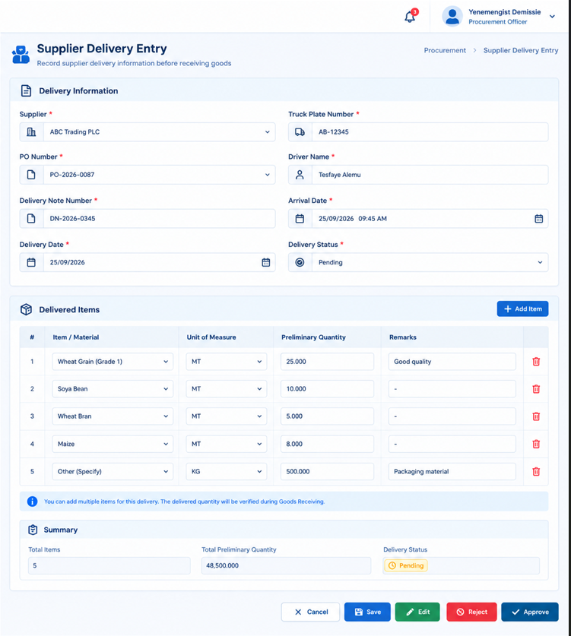

5. QC Performs Inspection and Testing
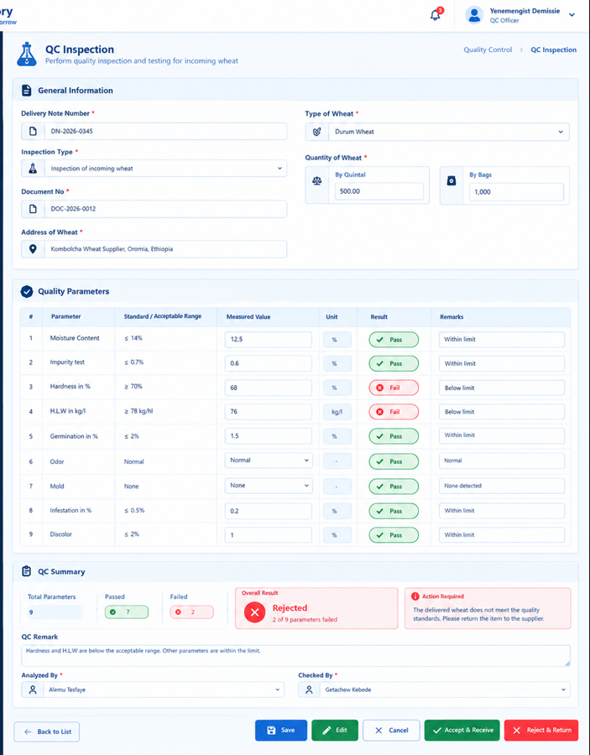
ROW MATRIAL STORE RECIVING MODUEL
6. Goods Receive
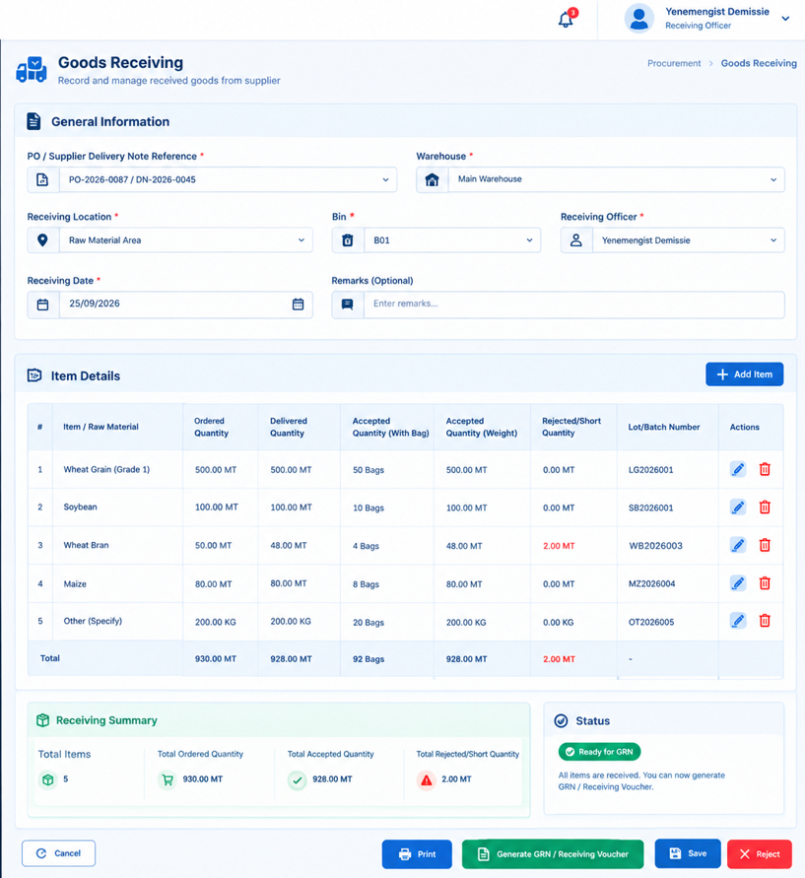

7. Bin card will be visible as shown below, if the inventory officer wants to see
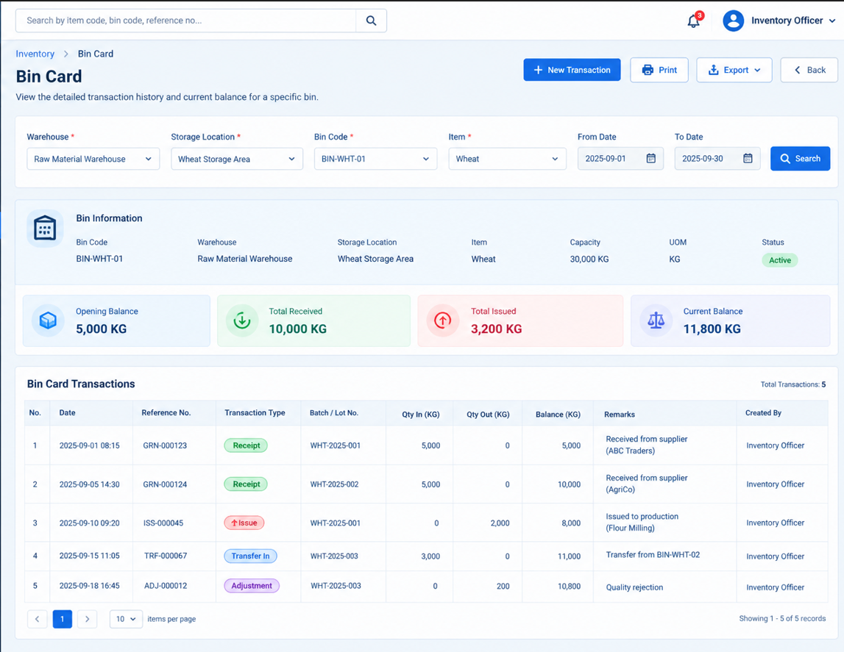

8. Stock Card will be visible as shown below, if the inventory officer wants to see
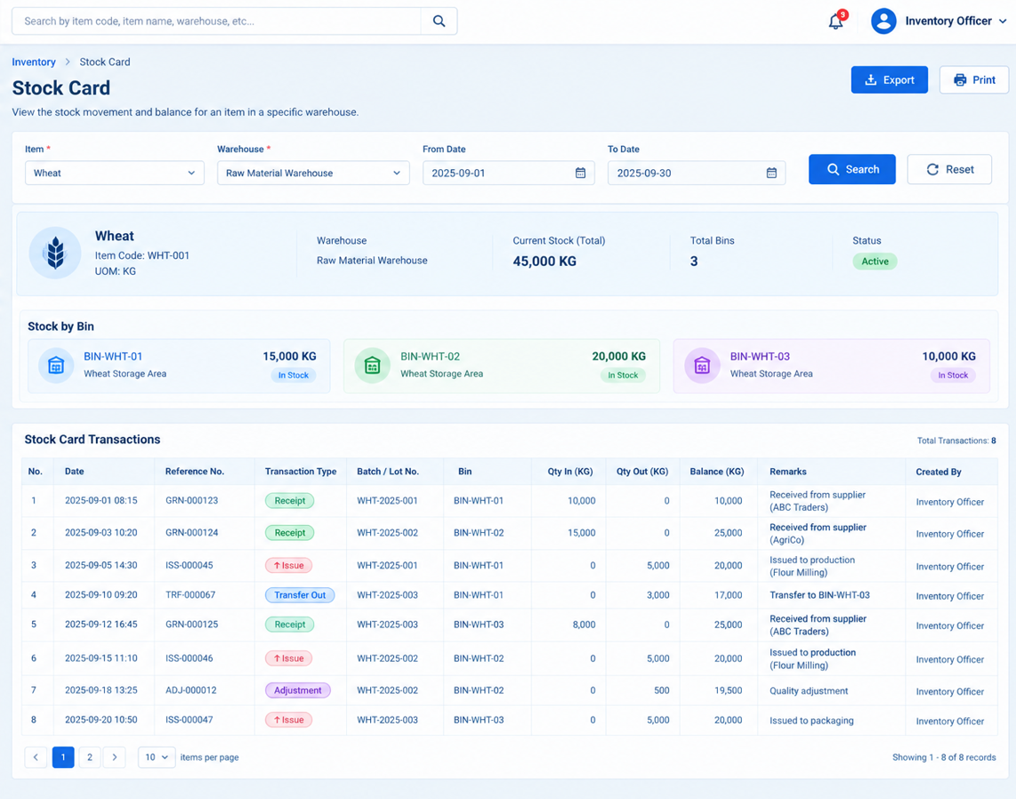
9. Goods Transfer
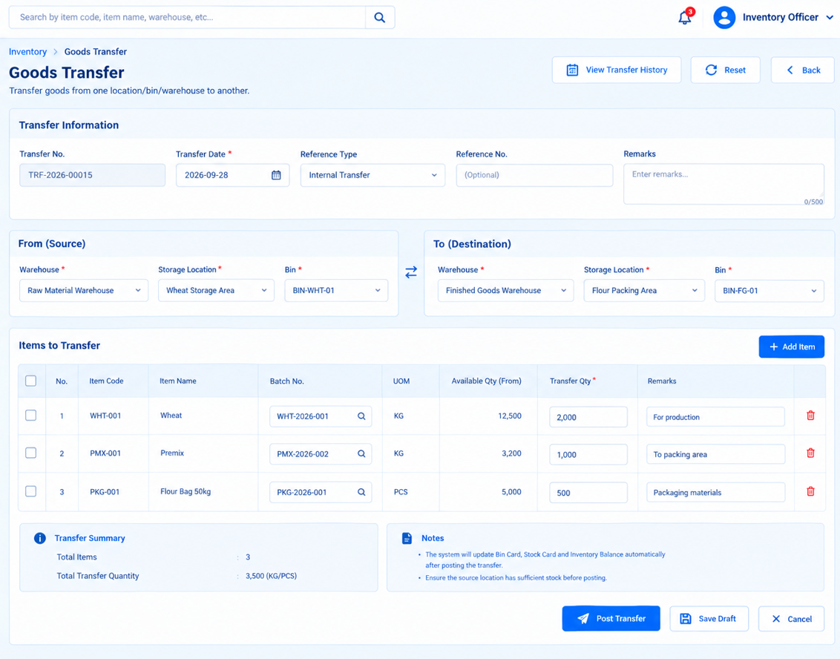
10. Physical Count
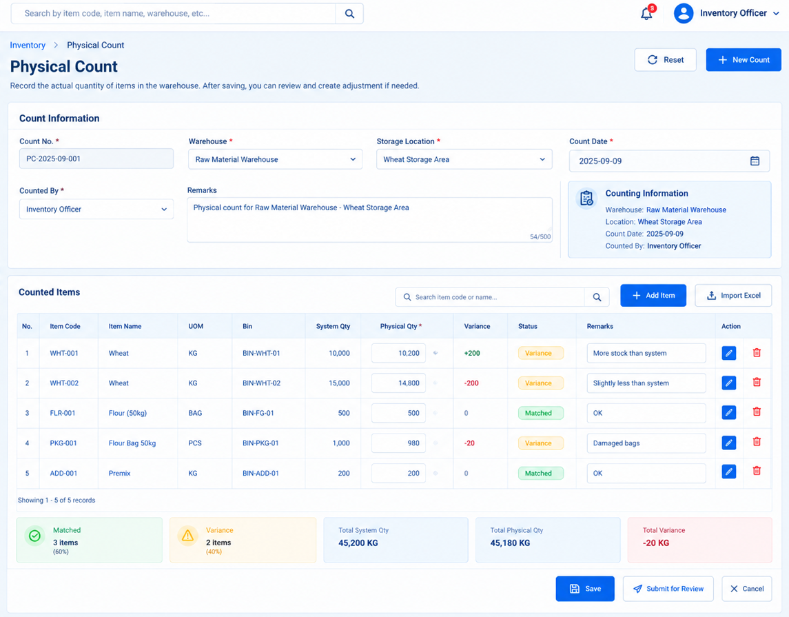
11. Physical Count Review
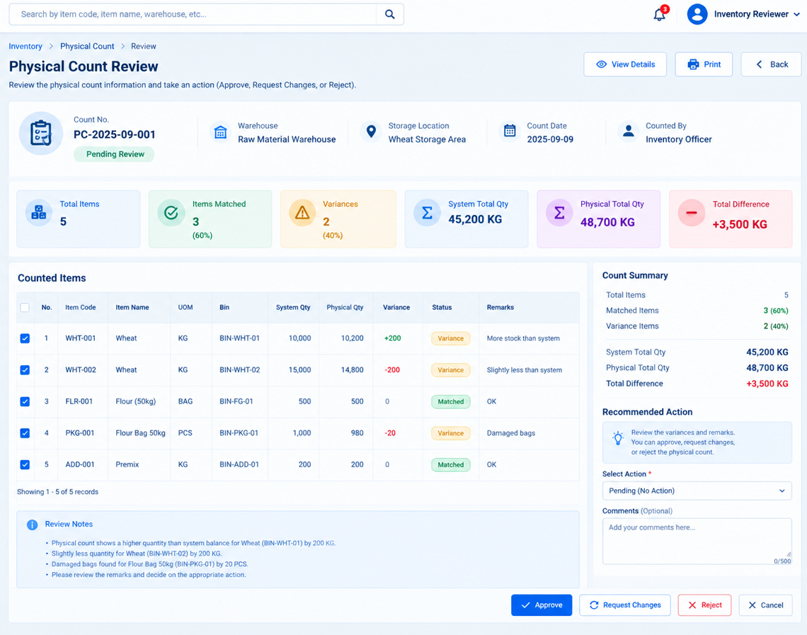
12. Post Stock Adjustments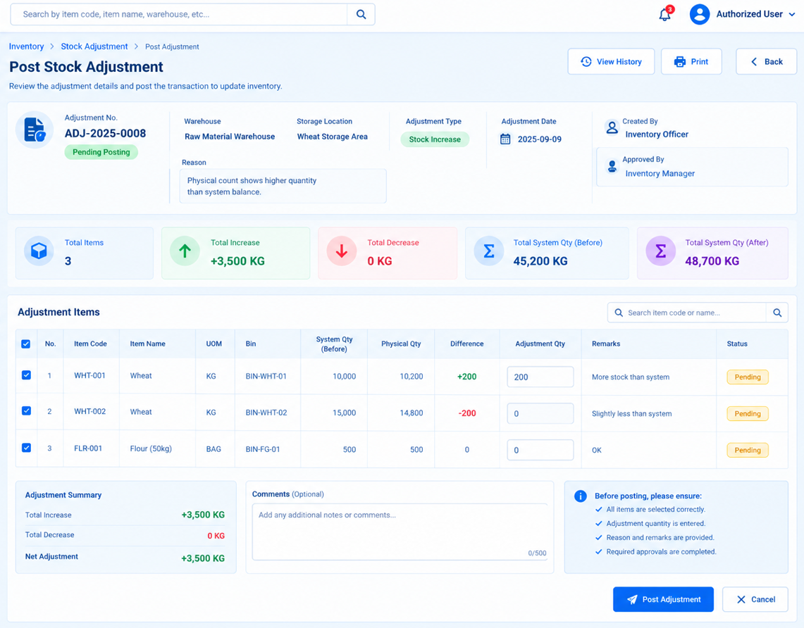
13. Item Master
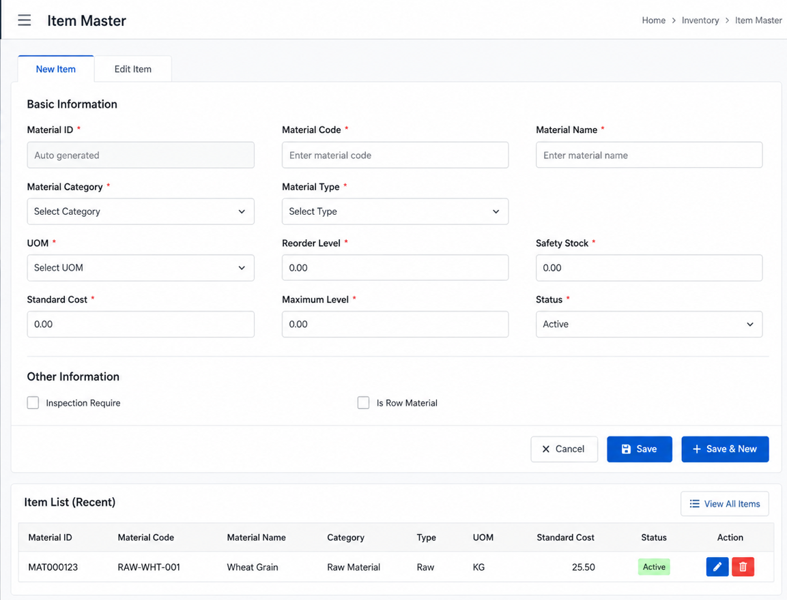

14. Warehouse Master

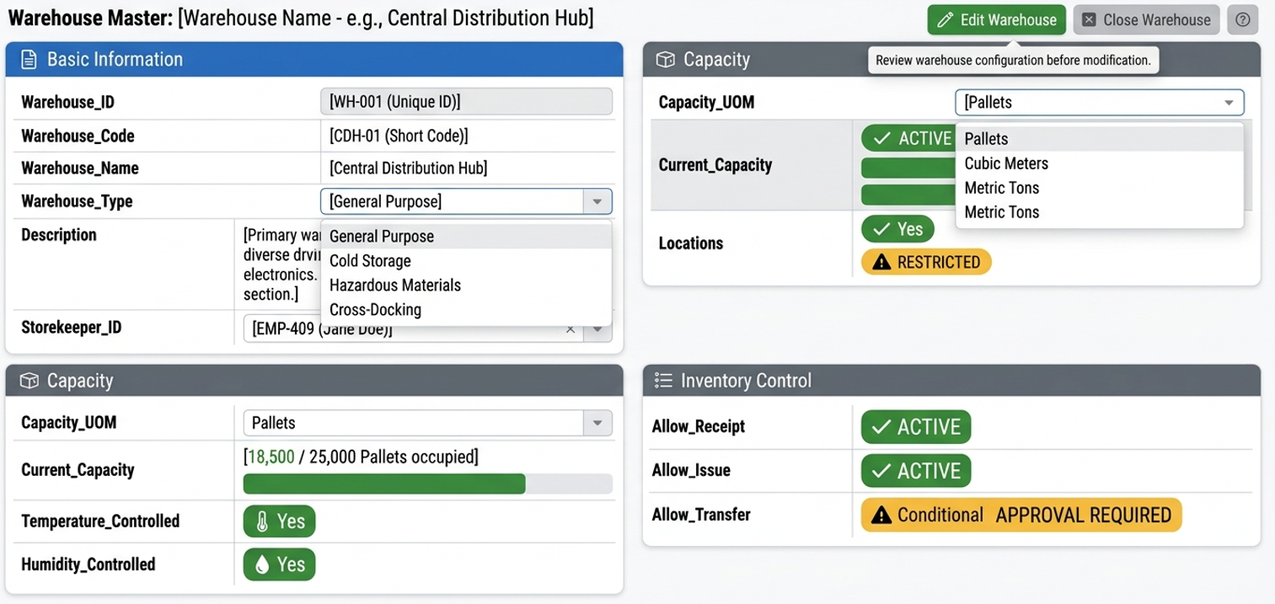

15. Store Master

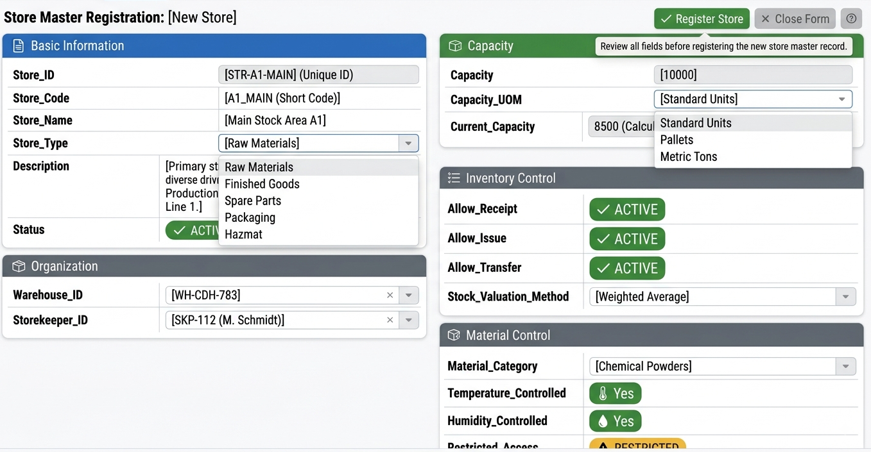

16. Silo Master

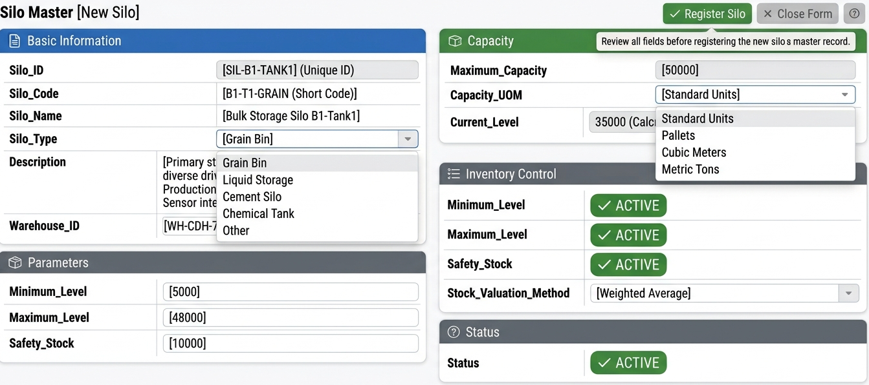

17. Bin Master
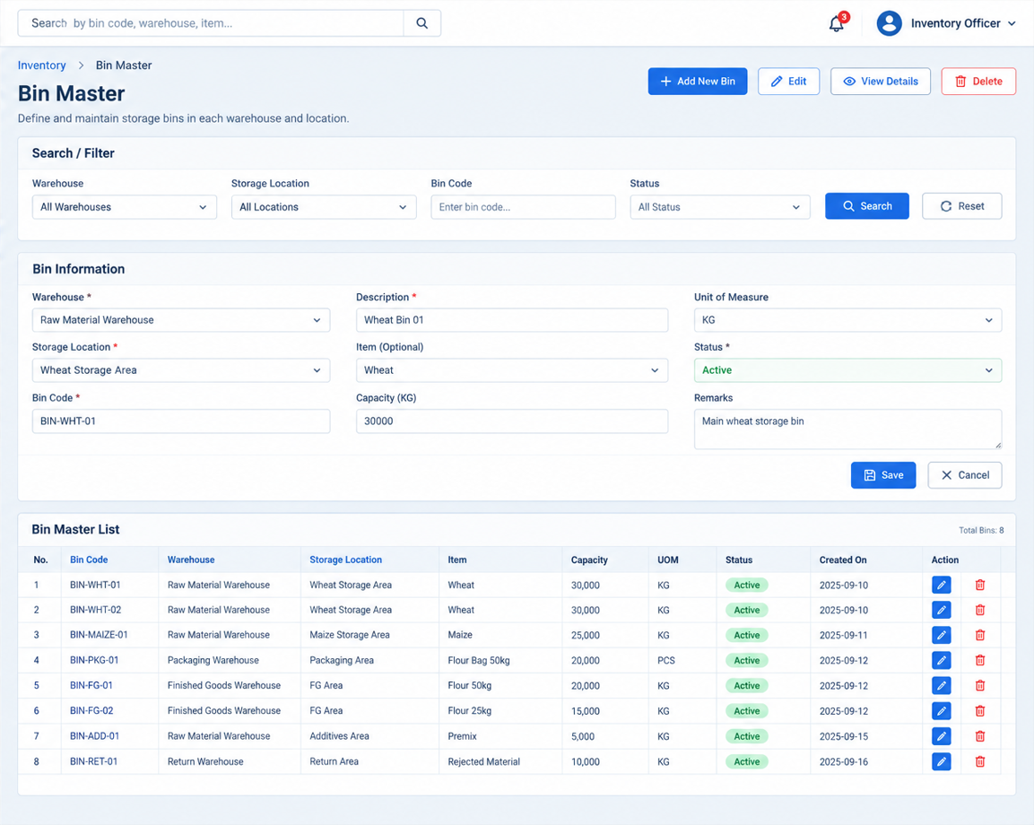
ROW MATRIAL DELVERY PAYMENT REQUEST
0. Supplier Invoice Registration
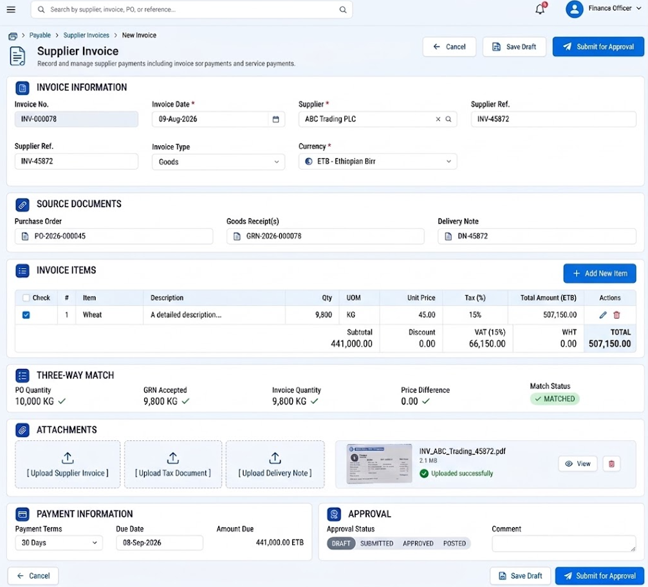

1. Supplier Payment Request
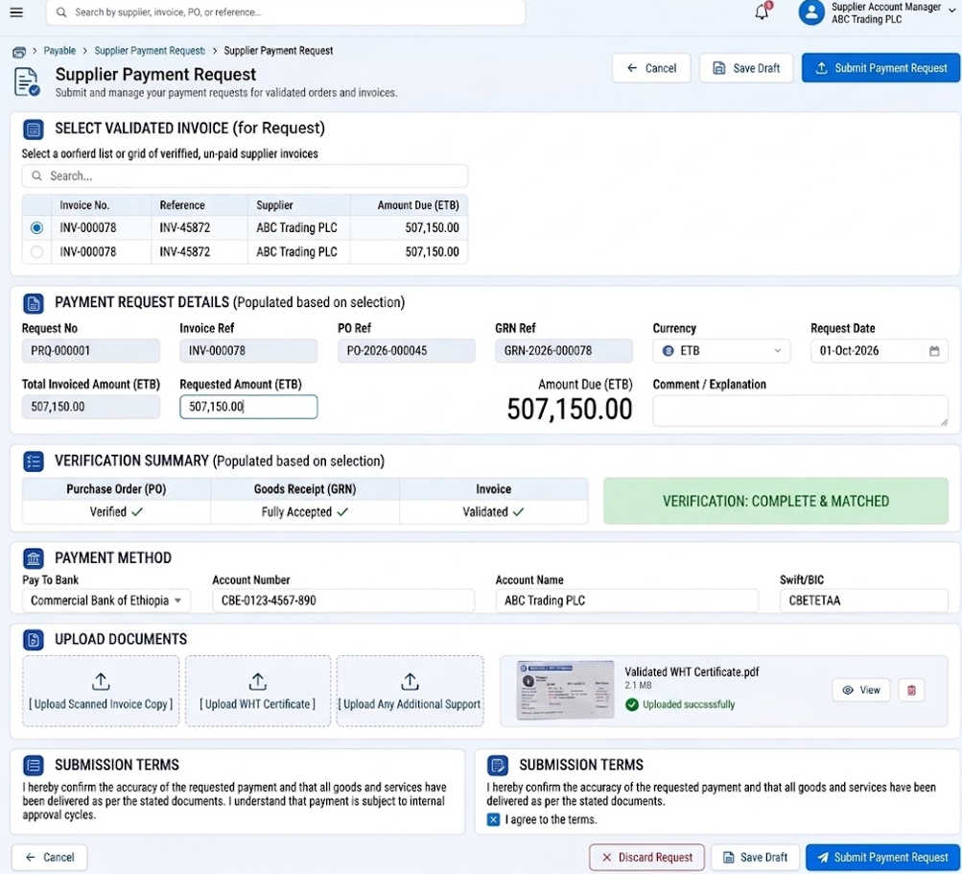

2. Approver takes action for the above PR
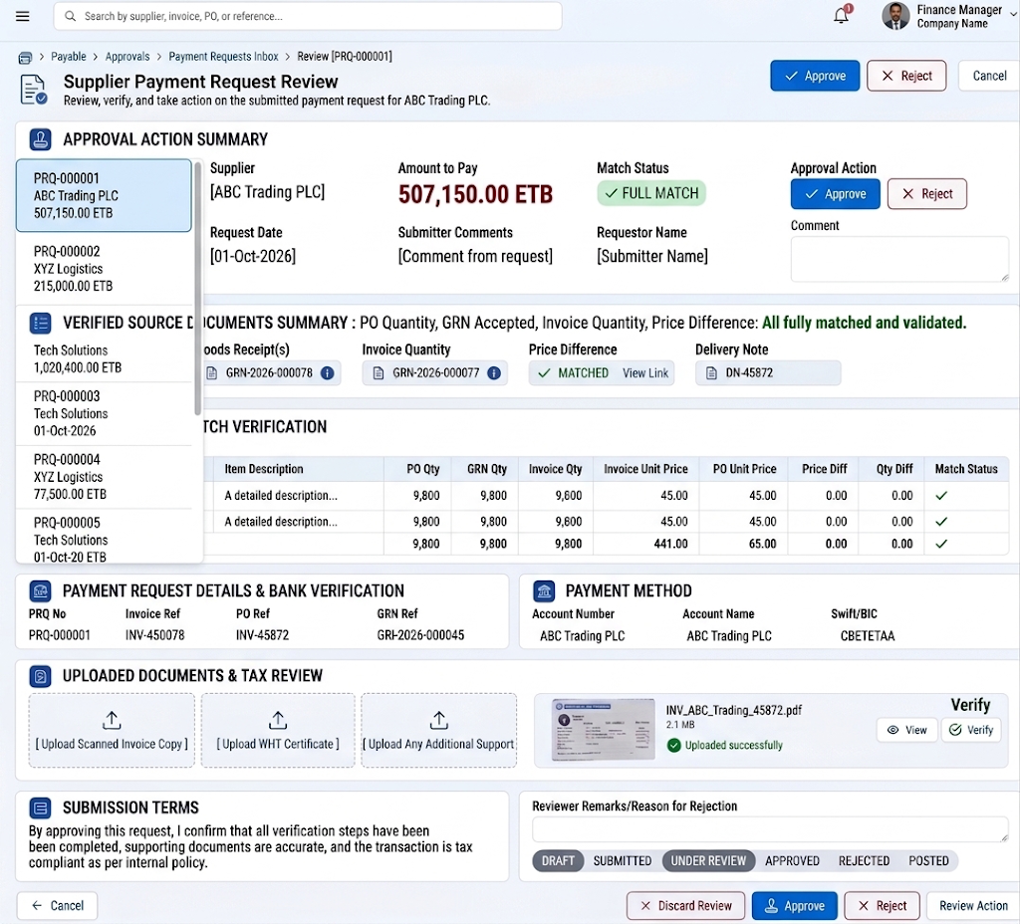
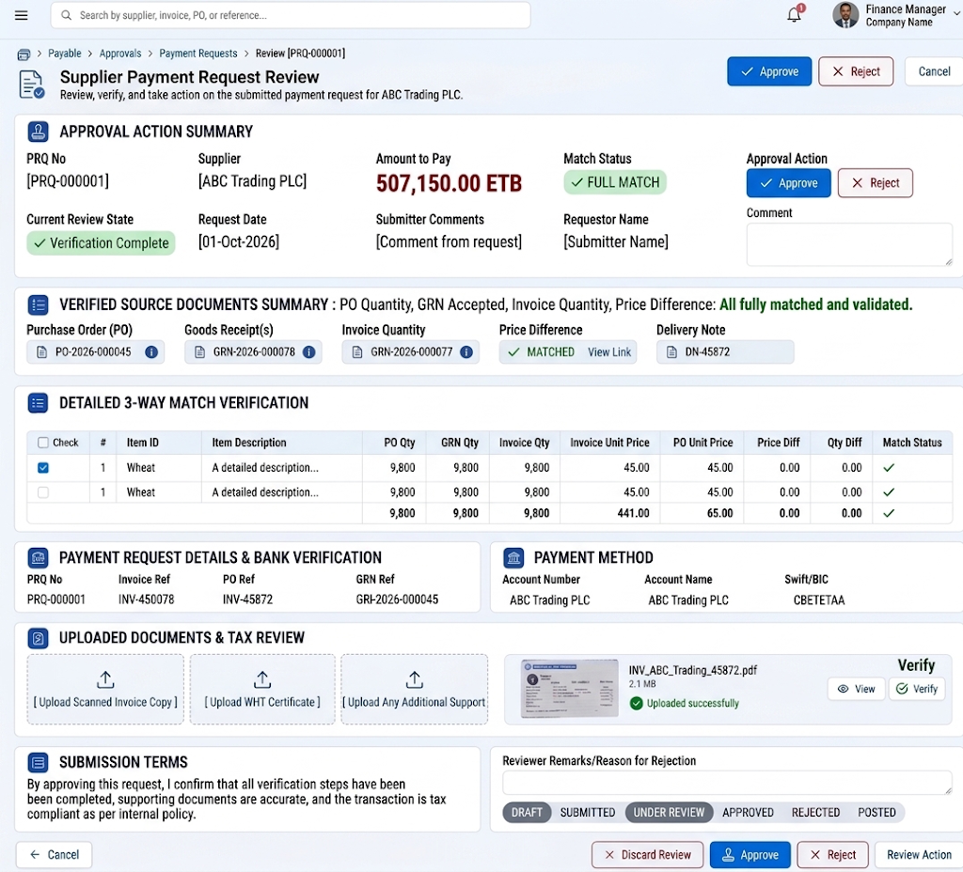

3. Supplier Payment Execution
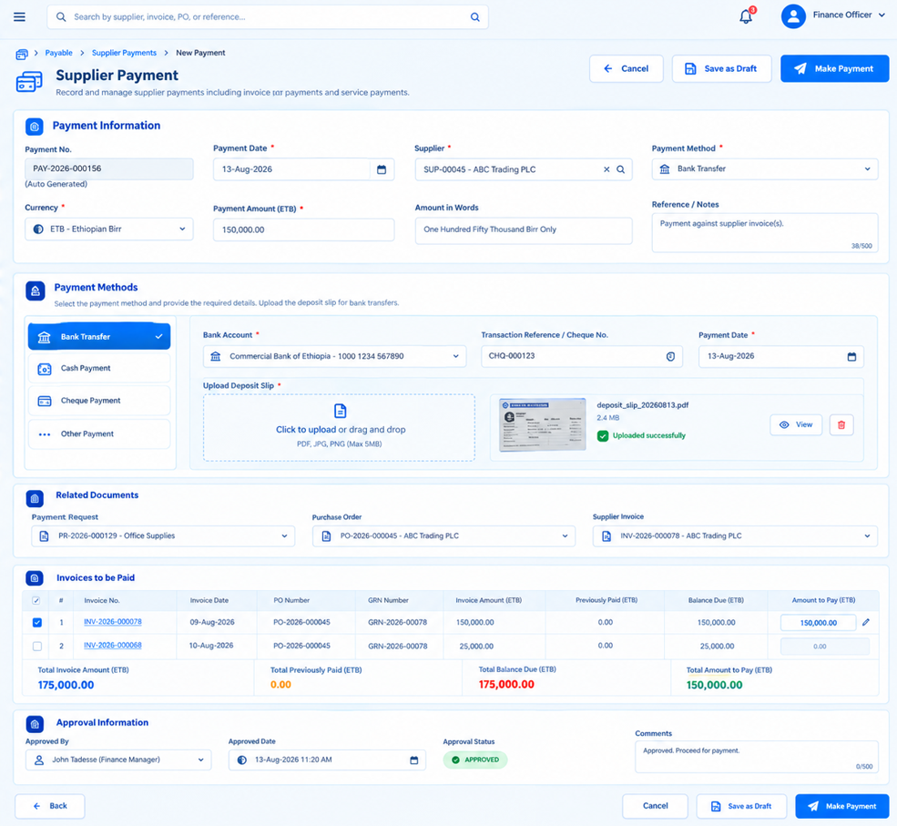

************************* End Process ***************************

