

**Addis Ababa Science and Technology University**

**College of Electrical and Mechanical Engineering**

**Department of Software Engineering**

**Simulation and Modelling Assignment**

**Name IDNO**

***1.Dawit Tolu ……………. … ETS0372/10***

***2.Dessalew Workineh ………… ETS0398/10***

***3.Eyasu Emana ……………. ETS0477/10***

***4 .Enquesel*assie kassahun…. *ETS0450/10***

**1 Poisson Arrival Pattern**

Poisson distribution deals with the number of occurrences in a fixed period of time.

The Poisson process is one of the most widely-used counting processes. It is usually used in scenarios where we are counting the occurrences of certain events that appear to happen at a certain rate, but completely at random (without a certain structure). For example, suppose that from historical data, we know that earthquakes occur in a certain area with a rate of per month. Other than this information, the timings of earthquakes seem to be completely random. Thus, we conclude that the Poisson process might be a good model for earthquakes. In practice, the Poisson process or its extensions have been used to model.

* the number of car accidents at a site or in an area;
* the location of users in a wireless network;
* the requests for individual documents on a web server;
* the outbreak of wars;
* photons landing on a photodiode.
* At a drive-through pharmacy, the number of cars driving up to the drop off window in some interval of time.
* The number of hot dogs sold by Papaya King from 12pm to 4pm on Sundays.
* Failures of ultrasound machines in a hospital.
* The number of vehicles passing through some intersection from 8am to 11am on weekdays.
* Number of electrical pulses generated by a photo-detector that is exposed to a beam of photons, in 1 minute.

**2 Definition of the Poisson Process:**

The resulting random process is called a Poisson process with rate (or intensity) . Here is a formal definition of the Poisson process.

Note that from the above definition, we conclude that in a Poisson process, the distribution of the number of arrivals in any interval depends only on the length of the interval, and not on the exact location of the interval on the real line. Therefore the Poisson process has stationary increments.

The Poisson Process

Let be fixed. The counting process is called a Poisson process with rates if all the following conditions hold:

1. N(0)=0.

2. N(t) has independent increments;

3. the number of arrivals in any interval of length τ>0 has Poisson(λτ) distribution .

**Rule of thumb:**

If n > 20 and p < 0.05 , then a binomial random variable with parameters (n, p) has a probability distribution very similar to that of a Poisson random variable with parameters  λ= np and t = 1 . (Think of dividing one interval of time into n subintervals, and having a probability p of an arrival in each subinterval. That's very much like having a rate of np arrivals (on average) per unit time.)

**3 The Poisson Process**

The Poisson process can be used to model the number of occurrences of events, such as patient arrivals at the ER, during a certain period of time, such as 24 hours, assuming that one knows the average occurrence of those events over some period of time. For example, an average of 10 patients walks into the ER per hour.

The Poisson process has the following properties:

1. It is made up of a sequence of random variables X1, X2, X3, …Xk such that each variable represents the number of occurrences of some event, such as patients walking into an ER, during some interval of time.
2. It is a stochastic process. Each time you run the Poisson process, it will produce a different sequence of random outcomes as per some probability distribution which we will soon see.
3. It is a discrete process. The Poisson process’s outcomes are the number of occurrences of some event in the specified period of time, which is undoubtedly an integer —i.e. a discrete number.
4. It has independent increments. What this is means is that the number of events that the process predicts will occur in any given interval, is independent of the number in any other disjoint interval. For e.g. the number of people walking into the ER from time zero (start of the observation) up through 10am, is independent of the number walking in from 3:33pm to 8:26pm, or from 11:00pm to 11:05pm and so on.
5. The Poisson process’s constituent variables X1, X2, X3,…Xk all have identical distribution.
6. The Poisson process’s constituent variables X1, X2, X3,…Xk all have a Poisson distribution, which is given by the Probability Mass Function:

Px(k)= $\left\{\begin{aligned}\frac{e^{-λ}*λ^{k}}{k!} \\ 0\end{aligned} for k ∈ RX\right.$

otherwise

The above formula gives us the probability of occurrence of k events in unit time, given that the average occurrence rate is λ events per unit time.

**4 Modeling the arrival times in a Poisson process**

Now that we know how to generate inter-arrival times, it is easy to generate the patient arrival times.

From the table of 10 sample inter-arrival times shown above, we can deduce the following:

Arrival time of first patient = x1 = 0.431257556

Arrival time of second patient = x1 + inter-arrival time between first and second patient = x1 + x2 = 0.431257556 + 0.264141966 = 0.6954   
Arrival time of third patient = x1 + x2 + x3 = 0.431257556 + 0.264141966 + 0.190045932 = 0.885445

… and so on

Keeping in mind that X1, X2, X3,…Xk are the inter-arrival times, if we define T1, T2, T3, …Tk as the variables that will represent the patient arrival times at the ER, we see that:

T1 = X1

T2 = X1 + X2

T3 = X1 + X2 + X3

…

Tk = X1 + X2 + X3 + … + Xk

Notice that since T1, T2, T3…Tk are defined as linear combinations of random variables X1, X2, X3,…Xk, the variables T1, T2, T3,…Tk are also random variables.

**Here is one more very interesting fact:**

Since T1, T2, T3…Tk are each the sum of exponentially distributed random variables X1, X2, X3,…Xk, the random variables T1, T2, T3,…,Tk follow the Gamma distribution. The arrival times in a Poisson process follow the Gamma distribution which is a continuous distribution. Let’s take a step back and note how smoothly we traveled from a discrete distribution to a set of continuous distributions! Such is the magical structure of the Poisson process. While the process itself is discrete, its substructure is represented entirely by continuous random variables.

**5 Simulating a Poisson process**

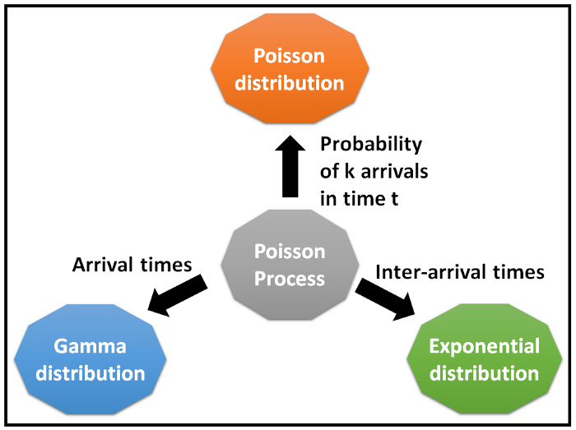

We are now ready to simulate the entire Poisson process.

To do so, we need to follow this simple 2-step procedure:

1. For the given average incidence rate λ, use the inverse-CDF technique to generate inter-arrival times.

2. Generate actual arrival times by constructing a running-sum of the interval arrival times

Here is python code to generate poisson arrival time.

import random

import math

_lambda = 5

_num_arrivals = 100

_arrival_time = 0

print('RAND,INTER_ARRV_T,ARRV_T')

for I in range(_num_arrivals):

#Get the next probability value from Uniform(0,1)

p = random.random()

#Plug it into the inverse of the CDF of Exponential(_lamnbda)

_inter_arrival_time = -math.log(1.0 - p)/_lambda

#Add the inter-arrival time to the running sum

_arrival_time = _arrival_time + _inter_arrival_time

#print it all out

print(str(p)+','+str(_inter_arrival_time)+','+str(_arrival_time))

The basic poisson arrival pattern source code generate:

* Times between consecutive events in a simulated Poisson process.
* Absolute times of consecutive events in a simulated Poisson process.
* Number of events occurring in consecutive intervals in a simulated Poisson process.
* Calculate the mean number of events per unit time