commit;
select * from bank;
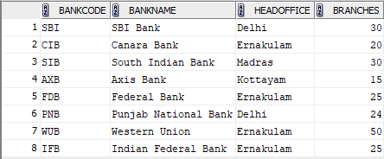

INSERT INTO BANK VALUES ('ICL','ICL Fincorp','Ernakulam',5);
savepoint A;
select * from bank;
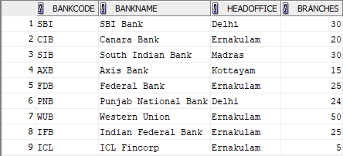

INSERT INTO BANK VALUES ('GMB','Grameen Bank','Punr',15);
savepoint B;
select * from bank;
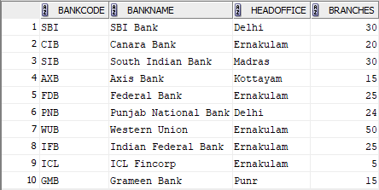
rollback to A;
select * from bank;

-------------------------------------------------------------------------------------------------------
grant select on student to c24csa36;
select * from c24csa35.bank;


revoke select on student from c24csa36;
select * from c24csa35.bank;
