1. SELECT AVG(PHY_MARK) AS AVG_PHYSICS_MARK FROM STUDENT;
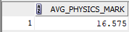

2. SELECT MAX(MAT_MARK) AS highest_marks_maths FROM STUDENT;
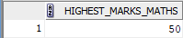

3. SELECT MIN(chem_mark) AS LOWEST_MARKS_CHEMISRTY FROM STUDENT;
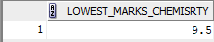

4. SELECT COUNT(*) AS PHYSICS_PASS_COUNT FROM STUDENT WHERE phy_mark >= 12;
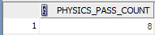

5. SELECT * FROM STUDENT WHERE (phy_mark >= 12 AND CHEM_MARK >= 12 AND MAT_MARK >= 25);
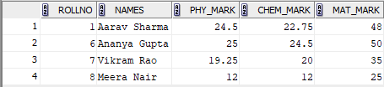

6. ALTER TABLE STUDENT ADD(TOTAL number(4,2));
UPDATE STUDENT SET TOTAl=phy_mark+chem_mark+mat_mark;
SELECT * FROM STUDENT ORDER BY TOTAL DESC;
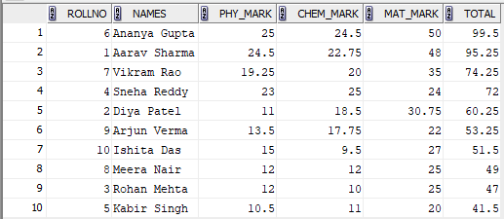

7. SELECT ((SELECT COUNT(*) FROM STUDENT WHERE mat_mark>=25)*100/(SELECT COUNT(*) FROM STUDENT)) AS MATH_PASS_PERCENT FROM STUDENT WHERE ROLLNO=1;
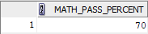

8. SELECT ((SELECT COUNT(*) FROM STUDENT WHERE (mat_mark>=25 AND phy_mark>=12 AND chem_mark>=12))*100/(SELECT COUNT(*) FROM STUDENT)) AS OVERALL_PASS_PERCENT FROM STUDENT WHERE ROLLNO=1;
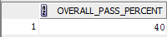

9. SELECT AVG(TOTAL) AS CLASS_AVERAGE FROM STUDENT;
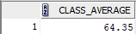

10. SELECT COUNT(*) AS TOTAL_STUDENTS_PASSED FROM STUDENT WHERE (phy_mark >= 12 AND CHEM_MARK >= 12 AND MAT_MARK >= 25);
